E-nose analysis to detect the milk of ruminants fed with the inclusion of fresh forage

Andrea Balivo (andrea.balivo@unina.it)

Dept. Agricultural Sciences, University of Naples Federico II, Portici (NA), Italy

Tutor: Prof. Alessandro Genovese

Electronic nose (E-nose) analysis was advantageously used to authenticate milk from highly biodiverse pasture-fed goats and to authenticate milk from buffaloes fed fresh hydroponic barley forage. SPME-GC/MS analysis was conducted to explore the volatile organic compounds (VOCs) that contributed to discriminate the odour of the two types of milk according to the diet fed to ruminants.

Analisi E-nose per autenticare il latte di ruminanti alimentati con foraggio fresco

L'analisi E-nose è stata utilizzata per autenticare il latte di capre alimentate al pascolo ad alta biodiversità e per autenticare il latte di bufale alimentate con foraggio fresco d'orzo idroponico. Poi, è stata condotta un'analisi SPME-GC/MS per identificare e quantificare i composti volatili che hanno contribuito a discriminare l'odore delle due tipologie di latte, in accordo con la dieta somministrata ai ruminanti.

**Key words**: Pattern recognition, raw milk odour, animal diet, aroma compounds, rapid control analysis.

# **1. Introduction**

In accordance with the PhD thesis project previously described (Balivo, 2022), for the two experimentations on small (A) and large ruminants (B), this poster reports the main results concerning:

(1) the classification of raw goat (A) and buffalo (B) milk according to the animal diet, performed by electronic nose (E-nose) analysis;

(2) the identification and quantification of VOCs to explain the differences in the response of the E-nose sensors to the different types of milk samples, carried out by SPME-GC/MS analysis.

# **2. Materials and Methods**

Milk samples were taken from a total of 90 Saanen goats (divided into two groups, stall group and pasture group, named S and P respectively) and 108 Italian Mediterranean buffaloes (divided into three groups, control group fed with maize silage as forage source, and two experimental treatments in which maize silage was replaced by hydroponic barley forage at 50% and 100%, named C, LH and HH respectively). Concentrate:forage ratio was constant (70:30 and 60:40 for A and B respectively). Goat milk samples were collected in 5 different milking days, while buffalo milk samples in 3 different milking days. Further sampling information has been previously described (Balivo, 2022).

For the analytical methodology, a detailed description is provided in Balivo et al. (2023). Briefly, 2 mL of sample was transferred into 20 mL glass vial with a Teflon/silicon septum in the screw cap and incubated at 25 °C for 30 min to analyse the odour fraction by E-nose. A portable E-nose PEN2 (Airsense Analytics GmbH, Schwerin, Germany), operating with 10 Metal Oxide Semiconductor sensors, was used at constant velocity (400 mL/min). The mean G/G0 values of each sensor response were calculated from measurements in the 55–59 s range (stability of the sensors) using Winmuster v.1.6 software (Airsense Analytics GmbH, Schwerin, Germany).

VOCs were extracted by adding 22.5 g of milk, 20 µL of 2-methyl-3-heptanone as internal standard (389 mg/L) and 2.75 g of sodium phosphate monobasic to a 50 mL glass bottle. The sample was magnetically stirred for 5 min at 55 °C. SPME 2 cm fibre (50/30 μm thick DVB/CAR/PDMS) was inserted through the Teflon septum in the bottle and exposed to headspace for 60 min at 55 °C while stirring. GC was equipped with a Zebron ZB-WAX capillary column (60 m×0.25 mm i.d.×0.25 μm film thickness; Phenomenex, Torrance, CA, USA). The carrier gas was helium with a flow of 1 mL/min. The temperature program was 40 °C for 10 min, then raised at 5 °C/min to 240 °C and held for 11 min. Identification was performed by comparison with pure reference compounds and use of NIST database. Quantification was carried out by normalising the peak areas of each compound with respect to the area of the internal standard peak (MSD ChemStation 5975 TAD Data Analysis software).

# **3. Results and Discussion**

## **3.1 Electronic Nose Analysis**

Figure 1 shows the linear discriminant analysis (LDA) plot obtained from the data vectors extrapolated from E-nose measurements, for goat (A) and buffalo (B) milk samples. E-nose provided good discrimination of milk samples in both investigations (A and B), according to animal diet.

Table 1 shows the confusion matrix with classification of milk samples obtained by LDA analysis. The correct classification of goat milk samples according to pasture and stall diet was 88%. P milk was misclassified as S milk seven times, while S milk was misclassified only three times as P milk.

**Figure 1** *LDA plot of E-nose data pattern extrapolated in the time range 55-59s (stability of sensors) from 45 Pasture (P) and 45 Stall (S) goat milk (A) and from 108 milk samples obtained from maize silage-fed buffaloes (C) and hydroponic forage-fed buffaloes, with 50% (LH) and 100% (HH) silage replacement percentage (B). Data processed with Winmuster v.1.6 software (Airsense Analytics GmbH, Schwerin, Germany).*

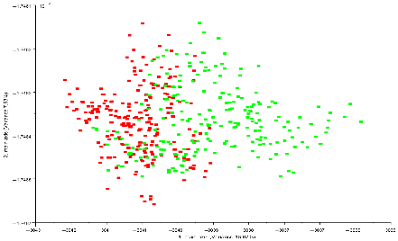

A)

1 main axis (variance: 13.07%)

2 main axis (variance: 7.93%)

**S**

**P**

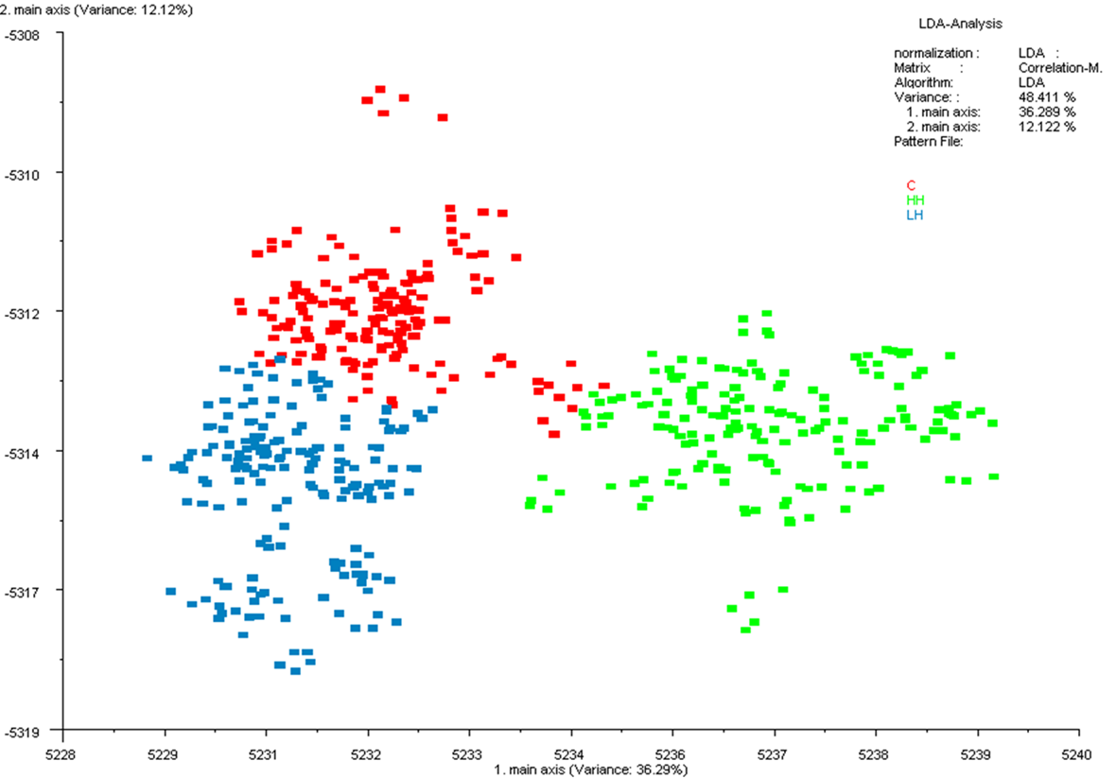

**C**

**LH**

**HH**

1 main axis (variance: 36.29%)

2 main axis (variance: 12.12%)

B)

1 main axis (variance: 13.07%)

***Table 1*** *Confusion matrix of the Pasture (P) and Stall (S) goat milk samples (A), and of* *the buffalo milk samples (B) from maize silage-fed (C) and hydroponic forage-fed, with 50% (LH) and 100% (HH) silage replacement.*

|  |  |  |  |  |  |  |
| --- | --- | --- | --- | --- | --- | --- |
| **A)** | **from/to** | **P** | **S** |  | **Total** | **Correct response (%)** |
|  | **P** | 37 | 8 |  | 45 | 82.2% |
|  | **S** | 3 | 42 |  | 45 | 93.3% |
|  | **Total** | 40 | 50 |  | 90 | 88% |
| **B)** | **from/to** | **C** | **LH** | **HH** | **Total** | **Correct response (%)** |
|  | **C** | 33 | 0 | 3 | 36 | 91.7% |
|  | **LH** | 0 | 36 | 0 | 36 | 100% |
|  | **HH** | 0 | 0 | 36 | 36 | 100% |
|  | **Total** | 33 | 36 | 39 | 108 | 97% |

For the buffalo milk samples, only three misclassifications occurred for C samples, which were recognised as HH samples, leading to a 97% total correct response. Milk from buffaloes fed with hydroponic barley forage (LH and HH) was 100% correctly classified. The results show that a pasture-fed diet, compared to an indoor diet, leads to a lower % of correct classification. The more variable responses obtained for P milk could be linked to VOCs, the presence of which varies both qualitatively and quantitatively according to the fed period and, hence, the botanical composition of the pasture (Altomonte et al., 2019).

## **3.2 Analysis of Volatile Compounds**

Compared to S milk, P milk had a higher overall quantity of VOCs in the headspace. Terpene compounds, such as α-pinene, β-pinene, β-caryophyllene and limonene, qualitatively characterised the P milk samples, while S milk had a higher quantity of hydrocarbons and ketones. Similar findings on milk VOCs from pasture-fed goats have been reported by Sant'Ana et al. (2019). Milk from buffaloes fed maize silage had a higher quantity of acids (e.g. butanoic and hexanoic) and ketones, such as diacetyl, while milk from buffaloes fed hydroponic forage had a higher amount of dimethyl sulphone, as well as 1-octen-3-ol, which can result from the metabolism of linoleic and linolenic fatty acids (Curioni and Bosset, 2002).

In conclusion, E-nose resulted a useful device for the rapid control of the genuineness of raw milk obtained from ruminants fed with the inclusion of fresh forage in the diet. It could be used to protect producers and consumers of dairy products from potential fraud.

# **4. References**

Altomonte I, Conte G, Serra A, Mele M, Cannizzo L, Salari F, Martini M (2019) Nutritional characteristics and volatile components of sheep milk products during two grazing seasons. *Small Rumin Res*, **180**: 41-49.

Balivo A (2022) Inclusion of fresh forage in lactating ruminant diet. Evaluation of sustainability and effect on the chemical and sensory properties of milk and dairy products. In Proc.s of the 26th Workshop on the *Developments in the Italian PhD Research on Food Science, Technology and Biotechnology*, Asti (Italy), 19-21 September, 2022, pp. 31-32.

Balivo A, Cipolletta S, Tudisco R, Iommelli P, Sacchi R, Genovese A (2023) Electronic Nose Analysis to Detect Milk Obtained from Pasture-Raised Goats. *Appl Sci*, **13**: 861.

Curioni P M G, Bosset J O (2002) Key odorants in various cheese types as determined by gas chromatography-olfactometry. *Int Dairy J*, **12**: 959-984.

Sant’Ana A M, Bessa R J, Alves S P, Medeiros A N, Costa R G, de Sousa Y R, Bezerril F F, Malveira Batista A S, Madruga M S, Queiroga R C (2019) Fatty acid, volatile and sensory profiles of milk and cheese from goats raised on native semiarid pasture or in confinement. *Int Dairy J*, **91**: 147-154.