Development of active antioxidant packaging to preserve the nutritional quality of minimally processed produce
Muhammad Rehan Khan (muhammadrehan.khan@unina.it)
Dept of Agricultural Science, University of Naples Federico II, Portici, Napoli, Italy
Tutor: Prof. ssa Elena Torrieri

This PhD thesis dealt with the assessment of the poorly understood concept in the food packaging domain that “for the packaging to be effective in the shelf-life extension of the product, the release kinetics of the active compound from active packaging must be of the same magnitude as of decay kinetics of the food to be preserved”. This project aimed to understand the release kinetics phenomenon and how bioactive release behavior can be modeled using a suitable mathematical model. Furthermore, the release behavior was correlated with decay kinetics of the minimally processed F&V using in-vitro and in-silico approaches.

Sviluppo di imballaggi antiossidanti attivi per preservare la qualità nutrizionale dei prodotti minimamente lavorati
Questa tesi si è occupata della valutazione del concetto poco compreso nel campo dell'imballaggio alimentare secondo cui "affinché l'imballaggio sia efficace nell'estensione della durata di conservazione del prodotto, la cinetica di rilascio del composto attivo dall'imballaggio attivo deve essere della stessa grandezza come cinetica di decadimento dell'alimento da conservare”. Questo progetto mirava a comprendere il fenomeno della cinetica di rilascio e il modo in cui il comportamento di rilascio bioattivo può essere modellato utilizzando un modello matematico adeguato. Inoltre, il comportamento di rilascio è stato correlato con la cinetica di decadimento dell'F&V minimamente elaborato utilizzando approcci in-vitro e in-silico.
Keywords: Release kinetics; decay kinetics; antioxidant packaging; mathematical modeling; polyphenol oxidase; molecular docking.

1. Introduction
Minimally processed fruits and vegetables (F&V) are those food products that are altered physically from their original state but remain in a fresh form. Over the years, the demand for consumption of minimally processed F&V has increased due to change in consumer’s requirements for convenient, healthy, and fresh foods. However, minimally processed produce is more perishable as compared to original raw materials and have a shelf life of several days as compared to several weeks or months of raw produce due to the presence of cut surfaces, active metabolism of tissues, microbial growth due to cross-contamination and removal of the outer protective layer. Considering the above facts, a holistic approach in terms of the development of an active packaging form is required to preserve the intrinsic quality of fresh produce. The main challenges for the implementation of the new technology to real food is related to the complexity of the food systems and to the highly product-specific packaging parameters (Khan et al., 2021). Furthermore, for the packaging to be effective in shelf-life extension of the product, the release kinetics of the active compound from active packaging must be of the same magnitude as of decay kinetics of the food to be preserved. Thus, an adequate knowledge of the release kinetics and how it can be used to slow down the decay by the active compound is essential to design an antioxidant package by using mathematical modelling. The aim of this PhD project is to design an active antioxidant package capable of preserving the nutritional quality of the food product. In this context the work was divided into four main activities:
A1) Investigating the release kinetics of active compounds from active packaging
A2) Modelling the release behavior using mathematical modeling
A3) Correlating the release kinetics with decay kinetics of minimally processed fruits and vegetables (F&V)
A4) Employing an in-silico approach to elucidate the mechanism of inhibition of oxidative enzyme (in case of reduced lower oxidative enzyme activity):

2. Materials and Methods
2.1 Investigating the release kinetics of active compounds from active packaging
Initially, a computational methodology was followed to understand the interaction mechanism between caseinate and a group of hydroxybenzoic acids, and the bioactive compound (i.e., gallic acid) with the best binding affinity was selected for further evaluation for in-vitro release kinetics according to EC regulation 10/2011. Furthermore, guar gum was also added to the mixture and gallic acid was used at different concentrations in the film-forming solutions (FFS).
Another study was carried out to evaluate the impact of the inclusion of fennel (FEN) and coffee humic (COF) substances on the structure, physical, and release properties of active substances from composite materials based on sodium caseinate, guar gum, and beeswax.
Ferulic acid displays poor thermal resistance during extrusion and compression moulding, slow 2,2-diphenyl-1-picrylhydrazyl (DPPH) reaction kinetics, and undetected release from polylactide (PLA) and polyhydroxyalkanoates (PHA)-based films into polar media. Thus, in this study, a ferulic acid derivative Bis-O-dihydroferuloyl-1,4-butanediol (BDF) was used as an active additive (up to 40 w%) in PLA, poly(3-hydroxybutyrate) (PHB), and poly(3-hydroxybutyrate-co-3-hydroxyvalerate) (PHBV) matrices to produce blends by extrusion. These blends were then used to prepare films by solvent casting.
2.2 Modelling the release behavior using mathematical modeling
The mathematical models are useful in describing the release behavior of a bioactive from the polymeric chains of a film into the food simulant by using Fick’s Second Law. The migration process was elucidated by the diffusion coefficient (D) and partition coefficient (K) of the migrant molecules. The Fick’s Model, boundary conditions, and differential equations are as follows:
$\frac{∂C\left(x,t\right)}{∂t}=D\left[\frac{∂^{2}C\left(x,t\right)}{∂x^{2}}\right]$ (1)
$\left\{\begin{aligned}{\left.\frac{ⅆc_{i}\left(t\right)}{ⅆ_{t}}\right|}_{i=0}=0 \\ {\left.\frac{ⅆc_{i}\left(t\right)}{ⅆ_{t}}\right|}_{i=n}=0\end{aligned}\right.$ (2)
Whereas C is the ratio of the concentration of bioactive at time t and its concentration after infinity. Furthermore, to simplify the solution of PDE of the Fick’s Law, the method of lines was used with respect to the spatial variable on the second derivative. This approximation transforms the PDE into an ordinary differential equation (ODE):
$\frac{ⅆC_{i}t}{ⅆt}=D\frac{\left(C_{i-1}(t)-2C_{i}(t\right)+C_{i+1}(t))}{x^{2}}$ (3)
x is the distance from the interface obtained by dividing the thickness of the film (e) to the total number of layers ($η$).
$C=\frac{M_{f,t}}{M_{f,∞}}$ (4)
$x=\frac{ⅇ}{η}$ (5)
For ensuring the validation of mathematical models and to ensure the goodness of fit of the predicted data with experimental by minimizing the sum of square of the differences between measured and predicted values, root mean square error (RMSE) was calculated by using MATLAB (version R2022a, MathWorks, USA).
2.3 Correlating the release kinetics with decay kinetics of minimally processed fruits and vegetables
The control (PHBV) and active packaging films (PHBV.BDF 10%, PHBV.BDF 20%) were prepared from extruded polymeric blends by the solvent casting method used previously by Khan et al. (2023). Different parameters were evaluated during storage of the product wrapped in the packaging films i.e., weight loss, color properties, ascorbic acid content, total polyphenol content by Folin’s method, polyphenol oxidase content by using a wet chemistry method.
It is essential to understand the degradation kinetics of ascorbic acid to predict quality losses during storage and the effect of release kinetics on the decay kinetics phenomenon. Thus, vitamin C degradation was described by zero-order (equation 6) and first-order models (equation 7):
P= P0 – kt (6)
P= P0 exp (-kt) (7)
Where P is the measured vitamin C content at time t, P0 is the initial ascorbic acid content, and k is the rate change constant. The quality of regression and fitted models was determined by the coefficient of correlation (R²).
2.4 Employing an in-silico approach to elucidate the mechanism of inhibition of oxidative enzymes
Molecular docking methods were used to study initially the interactions between gallic acid and PPO/AO (Zhou et al., 2016). To explore the reason for PPO inhibition caused by active PHBV-releasing films, molecular modeling was used between PPO and BDF molecules to understand the detailed interactions, stability of the protein/ligand complex, and mechanisms of inhibition (Zhou et al., 2016).

3. Results and Discussion

3.1 Release kinetics and mathematical modelling
In case of caseinate films, during the first 6 h of incubation, the concentration of released gallic acid was 171.76 ± 18.21 µg/ml, with a threefold increase (~624 µg/ml) in concentration after 48 h (Fig. 1). However, after 120 h, a non-significant increase in concentration was observed indicating towards equilibrium stage, which can be better defined in terms of the “swelling-controlled” model. In this study, ~26% of the gallic acid leached out into the food simulant, which could be due to migrant polarity similar to that of the food simulant and swelling of the polymer in the presence of the simulant. On the other hand, the addition of guar gum and different gallic acid concentrations also effected the release behaviour of gallic acid from the films. For instance, the gallic acid released from the films GAI*60 μg.ml⁻¹, GAII*250 μg.ml⁻¹ and GAIII*650 μg.ml⁻¹ was 67%, 32%, and 30% respectively. Similarly, the diffusion coefficient was also affected by an increase in the concentration and was: 8.10 × 10⁻¹² m²s⁻¹, 6.23 × 10⁻¹² m²s⁻¹, and 4.5 × 10⁻¹² m²s⁻¹ for GAI, GAII, and GAIII films respectively. Because of the hydrophilic nature of the packaging films another set of polymeric films were prepared with a novel ferulic acid derivative such as Bis-O-dihydroferuloyl-1,4-butanediol (BDF) for food applications. the films with low BDF concentration (i.e., 10–20 w%) displayed a higher release percentage (p < 0.05) as compared to films with the highest BDF content (40 w%). BDF is hydrophobic in nature thus a lower amount of BDF in the films means it has more affinity for hydrophilic food simulant (i.e., 10% ethanol), thus more release of BDF can be expected from films with lower BDF content. Furthermore, a higher percentage of BDF (40%) favoured the BDF-BDF interaction rather than the BDF-PHA interaction along with the formation of a crosslinking cluster of PHA-BDF-BDF-PHA structure that leaves the BDF trapped and then delays its release (Fig. 2).

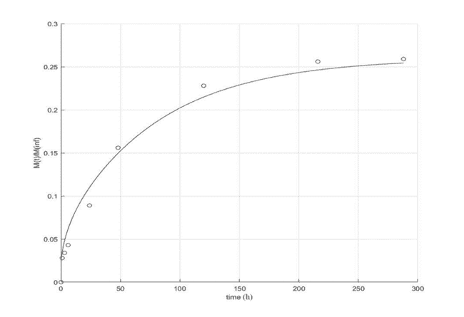
Figure 1 Release kinetics of gallic acid from caseinate films
Figure 2 Release kinetics of BDF from PHBV, PHB, and PLA films
3.2 Combining release and decay kinetics
Based on the release data acquired previously and film integrity active PHBV films were selected for application on minimally processed apples. The vitamin C degraded in all the apple slices irrespective of the treatment used throughout the storage period. However, there was a significant difference (p < 0.05) in the ascorbic acid contents of apple slices packed in active packaging and the control samples (Fig. 3). Figure 4 shows the PPO activity as a function of treatment and time. Although all the apple slices packed in different treatments displayed an increase in PPO activity throughout the storage period, however, the rate of increase of PPO activity was significantly faster (p < 0.05) in the un-packed apple slices or the ones packed in plain PHBV films mainly because PPO quickly utilized the substrate on apple surface. Ferulic acid derivative can either effectively decrease the reaction quinones produced (by donating electrons to PPO from their hydroxyl groups) during PPO-catalyzed oxidation of polyphenols or by cross-linking PPO through hydrogen bonding and π-π stacking interactions which can change the PPO polarity and reduce the brown-pigment formation. The lowest and highest TPC values (544.8±14.6 and 608.5±8.4 mgGAE/100g FW) were observed for apple slices unpacked and packed in 20% BDF-containing films (Fig. 5); these results can be directly correlated with the PPO activity since PPO enzymes are directly responsible for phenolic oxidation and degradation to produce brown pigments. PCA was used to uncover underlying mechanisms on how the different parameters i.e., weight loss, color parameters (a and L-value), PPO activity, and

TPC are related to each other, and to determine how the treatments can be compared when taking into account these parameters simultaneously. (Fig. 6)

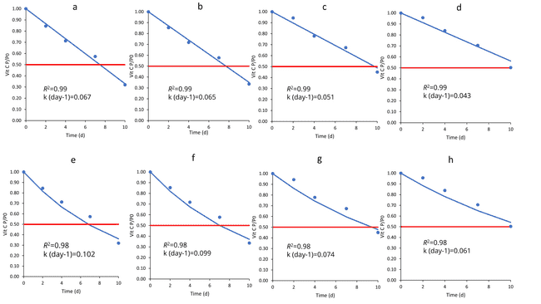
Figure 3 Decay kinetics of ascorbic acid of apple slices wrapped in different packaging materials whereas a-d) zero order decay and e-h) first order decay modelling of ascorbic acid from samples recovered without film, plain PHBV film, PHBV.BDF 10%, PHBV.BDF 20% respectively (dots represent experimental and line represent model used for fitting)
Figure 4 PPO activity of the samples without film (control), plain film (Film_C), PHBV.BDF 10% (Film_10), and PHBV.BDF 20% (Film_20)
Figure 5 TPC of the samples without film (control), plain film (Film_C), PHBV.BDF 10% (Film_10), and PHBV.BDF 20% (Film_20)
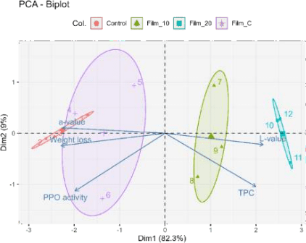
Figure 6 PCA biplot of the nutritional quality parameters of apple slices packed in different films
3.3 Inhibition mechanism exploration via in-silico study
Molecular modelling of BDF with PPO suggested a binding energy of -5.9 kcal/mol. Pi-Pi stacking was observed between benzene ring of BDF and PHE492 of the PPO enzyme which changed the polarity of the enzyme by causing rearranmnet of the secondary structure ultimately avoiding the formation of oxidation product as also observed previoulsy in in-vitro trials. Hence it was proved that BDF has the potential to inhibit the activity of PPO by binding near the active site (especially formation of hydrogen bonds could reduce the overall polarity of the enzyme).

4. Conclusions and Future Perspectives
While most of the literature available has focused on the effect of antioxidant packaging on lipid still there is limited information about the impact of antioxidant packaging on the quality of fresh and minimally processed F&V during shelf- life especially the loss of nutritional quality due to oxidative enzyme activity. Initially, casein-based systems were explored for release kinetics however their hydrophilic nature restricted their potential for packaging purposes. A comparative study between microbial origin-biopolymers and poly (lactide)s was carried out and PHBV-based systems displayed better release and structural integrity Ferulic acid derivative (BDF) effectively decreased the reaction quinones produced (by donating electrons to PPO from their hydroxyl groups) during PPO-catalyzed oxidation of polyphenols. This thesis provided evidence that release kinetics can be effectively used as an indicator for managing decay of the product. However, future studies are still required to improve the mechanical behavior of PHBV films; to explore the leeching phenomenon in detail, or the regulatory status of using ferulic acid derivatives in releasing packaging systems.

5. References
Khan MR, Di Giuseppe FA, Torrieri E, & Sadiq MB (2021) Recent advances in biopolymeric antioxidant films and coatings for preservation of nutritional quality of minimally processed fruits and vegetables. Food Packag 30: 100752.
Khan MR, Volpe S, Salucci E, Sadiq MB, & Torrieri E (2022) Active caseinate/guar gum films incorporated with gallic acid: Physicochemical properties and release kinetics. J. Food Eng 335: 111190.
Khan MR, Fadlallah S, Gallos A, Flourat AL, Torrieri E, & Allais F (2023) Effect of ferulic acid derivative concentration on the release kinetics, antioxidant capacity, and thermal behaviour of different polymeric films. Food Chem 410: 135395.
Zhou L, Liu W, Xiong Z, Zou L, Chen J, Liu J, & Zhong J (2016). Different modes of inhibition for organic acids on polyphenoloxidase Food Chem 199: 439-446.

