Development of field-effect transistor-based platforms for the detection of foodborne hazards
Anna Tagliaferri (atagliaferri@unibz.it)
Faculty of Agricultural, Environmental and Food Sciences, Free University of Bozen-Bolzano, Bolzano, Italy
Faculty of Engineering, Free University of Bozen-Bolzano, Bolzano, Italy
Tutor: Prof. Paolo Lugli

My PhD project aims to develop sensors for detecting foodborne hazards, specifically focusing on remnants of fertilizers, such as ammonium ions, and bacterial byproducts like ammonia and biogenic amines. The first part of the project involved developing an electrolyte-gated carbon nanotube field-effect transistor (EG-CNTFET)-based biosensor functionalized with a selective membrane using the actinomycete ionophore nonactin for ammonium detection. To enhance stability and reduce stabilization time, a lipophilic membrane was added to the biosensors.
Sviluppo di piattaforme basate su transistor ad effetto di campo per il rilevamento dei rischi alimentari
Il progetto di dottorato mira a sviluppare sensori per rilevare rischi alimentari, concentrandosi in particolare su tracce di fertilizzanti, come gli ioni ammonio, e sui sottoprodotti batterici come l'ammoniaca e le ammine biogene. La prima parte del progetto ha previsto la creazione di un biosensore basato su electrolyte-gated carbon nanotube field effect transistor (EG-CNTFET) con una membrana selettiva, utilizzando lo ionoforo di actinomiceti, nonactin. Per migliorare la stabilità e ridurre il tempo di stabilizzazione, ai sensori è stata aggiunta una membrana lipofilica.

Key words: Ammonium, Biogenic Amines, Ion-selective membrane, Lipophilic membrane, Biosensor

1. Introduction
Electrolyte-gated carbon-nanotube field-effect transistors (EG-CNTFETs) are successful biosensing platforms that are able to amplify signals, improving sensitivity and detection limits (Makowski, Ivanisevic 2011). They operate at low voltages, allowing the detection of biomolecules in food without water electrolysis. Early detection of food intoxicants is crucial to prevent outbreaks. Ammonium, found in fertilizers used on crops, requires tight regulation due to potential adverse effects when ingested (Li et al. 2018). Additionally, bacterial amino acid metabolism in protein-rich foods can produce ammonia and biogenic amines, like histamine, causing a range of unpleasant symptoms when consumed in high quantities (Franceschelli et al. 2021, Santos 1996). This poster presents the development of a stable EG-CNTFET biosensor for detecting ammonium in food. Future objectives include histamine sensing, mathematical model evaluation, and computational simulations for validation.

2. Materials and Methods
A planar EG-FET device (Figure 1a) was fabricated by means of standard single-step negative photolithography followed by evaporation of 10nm titanium and 50nm gold; single-walled CNTs were then deposited on the channel using a spray-coater. The protocol was previously described (Shkodra et al. 2022, Shkodra et al. 2021). Atomic Force Microscopy was then conducted to verify the uniform and dense distribution of the CNTs. Later, a lipophilic membrane was prepared and deposited through drop-casting (Joshi et al. 2018). A second membrane was prepared, to functionalize the gate electrode with the nonactin ionophore, to make it selective for ammonium (${NH}_{4}^{+}$) detection (Guinovart et al. 2013). The transfer characteristics (source-drain current, I_{DS}, vs gate-source voltage, V_{GS}) were registered in 40 cycles to test the stability of the device: the curves were registered by sweeping the V_{GS} from 0.2V to -0.8V, keeping the drain voltage fixed at -0.1V. The stability was evaluated with 200µl 1x PBS, we tested the performance by adding increments of 20µl of ${NH}_{4}^{+}$every 10 minutes to test the ability of the device to detect the analyte at 0.01mM, 0.1mM, 1mM, 10mM and 100mM in 0.1x PBS.

3. Results and Discussion

3.1 Stability of the devices
First, we had to optimize the volume and thickness of the deposited membrane: the desired thickness of membrane was found to be reached by dropcasting 8+7µl of membrane in two separate steps, leading to an average thickness of 80µm. The devices encapsulated by the lipophilic membrane were found to stabilize on average in 34 minutes (see Figure 1b, inset), which is close to half the time of the state-of-the-art devices (Molazemhosseini et al. 2021). Moreover, these devices were able to improve their performance over time, compared to the bare devices (with no encapsulation), whose performance worsened over time, eventually reaching a 0µA current.

3.2 Ammonium detection
The gate electrode of the device was functionalized with an ion-selective membrane based on the nonactin ionophore to detect ${NH}_{4}^{+}$. The resulting biosensors were found to be able to detect the ${NH}_{4}^{+}$ analyte in lab conditions at all concentrations tested, from 0.01mM to 100mM. The biosensor's calibration curve in Figure 1c shows that the device is able to detect the analyte with a coefficient of determination of 94.71%, with a response of 0.143µA/decade.
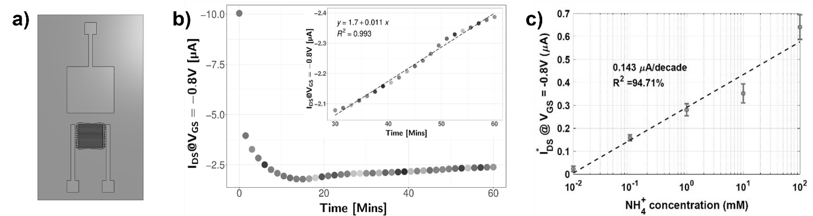
Figure 1 a) Structure of the EG-CNTFET device; b) I_{DS} at -0.8V collected for each round of transfer: the current initially drops and subsequently increases in linear form. The linearity of I_{DS} over time is reached after 30 minutes (inset of b), i.e., this specific device shows an increase of 11 nA/min with a coefficient of determination of 99.3%; c) Calibration curve of the biosensor for NH₄⁺ detection. The sensor exhibits good linearity over the range of concentrations tested, with sensitivity of 0.143 µA/decade and coefficient of determination 94.71%.
4. References
Franceschelli, L., Berardinelli, A., Dabbou, S., Ragni, L. And Tartagni, M., 2021. Sensing Technology for Fish Freshness and Safety: A Review. Sensors (Basel, Switzerland), 21(4), pp. 1373.
Guinovart, T., Bandodkar, A.J., Windmiller, J.R., Andrade, F.J. And Wang, J., 2013. A potentiometric tattoo sensor for monitoring ammonium in sweat. Analyst (London), 138(22), pp. 731-738.
Joshi, S., Bhatt, V.D., Jaworska, E., Becherer, M., Maksymiuk, K., Michalska, A. And Lugli, P., 2018. Using Lipophilic Membrane for Enhanced‐Performance Aqueous Gated Carbon Nanotube Field Effect Transistors. Physica status solidi. A, Applications and materials science, 215(11), pp. 1700993-n/a.
Li, S., Tian, Y., Wu, K., Ye, Y., Yu, J., Zhang, J., Liu, Q., Hu, M., Li, H., Tong, Y., Harberd, N.P. And Fu, X., 2018. Modulating plant growth–metabolism coordination for sustainable agriculture. Nature, 560(7720), pp. 595-600.
Makowski, M.S. And Ivanisevic, A., 2011. Molecular Analysis of Blood with Micro-/Nanoscale Field-Effect-Transistor Biosensors. Small (Weinheim an der Bergstrasse, Germany), 7(14), pp. 1863-1875.
Molazemhosseini, A., Viola, F.A., Berger, F.J., Zorn, N.F., Zaumseil, J. And Caironi, M., 2021. A Rapidly Stabilizing Water-Gated Field-Effect Transistor Based on Printed Single-Walled Carbon Nanotubes for Biosensing Applications. ACS applied electronic materials, 3(7), pp. 3106-3113.
Santos, M.H.S., 1996. Biogenic amines: their importance in foods. International journal of food microbiology, 29(2), pp. 213-231.
Shkodra, B., Petrelli, M., Angeli, M.A.C., Inam, A.S., Lugli, P. And Petti, L., 2022. Optimization of the spray-deposited carbon nanotube semiconducting channel for electrolyte-gated field-effect transistor-based biosensing applications. IEEE sensors journal, , pp. 1.
Shkodra, B., Petrelli, M., Costa Angeli, M., Sarwar Inam, A., Avancini, E., Munzenrieder, N., Lugli, P. And Petti, L., Jun 20, 2021Flexible carbon nanotube-based electrolyte-gated field-effect transistor for spermidine detection, Jun 20, 2021, IEEE, pp. 1-4.

