Innovative approach to design cereal-based product with low glycemic response
Marianna Tagliasco (tagliasco.marianna@spes.uniud.it)
Department of Agricultural, Food, Environmental and Animal Sciences, University of Udine, Udine, Italy
Tutor: Prof.ssa Nicoletta Pellegrini

The aim of this project is to investigate, from micro to macro, the effect of structural features, such as cell wall intactness, protein matrix, and food texture and their interactions, on the starch digestibility of bread. In the first two chapters of the Ph.D. program, the role of the cell wall integrity and textural features on the starch digestibility of durum wheat and rye flour and bread produced with these flours was studied. From each cereal, three particle sizes were produced, i.e., small (<350 µm), medium (1000 µm-1800 µm), and large (> 1800 µm) flour. For both cereals, the presence of a cluster of intact cell wall decreased the starch digestibility in flour acting as a barrier between starch and enzyme, but this effect of protection was lost with bread production. It was hypothesized that the long mixing time of medium and large flours needed to reach an optimum developed dough increased the cell wall porosity due to the solubilization of their components and in turn the enzyme penetration. Moreover, the use of coarse flour reduced the cohesiveness of the bread crumb, increasing the disintegration rate during digestion and, in turn, the starch accessibility. Based on these results, in the third chapter of the thesis, it was evaluated the effect of reduced mixing time and increased cohesiveness of bread crumb on textural features and starch digestibility of bread made with coarse durum wheat (>1000 µm). To increase the bread cohesiveness, two approaches were evaluated: the decrease in bread moisture content and the substitution of 20% of coarse semolina with vital gluten. The final aim was to identify the best recipe to obtain bread with reduced accessibility and acceptable textural quality to be tested in an acute study in humans.

Approccio innovativo nella progettazione di prodotti da forno a bassa risposta glicemica

Lo scopo di questo progetto è quello di indagare, dal micro al macro, l'effetto di diverse caratteristiche strutturali, come la presenza della parete cellulare intatta, la matrice proteica, la texture e le loro interazioni, sulla digeribilità dell'amido del pane. Nella prima parte del dottorato è stato studiato il ruolo dell'integrità della parete cellulare e delle caratteristiche strutturali sulla digeribilità dell'amido della farina di grano duro e di segale e del pane prodotto con le stesse farine. Da ciascun cereale sono state prodotte tre granulometrie, ovvero fine (<350 µm), media (1000 µm-1800 µm) e grossolana (> 1800 µm). Per entrambi i cereali, la presenza di cluster di cellule integre diminuisce la digeribilità dell'amido nella farina, agendo da barriera tra l’amido e l’enzima; tuttavia, questo effetto di protezione viene perso quando da queste farine vengono prodotti i pani. Si è ipotizzato che durante la lunga miscelazione (fino a 90 min per la farina grossolana) le pareti cellulari aumentano la loro porosità a causa della solubilizzazione dei componenti delle pareti cellulari aumentando la diffusività degli enzimi all'interno della cellula. Inoltre, l'uso di semola grossolana può aver ridotto la coesività della mollica, aumentandone la velocità di disgregazione durante la digestione e, a sua volta, l'accessibilità all'amido. Sulla base di questi risultati, nel terzo capitolo della tesi, è stato valutato l'effetto della riduzione del tempo di miscelazione e dell'aumento della coesività della mollica sulla texture e sulla digeribilità dell'amido di pani prodotti con semola grossolana (>1000 µm). Al fine di modificare la consistenza del pane prodotto con la semola grossolana sono stati utilizzati due approcci, quello di ridurre l’idratazione dell’impasto e la sostituzione del 20% di semola con glutine vitale. Lo scopo finale è stato quello di individuare, tra i campioni testati, il pane con minore digeribilità dell’amido ma accettabili caratteristiche strutturale, da testare in uno studio in acuto nell’uomo.

Keywords: durum wheat; rye; gluten; cohesiveness; hardness; in vitro starch digestion.

Introduction

Worldwide, the number of people suffering from type 2 diabetes is around 422 million and this number is continuously rising (World Health Organization, 2021). The spread of diabetes in the last decades is the result of a global rise in obesity, a more sedentary lifestyle, and an energy-dense diet, given by the overconsuming of mainly highly digestible starchy food (Chatterjee et al., 2017). Among highly digestible starchy foods, bread is a staple food daily consumed in Western countries and is characterized by a high glycemic index (GI). For this reason, how decreasing the blood glucose response of starchy food, such as bread, and consequentially its GI has been extensively studied in the last decades. Limiting starch accessibility to α-amylase is a promising approach to decrease starch accessibility (Rovalino-Córdova et al., 2019). In plant food, starch granules are naturally encapsulated in the cell. In cereals, the intact cells could limit the accessibility to starch when isolate cells, flours (wheat, sorghum, and barley) and simple food product, such as porridge, are studied both in vitro and in vivo (Bhattarai et al., 2018; Edwards et al., 2015; Korompokis et al., 2019), However, contradictory results were found when the effectiveness of coarse flour with large particle size rich in clusters of intact cells was investigated in bread. Lin et al., (2020) found that increasing particle size of whole wheat flour significantly decreased starch digestibility in bread, whereas (Korompokis et al., 2021) demonstrated that the incorporation of coarse flour did not have an effect in modulating the rate of starch digestibility in bread. In bread, not only the cell wall can act as a barrier limiting the contact between starch and enzyme but also protein, the second macronutrient present in cereals, also has a role in this sense. Gliadin and glutenin, which are the main protein of some grains, after hydration and mixing force, form a discontinuous network that surround the starch granules which could decrease the digestibility limiting the starch accessibility (Chen et al., 2019). Gluten, moreover, not only can physically hamper the contact between starch and enzyme, but it was demonstrated that this protein complex could bind the pancreatic alpha-amylase, and consequentially inhibit starch digestibility (López-Barón et al., 2017). In the same direction, the food structure also plays an important role in the digestion and absorption of nutrients. Bread texture could affect bread mastication and consequentially the bolus disintegration during the gastric phase. It was proven that the relatively big size of compact digesta could limit the diffusivity of the enzymes inside the bread structure, delaying and limiting the starch digestibility (Martínez et al., 2018). The aim of this project is to investigate, from micro (cell wall intactness and protein matrix) to macro (food texture), the effect of structural features on the starch digestibility of bread. In accordance with the Ph.D. thesis project previously described (Tagliasco, 2021), this oral communication reports the main results of the following three research activities: A1) Monitoring the effect of cell wall integrity in modulating the starch digestibility of durum wheat during different steps of bread making. A2) Role of particle size in modulating starch digestibility and textural properties in rye flour and bread model system. A3) The effect of gluten addition, dough moisture content, and different mixing time, on the textural properties and in vitro starch digestibility of durum wheat bread made with coarse semolina.
2. Experimental plan

A1) Monitoring the effect of cell wall integrity in modulating the starch digestibility of durum wheat during different steps of bread making. (Tagliasco et al., 2022)

The aim of the first study was to evaluate the effect of three semolina particle sizes, i.e., small (<350 µm), medium (> 1000 µm < 1800 µm), and large (> 1800 µm), on starch digestibility in raw semolina, dough, and bread, to better understand how the processing affects the ability of cereal cell wall to act as a barrier to the enzyme accessibility. The aim was to determine at which stage of the baking process the physical encapsulation of starch within cell walls lost its ability to effectively reduce the starch in vitro digestibility.

Materials and methods

Peeled durum wheat grain was purchased from Duru BakliyatTM (Hediklik Dis ̧ Bug ̆dayı, Turkey). Small (<350 µm), medium (> 1000 µm < 1800 µm), and large (> 1800 µm) particle size flours were obtained with a pin mill (Multi-mill, Alpine Hosokawa, Augsburg, Germany). The dough was prepared according to a standard recipe with 1.2% yeast and 1% salt as % wet flour basis and optimized, in terms of moisture content and mixing time, to obtain dough with the same consistency (500 Brabender Units). Small flour needed 5 min of mixing, medium one 60 min and large one 90 min. The starch digestibility of flour, dough, and bread was tested with the in vitro Englyst’s method (Englyst et al., 1992). Confocal laser scanning microscopy was used to check the presence of intact cells in each step of baking. Texture analyses were conducted to evaluate the textural features of bread made with increasing flour particle size.

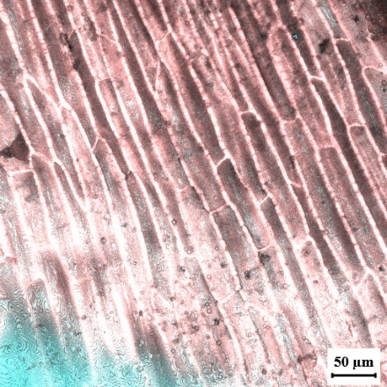
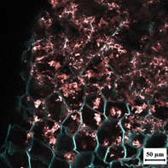
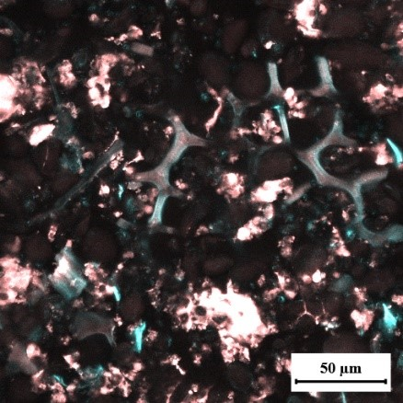
Results and discussion
LF
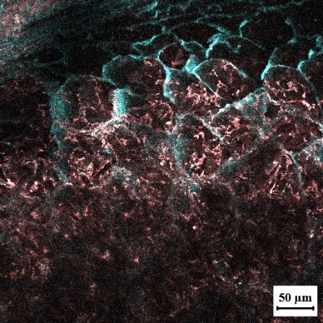
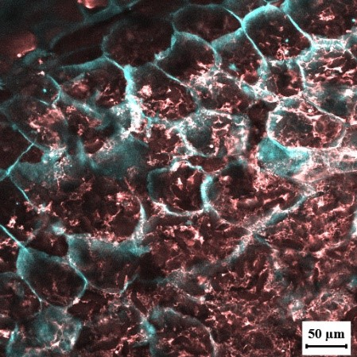
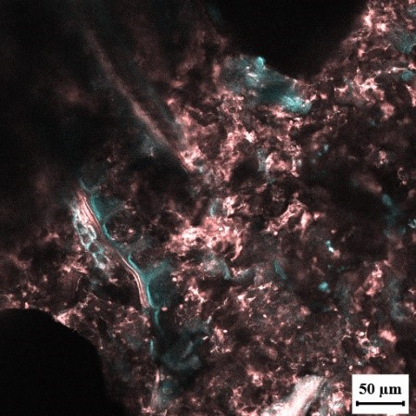
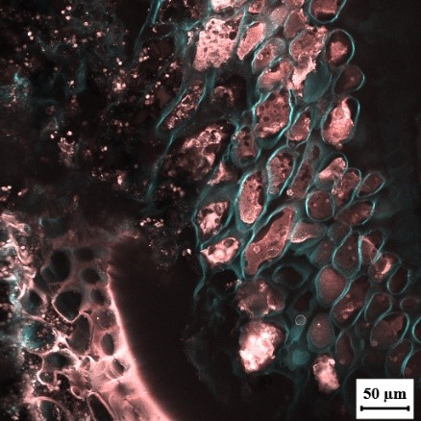
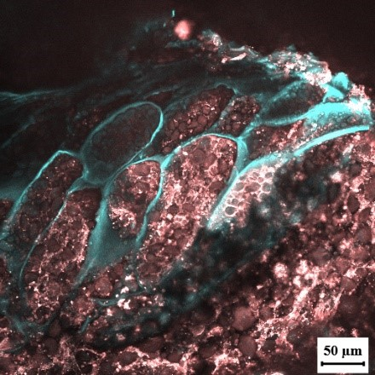
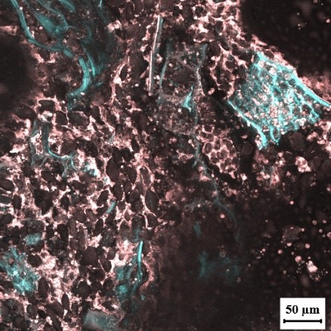
The images from the confocal laser scanning microscopy showed that the integrity of the cell wall (stained in blue) was kept during the whole bread processing for the medium and large particle size flours (MF, LF, MD, LD, MB and LB) whereas cell walls were mostly destroyed in the flour of small particle size (SF, SD and SB). In vitro starch digestibility of flour decreased, increasing particle size. This effect can be mainly ascribed to the presence of a higher fraction of intact cells, which acts as a barrier limiting the contact between enzyme and starch, in the flour of medium and large size than in fine flour. For what concern the dough, no difference in starch digestibility was found as shown in Table 1. This indicates that the effect of large particle size was no longer able to modulate the starch digestibility even though intact cells were still present in the middle and large particle size dough. Therefore, we hypothesize that, during the long mixing time (60 and 90 min, respectively for the medium and large flour) and fermentation steps, the porosity of the cell walls increased due to the solubilization of the main components of the wheat cell wall. For what concern bread, instead, a modest decrease in starch digestibility for bread made by large particles was observed, likely due to its dense structure. Bread made with large particle size flour, indeed, was more compact and denser than those made with medium and small flours. This difference in the texture could have delayed the lower rate of starch digestion than other bread types.
Figure 1. Confocal laser scanning microscopy images of small flour (SF); medium flour (MF); large flour (LF); small dough (SD); medium dough (MD); large dough (LD); small bread (SB); medium bread (MB); large bread (LB).
LD
MD
SD
MF
SF
LB
MB
SB
Table 1. Rapidly digestible starch (RDS); slowly digestible starch (SDS) and resistant starch (RS) of flour, dough, and bread made with small flour (< 350 µm), medium flour (> 1000 µm; < 1800 µm) and large flour (> 1800 µm).
 |  | RDS (g/100 g total starch) | SDS (g/100 g total starch) | RS (g/100 g total starch)
Flour | Small | 30.4 ± 4.2ª | 63.4 ± 2.6ª |  | 6.8 ± 1.1^{c}
 | Medium | 16.5 ± 3.2^{b} | 60.4 ± 5.6ª |  | 25.6 ± 3.9^{b}
 | Large | 8.9 ± 0.1^{c} | 36.0 ± 1.8^{b} |  | 56.1 ± 2.4ª
Dough | Small | 32.0 ± 4.5^{A} | 42.3 ± 15.3^{A} |  | 26.3 ± 12.9^{A}
 | Medium | 25.9 ± 9.3^{A} | 48.5 ± 13.2^{A} |  | 25.6 ±13.6^{A}
 | Large | 25.8 ± 6.4^{A} | 48.9 ± 4.2^{A} |  | 28.5 ± 8.1^{A}
Bread | Small | 68.4 ± 9.7ª | 22.5 ± 6.4 ^{b} |  | 7.6 ±1.6ª
 | Medium | 59.1 ± 14.1^{ab} | 33.7 ± 4.6ª |  | 9.2 ± 0.2ª
 | Large | 55.7 ± 5.8 ^{b} | 37.2 ± 3.5 ª |  | 3.7 ± 0.7^{b}
The same letter indicates no significant difference among the three particle sizes for flour, dough, and bread for each column (p < 0.05, Tukey’s test, n =3).

A2) Role of particle size in modulating starch digestibility and textural properties in a rye bread model system.
The second study elucidates the effect of clusters of intact cells on the starch digestibility of rye flour and a model rye bread. The textural quality, in vitro starch digestion, and physical disintegration during the digestion were investigated to study the relationship among the integrity of cell walls, the structural features of bread, and the in vitro starch digestibility.

Materials and method
Rye (Secale cereale L.) grain was purchased from Tibiona (Villanova Mondovi, Italy) and ground using a multi mill (Alpine Hosokawa, Augsburg, Germany) to obtain three particle size flours: small rye (S) (<350 µm), medium rye (M) (> 1000 µm < 1800 µm), and large rye (L) (> 1800 µm). the bread was prepared following a standard recipe with 2% yeast and 1% salt as % wet flour basis. The starch digestibility of flour and bread was tested with the in vitro Englyst’s method (Englyst et al., 1992). Texture profile analyses (TPA) was conducted to evaluate the textural features of bread. The disintegration of the samples during the in vitro digestion was studied by image analysis, measuring the particle size of the digesta over time.

Results and discussion
In the present study, the effect of three different particle sizes on the digestibility and textural quality of rye flour and bread produced therefrom were investigated. The starch digestibility of small rye flour was higher than medium and large ones. In bread, instead, the results obtained were quite unexpected. Rapidly digestible starch (RDS) (Table 2) was not significantly different among the three bread samples. Instead, slowly digestible starch (SDS) was significantly lower in bread made with small particles (SB) than the ones made with medium (MB) and large particles (LB). Probably during bread processing the cell wall was not damaged, but its porosity increased due to the solubilization of arabinoxylans. Moreover, the differences found for SDS and resistant starch (RS) among the three samples could be also ascribed to the distinct texture of bread. As shown in Figure 2, the crumb cohesiveness, which represents the ability of the crumb to regain its height after a stress, decreased drastically with the increase in particle size. The texture parameters mirrored the different disintegration behavior observed during the in vitro digestibility. Indeed, MB and LB, which were characterized by a lower cohesiveness compared to SB, produced more small particles after the first 20 min of digestion (data not shown). The relatively bigger size of the compact digesta particles in SB could instead have limited the diffusivity of the enzymes inside the bread structure, slowing down starch digestibility, and therefore produced a higher amount of starch that escaped digestion, i.e., RS. In conclusion, the intactness of cell walls is a limiting factor that controls the extent of hydrolysis of starch only in rye flour but not in a bread matrix. Instead, bread that disintegrated less during digestion was the one with the lower starch accessibility.
Table 2. Rapid digestible starch (RDS); slowly digestible starch (SDS) and resistant starch (RS) of flour, dough and bread made with small, medium and large rye flour and bread.
 |  | RDS (g/100 g total starch) | SDS (g/100 g total starch) |  | RS (g/100 g total starch)
Flour | Small | 26.1 ± 4.1ª |  | 71.8 ± 7.4ª | 2.1 ± 1.4^{c}
 | Medium | 18.2 ± 2.7^{b} |  | 60.3 ± 7.2ª | 23.1 ± 7.7^{b}
 | Large | 14.1 ± 0.1^{b} |  | 55.5 ± 0.3^{b} | 30.1 ± 1.7ª
Bread | Small | 56.2 ± 7.4ª |  | 32.1 ± 3.4 ^{b} | 26.1±10.4ª
 | Medium | 49.3 ± 3.6^{b} |  | 59.4 ± 9.3ª | 5.5 ± 4.9^{b}
 | Large | 58.6 ± 11.1ª |  | 48.2 ± 4.5 ª | 6.1 ± 5.8^{b}

Figure 2. Cohesiveness (-) of rye bread made with small (SB), medium (MB) and large (LB) particle flours. Columns sharing the same letter were not significantly different (p<0.05, Tukey’s test, n =9).
C
B
A
*The same letter in the same column indicates no significant differences (p < 0.05, Tukey’s test, n =3).

A3) The effects of gluten addition, dough moisture content, and different mixing time, on the textural properties and in vitro starch digestibility of durum wheat bread made with coarse semolina.

The third study aims to elucidate the effect of dough mixing time and different textural characteristics on the starch digestibility of wheat durum bread prepared with coarse semolina (particle size > 1000 µm). To change the crumb texture, two approaches were evaluated: the decrease in bread moisture content and the substitution of 20% of coarse semolina with vital gluten.

Materials and methods
Peeled durum wheat grain was purchased from Duru BakliyatTM (Hediklik Dis ̧ Bug ̆dayı, Turkey) and milled with a pin mill (Multi-mill, Alpine Hosokawa, Augsburg, Germany) to obtain particle size > 1000 µm. Six durum wheat bread samples were prepared using only coarse semolina (S, particle size > 1000 µm) or 20% vital gluten Primeal (Peaugres, France) in substitution of S, 70% of water (optimum water absorption) or 55% (low water absorption) and different mixing times 5 min (short mixing time) and 45 min (optimum mixing time to obtain a dough with 500 BU). Textural properties were evaluated by a texture profile analysis (TPA) and in vitro starch digestibility was assessed according to Englyst’s method.

Results and discussion
The results of the study showed that the gluten-enriched bread samples exhibited, in general, better textural properties: lower hardness, higher cohesiveness, and bigger volume, than the samples produced with only coarse semolina (Table 3). Only, the sample, 80Semolina+20Gluten_5min_70%moisture behaved differently, having the same volume and hardness as the bread sample 100Ssemolina_45min_70%moisture. This could be due to the high hydration level and the short mixing time; 5 minutes of mixing are probably not enough to absorb all the water added to the flour and, as a result, the bread structure collapsed. For what concern the starch digestibility bread made only with semolina at low hydration (100S_45_55%) had significantly lower RDS than bread made with 20% of gluten and optimum mixing time and hydration level (80S+20G_45min_70%). Moreover, the sample 100S_45_55% showed the smallest volume and hardest crumb texture, instead, 80S+20G_45min_70% had the least hardness and biggest volume. It is clear from these results that during the first 20 min of digestion, the starch is more accessible, and easily digested, due to the aerated crumb structure. This is also confirmed by the significant positive correlation (r= 0.854) between volume and RDS, the higher the bread volume, the higher is RDS value. However, during the further 100 min of digestion, the trend changes, the samples with the highest cohesiveness turned out to be the least digestible. This is probably due to the cohesive structure of the bread that during digestion which could limit the crumb disintegration and consequently starch accessibility. SDS indeed is highly negatively correlated with the cohesiveness results (r=-0,905). These results demonstrated the pivotal role of textural characteristics on the starch digestibility of bread.

Table 3. Volume (cm³), hardness (N), cohesiveness (-), rapidly digestible starch (RDS), slowly digestible starch (SDS) and resistant starch (RS) of coarse semolina bread samples
 | Volume (cm³⁾ | Hardness (N) | Cohesiveness (-) | RDS  (g/100 g  total starch) | SDS  (g/100 g  total starch) | RS  (g/100 g total starch)
80S+20G_5min_70% | 105.0 ± 5.0^{c} | 22.3 ± 3.2^{b} | 0.76 ± 0.01^{b} | 48.1 ± 2.5^{ab} | 33.9 ± 2.0^{b} | 18.0 ± 3.3ª
80S+20G_5min_55% | 205.0 ± 8.6^{b} | 4.5 ± 0.7^{c} | 0.81 ± 0.01ª | 46.5 ± 2.1^{ab} | 35.0 ± 2.9^{b} | 18.5 ± 4.6ª
80S+20G_45min_70% | 315.0 ± 13.2ª | 3.8 ± 0.4^{c} | 0.82 ± 0.01ª | 54.4 ± 3.0ª | 33.9 ± 4.7^{b} | 11.6 ± 7.8ª
80S+20G_45min_55% | 286.7 ± 31.7ª | 4.0 ± 0.7^{c} | 0.81 ± 0.02ª | 50.0 ± 4.7^{ab} | 30.8 ± 2.8^{b} | 19.1 ± 2.3ª
100S_45_70% | 111.7 ± 12.6^{c} | 23.8 ± 0.0^{b} | 0.71 ± 0.01^{c} | 46.8 ± 1.5^{ab} | 44.0 ± 10.7^{ab} | 9.1 ± 10.4ª
100S_45_55% | 90.0 ± 13.2^{c} | 43.8 ± 10.5ª | 0.70 ± 0.01^{c} | 42.9 ± 3.6^{b} | 49.8 ± 7.3^{b} | 7.3 ± 4.6ª
S; semolina, G; gluten, 5 and 45 min; mixing time, 55% or 70%; moisture absorption. The same letter in the same column indicates no significant differences (p < 0.05, Tukey’s test, n =3)

3. Conclusions and Future Perspectives
In conclusion, as shown from the PCA (Figure 3), the bread sample produced with the addition of 20% gluten, low hydration (55%) level, and 5 min of mixing, was the best compromise between acceptable textural features such as high cohesiveness and low hardness, and low starch digestibility. The latter was well correlated with RS and inversely correlated with SDS. This could be explained by the preservation of cells' wall integrity, associated with the effect of the gluten network that was able to hamper the enzyme and the presence of a cohesive crumb texture which didn’t disintegrate during digestion. However, these results must be confirmed by a human study in which the effect of these bread characteristics is evaluated on oral processing and the consequent effect on glucose release. For this reason, the next study will aim to evaluate the glycemic and insulinemic response in healthy volunteers of bread made with durum wheat coarse flour and gluten compared to a standard durum wheat bread made with fine semolina. Moreover, the oral processing of bread samples will be studied to evaluate the effect of gluten on oral disintegration, inhibition of salivary alpha-amylase, and consequentially glucose release.
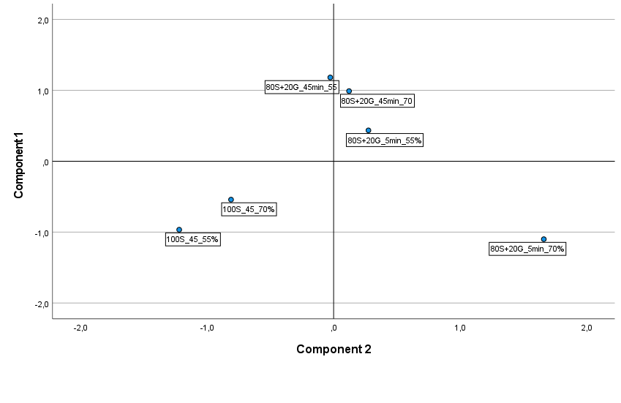
Figure 3. Data of bread characteristics displayed through the first two principal components (PC1 and PC2) derived from the PCA (principal components analysis) (A): biplot of the first two components; (B): rotated principal scores of bread samples produced. volume; hardness; springiness; cohesiveness; deformation area, extensibility peak (Ep), the maximum force of extensibility (Rmax); rapidly digestible starch (RDS); slowly digestible starch (SDS); resistant starch (RS).

4. References
Bhattarai, R. R., Dhital, S., Mense, A., Gidley, M. J., & Shi, Y. C. (2018). Intact cellular structure in cereal endosperm limits starch digestion in vitro. Food Hydrocolloids, 81, 139–148. https://doi.org/10.1016/j.foodhyd.2018.02.027
Chatterjee, S., Khunti, K., & Davies, M. J. (2017). Type 2 diabetes. The Lancet, 389(10085), 2239–2251. https://doi.org/10.1016/S0140-6736(17)30058-2
Chen, X., He, X., Zhang, B., Sun, L., Liang, Z., & Huang, Q. (2019). Wheat gluten protein inhibits α-amylase activity more strongly than a soy protein isolate based on kinetic analysis. International Journal of Biological Macromolecules, 129, 433–441. https://doi.org/10.1016/j.ijbiomac.2019.01.215
Edwards, C. H., Grundy, M. M. L., Grassby, T., Vasilopoulou, D., Frost, G. S., Butterworth, P. J., Berry, S. E. E., Sanderson, J., & Ellis, P. R. (2015). Manipulation of starch bioaccessibility in wheat endosperm to regulate starch digestion, postprandial glycemia, insulinemia, and gut hormone responses: A randomized controlled trial in healthy ileostomy participants. American Journal of Clinical Nutrition, 102, 791–800. https://doi.org/10.3945/ajcn.114.106203
Englyst, H. N., Kingman, S. M., & Cummings, J. H. (1992). Classification and measurement of nutritionally important starch fractions. European Journal of Clinical Nutrition, 46, 33–50. https://doi.org/10.1016/S0271-5317(97)00010-9
Korompokis, K., De Brier, N., & Delcour, J. A. (2019). Differences in endosperm cell wall integrity in wheat (Triticum aestivum L.) milling fractions impact on the way starch responds to gelatinization and pasting treatments and its subsequent enzymatic in vitro digestibility†. Food and Function, 10(8), 4674–4684. https://doi.org/10.1039/c9fo00947g
Korompokis, K., Deleu, L. J., & Delcour, J. A. (2021). The impact of incorporating coarse wheat farina containing intact endosperm cells in a bread recipe on bread characteristics and starch digestibility. Journal of Cereal Science, 102, 103333. https://doi.org/10.1016/j.jcs.2021.103333
Lin, S., Gao, J., Jin, X., Wang, Y., Dong, Z., Ying, J., & Zhou, W. (2020). Whole-wheat flour particle size influences dough properties, bread structure and: In vitro starch digestibility. Food and Function, 11(4), 3610–3620. https://doi.org/10.1039/c9fo02587a
López-Barón, N., Gu, Y., Vasanthan, T., & Hoover, R. (2017). Plant proteins mitigate in vitro wheat starch digestibility. Food Hydrocolloids, 69, 19–27. https://doi.org/10.1016/j.foodhyd.2017.01.015
Martínez, M. M., Román, L., & Gómez, M. (2018). Implications of hydration depletion in the in vitro starch digestibility of white bread crumb and crust. Food Chemistry, 239, 295–303. https://doi.org/10.1016/j.foodchem.2017.06.122
Rovalino-Córdova, A. M., Fogliano, V., & Capuano, E. (2019). The effect of cell wall encapsulation on macronutrients digestion: A case study in kidney beans. Food Chemistry, 286, 557–566. https://doi.org/10.1016/j.foodchem.2019.02.057
Tagliasco, M., Tecuanhuey, M., Reynard, R., Zuliani, R., Pellegrini, N., & Capuano, E. (2022). Monitoring the effect of cell wall integrity in modulating the starch digestibility of durum wheat during different steps of bread making. Food Chemistry, 396(7), 133678. https://doi.org/10.1016/j.foodchem.2022.133678
World Health Organization. (2021). The Global Diabetes Compact: what you need to know. Oms, 6. https://cdn.who.int/media/docs/default-source/country-profiles/diabetes/gdc_need_to_know_web.pdf?sfvrsn=dddcb962_1&download=true

