Industry 4.0 in the agri-food sector: innovative sensors and smart
logistics to support the sustainability of the supply chain

Alessia Pampuri (alessia.pampuri@unimi.it)
Department of Food, Environmental and Nutritional Sciences – DeFENS, Via Celoria, 2 Milano (Italy)
Tutor: Prof. Beghi Roberto

The aim of this PhD research project is to find solutions that can objectively measure the quality of high value-added productions. This will be achieved through the creation of simplified portable devices that exploit vis/NIR spectroscopy technology. This technology is already widely used in these sectors but requires complex and expensive instrumentation. The implementation of new smart sensors could lead to improvements in production, increased awareness of supply chain operators, more effective management of resources and ultimately, a reduction in waste. The latter in particular is one of the final objectives of the entire agri-food chain.

Keywords: vis/NIR spectroscopy, sensors, industry 4.0, non-destructive, food quality.

Industria 4.0 nel settore agroalimentare: sensori innovativi e logistica smart a supporto della sostenibilità di filiera

L'obiettivo di questo progetto di ricerca di dottorato è trovare soluzioni che possano misurare in modo oggettivo la qualità di produzioni ad alto valore aggiunto. Ciò verrà realizzato attraverso la creazione di dispositivi portatili semplificati che sfruttano la tecnologia della spettroscopia vis/NIR. Questa tecnologia è già ampiamente utilizzata in questi settori, ma richiede strumentazione complessa e costosa. L'implementazione di nuovi sensori smart potrebbe portare a miglioramenti nella produzione, a un aumento della consapevolezza degli operatori di filiera, a una gestione più efficace delle risorse e, infine, a una riduzione degli sprechi. Quest'ultimo in particolare è uno degli obiettivi finali di tutta la filiera agroalimentare.

1. Introduction
There is currently a significant shift occurring in measurement technologies within the agri-food sector. There is growing interest in replacing traditional laboratory-based analytical techniques with rapid, non-destructive, and environmentally sustainable methods (Nicolai et al., 2007). One effective approach is the utilization of visible and Near Infrared (vis/NIR) spectroscopy and imaging techniques. These methods have been extensively researched and utilized in the agri-food sector for their numerous advantages, including non-destructive sampling, fast results, and the ability to conduct checks throughout production processes. However, the instruments required for these techniques are often expensive, complex to operate and unsuitable for settings outside specialized laboratories.
To address this, researchers are focusing on developing low-cost prototypes with comparable characteristics to reliable laboratory instruments, albeit with slightly lower performance (Tugnolo et al., 2021). These devices could be deployed in larger quantities along the supply chain, allowing precise quality controls due to their affordability.
By conducting meticulous quality checks, the aim is to deliver products of the highest quality while addressing customer interests in healthiness and sustainability. Chemometrics is critical for proper data interpretation, predictive modelling, and variable selection, essential for simplifying devices.
This PhD program aims to offer a potential solution to the requirements of high value-added supply chains by implementing and applying a simplified spectroscopic device that uses only a limited number of wavelengths (dos Santos Costa et al., 2019). These devices will be able to facilitate punctual and real-time analysis, guaranteeing the production of high-quality finished products while minimizing waste.

2. Materials and Methods
This PhD thesis project has been divided into several activities. Initially it was applied a portable device, originally built for the analysis of small matrices such as grapes and olives, on larger matrices such as figs. The aim, in addition to the creation of predictive models, was to identify the required hardware modifications on the first version of the prototype.
Subsequently, the experiments focused on matrices that can be considered a cross between a solid matrix and a liquid matrix (must) or grapes at winery consignment. These grape samples (Vitis Vinifera L.) variety "Ancellotta" were analysed with a bench/process spectrophotometer with a lab scale experimental setup reproducible at the winery. Samples were analysed both in the laboratory and at the winery with the same instrument and the same sampling methods and predictive models were created for the measurement of some qualitative parameters and the polyphenol content.
The experiments then moved on to the creation of a simplified prototype for the analysis of liquid matrices, with the intention of applying it to liquids such as wine to identify adulterations but also to denser samples such as for example musts (also in this case to measure qualitative parameters and polyphenol content), to be able to try to carry out the same analyses conducted with the bench instrument with this new simplified version. The pre-prototype was built using a 3D printer and, inside the case built through additive manufacturing, it was assembled low-cost sensors (Hamamatsu Photonics) with a module in the visible wavelengths range and a module in NIR range. The experiments of the prototype for the liquid matrices started analysing fruit juices to verify the best experimental setup to proceed with the analysis of wines and to verify the effective functioning of the prototype.

3. Results and Discussion
The experimentation carried out on figs has shown that for the analysis of large matrices several modifications are necessary to the portable device which currently has the shape of a clamp (therefore capable of completely embracing the small sample).
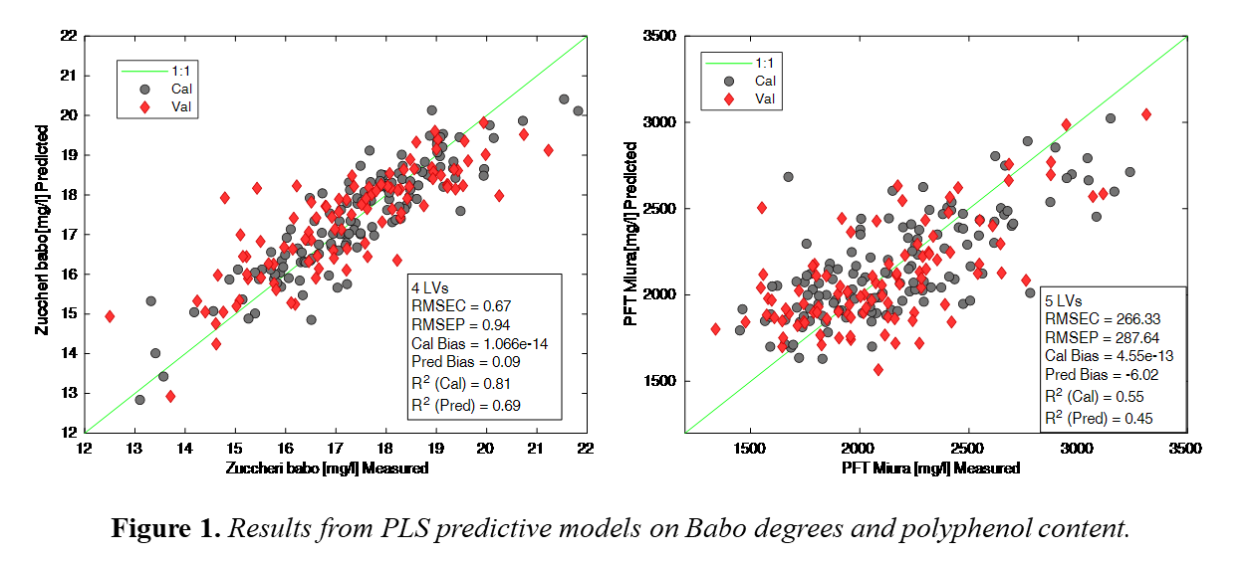
The experimentation concerning the Ancellotta grape samples has led to good results. Partial Least Square (PLS) regression analysis was applied on grape spectra in order to predict different parameters such as soluble solids content (Babo degrees) and polyphenol content. The results from the PLS models gave coefficients of determination and root mean square errors in calibration and in prediction, respectively, equal to 0.81 and 0.69, and 0.67 (mg/l) and 0.94 (mg/l) for Babo degrees, equal to 0.55 and 0.45, and 266.3 (mg/l) and 287.6 (mg/l) for polyphenols (Figure 1).
The experimentation with the prototype version for liquid analysis initially started to check its performance (using fruit juices of different colours and densities), and then proceeded to identify the parameter setup (integration time and voltage of the halogen lamp) to analyse different types of wine.
From the first tests it was evident how (both with the visible module and with the NIR module) the acquisition is able to give better results in a filtered sample (blueberry sample) which has characteristics more similar in terms of density and colour to those of wine (Figure 2). In the case of must analysis, it will be necessary to carry out filtrations in order to use the prototype.
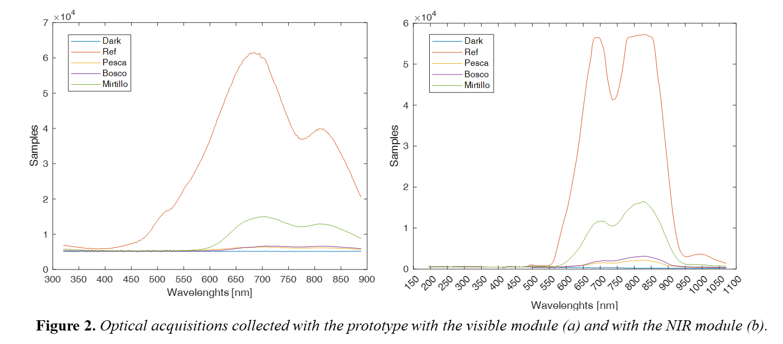

4. Selected References
dos Santos Costa, D., Mesa, N. F. O., Freire, M. S., Ramos, R. P., & Mederos, B. J. T. (2019). Development of predictive models for quality and maturation stage attributes of wine grapes using vis-nir reflectance spectroscopy. Postharvest Biology and Technology, 150, 166-178.
Nicolai, B. M., Beullens, K., Bobelyn, E., Peirs, A., Saeys, W., Theron, K. I., & Lammertyn, J. (2007). Nondestructive measurement of fruit and vegetable quality by means of NIR spectroscopy: A review. Postharvest biology and technology, 46(2), 99-118.
Tugnolo, A., Giovenzana, V., Beghi, R., Grassi, S., Alamprese, C., Casson, A., ... & Guidetti, R. (2021). A diagnostic visible/near infrared tool for a fully automated olive ripeness evaluation in a view of a simplified optical system. Computers and Electronics in Agriculture, 180, 105887.

