Dietary Habits and Biogenic Amine Exposure in Mediterranean Populations: Insights from the Italian Aperitivo/Happy Hour Context
Luigi Esposito (lesposito2@unite.it)
Department of Biosciences and Technology for Food, Agriculture, and Environment, University of Teramo Campus coste S. Agostino, Via R. Balzarini 1, 64100 Teramo -località Colleparco- Italy
Tutors: Professor Dino Mastrocola, Professor Maria Martuscelli
This project is primarily focused on understanding the exposure of various Mediterranean populations to biogenic amines (BAs) through their dietary habits. To achieve this goal, an extensive survey was conducted to examine people's meal choices. Potentially hazardous meal occasions were identified, and specific food categories rich in biogenic amines were analyzed. The presented portion represents only a part of a larger research project, specifically focusing on the Italian population during aperitivo/happy hour occasions.
Abitudini alimentari ed esposizione alle amine biogene in popolazioni meditarranee: Approfondimenti sulla popolazione italiana durante l’aperitivo
Questo progetto è incentrato sul comprendere l’esposizione di diverse popolazioni del bacino Mediterraneo alle amine biogene, per mezzo delle abitudini alimentari. Per raggiungere tale scopo è stata condotta una minuziosa indagine sulle scelte alimentari delle persone. I pasti possibilmente pericolosi (per il contenuto in amine biogene) sono stati individuati e le classi di alimenti contenenti tali composti, analizzati. Qui viene presentata una parte di un progetto più vasto, quella riferita alla popolazione italiana rispetto all’occasione dell’aperitivo/happy hour.
Keywords: dietary habits, histamine, tyramine, exposure
1. Introduction
- Before setting the risk exposure to BAs for distinct populations, several considerations were made.
- Revise the available literature about the BAs role and their negative and hazardous potential.
- Understanding the diversity of BAs in foods and beverages.
- Focus on the population.
A novel approach for gathering real (the closest to the reality) data on dietary habits, especially about food and beverages combinations, servings eaten, and frequency was considered. Moreover, this approach has led to know about hindering factors that may augment the effect of BAs, such as drugs assumption and others.
- Analyze all this information together regarding specific meal occasions of the day.
2. The state of the art about BAs
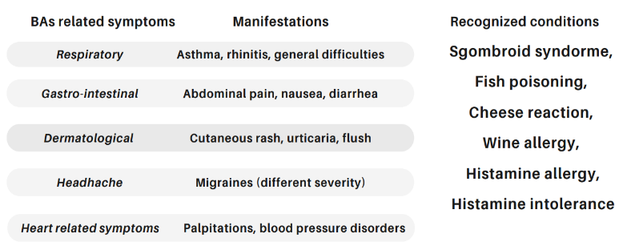
The amino compounds included in the group of biogenic amines constitute a broad class of molecules involved in numerous activities within human metabolism. Primarily, they act as signaling molecules and regulate metabolic and hormone-related responses. They are generally recognized as safe and endogenously produced for the purposes briefly mentioned (Martuscelli et al., 2020). However, biogenic amines can become hazardous when the detoxification systems responsible for their management, namely monoamine oxidase and diamine oxidase (MAO, DAO), are overloaded or compromised, resulting in various symptoms (Figure 2). Due to their direct association with cellular metabolism, biogenic amines are commonly found in animal and plant tissues, as well as in microorganisms. The latter can convert amino acids into biogenic amines through specific enzymes called decarboxylases (Schirone et al., 2022). Many of these species are of technological interest in food production. Salami, cheeses, a wide range of other fermented products, and certain alcoholic beverages are produced through fermentation (Ashaolu et al., 2021). These items are popular worldwide and are prominent in the composition of Mediterranean countries' aperitivo/happy hour. The presence of biogenic amines in foods and beverages may pose a health hazard for consumers, leading to various symptoms of varying severity depending on specific patterns (Figure 2). These patterns can be categorized into personal health factors, food quality, and choice/combination factors. Naturally, these factors can coexist and collaborate to amplify the final effect (Sànchez Pérez et al., 2022).
Figure 1 BAs related symptoms. A summary of the main symptoms and known conditions.
Not all biogenic amines can be classified as toxic. Furthermore, due to the aforementioned reasons, establishing a defined hazard for everyday diets presents challenges. Multiple factors interact, and individual responsibility regarding the amount consumed daily can make any meal potentially capable of causing symptoms. Over the years, significant efforts have been made by the scientific community and institutions such as the European Food Safety Authority (EFSA). Currently, we have thresholds for histamine and tyramine and recognized pathologies primarily associated with these two amines (EFSA 2011; Commission Regulation (EC) 2073/2005). They are indeed toxic, and histamine, in particular, is known for its connection to certain fish species and their derived products.
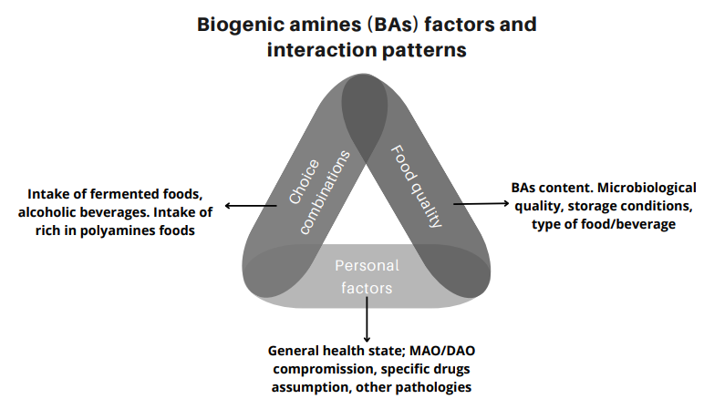

Figure 2 BAs contributing factors, patterns, and interaction.

3. Materials and methods
An important step of this project regarded the redaction of a survey to collect people answers, understanding how they compose their aperitivo/happy hour, and get frequency of consumption. This part was achieved with Google forms by Google platform. Surveys were primarily shared with students and personnel from the departments of biosciences and food technology, and communication sciences of the University of Teramo. Then, spread on social media to recruit a higher number of participants. Survey correctness was assessed by an internal validation with experts, then submitted to the advice of the Ethical Committee for the provinces of Teramo and L’Aquila before spreading. After receiving the positive statement, the survey was launched on-line. The elapse of time was of one month September-October 2022. A total of 424 valid responses was collected.
Contents of BAs from foods and beverages were in part determined ex novo, from several food matrices, and taken from internal database especially for fermented (animal-origin) foods. Experimental data were determined according to Latorre-Moratalla et al., (2009). Different classes of foods and beverages were analyzed and divided into meat-based foods, cheese and milk derived products, vegetables-based foods, seafoods and fish products, and alcoholic beverages. Mostly of the items indagated are known for their medium/high content of BAs and especially of histamine and tyramine; others were put because no data are available or few references report them. From a methodological point of view, we restricted the exploration about exposure to histamine and tyramine since they have established threshold limits to which compare. The landmark was the work of EFSA (2011) reporting for tyramine the thresholds of 6 mg/meal/person for patients treated with inhibitors of the enzyme monoaminoxidase (MAOI) drugs, 50 mg/meal/person for patients receiving third generation of MAOI drugs, so called RIMA (reversible inhibitors of MAO-A); and 600 mg/meal/person for healthy individuals. For histamine, the safe threshold considered for healthy population was 25 mg/meal/person as the most conservative level.
Calculation of exposure was done for those classes of products more chosen from respondents. Various probability distributions were fitted using @Risk 7.0 (Palisade Corporation, NewField, NY). The goodness of fit was evaluated using the Chi-square (χ²) test. The best-fitting distributions describing tyramine or histamine contents and the consumption were selected as an input for the assessment of the exposure to these compounds by the probabilistic estimation using the Monte Carlo simulation technique with 10,000 iterations. Exposure consisted of crossing quantities of product eaten per occasion (g/aperitivo) with contents of histamine and tyramine (mg/kg of product) and summing all the products eaten for that occasion.

4. Results and discussion
Based on the survey results, we can outline the profile of the average respondent. Women make up the majority of the sample, accounting for 66.4% with an average age of 30.09 ± 11.7 years. The majority of respondents (88.9%) follow an omnivorous dietary pattern. Among them, 21.4% report having allergies or intolerances, with lactose intolerance being the most prevalent (9.7%). Regarding medication, 17.6% of the participants regularly take birth control drugs (16 out of 71 subjects), antihypertensives (11 out of 71 subjects), and antihistamines (10 out of 71 subjects).
When it comes to aperitivos, meat-based foods and dairy products are the preferred choices. Specifically, the most popular meat-based foods fall into the category of "ripened not fermented or cooked not fermented foods" and "fermented uncooked products." For dairy products, "ripened, fermented cheeses" are the top choice. The first result regards the average intake of some products; 28.22 g ± 15.28 for 0.89 times a week for fermented uncooked products and 26.08 g ±18.32 for 1.81 times a week for fermented cheeses. Nuts are the most consumed vegetable-based option. In terms of beverages, wines (red, white, and rosé) and beer are equally favored. For certain food categories that do not contain histamine and/or tyramine (or contain them in reduced quantities), exposures were not calculated. Salami (fermented uncooked items), fermented cheeses, wines, and beers are instead discussed here.
The calculated exposure indicates a low probability of being exposed to histamine and tyramine through the consumption of non-cooked fermented products and fermented cheeses. Graphs illustrate the distribution of amine contents (mg/kg) versus frequency of occurrence. Examples of graphs for histamine and tyramine in fermented cheeses and beer are shown (Figure 3-4). The frequency of being exposed to tyramine through the consumption of fermented meat-based products is limited, with many iterations simulating a frequency value close to or equal to 0 mg/kg in 95% (P95) of the cases calculated. As for histamine exposure, the sample falls within a range of 0-3.51 mg/kg (mean value: 7.67±2.09). Again, many iterations yield a probability close to or equal to 0. For cheeses, the exposure to tyramine ranges from 0-277 mg/kg (mean value: 42.3±7.7). Regarding histamine, which generally has lower contents, the analyzed population (P95%) is exposed to a range of 0-3.51 mg/kg (mean value: 6.96±).
In general, alcoholic beverages are popular, with beer being more consumed than wine, averaging 433 mL±275. Red wine is preferred over white and rosé. The consumption rates are approximately 105 mL±73 for red wine and 133 mL±89.6 for white/rosé wine. Specifically, beer consumption leads to an exposure to tyramine ranging from 0-150.2 mg/meal (mean value: 27.54±53.4) and histamine ranging from 0-25.2 mg/meal (mean value: 4.48±9.6). For red wine, the range for tyramine is 0-10.94 mg/meal (mean value: 2.76±3.06) and for histamine, it is 0-8.94 mg/meal (mean value: 1.13±4.6). White and rosé wines have the following distributions: tyramine 0-12.9 mg/meal (mean value: 0.91)
Thus, if considering a common aperitivo (according to responses collected) it can be affirmed that an Italian consumer is possibly ingesting about 102.26 mg\meal of tyramine and 19.11 mg\meal of histamine for an aperitivo composed of 28.22 g of fermented uncooked products, 26.08 g of fermented cheeses and 433 mL of beer.
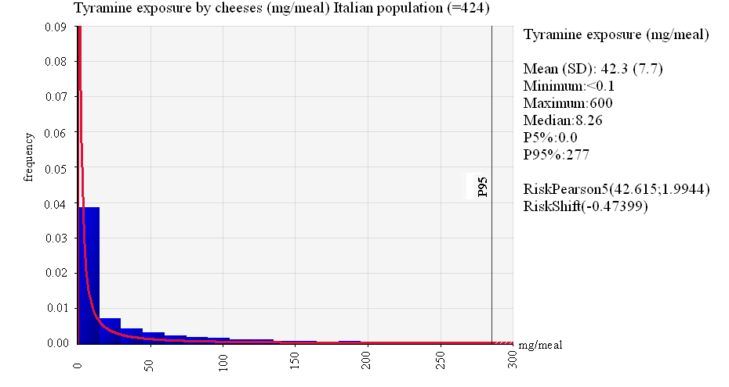
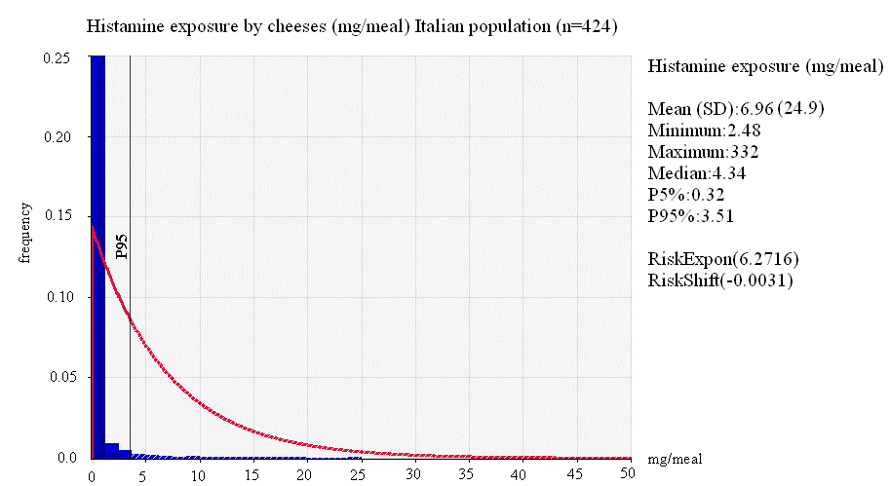

Figure 3 Histamine and tyramine exposure by fermented cheese consumption during aperitivo with statistics of the distribution.
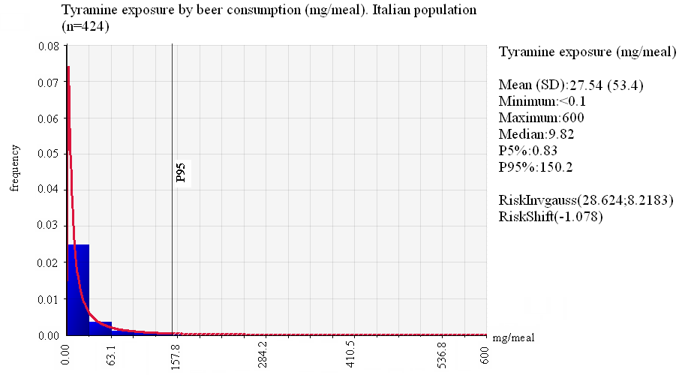
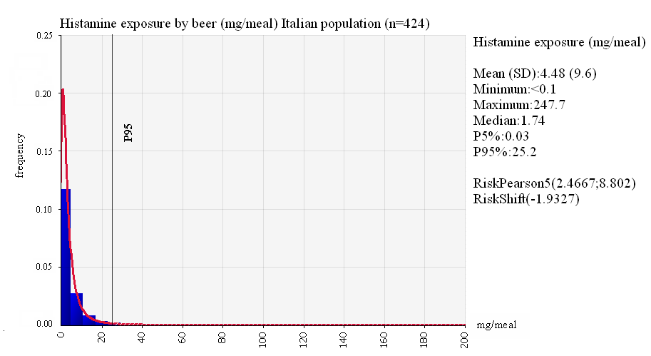
Figure 4 Histamine and tyramine exposure by beer consumption during aperitivo with statistics of the distributions.
5. Conclusions and future perspectives
As discussed, the concern about biogenic amines remains present in our lives like a continuous low-volume alarm. On one hand, limited legislation is in force to monitor histamine in some fishery products; on the other hand, exposure to hazardous ingestions in daily life is very limited, as previously shown. The problem with biogenic amines is that a great variability dominates the entire framework. Food samples may contain extremely different contents of several amines, as confirmed by the literature and this study. Moreover, the severity of symptoms covers such a wide diversity and may often be wrongly attributed to other conditions or generally dismissed as an allergy. In addition, these symptoms are usually very fast and transient, acting with tremendous individual specificity.
Recently, the difficulty of modulating the diet for allergic subjects has also been highlighted. The total elimination of fermented/suspicious foods may not be enough, as diverse physiological factors interact, and the human microbiome can enhance the production of some BAs. These compounds are stable under various conditions (temperature, pH, salt concentration), and those safe products (free of histamine and tyramine) can provide polyamines, which are widely distributed and can amplify the action of histamine and tyramine traces.
The most significant issue related to exposure to biogenic amines is still linked to people's habits and the difficulty in reporting accurate consumption data. The survey used in this study was carefully designed to capture the most realistic situation, accompanying each question with common foods and tableware to convert measurements perfectly into grams and milliliters. However, it is impossible to precisely match what an individual actually consumes during a meal.
Even though the data reported here depict a safe scenario, it must be considered that only one meal (the aperitivo) contributes a significant load of biogenic amines, especially when considering that only histamine and tyramine are calculated. As mentioned, other biogenic amines are not directly toxic, but their detoxification may simply require extra work from the enzymes involved, unless they are compromised due to specific conditions, or they may collaborate with histamine and tyramine, thereby increasing their hazardousness.
The general conclusion is that consumers should be advised of this potential hazard. This responsibility may primarily lie with medical doctors, but food producers could consider innovative ways to communicate about this reality, especially for fermented products or those already regulated by European law. This should not be seen as a negative aspect but, on the contrary, could become a qualitative enhancement of a product. The presented research also provides an overview of the general quality status of the analyzed samples, and as can be seen, all samples were obtained under optimal hygienic conditions.
Future steps involve observing other Mediterranean countries, primarily Spain, and investigating the snacking habits of children and toddlers throughout the day, shifting attention to other foods and beverages.
6. References
Martuscelli M, Esposito L, Mastrocola D, (2021) "Biogenic amines’ content in safe and quality food." Foods 10.1: 100
Schirone M, Esposito L, D’Onofrio F, Visciano P, Martuscelli M, Mastrocola D, Visciano P, Paparella A, (2022) Biogenic Amines in Meat and Meat Products: A Review of the Science and Future Perspectives Foods 11(6), 788
Ashaolu T. J, Khalifa I, Mesak M. A., Lorenzo J. M., & Farag, M. A, (2021). A comprehensive review of the role of microorganisms on texture change, flavor and biogenic amines formation in fermented meat with their action mechanisms and safety.Critical Reviews in Food Science and Nutrition 1-18
Sánchez-Pérez, S., Comas-Basté, O., Costa-Catala, J., Iduriaga-Platero, I., Veciana-Nogués, M. T., Vidal-Carou, M. C., & Latorre-Moratalla, M. L. (2022). The rate of histamine degradation by diamine oxidase is compromised by other biogenic amines. Frontiers in Nutrition, 9.
EFSA Panel on Biological Hazards (BIOHAZ). (2011). Scientific opinion on risk based control of biogenic amine formation in fermented foods. Efsa Journal, 9(10), 2393.
Commission Regulation (EC) No 2073/2005 of 15 November 2005 on microbiological criteria for foodstuffs
Latorre-Moratalla, M. L., Bosch-Fusté, J., Lavizzari, T., Bover-Cid, S., Veciana-Nogués, M. T., & Vidal-Carou, M. C. (2009). Validation of an ultra high pressure liquid chromatographic method for the determination of biologically active amines in food. Journal of Chromatography a, 1216(45), 7715-7720.

