New Strategies to Face Antibiotic Resistance in Healthcare and Food Sectors
Debora Pinamonti (pinamonti.debora@spes.uniud.it)
Department of Agricultural, Food, Environmental and Animal Science, University of Udine, 33100 Udine, Italy
Tutor: Prof. Marisa Manzano

The PhD thesis project aims to develop an electrochemical genosensor to detect specific antibiotic-resistant genes (ARGs) in food matrices. From milk and meat samples Staphylococcus aureus and Escherichia coli were isolated and tested for resistance against antibiotics. Specific primers for the main ARGs were employed in multiplex PCRs on the isolates. DNA sequences of ARGs were aligned and used for the design of DNA probes, intended for utilization in the electrochemical genosensor.
The isolated strains were tested for their capability of biofilm production to investigate the potential correlation between biofilm formation and antibiotic resistance (AMR).

Nuove strategie per combattere la resistenza agli antibiotici nei settori sanitario e alimentare
Il progetto di dottorato mira a sviluppare un genosensore elettrochimico per rilevare specifici geni responsabili di resistenza agli antibiotici (ARG) in alimenti. Staphylococcus aureus ed Escherichia coli sono stati isolati da latte e carne e testati per la resistenza agli antibiotici. Primer specifici per i principali ARG sono stati impiegati in multiplex PCR sugli isolati. Le sequenze di DNA degli ARG sono state allineate e utilizzate per la progettazione di sonde per il genosensore elettrochimico.
Gli isolati sono stati testati per la produzione di biofilm per studiare la potenziale correlazione tra biofilm e resistenza agli antibiotici (AMR).

Keywords: Antibiotic resistance (AMR), Antibiotic-resistant genes (ARGs), Electrochemical genosensors, DNA probe design.

1. Introduction
In accordance with the PhD thesis project previously described (Pinamonti, 2022), this poster reports the main results of the microbiological and molecular analyses.
(A1) Microbiological analyses. S. aureus and E. coli isolation from food matrices and phenotypic characterization. AMR profiling of the isolates.
(A2) Molecular analyses. DNA extraction and PCR confirmation of the species. Selection of specific primers for ARG detection and multiplex PCR on S. aureus and E. coli isolated resistant and susceptible strains. Design of DNA probes specific for ARGs.
(A3) Biofilm production test. Analysis of biofilm production with classical method.

2. Materials and Methods
A total of 29 samples of raw cow milk and 12 samples of raw milled meat (beef and pork) were analysed.
The bacterial pathogens, S. aureus and E. coli, were isolated on selective media within 24 hours after milking or purchase. From the countable plate, up to five colonies of each suspected S. aureus and E. coli were picked up, purified, and subjected to catalase, oxidase, and Gram staining tests.
DNA extraction of the strains followed the classical phenol-chloroform method described by Manzano et al. (2003).
The isolated strains were confirmed using PCR targeting the species-specific thermonuclease nuc gene for S. aureus and the malic acid dehydrogenase mdh gene for E. coli (Hsu & Tsen, 2001; Javid et al., 2018).
The confirmed S. aureus and E. coli strains were tested for antimicrobial susceptibility (AST) following the EUCAST Disk Diffusion test instructions (EUCAST, 2022). Based on the AST results, ARGs were selected and tested for their presence in the isolates. To this aim multiplex PCRs were performed. DNA ARG sequences were used as templates to design DNA probes for the detection of specific ARGs. The probes were evaluated in silico using AmplifX 1.5.4, OligoAnalyzer and BLAST (Basic Local Alignment Search Tool) programs. The specificity of the probes was further confirmed using the dot-blot technique (Cecchini et al., 2012).
Finally, the biofilm production capability of the isolated strains was quantified in microtiter plates, following the method described by Stepanović et al. (2007).

3. Results and Discussion

3.1 Microbiological analyses: S. aureus and E. coli isolation and Disk Diffusion test for antimicrobial susceptibility test (AST)
In raw milk samples, E. coli was detected in concentrations ranging from <1 colony-forming unit (CFU)/mL to 8x10³ CFU/mL, while S. aureus was found in concentrations ranging from <2 CFU/mL to 7x10³ CFU/mL. In the raw meat samples, the concentration of S. aureus varied from 2 CFU/g to 4x10¹ CFU/g in beef and from <2 CFU/g to 1x10³ CFU/g in pork meat. On the other hand, E. coli was present in concentrations ranging from 1 CFU/g to 5x10¹ CFU/g in beef and from 6 to 1x10² CFU/g in pork meat.
A total of 71 S. aureus strains and 102 E. coli strains were isolated from the milk samples, while 33 S. aureus strains and 75 E. coli strains were isolated from the meat samples. These isolates were confirmed by PCR analysis. The results of the AST for the isolates are reported in Figure 1. The predominant antibiotic resistances among S. aureus strains isolated from the food matrices were resistance to tetracycline, erythromycin, and gentamicin. Among E. coli strains, the most frequently observed antibiotic resistances were resistance to ampicillin, ciprofloxacin, gentamicin, trimethoprim-sulfamethoxazole, and piperacillin-tazobactam.

3.2 Molecular analyses: multiplex PCRs and DNA probes for antibiotic-resistance genes (ARGs)
The multiplex PCRs detected the presence of tetracycline-resistant genes (tetK, tetL, tetM, tetO, and/or tetS), as well as macrolide-resistance genes (ermA, ermB, ermC, msrA, and/or mef), and β-lactam-resistance gene (mecA) in S. aureus isolates. Additionally, through multiplex PCRs, the presence of β-lactamase genes (blaTEM, blaSHV, and/or blaCMY-2) and sulfamide-resistant genes (sul1 and/or sul2) was confirmed. These findings provide evidence of the presence of specific ARGs in strains that demonstrated resistance to AST.
To confirm the specificity of the designed DNA probes for tetK, tetM, mecA, and blaTEM genes, dot-blot tests were conducted. The synthesized and labeled DNA probe with 5’-end digoxigenin demonstrated specificity to tetK gene. The specificity of other DNA probes was validated through in silico analysis at this stage.

3.3 Relationship between biofilm production and antibiotic resistance (AMR)
The exploration into the biofilm formation capability of the isolated strains, both S. aureus and E. coli, has thus far failed to reveal an evident relationship with AMR.
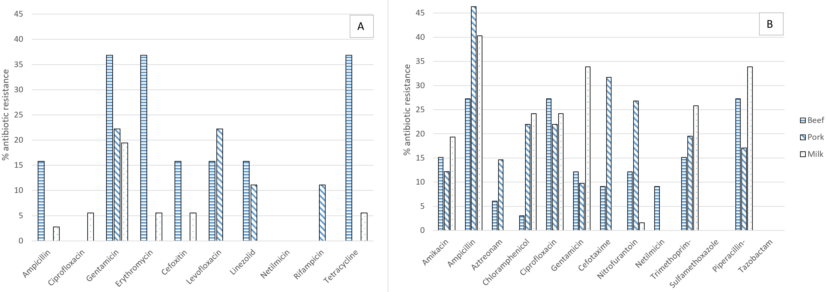
Figure 1 Percentages of AMR S. aureus (A) and E. coli (B) isolates after Disk Diffusion test

4. References
Cecchini F, Iacumin L, Fontanot M, Comi G, Manzano M (2012) Identification of the unculturable bacteria Candidatus arthromitus in the intestinal content of trouts using Dot blot and Southern blot techniques, Vet. Microbiol. 156: 389–394.
EUCAST (2022) Antimicrobial susceptibility testing EUCAST disk diffusion method, 1–22.
Hsu SC, Tsen HY (2001) PCR primers designed from malic acid dehydrogenase gene and their use for detection of Escherichia coli in water and milk samples, Int. J. Food Microbiol. 64: 1–11.
Javid F, Taku A, Bhat MA, Badroo GA, Mudasir M, Sofi TA (2018) Molecular typing of Staphylococcus aureus based on coagulase gene, Vet. World. 11: 423–430.
Manzano M, Cocolin L, Cantoni C, Comi G (2003) Bacillus cereus, Bacillus thuringiensis and Bacillus mycoides differentiation using a PCR-RE technique, Int. J. Food Microbiol. 81: 249–254.
Pinamonti D (2022) New strategies to face antibiotic resistance in healthcare and food sectors. In Proc.s of the 26th Workshop on the Developments in the Italian PhD Research on Food Science, Technology and Biotechnology, Asti (Italy), 19-21 September 2022, pp 159–160.
Stepanović S, Vuković D, Hola V, Di Bonaventura G, Djukić S, Ćirković I, Ruzicka F (2007) Quantification of biofilm in microtiter plates: overview of testing conditions and practical recommendations for assessment of biofilm production by staphylococci, APMIS. 115: 891–899.

