POSTER COMMUNICATIONS

Cow's Milk and Plant-based Beverages: a comparison of their effect on markers of human health and on nutrient intake
Paola Biscotti (paola.biscotti@unimi.it)
Dept. Food, Environmental and Nutritional Sciences, University of Milan, Milan, Italy
Tutor: Prof. Daniela Martini

The first two activities of the PhD thesis project are described. Firstly, a systematic review of the impact of substituting cow’s milk (CM) with plant-based drinks (PBD) on markers of human health was performed. Secondly, the impact on nutrient intake following the substitution of CM with PBD in two Mediterranean dietary patterns, one based on the Italian Dietary Guidelines (IDG) and the other in line with the “Planetary Diet” and adapted to the Italian food habits (EAT-IT), was assessed.

Il latte e le bevande vegetali: comparazione dei loro effetti su marker della salute e sull’assunzione di nutrienti
Le prime 2 attività del progetto di tesi di dottorato sono descritte. È stata svolta una revisione sistematica riguardante l’impatto della sostituzione del latte con le bevande vegetali sui marker della salute. Successivamente, è stato valutato l’impatto sull’intake di nutrienti a seguito della sostituzione del latte con le bevande vegetali in due piani alimentari mediterranei, uno basato sulle linee guida italiane e l’altro in linea con la “Dieta Planetaria” adattata alle abitudini alimentari italiane.

Key words: Cow’s milk, plant-based alternatives, dietary patterns, and health, nutrition, sustainability.

1. Introduction
In accordance with the PhD thesis project previously described (Biscotti, 2021), this poster reports the main results of the first two activities concerning:
(A1) the analysis of data in literature regarding the effects of the CM substitution with PBD on markers of human health through a systematic review;
(A2) the assessment of the impact on nutrient intake due to the substitution of CM with PBD both within a dietary pattern based on the Italian Dietary Guidelines (IDG) (CREA, 2018) and an Italian-Mediterranean dietary pattern based on the EAT-Lancet Reference Diet (EAT-IT) (Tucci et al., 2021).

2. Materials and Methods
(A1) A systematic literature search was conducted using two digital databases PubMed® and Scopus. The search was performed in May 2022 and updated in July 2022. Studies were included if they were clinical trial tested the substitution of CM with PBD on markers of human health. There were restrictions pertaining to age (<18 years within the target population), but not to other characteristics of study participants (e.g., BMI and health condition).
(A2) The list of ingredients and the nutrition declaration of PBD were collected from home-shopping website of the retailers present on the Italian market. Selected PBD were grouped into six categories: almond drinks; blends (≥2 plant-based ingredients); oat drinks; rice drinks; soy drinks; other single ingredient (e.g., coconut drinks). Then, the PBD categories were divided in calcium-fortified (Ca) and not-calcium fortified (nCa) products. The substitution of CM within IDG and EAT-IT dietary patterns was made with the average nutritional value declared on the food labels of 309 retrieved PBD. The elaboration of dietary patterns and the estimation of the nutritional composition of the different dietary plans were made by MetaDieta Software.

3. Results and Discussion

3.1 The effect of cow’s milk substitution with PBD on markers of human health
A total of 29 papers were collected; 27 studies focused on soy drink (SD) (one of which included two trials and one of which also evaluated the effects of almond drink) while 2 studies focused on rice drink. However, it’s important to note that, on the market, there are at least 20 different PBD derived from cereals, legumes, nuts, pseudo-cereals, and seeds.
The most investigated parameters following the CM substitution with SD were anthropometric measurements (n = 13), lipid profile (n = 8), markers of inflammation and/or oxidative stress (n = 7), glucose and insulin response (n = 6) and blood pressure (n = 4). A comparison of the findings of the studies included was difficult due to variability in terms of doses, nutritional composition of PBD and CM, study design, characteristics of the recruited subjects, duration, and markers. However, the results of this systematic review seem to suggest a potential protective role of SD on lipid profile since five of the eight studies included showed that consumption of SD compared to CM resulted in LDL-C lowering effect. Regarding the other health-related outcomes, no differences of interest between the consumption of SD and CM were found.
Since only one study focused on bone health and also because the main nutritional differences between CM and PBD are related to Ca and Vit. D, which have a wide impact on bone health, future studies should focus also on their impact on markers of bone health (e.g., bone mineral density). In conclusion, further studies are needed to better elucidate the effect of substituting CM with PBD in different target of groups of the population, especially in the long term.

3.2 The effects of cow’s milk substitution with PBD on nutrient intake
The analysis of nutrient intake showed that substitution of CM with all PBD had the same effects in both IDG and EAT-IT dietary patterns. In terms of macronutrients, the substitution of CM with all-PBD resulted in a reduced intake of protein, saturated fat (SFA), cholesterol, and increased intake of fiber. The amount of total fat, carbohydrates and sugars was dependent on the type of PBD; the detailed differences are shown in Fig. 2.
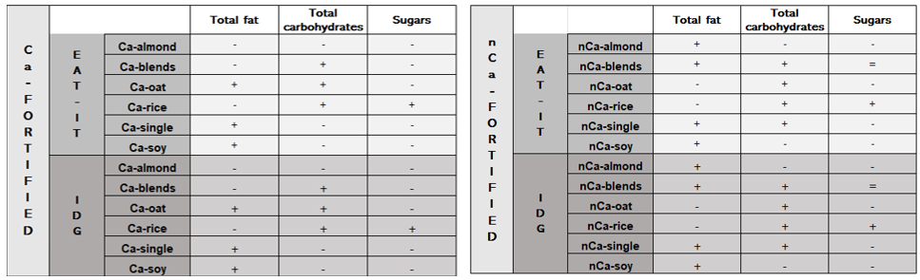
Figure 2 Specific differences on macronutrients between EAT-IT and IDG with Ca-PBD and nCa-PBD compared to CM-EAT-IT and CM-IDG.
Regarding micronutrients, all PBD-dietary patterns provided a lower amount of Vit. B_{1,} Vit. B₂ and Vit. B₁₂ compared to both CM-dietary patterns. The intake of other micronutrients was different based on the type of considered PBD; these differences are shown in Fig. 3. In detail, the replacement of CM with all nCa-PBD resulted in a reduced intake of Vit. D and Ca. Since fortification with Ca is often combined with Vit. D, after replacement with Ca-PBD the amount of Vit. D was higher in comparison to both CM-dietary patterns. In fact, the fortification used in PBD are up to 1,5 µg/100 mL of Vit. D; however, it’s important to highlight that the CM used within both dietary patterns was not fortified with Vit. D even if its fortification is increasingly present in CM on the market.
Following the replacement with Ca-PBD, the amount of Ca was dependent on the type of considered Ca-PBD. These differences are due to a variable fortification of PBD.
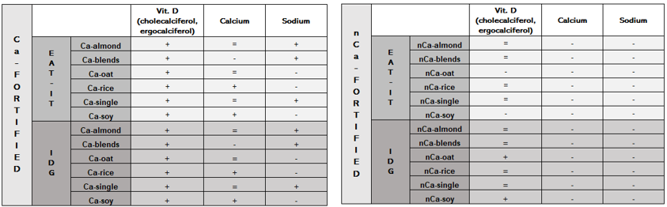
Figure 3 Differences on micronutrients between EAT-IT and IDG with Ca-PBD and nCa-PBD compared to CM-EAT-IT and CM-IDG.
It is important to consider that, despite fortified PBD contain considerable amount of micronutrients (e.g, Ca and Vit. D), their availability could still be poor (Aydar et al., 2020). Therefore, unaware substitution could lead to unintended nutritional consequences due to a reduced intake of micronutrients among, for example, individuals for whom the consumption of milk may be decisive to reach the peak bone mass. However, the role of PBD should be deepened to promote a reduced intake of SFA and cholesterol in specific target of population and to reduce the environmental impact of diet. Therefore, future studies aimed to optimize dietary plans including CM and/or PBD in order to maximize diet quality minimizing their environmental impact are necessary.

4. References
Biscotti P (2022) The effect of cow’ milk substitution with PBD on nutrient intake. In Proc.s of the 26th Workshop on the Developments in the Italian PhD Research on Food Science and Technology, Asti, 19-21 September, 2022, pp. 45-46.
Aydar E F, Tutuncu S, Ozcelik B (2020) Plant-Based Milk Substitutes: Bioactive Compounds, Conventional and Novel Processes, Bioavailability Studies, and Health Effects. J. Funct. Foods 70: 103975.
Tucci M, Martini D, Del Bo' C, Marino M, Battezzati A, Bertoli S, Porrini M, Riso P (2021) An Italian-Mediterranean Dietary Pattern Developed Based on the EAT-Lancet Reference Diet (EAT-IT): A Nutritional Evaluation. Foods 10: 558.
CREA (2018) Linee Guida per una Sana Alimentazione. Rome, Italy; pp. 1–231

Progetto finanziato nell’ambito PON: “Ricerca e Innovazione” 2014-2020, Asse IV “Istruzione e ricerca per il recupero” con riferimento all’Azione IV.4 “Dottorati e contratti di ricerca su tematiche dell’innovazione” e all’Azione IV.5 “Dottorati su tematiche green”. DM 1061/2021

