Biobased approaches at modulating the interaction between legume biopolymers and bioactives: a perspective for the production of baked goods
Sara Margherita Borgonovi (sara.borgonovi@unimi.it)
Dept. of Food, Environmental and Nutritional Science, University of Milan, Milan, Italy
Tutor: Dr. Mattia Di Nunzio

The purpose of the second-year activity was to evaluate the impact of different sprouting times (24, 48, and 72 hours) on the biomolecular profile of bean (Vigna unguiculata) seeds. The results show that germination is able to reduce nutritional factors and increase the degree of protein hydrolysis and polyphenols with a maximum effect at 72 hours of germination. Based on the results obtained bakery products (bread) enriched with 72h sprouted bean flour and their respective controls were manufactured, biomolecularly characterized and in vitro digested.

Approcci biomolecolari per lo studio delle interazioni tra biopolimeri e bioattivi nei legumi: una prospettiva futura per la produzione di prodotti da forno
Scopo dell’attività di questo secondo anno è stato valutare l’impatto di differenti tempi di germinazione (24, 48, e 72h) sul profilo biomolecolare di semi di fagiolo (Vigna unguiculata). I risultati evidenziano come la germinazione sia in grado di decrescere i fattori nutrizionali e di aumentare l’idrolisi di proteine e di polifenoli con un massimo effetto a 72h di germinazione. Sulla base dei risultati ottenuti, si è proceduto alla realizzazione, alla caratterizzazione biomolecolare ed alla digestione in vitro di prodotti da forno (pane) arricchiti con la farina fagiolo germinata per 72h e dei rispettivi controlli.

1. Introduction
The Ph.D thesis project aims to evaluate the effect, through a biomolecular approach, of innovative and technological processes on cowpea seeds for the production of bakery products with high nutritional value.
In accordance with the previously described PhD thesis project, the main activities during this second year were:
(A1) A complete evaluation, through a biomolecular approach, of the impact of sprouting bean (Vigna unguiculata) seeds conducted for various time (24, 48, and 72 hours) on the presence of anti-nutritional factors such as trypsin inhibitory activity and phytate concentration, oligosaccharide, free polyphenol content, and protein profile.
(A2) Making wheat bread enriched with 25% flour from been seeds sprouted for 72h. The sprouting time was chosen based on the results obtained in previous activities. The baked goods were characterized from a biomolecular point of view (protein profile and anti-nutritional factors) and will be subjected to in vitro digestion in order to assess the impact of the functional ingredient on the bioaccessibility of nutrients and bioactive compounds. The results so obtained were compared with the data provided from wheat bread and bread enriched with 25% non-sprouted bean seed flour.

2. Materials and Methods
Seeds were soaked in water (1:3, w/w) for 16 h at 27°C and sprouted in a lab-scale climate chamber for 24h, 48 h and 72 h at 27°C and 90% relative humidity. After sprouting, seeds were dried at 50°C for 8 h and unsprouted seeds were used as the control. All samples were milled into powder in a laboratory mill. In bean powder, protein profile and hydrolysis degree were evaluated by SDS-PAGE in the presence/absence of disulfide reducing agent and OPA assay, respectively. Trypsin inhibitory activity and free phenols content were measured according EN ISO 14902 standard and Folin-Ciocalteau assay, respectively, while phytates and oligosaccharides content by commercial kit following the manufacturer’s instructions.
Experimental bread has been prepared according to a traditional recipe (Bresciani A. et al., 2019). Samples bread were: 100% wheat flour bread; wheat bread enriched with 25% of unsprouted bean seed flour; wheat bread with 25% of bean seed 72h sprouted flour. Protein profile and anti-nutritional factors in bread samples were evaluated as described previously. Bread samples will be subjected to in vitro static gastrointestinal digestion according to the INFOGEST protocol, and the kinetics of protein release and bioactive compounds will be detected by sampling at the end of the gastric phase, as well as in the middle and at the end of the intestinal phase.

3. Results and Discussion
The results on the germinated flour indicated that sprouting led to a progressive decrease in antinutritional factors and oligosaccharides, along with an increase in free polyphenols content and protein hydrolysis. The molecular investigation of germinated flour included the detection of -SH group exposure and tryptophan fluorescence by front face fluorescence in order to describe proteins structural features modifications induced by sprouting (Bonomi et al.,2004). The collected data indicated no significant difference in the number of SH group exposed between the germinated and untreated flour samples suggesting no major modification in the overall compactness of protein organization. Conversely, the front face fluorescence spectra (intrinsic tryptophan fluorescence) indicated that overall protein structural modifications were modified by sprouting. All together the data provided from this study indicated that 72 hours of sprouting represents the optimal time, and we used this time to produced bread enriched with sprouted been seed flour. The modifications induced by sprouting in micro/macromolecules profile are maintained in bread suggesting that they were not affected by technological processes. In figure 1 the the proteins profile of the bread sample CB, BB0 and BB72 in reducing (A) and non-reducing conditions (B) are shown. In this figure, protein profiles of the samples, under reducing and non-reducing conditions differ significantly. Sprouting was accompanied by a time-dependent proteolysis of the large soluble aggregates evident under non reducing conditions to produce species of molecular weight around 40 kDa along with smaller peptides that may have escaped detection (Borgonovi SM. et al., 2022).
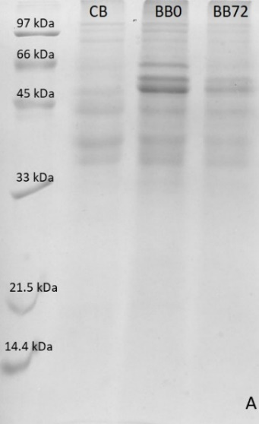
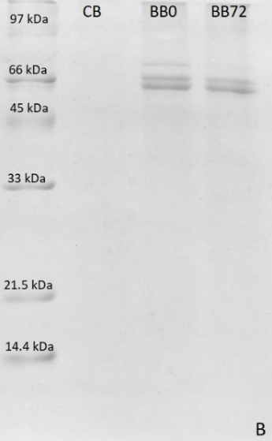
Figure 1 SDS-PAGE of proteins aqueous extract in the presence (A) and in the absence (B) of reducing agent from wheat- bread (CB) bread enriched with 25% of unsprouted bean seeds flour (BB0), and bread enriched with 25% of 72h sprouted bean seeds flour (BB72).

The data on micromolecules characterization indicated that bread made with the 25% germinated bean seeds flour show the lowest levels of trypsin inhibitors and phytates when compared to the wheat bread and non-germinated bean seeds flour bread. Further investigations on phenolic and proteins profile of various bread samples before and after in vitro digestion will be carried out during the period abroad at the University of Granada, Spain.
Based on these results, it can be assumed that incorporating sprouted beans flour as a food ingredient may be used for production of bread with an increase in nutritional properties.

4. References
Bonomi F, Mora G, Pagani MA, Iametti S. Probing structural features of water-insoluble proteins by front-face fluorescence (2004). Anal Biochem 329(1):104-11.
Borgonovi SM, Chiarello E, Pasini F, Picone G, Marzocchi S, Capozzi F, Bordoni A, Barbiroli A, Marti A, Iametti S, Di Nunzio M. (2023). Effect of Sprouting on Biomolecular and Antioxidant Features of Common Buckwheat (Fagopyrum esculentum). Foods 12, 2047.
Bresciani A., Marti A. (2019). Using Pulses in Baked Products: Lights, Shadows, and Potential Solutions. Foods 8, 451.

