Sustainable Solutions in Technology and Quality Control of Olive Oil
Ilaria Grigoletto (ilaria.grigoletto2@unibo.it)
Dept. of Agricultural and Food Sciences, Alma Mater Studiorum – Università di Bologna, Cesena, Italy
Tutor: Prof. Enrico Valli, co-tutors: Prof. Tullia Gallina Toschi, Dott. Enrico Casadei

This PhD thesis deals with the set-up and application of rapid, innovative, and sustainable instrumental analytical methods for supporting the sensory analysis (Panel test) of virgin olive oils. Furthermore, it is focused on olive pomace valorization by developing sustainable methods for the extraction of phenolic compounds, followed by the characterization and shelf-life evaluation of the obtained extracts.

Soluzioni sostenibili nella tecnologia e nel controllo qualità dell’olio di oliva
Questa tesi di dottorato riguarda la messa a punto e l’applicazione di metodi analitici rapidi, innovativi e sostenibili, per la determinazione della qualità e purezza degli oli di oliva vergini come supporto all’analisi sensoriale. Inoltre, l’attività di ricerca è focalizzata sulla valorizzazione della sansa di oliva attraverso lo sviluppo di metodi sostenibili per l’estrazione di composti fenolici e le successive fasi di caratterizzazione e valutazione della shelf-life degli estratti ottenuti.

Key words: virgin olive oils; rapid analytical methods; Panel test; quality control; sustainability; olive pomace.

1. Introduction
This oral communication reports the main results of the following two research activities carried out in this PhD project: this oral communication reports the main results of the following four activities directed to:
A1) development and application of easy-to-use, innovative, rapid, and sustainable analytical instrumental methods to support the sensory analysis of virgin olive oils. In particular, a focus is carried out on the study of the volatile fraction by gas-chromatographic analyses and the composition by spectroscopic techniques, as a relevant potential tools in the determination of the commercial category of virgin olive oils;
A2) olive pomace valorisation: set-up of sustainable methods for extraction of phenolic compounds from olive pomace, as well as characterization and shelf-life evaluation of the so obtained phenolic extracts. This activity is aimed to produce extracts potentially usable in different industrial sectors, such as pharmaceutical, food and cosmetic.

2. Sustainability Aspects and Related Gaps in the Quality Control and Technology of Olive Oil Sector
Nowadays, one of the main worldwide challenges is the achievement of the 17 sustainable development goals, known as SDGs in the framework of UN Agenda 2030. Among these, it is important to mention the most related to this PhD project, the SDG 12, namely “responsible consumption and production”, and specifically the target 12.3 which focuses on the halve per capita food waste at the retail and consumer level and reduce food losses along the food production and supply chains; and the target 12.4, that focuses on the management of chemicals and waste to significantly reduce their release to air, water and soil in order to minimize their adverse impacts on human health and the environment.
In the Mediterranean basin, olive oil represents one of the main food products, since more than 90% of the global production comes from this area, concentrating mainly on European countries like Spain, Greece, and Italy (European Commission, 2023). In the European Union, virgin olive oils (VOOs) can be classified in three commercial categories depending on their quality degree: extra virgin (EV), virgin (V) and lampante (L) (EU Reg. 2022/2104). The different quality level of each commercial category corresponds to different values and, subsequently, to various prices.
It is important to consider that most of the official analytical methods to assess the quality and genuineness of VOOs consist of time-consuming and complex procedures, often with the use of toxic chemicals and solvents which are dangerous for human health and the environment or are expensive and difficult to be managed. For these reasons, there is a strong and growing demand for rapid, easy-to use and environmentally friendly analytical procedures to support the official ones. This includes procedures that do not require solvents at all, such as the determination of volatile compounds by gas-chromatographic techniques with headspace-solid phase microextraction (HS-SPME-GC), ion mobility spectrometry (HS-GC-IMS) or HS-Flash-GC (Quintanilla-Casas et al., 2020). It is well known that volatile compounds have a crucial role to determinate VOOs quality, since they are directly responsible for the olfactory notes, and methods for their determination could be used as support for sensory analysis in the classification of VOO based on the quality grade (Barbieri et al., 2020a; Quintanilla-Casas et al., 2020).
Furthermore, regarding rapid, innovative, and sustainable techniques for the assessment of VOOs quality and genuineness, current investigations are also focused on the adoption of optical techniques (Delfino et al., 2018). In particular, NIR, MIR, Raman and FT-IR spectroscopic methods are useful tools for the rapid determination of food composition and molecular structure, also in the case of olive oils.
In the context of a sustainable olive oil production, olive pomace is the main residue in the mechanical extraction of the olive oil from the olive fruits and it is basically composed of skin, pulp and stone pieces, water, and oil. The major problem related to olive pomace is that it also contains organic compounds with phytotoxic properties, that are dangerous for the environment (Nunes et al., 2021). Although it represents an important environmental issue, olive pomace is also characterized by the presence of high added value molecules, such as phenolic compounds (Dermeche et al., 2013), widely recognised for their beneficial properties (e.g. antioxidant activity). For this reason, this by-product is a potential source of phenolic compounds and their valorisation as functional ingredients in pharmaceutical, cosmetic and food industries (Nunes et al., 2016) represents a promising sustainable valorisation strategy, especially in a circular economy perspective.

3. Experimental Procedure
Regarding the first activity (A1), the research has started with the collection of commercial VOOs. The sensory analysis (Panel test) was carried out by four panels to robustly determine the commercial category of each sampled oil, among EV, V and L. Secondly, the same sample set was analysed by gas chromatography coupled with ion mobility spectrometry (HS-GC-IMS) and Flash-gas chromatography (Flash-GC) to investigate the volatile fraction, since it is strictly correlated with the sensory attributes, both fruity and defects. The data obtained from the two techniques were elaborated by applying chemometric approaches, such as PLS-DA models, to predict the commercial category.
Finally, a selection of the same samples set was analysed by spectroscopic techniques (NIR, FT-IR and Raman), during a 3-months visiting period at Queen’s University Belfast (from November 2022 to February 2023) to investigate composition and molecular structure of VOOs. Regarding data elaboration, a focus on rancid defect is under investigation, mainly applying PLS-DA models, since it is directly related to the oxidation status of olive oil (Frankel et al., 1983), and consequently to its quality. Also, a “data fusion” between the results of the different analytical techniques will be considered to obtain more robust predictive models.
Regarding the second activity (A2), the sustainable valorisation of olive pomace by obtaining extracts rich in phenolic compounds was carried out in the framework of the PRIMA project SUSTAINOLIVE “Novel approaches to promote the SUSTAInability of OLIVE cultivation in the Mediterranean" (Grant Agreement no. 813904, 2019 – 2023).
The research has started from the set-up of the analytical procedure for the extraction of phenolic compounds and the characterization of the phenolic profile of olive pomace samples. Subsequently, the activities were aimed to develop a sustainable procedure through the application of a mechanical approach, using less toxic solvents than those usually adopted such as food grade ethanol, to obtain phenolic hydroalcoholic extracts. On these extracts, a shelf-life study, including both sensory and instrumental evaluations, was carried out to investigate their stability over time.

4. Materials and Methods

4.1 Rapid and sustainable instrumental analytical methods to support the sensory analysis
In this context, Flash-GC (FGC-E-nose Heracles II, AlphaMos, Toulouse, F) and HS-GC-IMS (Flavourspec®, G.A.S. Dortmund, Dortmund, D) techniques were performed on 120 VOOs, collected in order to have a relevant and balanced variety in the commercial categories. The samples were assessed by sensory analysis (Panel test) carried out by 4 Italian panels, in order to have a robust sensory classification thanks to the application of a decision tree developed within the H2020 OLEUM project (Barbieri et al., 2020b). To predict the commercial category, previously developed chemometric approaches based on a PLS-DA models, both for Flash-GC (Barbieri et al., 2020a) and HS-GC-IMS (Valli et al., 2020), were applied on a selection of these samples. In particular, the models combined to assign the commercial category and classify the samples with a certain probability were: EV vs noEV; L vs noL; EV vs V; L vs V.
In addition, regarding the HS-GC-IMS, the whole sample set was analysed also using improved analytical conditions with respect to the published ones (Valli et al., 2020), in which sample conditioning and other analytical parameters were modified to improve the resolution and sensitivity of the method.
One hundred out of 120 total samples were analyzed also by spectroscopic techniques, namely NIR, FT-IR and Raman, with the aim to support sensory analysis and with a specific focus on rancid defect. NIR spectra were acquired by FT-NIR diffuse reflectance module (Nicolet iS50, Thermo Scientific, Waltham, Massachusetts, USA), equipped with Ge coated KBr beam splitter and InGaAs (Indium Gallium Arsenide) detector. FT-IR analysis was conducted using FT-IR module (Nicolet iS50, Thermo Scientific, Waltham, Massachusetts, USA), equipped with a DTGS detector and KBr beam splitter. Finally, FT-Raman measurements were performed using a Raman Microscope (DXR2 Raman Microscope, Thermo Scientific, Waltham, Massachusetts, USA) operated with an excitation laser light of 785 nm.

4.2 Olive pomace valorization
After the set-up of a sustainable method for the extraction of phenolic compounds without the use of toxic solvents, a mechanical approach (using a lab scale screw-press) was applied on the olive pomace by adding a mixture of water and food grade ethanol (80:20 % v/v) and two types of samples were obtained: one more liquid drained from the lower part of the mill (named SI) and one drier from the frontal part (named SF). On these samples, including olive pomace as it is (named TQ), a study focused on the phenolic fraction was carried out.
The more liquid samples drained from the lower part of the mill (SI) has been selected as more suitable to obtain stable hydroalcoholic phenolic extracts. Subsequently, the technological conditions to obtain this extract were developed: the procedure included filtration of the olive pomace, evaporation, and addition of food grade ethanol. On the selected extract, the phenolic compounds characterization and the assessment of its stability during a shelf-life study were performed, including both sensory and instrumental evaluations. The latter concerned the characterization of the phenolic fraction by UHPLC-MS/MS, the determination of the sum of simple phenolic molecules after acid hydrolysis (by UHPLC-DAD) and the determination of the total reducing molecules content through the Folin-Ciocalteu method. On the other side, a sensory descriptive analysis was carried out by 8 panelists trained for VOO assessment, through an olfactory evaluation, and excluding the perception of ethanol.
In particular, the shelf-life study was performed on a monthly basis and for two months (T0, T1 and T2) on the extract stored at room temperature and in dark conditions.

5. Results and Discussion

5.1 Rapid and sustainable instrumental analytical methods to support the sensory analysis
At now the data elaboration was completed on a set composed of 52 VOOs samples classified into the commercial category (EV, V and L), using previously developed prediction approaches based on PLS-DA models, both for Flash-GC (Barbieri et al., 2020a) and HS-GC-IMS (Valli et al., 2020) data. The commercial category was assigned with a certain probability combining the 4 models: EV vs noEV (Fig. 1); L vs noL; EV vs V; L vs V.
The results show comparable effectiveness between these two techniques, and they are satisfactory in terms of percentage of correctly classified samples for the different commercial categories (Table 1) with respect to that established by Panel test through the decision tree (Barbieri et al., 2020b), confirming the robustness and capabilities of such developed models.
Table 1 Flash-GC and HS-GC-IMS outcomes, in terms of samples correctly classified compared to the sensory assessment, by the prediction models.
 | Flash-GC |  | HS-GC-IMS
COMMERCIAL CATEGORY | SAMPLES CORRECTLY CLASSIFIED | % | SAMPLES CORRECTLY CLASSIFIED | %
EV | 16/17 | 94.1 | 15/17 | 88.2
V | 17/19 | 89.5 | 17/19 | 84.2
L | 13/16 | 81.3 | 15/16 | 93.8
TOTAL | 46/52 | 88.5 | 47/52 | 90.4

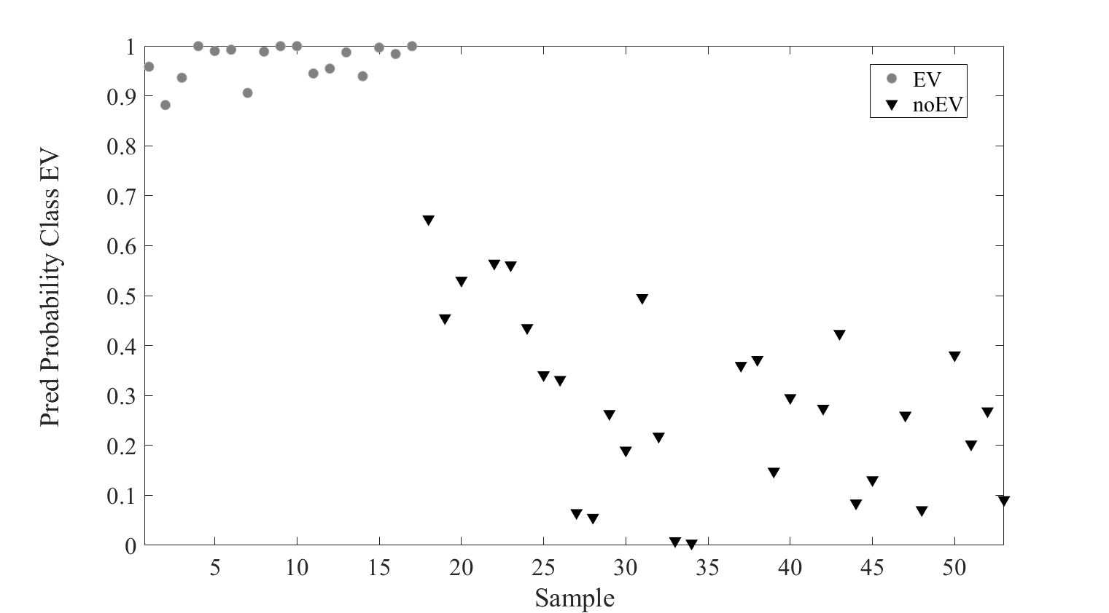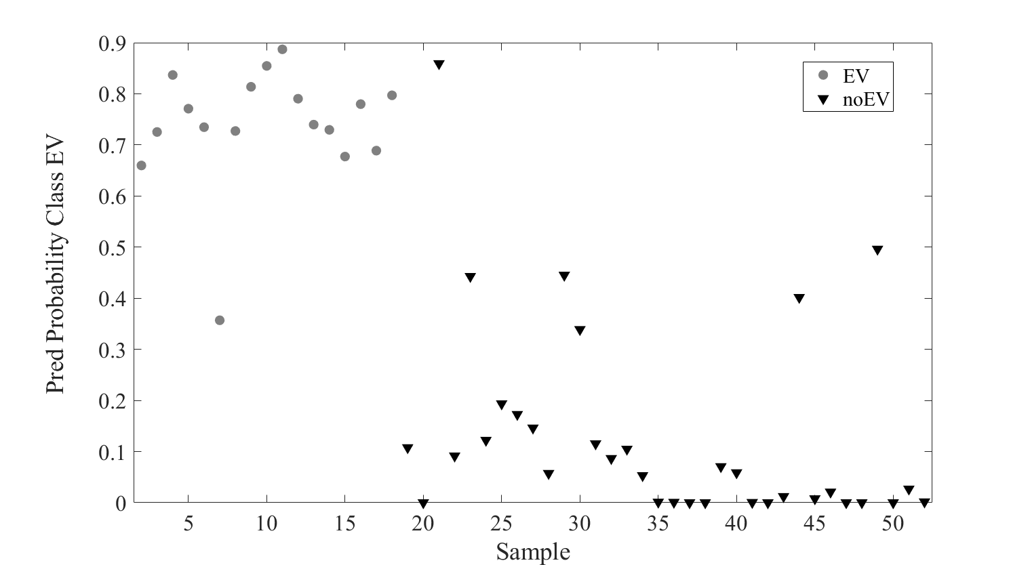
Figure 1 Graphical results regarding the values of the class prediction probability by the single model EV vs. noEV, for both Flash-GC (on the left) and HS-GC-IMS (on the right). EV samples: grey circles; noEV samples: black triangles.
The other 68 VOOs samples were also analyzed by sensory analysis (Panel test) and by both the abovementioned instrumental techniques, and the data elaboration is still ongoing.
In addition, regarding HS-GC-IMS technique, data elaboration on the results obtained using the improved analytical conditions with respect to the published ones (Valli et al., 2020) for the 120 VOOs is also at now ongoing.

5.2 Olive pomace valorization
The results show that the extract obtained from the olive pomace drained from the central part of the lab-scale mill, SI, is the richest in the concentration of both total reducing molecules, including the phenolic compounds, and detected simple phenolic molecules after hydrolysis (Table 2). For this reason, it has been selected as the most suitable sample as phenolic hydroalcoholic extract.
Table 2 Average concentrations and relative standard deviations in the extracts obtained from the sample TQ, SI, SF (see the description of these samples in the paragraph 4.2). In the first column the total concentrations of the sum of unknown compounds (Unk), hydroxytyrosol (HTyr), and tyrosol (Tyr), obtained after acid hydrolysis of the extracts, are reported. In the third column, the concentrations in total reducing molecules contents by Folin-Ciocalteu method are reported. Statistical analysis: ANOVA, HSD Tukey, p <0.05.

Sample | Concentration  (g Tyr + HTyr + Unk/kg olive pomace) | SD | Concentration  (g gallic acid/kg olive pomace) | SD
TQ | 1.12^{b} | 0.25 | 3.29^{b} | 0.38
SI | 1.54ª | 0.14 | 7.10ª | 0.42
SF | 0.64^{c} | 0.02 | 3.09^{b} | 0.39

Despite the statistic shows some significant differences among the three samples T0, T1, and T2, a clear reduction in the phenolic contents during the two months of the shelf-life is not observed (Table 3).

Table 3 Average concentrations and relative standard deviations of the extracts from the sample T0, T1, T2 (see the description of these samples in the paragraph 4.2). In the first column the total concentrations of the sum of unknown compounds (Unk), hydroxytyrosol (HTyr), and tyrosol (Tyr), obtained after acid hydrolysis of the extracts, are reported. In the third column, the concentration in total reducing molecules contents by Folin-Ciocalteu method are reported. Statistical analysis: ANOVA, HSD Tukey, p <0.05.

Sample | Concentration  (mg Tyr + HTyr + Unk/mL extract) | SD | Concentration  (mg gallic acid/mL extract) | SD
T0 | 0.23^{b} | 0.00 | 0.55^{c} | 0.01
T1 | 0.25ª | 0.00 | 0.63ª | 0.02
T2 | 0.24^{a,b} | 0.00 | 0.60^{b} | 0.01

Regarding the UHPLC-MS/MS analytical approach, data elaboration is still ongoing to investigate the phenolic profile of the extracts.
Moreover, a sensory descriptive analysis was carried out by 8 panelists trained for olive oil assessment, through only an olfactory evaluation, and they were asked to exclude the perception of ethanol in their assessment. Defects or other negative attributes were not perceived. The attributes were all considered as positive and related mostly to specific notes resembling vanilla, caramel, red fruits, and olive fruits.

6. Conclusions and Future Perspectives
Most of the VOOs were correctly classified by the predictive models, according to the commercial category obtained by the application of a decision tree on the sensory results of four different panels. The two analytical approaches (HS-GC-IMS and Flash GC) both showed effectiveness as potential instrumental screening methods to support the Panel test: this is confirmed also by the comparison of the satisfactory percentages of samples herein correctly classified with those obtained in external validations from the previous studies conducted by Barbieri et al. (2020) and Valli et al. (2020). For this reason, the adoption of such rapid and innovative gas chromatographic techniques could represent a potential useful tool to support the sensory analysis for the determination of the commercial category of VOOs, thus pre-classifying some samples, and simplifying the quality control work of the laboratories and companies in the olive oil sector. In fact, the concrete applicability of such rapid screening methods to predict the commercial category of VOOs could reduce the number of samples to be assessed by Panel test. Although these encouraging results, further efforts to improve the robustness of the models, i.e. by increasing the dataset, are needed. Moreover, the elaboration of the obtained results by a new HS-GC-IMS method with improved analytical conditions is now ongoing. In addition, also rapid spectroscopic techniques (FT-IR, NIR and Raman) were applied to a selection of the same sample set to investigate their ability to support the sensory analysis as well, and the results are now under investigation. Finally, further studies are considering innovative chemometric approaches, such as the "data fusion" between the results obtained with the different analytical techniques adopted during this PhD project.
The second activity, related to the olive pomace valorization, was aimed to obtain phenolic hydroalcoholic extracts. Researchers, food industries and stakeholders are paying more and more attention to waste and by-products especially when they represent a source of bioactive molecules, such as olive pomace. Within this PhD research work it has been developed a sustainable phenolic extraction procedure (i.e. by a mechanical approach), using less toxic solvents, such as food grade ethanol. The obtained extract, during the shelf-life study, demonstrates stability over time, since a relevant reduction of the phenolic content was not observed, nor sensory defects or other negative sensory attributes were perceived. Thus, this research could contribute to improve the valorization of olive oil pomace, well-known for its high content of phenolic compounds, known for their beneficial properties, such as the antioxidant activity; in fact, extracts potentially usable in different industrial sectors, such as pharmaceutical, food and cosmetic, were obtained and the phenolic fraction will be soon completely characterized.
In conclusion, the research activities in this PhD project are providing sustainable solutions in relation to technology and quality control of olive oils.

7. References
Barbieri S, Brkić Bubola K, Bendini A, Bučar-Miklavčič M, Lacoste F, Tibet U, Winkelmann O, García-González DL, Gallina Toschi T (2020b) Alignment and Proficiency of Virgin Olive Oil Sensory Panels: The OLEUM Approach. Foods 9: 355.
Barbieri S, Cevoli C, Bendini A, Quintanilla-Casas B, García-González DL, Gallina Toschi T (2020a) Flash Gas Chromatography in tandem with chemometrics: a rapid screening tool for quality grades of virgin olive oils. Foods 9: 862.
Delfino I, Cavella S, Lepore M (2018) Scattering-based optical techniques for olive oil characterization and quality control. Food Measure 13: 196–212.
Dermeche S, Nadour M, Larroche C, Moulti-Mati F, Michaud P (2013) Olive mill wastes: biochemical characterizations and valorization strategies. Process Biochem 48: 1532–1552.
European Commission. Reg. (EU) n. 2022/2104 supplementing Regulation (EU) No 1308/2013 of the European Parliament and of the Council as regards marketing standards for olive oil, and repealing Commission Regulation (EEC) No 2568/91 and Commission Implementing Regulation (EU) No 29/2012.
European Commission (2023) Market situation in the olive oil and table olives sectors.
Frankel EN (1983). Volatile lipid oxidation products. Prog Lipid Res 22: 1-33.
Nunes A, Goncalves L, Marto J, Martins AM, Silva AN, Pinto P, Martins M, Fraga C, Ribeiro HM (2021) Investigations of Olive Oil Industry By-Products Extracts with Potential Skin Benefits in Topical Formulations. Pharmaceutics 13: 465.
Nunes MA, Pimentel FB, Costa ASG, Alves RC, Oliveira MBPP (2016) Olive by-products for functional and food applications: challenging opportunities to face environmental constraints. Innov Food Sci Emerg Technol 35: 139–148.
Quintanilla-Casas B, Bustamante J, Guardiola F, García-González DL, Barbieri S, Bendini A, Gallina Toschi T, Vichi S, Tres A (2020) Virgin olive oil volatile fingerprint and chemometrics: towards an instrumental screening tool to grade the sensory quality. LWT - Food Sci Technol 121: 108936.
Valli E, Panni F, Casadei E, Barbieri S, Cevoli C, Bendini A, García-González DL, Gallina Toschi T (2020) An HS-GC-IMS Method for the Quality Classification of Virgin Olive Oils as Screening Support for the Panel test. Foods 9: 657.

