ORAL COMMUNICATIONS

Study and Evaluation of Strategies for Replacing Plastic Materials with Greener and Eco-Sustainable Alternatives
Emanuela Lo Faro (emanuela.lofaro@unimore.it)
Dept. of Life Science, University of Modena and Reggio Emilia, Reggio Emilia, Italy
Tutor: Prof. Patrizia Fava

In this PhD thesis, strategies for the replacement of common plastic materials of non-biodegradable petroleum origin with eco-sustainable and renewable alternatives have been studied and evaluated. We were concerned not only with testing the performance of paper-based packaging materials and renewable materials already on the market, but also and above all, the creation of films and coatings on kraft paper to improve their performance and use them as substitutes for common plastic packaging.
Studio e Valutazione di Strategie per Sostituire i Materiali Plastici con Alternative più Green ed Ecosostenibili
In questa tesi di dottorato sono state studiate e valutate strategie per la sostituzione dei comuni materiali plastici di origine petrolifera non biodegradabili con alternative ecosostenibili e rinnovabili. Ci siamo preoccupati non solo di testare le prestazioni dei materiali di imballaggio a base carta e dei materiali rinnovabili già presenti sul mercato, ma anche e soprattutto, della creazione di film e rivestimenti su carta kraft per migliorarne le prestazioni e utilizzarli come sostituti dei comuni imballaggi in plastica.
Key words: compostable bioplastics; coatings; food-paper; renewable materials; food-packaging.
1. Introduction
In this oral communication the main results of the following activities will be reported
A1) Comparison of the performance of packaging made from environmentally sustainable and renewable materials with non-biodegradable petroleum-based packaging.
A2) Strategy for improvement the performance of paper for food use with the use of biopolymers films made by coating technique.

A1. Replacement of traditional plastic packaging for fruit and vegetables
In the food industry, a growing concern is the availability of packaging materials with suitable thermal, mechanical and barrier characteristics to prevent contamination and food waste, maintaining an adequate shelf life, etc., but greener and more eco-sustainable. To achieve this goal, biopolymers should be affordable, renewable, and available in abundance. In this regard, bioplastic packaging materials based on renewable biomass could be used as a sustainable alternative to petrochemical plastics. The three most commonly used bio-based plastics with unique properties are PLA, Starch based plastics and Cellophane (Tyagi et al., 2023). Like for fossil-based plastics, careful selection of a bio-based and/or biodegradable packaging material is necessary to ensure that a packed product has the required shelf life. First all, it is quite important remembering that the terms bio-based and biodegradable are not synonymous; indeed, - ‘Bio-based’ is defined in European standard EN 16575 as ‘derived from biomass’ and - Biodegradable materials are materials that can be broken down by microorganisms (bacteria or fungi) into water, naturally occurring gases like carbon dioxide (CO2) and methane (CH4) and biomass (e.g. growth of the microorganism population) (Van den Oever et al, 2017) . In this regard, it should be noted that (Table 1) not all materials defined as bio-based enter the category of biodegradable materials, and even the petrochemical material can be biodegradable.

Table 1. Biodegradable and Non-biodegradable materials.
 | PETROCHEMICAL | PARTLY  BIO-BASED | BIO-BASED
NON-BIODEGRADABLE | PE, PP, PET, PS, PVC | Bio-PET, PTT | Bio-PE
BIODEGRADABLE | PBAT, PBS(A), PCL | Starch blends | PLA, PHA, Cellophane

A2. Focus on improvement of paper for food-use.
One of the most widely studied materials is paper, a renewable and biodegradable material, mainly composed of cellulose from a wide range of sources in nature, used as primary and secondary food packaging (Oloyede and Lignou, 2021; Deshwal et al., 2019).
However, base paper (uncoated paper) is not suitable for food with a long shelf-life, because of its inherent shortcomings, such as poor microbial resistance, low mechanical properties and a porous structure which essentially make it difficult to prevent the penetration of moisture, oils and oxygen. Actually, to overcome these drawbacks, with the aim to expand the application of paper, various advanced functionalization technologies have been extensively studied and developed. For example, paper is commonly coated with chemicals or laminated with aluminum foil or plastic thin films to improve its barrier effect to water vapor, oxygen, mineral oils, and grease (Kopacic et al., 2018), but these solutions have some drawbacks such as limited recyclability and compostability. For these reasons, eco-sustainable approaches have to be studied and evaluated and one of the focus points of the PhD work was the formulation of several coating for the improvement of paper for food use.
2. Materials and Methods
Different materials were used for different studies according to the purposes to be pursued and consequently different were the methods applied according to the characteristics of the materials that had to be tested. For this purpose, this session has been divided into two sessions.

A1): Materials: R-PET cup closed with perforated snap-on lid, a tray made of a layer of cardboard in pure virgin bleached cellulose fiber (ECF) and a barrier coating suitable for direct food contact, PLA (polylactic acid) tray closed with snap-on lid, R-PET tray hermetically sealed with a PET film and R-PET tray hermetically sealed with laser-perforated PET film top (with average hole diameter 30 μm); two different cultivar of white grapes (Melanie and Sugar Crips), small red fruits (blackberries and blueberries) and a fruit salad.
Methods: evaluation of atmospheric variation over time for hermetically sealed packages, weight loss assessment, Brix and acidity measurement, shear force over time of grape samples, microbiological load assessment, sensory analysis and statistical data analysis. All evaluations were performed at different shelf lifetimes of the product, so as to evaluate the variation of the parameters over time, comparing the standard reference packaging with the packages obtained with alternative materials.

A2): Materials: calendared bleached paper, poly(-3-hydroxybutyrate-co-3-hydroxyvalerate) (PHBV, NaturePlast®, Ifs, France), polycaprolactone (PCL, Sigma-Aldrich, Mw ~80.000), polyethylene glycol (PEG) 200 (Mw ~190–210; Fluka Analytical), poly (vinyl alcohol) (PVA, Incheon, Korea), glycerol 99.5% (Sigma Aldrich, Germany), potato starch (CAS-No 9005-84-9, PanReac AppliChem ITW Reagents), agar-agar (OXOID, Thermo Fisher), (±)-Epichlorohydrin (ECH), zinc nitrate hexahydrate and melamine (Sigma-Aldrich, MO, USA) and sodium hydroxide (Daejung, South Korea).
Methods: grammage and thickness determination, scanning electron microscopy - energy dispersive spectroscopy analysis (SEM-EDS), measurement of water vapor transmission rate (WVTR), oil and grease resistance, water and oil contact angle measurement, mechanical properties, Fourier-transform infrared spectrometry (FT-IR), thermogravimetric analysis (TGA), mechanical properties tests, antimicrobial activity whit clear zone inhibition test and statistical analysis
3. Results and Discussion
A1. Comparison of the performance of packaging for fruits and vegetables made from environmentally sustainable and renewable materials with non-biodegradable petroleum-based packaging.
The primary objective of this work was to evaluate how the use of packaging made with bio-based and/or biodegradable materials could influence the final quality of the selected fruit samples, compared with the same product stored in commercial packaging. All the trials were carried out in duplicate, and it was evident as regards weight loss, the packages not hermetically sealed recorded more significant weight losses. Excellent results were recorded with the cellulose packaging and sealed with a cellophane lid, both for the measurement of weight loss and for the variation of atmospheric content. Excellent results have been obtained for alternative packaging, also with regard to the microbial load, which for all packages, has remained within the limits of acceptability until the end of the shelf life of the product. Finally, the sensorial evaluation (not trained panelists) demonstrated a high degree of acceptability of the fruit products stored in all the different packages, commercial and alternatives, confirming even more the hypothesis that the packaging materials, to date, used for fruit and vegetable products can be replaced with valid alternatives more eco-sustainable and green.

A2. – Improvement of Paper Resistance against Moisture and Oil by Coating with Poly(-3-hydroxybutyrate-co-3-hydroxyvalerate) (PHBV) and Polycaprolactone (PCL).
In this work a calendered bleached paper (Advantage MG White High Gloss, Mondi Group, Addlestone, UK) was used as reference paper. Commercial polyethylene-coated paper and fluorinated paper were used as commercial references. Coating paper solutions were prepared dissolving in chloroform one of the two biopolymers (5% w/v of PHBV or PCL) and dissolved in under magnetic stirring at 60 °C for 50 min, and subsequently, at about 75 °C for 10 min. The optimization of PHBV and PCL coating solutions was attempted by addition of polyethylene glycol (PEG) (at 5%, 10% and 20% on biopolymer dry weight) to improve coating uniformity and spreadability. Paper samples were coated via bar coating with an automatic film applicator.
The SEM analysis (Figure 1) of the developed coated samples showed the disappearance of the typical fiber network of paper and allowed to observe a continuous layer of coating. The smoothness of the coating surface was used as an indicator of good biopolymer solubilization.

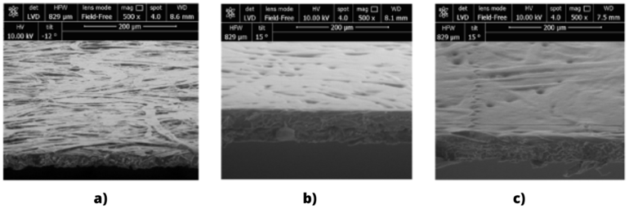
Figure 1.SEM-analysis of a) Uncoated paper; b) PHBV with PEG10%; c) PCL with PEG 10%.
Coated samples developed in this work showed a significant improvement of water vapor barrier compared to uncoated paper. The significant reduction of WVTR (Figure 2) is a promising feature of developed coated paper samples, according to the importance of this parameter for food quality preservation.
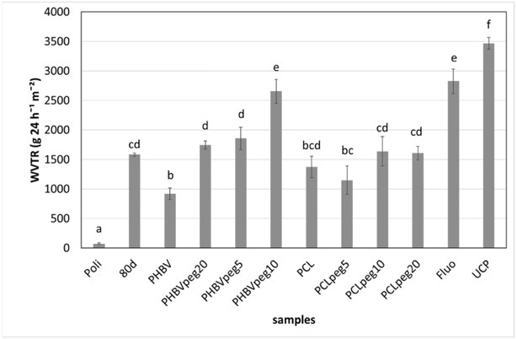

Figure 2. WVTR values (g 24 h⁻¹ m⁻²) of PHBV and PCL coated samples both pure and with PEG at different concentration, compared to Uncoated paper sample (UCP). “Fluo” refers to fluorinated paper and “Poli” to polyethylene coated paper.

Coated paper samples showed improved grease resistance, still not comparable with commercial samples; even if, PCL-coated samples showed the best resistance, from 4 to 12 h.
PHBV and PCL coating with PEG at 20% showed good water contact angles. The measured oil contact angles were much lower compared to commercial paper.

- PCL/starch/agar coatings for food-packaging paper: statistical correlation of the formulations’ effect on diffusion mechanism and resistance to grease and tensile stress.
In the coating formulation, PCL and glycerol concentration were kept constant, respectively at 5% w/v and 4% (w/v), whereas the amount of agar, starch and PEG was varied among selected ranges.
All the solutions were prepared by dissolving 5% w/v PCL in previously heated ethyl acetate, under continuous stirring in a water bath at 60 °C for 40 minutes. After the complete cooling of the solution, PEG (5% or 15%) was added if required following the experimental plan of the formulations. The water-solutions containing starch (5% or 10%) and the agar-agar (1.5%) in its desired concentrations were prepared separately by stirring at room temperature. Finally, after the addition of the starch-agar solution to the one containing PCL and PEG, a 4% (w/v) of glycerol was added to all the samples. Paper samples were coated via bar coating with an automatic film applicator.
From the SEM analysis (Figure 3) is evident how the uncoated paper sample showed the normal open and porous network structure with a non-uniform surface, while in all the coated samples the typical cellulose fibers and holes of the paper are not visible.

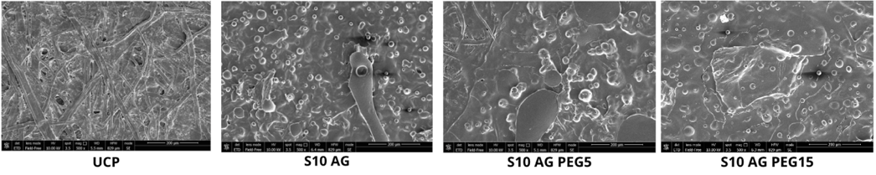
Figure 3. SEM analysis of UCP) Uncoated paper; S10AG) Sample paper with 5% PCL, 10% Starch and agar; S10AGEG5) Paper sample with 5% PCL, 10% Starch, agar and 5% PEG; S10AGPEG15) Paper sample with 5% PCL, 10% Starch, agar and 15% PEG.
The addition of starch, even at its lowest level (5%) is fundamental for oil resistance as it has a relevant influence on the contact angle measured with oil. Furthermore, a positive interaction in this sense has been observed when PEG (15%) is employed in the coating formulation, as it leads to positive changes in coating structure. In addition, agar presence has shown in combination with PEG a beneficial key role for oil resistance (Table 2, tested by using the standard method, namely T 559 pm-96 and with the contact angle determination) and for water vapor transmission rate, nevertheless, causing a significant detriment of the mechanical properties. The best coating composition has been calculated and it is: 10% Starch, 1.5% Agar and 15% PEG, however, improvements should be made (in terms of new further mixture components) to overcome mechanical properties depletion and to achieve a trend comparable to uncoated paper.

Table 2. Grease resistance values, ANOVA and Tukey’s HSD test are reported as FValues and lowercase letter (‘a’> ‘b’ > ‘c’) respectively, different letters identify significantly different samples (p ≤ 0.05). * = p ≤ 0.05; ** = p ≤ 0.01; *** = p ≤ 0.001.

 |  | Sample Name |  |  |  |  | d.s.
 | S E T 1 | S5 AG |  |  | 9.33 | ± | 0.6 | bc
 |  | S10 AG |  |  | 8.33 |  | 0.6 | c
 |  | S5 |  |  | 8.67 |  | 0.6 | bc
 |  | S10 |  |  | 10.3 |  | 0.6 | ab
 | S E T 2 | PEG5 S5 AG |  |  | 11.3 |  | 0.6 | a
 |  | PEG5 S10 AG |  |  | 4.33 |  | 0.6 | d
 |  | PEG5 S5 |  |  | 8.33 |  | 0.6 | c
 |  | PEG5 S10 |  |  | 10.3 |  | 0.6 | ab
 | S E T 3 | PEG15 S5 AG |  |  | 9.33 |  | 0.6 | bc
 |  | PEG15 S10 AG |  |  | 8.33 |  | 0.6 | c
 |  | PEG15 S5 |  |  | 8.67 |  | 0.6 | bc
 |  | PEG15 S10 |  |  | 9.33 |  | 0.6 | bc
 |  | UCP |  |  | 0.33 |  | 0.6 | e
 | Multifactorial ANOVA
 | AGAR AGAR |  |  | STARCH |  |  |  |  | PEG*AGARAGAR
 | *** |  |  | *** |  |  |  |  | *
 | PEG*STARCH |  |  | AGARAGAR*STARCH |  |  |  |  | PEG*AGARAGAR*STARCH
 | *** |  |  | *** |  |  |  |  | ***

This study confirms that a well-balanced combination of biopolymers, also from natural origins, could be used to obtain bioplastic coating suitable for the functionalization of paper for food packaging in a circular economy perspective.

- Introduction of the Zn²⁺-MA complex to polyvinyl alcohol (PVA) as an antimicrobial packaging film.
In this study, the Zn²⁺–melamine complex was introduced to polyvinyl alcohol (PVA) using epichlorohydrin (ECH) as an epoxide crosslinker; the melamine was used at different concentration to test how changing the formation of the 3D complex and it antimicrobial effect. The interactions between PVA, ECH, MA and Zinc, and the change in the chemical structure of the film were identified via FTIR spectroscopy. Indeed, from the Figure 4, we can note the interaction, first all, between the -OH group of PVA with the ECH around 3400 cm⁻¹, then, it is showed the interaction of the Zn²⁺–MA complex in the PVA film; even the PVA peaks at 1400 cm⁻¹ (wagging vibration of -CH) and 1086 cm⁻¹ (stretching vibration of C-OH) undergo variations due to the introduction of the Zn²⁺-melamine complex. The thermal properties of samples, tested by TGA analysis (Figure 5), showed that the introduction of the Zn²⁺–MA complex did not change the film properties in the range between 0 and 200 °C (food-use range).
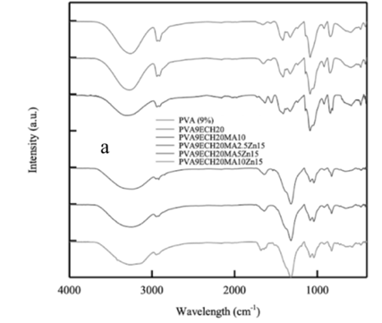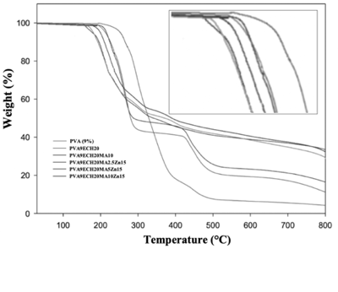
Figure 4. FT-IR analysis of all samples. Figure 5. TGA analysis of all samples.

From SEM-EDS analysis (Figure 6) can see the morphology of the samples, the distribution of Melamine (N) and zinc ion and the creation of the 3D structure after the introduction of the zinc ion.
1
3
2
Figure 6. SEM micrographs illustrating the morphology of a₁ PVA9ECH20Zn15, b₁ PVA9ECH20MA2.5Zn15, c₁ PVA9ECH20MA5Zn15. EDX elemental analysis results showing the distribution of N (a₂ PVA9ECH20Zn15, b₂ PVA9ECH20MA2.5Zn15 and c₂ PVA9ECH20MA5Zn15) and Zn (a₃ PVA9ECH20Zn15, b₃ PVA9ECH20MA2.5Zn15 and c₃ PVA9ECH20MA5Zn15).
b
a

c

Moreover, the antimicrobial properties of the metal-ligand complex (Table 3) were evaluated against S. aureus and E. coli using the zone of inhibition assay. Accordingly, the metal-ligand complex film showed a large inhibition zone against both microbes, in which the zone of inhibition against E. coli was bigger compared to S. aureus.
Table 3. Clear zone inhibition test values
Samples | E. Coli | Staphylococcus Aureus
PVA 9% | 0 | 0
CTRL1 (PVA9ECH20) | 0 | 0
CTRL2 (PVA9ECH20MA10) | 0 | 0
CTRL3 (PVA9ECH20Zn15) | 10±0.5 | 4.0±1
PVA6E20MA2.5Zn15 | 13.0±1 | 5.0±1
PVA6E20MA5Zn15 | 14.0±1 | 4.0±1
PVA6E20MA10Zn15 | 13.0±1 | 5.0±1
POSITIVE CONTROL | 7.5±0.5 | 6.0±1
4. Conclusions and Future Perspectives
All the studies and the trials done during my PhD thesis period demonstrated that the replacement of common non-biodegradable petroleum-based plastic materials with eco-sustainable and renewable alternatives is possible. The paths to follow are still many and there are still many alternative materials that must be and can be tested.
5. References
- Tyagi P, Rumjit NP, Garg S, Ahmed S, Lai CW (2023) Advanced Applications of Biobased Materials: Food, Biomedical, and Environmental Applications, New York: Elsevier, pp. 231-243.
- Van den Oever M, Molenveld K, Van der Zee M, Bos H (2017) Bio-based and biodegradable plastics – Facts and Figures: Focus on Food Packaging in the Netherland, Report n. 1722, Wageningen: Wageningen Food & Biobased Research, pp. 15-17.
- Oloyede OO, Lignou S (2021) Sustainable paper-based packaging: a consumer’s perspective, Foods 10:1035.
- Deshwal GK, Panjagari NR, Alam T (2019) An overview of paper and paper-based food packaging materials: health safety and environmental concerns, J Food Sci 56:4391–4403.
- Kopacic S, Walzl A, Zankel A, Leitner E, Bauer W (2018) Alginate and chitosan as a functional barrier for paper-based packaging materials, Coatings 8:235.

