Olive Vinegar as Functional Ingredient and Antioxidant Agent in Vegetable Sauce
Ayesha Iftikhar (a.iftikhar@studenti.unimol.it)
Dept. of Agricultural, Environmental and Food Sciences (DiAAA), University of Molise, Via De Sanctis, 86100 Campobasso, Italy
Tutor: Prof. Antonella De Leonardis

This study explores the potential of olive leaf vinegar (OLV) in vegetable sauce (VS). OLV-VS exhibited a total phenolic and oleuropein content of 0.68 mg/g GAE and 0.18 mg/g Hydroxytyrosol equivalent respectively confirming the functional potential of VS. The strong antioxidant activity of OLV was reflected by incredibly low value of DPPH IC50 (0.10 mg/g). The minimal changes in peroxide value (PV) were observed during the oven test at 40 °C up to 60 days, which also signifies the role of OLV as strong antioxidant agent in sauce. Ultimately, functional and antioxidant role of OLV was proven in the VS formulation.

Aceto di oliva nella salsa di vegetali in qualità di Ingrediente Functionale e di Attivo Antiossidante
Il presente studio esplora il potenziale dell'aceto di foglie di olivo (OLV) nella salsa di vegetali (VS). L'OLV-VS ha mostrato un contenuto di fenoli totali e di oleuropeina rispettivamente di 0,68 mg/g di GAE e 0,18 mg/g di Idrossitirosolo equivalente, confermando il potenziale funzionale della VS. La forte attività antiossidante dell'OLV è stata riflessa dal valore molto basso dell'IC50 del DPPH (0,10 mg/g). Le variazioni minime del valore di perossido (PV) sono state osservate durante il test in forno a 40 °C fino a 60 giorni, il che indica anche il ruolo dell'OLV come forte agente antiossidante nella salsa. Infine, è stato dimostrato il ruolo funzionale e antiossidante dell'OLV nella formulazione VS.

Key words: olive leaf vinegar, vegetable sauce, functional, oleuropein, antioxidant DPPH test, oven test.

1. Introduction
Food industries are paying great attention to producing healthier products endowed with high nutritional value and therapeutic benefits. Several studies have been conducted with the specific aim of replacing some conventional ingredients in the preparation of vegetable sauce.
In a previous study De Leonardis et al (2022a), olive leaf vinegar (OLV) was produced, and its functional potential was assayed in an oil/vinegar dressing-based formulation. In addition, the feasibility of the use of OLV in vegetable sauce (VS) was investigated in current research. Chemical characterization of the VS was performed through moisture, fat, pH, total phenols, and peroxide value (PV) determination. Finally, the oxidative stability of VS was evaluated by PV evolution during an accelerated storage test (oven test). Study unveils an intriguing exploration into the exceptional properties of OLV within culinary applications.

2. Materials and Methods
OLV was prepared by maceration of dried olive leaves in 18% acetic acid vinegar (AV) following the procedure described in De Leonardis et al (2022a). Sauce preparation was conducted according to the method described in De Leonardis et al (2022b) with slight modification. By unlocking the potential of following ingredients in definite percentages: 56% soybean and sunflower seed oil blend (15:85, v/v), 35% commercial soymilk, 8% OLV as test ingredient while AV as control ingredient and 1% salt. Final packaging of VS was performed manually in aluminum sachets of 15 g capacity.
Physicochemical parameters, such as moisture, fat, pH, peroxide value, phenols, and antioxidant potential were determined as described by De Leonardis et al (2022a). Specifically, Total Phenols (TP) was determined by Folin–Ciocalteu spectrophotometric method expressing the results in gallic acid equivalent (GAE), while the oleuropein (OLE) was quantified by HPLC analysis in hydroxytyrosol equivalent (HYE). Antioxidant potential was evaluated by calculating IC50 dose (g of sauce) of DPPH inhibition percentage (I%) calculated with the following equation:
%I = ((Abs blank − Abs sample)/Abs blank) × 100 (1)
Finally, oven test was conducted placing the sauce sachets in a thermostat at 40 °C for 2 months.

3. Results and Discussion

3.1 Physicochemical properties of formulated vegetable sauce
The physicochemical characteristics of the vegetable sauce play a pivotal role in determining its quality, flavor, and stability, thereby ensuring an optimal taste experience and extended shelf-life. As indicated in Table 1, no statistically significant differences were observed between the samples (AV-VS and OLV-VS) in terms of pH, moisture and fat content. The remarkably low average pH value of 2.15 in both sauces serves as a robust safeguard against microbial spoilage. While AV-VS exhibited only trace amounts of total phenols, OLV-VS showcased a notable concentration of 0.68 mg/g GAE, with the presence of oleuropein as a predominant phenolic compound, supported by the HPLC chromatogram (Figure 1). These findings highlight the distinctive phenolic profile and potential health benefits associated with OLV-VS.
Table 1 Analytical determinations of the vegetable sauce samples. (AV-VS: 18% acetic acid vinegar sauce; OLV-VS: olive leaf vinegar sauce sample)
Sample | Moisture % | Fat % | pH | Peroxide value (meqO₂/kg) | Total phenols (mg/g GAE) | Oleuropein  (mg/g) HYE
AV-VS | 31.6 ± 1.9ª | 58.2 ± 2.6ª | 2.16 ± 0.45ª | 2.0 ± 0.1ª | Traces | Traces
OLV-VS | 31.0 ± 1.7ª | 57.0 ± 2.4ª | 2.15 ± 0.38ª | 1.9 ± 0.1ª | 0.68 ± 0.08^{b} | 0.18 ± 0.02^{b}

3.2 Functional potential
In the domain of olive tree products, hydroxytyrosol and its derivatives (HY&Der), including oleuropein, are prominent bioactive compounds known for their well-established antioxidant, antimicrobial, anti-inflammatory, and anticancer properties, as well as their potential in the prevention of cardiovascular diseases, metabolic syndromes, and neurodegenerative disorders Hadrich et al (2022). Notably, the European Food Safety Authority (EFSA) permits the inclusion of a health claim on the labels of extra virgin olive oils, stating that the polyphenols naturally present in these oils contribute to the protection of blood lipids against oxidative stress. To attain this benefit, a daily intake of at least 5 mg of HY&Der is recommended. The functional role of OLV in the formulated VS is demonstrated in Figure 2, wherein a 15 g portion of OLV-VS (one sachet) contained 2.5 mg HY&Der, approximately 50% of the recommended daily dosage. Furthermore, the DPPH IC50 value determined in OLV-VS was 0.10 mg/g, affirming the functional potential of the formulated vegetable sauce.
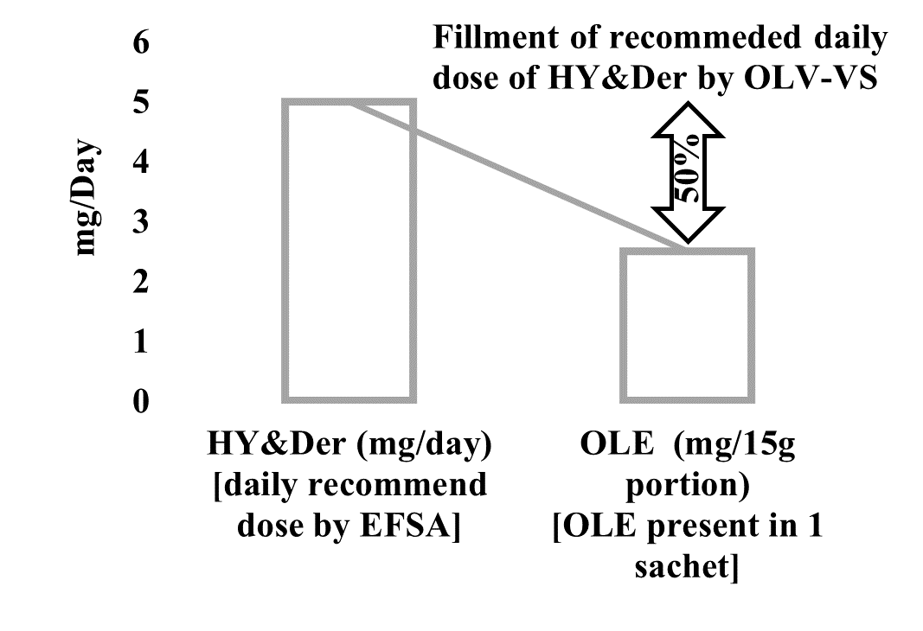
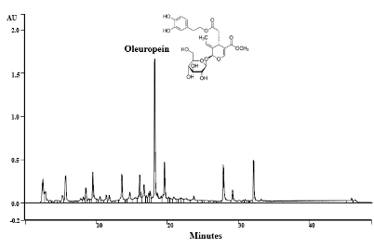
Figure 1 Chromatogram from HPLC for Oleuropein content in OLV-VS at 240 nm
Figure 2 Relation between recommended daily dose of HY&Der and provided by OLV-VS

3.3 Antioxidant effect on the vegetable sauce shelf life

Measurement of the PV can help to estimate the oxidation stage. The oven test represents an accelerated method frequently used to test autoxidation in oils and fats under medium high temperatures. Results of the oven test conducted in this research are shown in Figure 5.
OLV-VS showed oxidation stability higher than the control. Specifically, extraordinarily slight change in PV was observed for OLV-VS (from 1.9 to 4.7 meqO₂/kg) in 60 days, against the PV increase (from 2.0 to 30.1 meqO₂/Kg), observed in VS-AV (control).Therefore, OLV, thanks to its phenolic component, has proven to be a good antioxidant agent for the sauce.
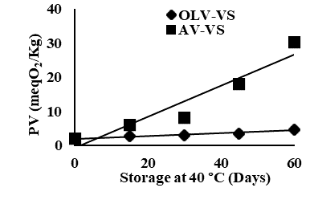
Figure 3 Variation of Peroxide value (PV) measured at 40 °C for 2 months in sauce samples prepared with olive leaf vinegar (OLV-VS) and alcoholic vinegar (AV-VS).

4. References
De Leonardis A, Macciola V, Iftikhar A, Lopez F (2022b). Characterization, Sensory and Oxidative Stability Analysis of Vegetable Mayonnaise Formulated with Olive Leaf Vinegar as an Active Ingredient. Foods 11(24), 4006.
De Leonardis A, Macciola V, Iftikhar A, Lopez F, (2022a). Antioxidant effect of traditional and new vinegars on functional oil/vinegar dressing-based formulations. Eur Food Res Technol 248(6), pp.1573-1582.
E.C. Regulation (2012) Establishing a list of permitted health claims made on foods, other than those referring to the reduction of disease risk and to children’s development and health, E.C. No, 432. Official J. of the Eur. Union, L136, pp. 1-40.
Hadrich F, Chamkha M, Sayadi S (2022) Protective effect of olive leaves phenolic compounds against neurodegenerative disorders: Promising alternative for Alzheimer and Parkinson diseases modulation. Food Chemical Toxicol 159, p.112752.

