Wine stability: implications of yeast mannoprotein additions  
 prior to the bottling of red wine

Cristian Galaz Torres (cristian.galaz2@unibo.it)

Dept. of Agricultural and Food Sciences (DISTAL), University of Bologna, Cesena, Italy

Tutor: Andrea Versari; Co-tutor: Giuseppina P. Parpinello e Arianna Ricci

This Ph.D. project aims to investigate the impact of mannoproteins on winemaking, especially when added just before bottling, by studying their physicochemical and organoleptic effects, particularly on colour, mouthfeel and aromas.

Stabilità del vino: implicazioni delle aggiunte di mannoproteine del lievito   
prima dell'imbottigliamento del vino rosso

Questo progetto di dottorato si propone di indagare l'impatto delle mannoproteine nella vinificazione, soprattutto quando vengono aggiunte poco prima dell'imbottigliamento, studiando gli effetti fisico-chimici e organolettici, in particolare su colore, aroma e sapore dei vini.

**Key words**: mannoproteins; wine stability; physico-chemical and sensory parameters; by-products valorization.

# **1. Introduction**

Yeast mannoproteins are highly glycosylated glycoproteins that contain about 80% D-mannose associated with D-glucose residues and N-acetylglucosamine, with 10-20% of proteins. They present a wide range of molecular weights that can typically vary from 5 to 400 kDa, but even up to 800 kDa. Their location is in the external layer of the yeast cell wall and are connected to a matrix of amorphous β-1,3 glucan by covalent bonds, making up to 35-40% of the cell wall. There are two moments in vinification when they are released: During alcoholic fermentation and after yeast autolysis by exogenous β-1,3-glucanase enzyme, being this last group similar but with less protein content (Rodrigues *et al*., 2012). Commercial preparations of yeast mannoprotein were first authorized for their addition in white wine to improve its tartaric and protein stability in the early 2000s, but then, its use quickly spread to red wines for other purposes than well-known chemical stabilization, starting to be attractive due to its apparent influence on technological and organoleptic effect on these wines. Within the already known enological properties of mannoproteins in wine production, the following can be named: inhibition of tartrate salt crystallization, reduction of protein haze, stimulation of malolactic fermentation, wine enrichment during autolysis of lees, interaction with flor wines, yeast flocculation, and autolysis in sparkling wines, adsorption of toxic ochratoxin; interaction with aromatic compounds, colour stabilization, reduction of astringency and increased body and mouthfeel sensations (Guadalupe and Ayestarán, 2008). The doctoral thesis project will explore the interaction between the physicochemical characteristics of mannoproteins and the wine matrix, which are not fully understood at the moment. The ultimate goal is to provide guidance on their selection and dosage before bottling, improving red wine quality.

This oral communication reports the main results of the following four activities directed to:

A1) Preliminary physicochemical and technological characterization of 5 commercial mannoproteins;

A2) Sensory analysis of two commercial qualities of Cabernet Sauvignon red wines of Chile, to which a standardized dose of mannose was applied prior to bottling for the same 5 commercial mannoproteins plus control;

A3) In-depth physicochemical and technological the same 5 commercial mannoproteins;

A4) selection of one mannoprotein and study 3 different doses applied to the same two commercial Cabernet Sauvignon wine qualities plus a control with measurements at 3 and 6 months of bottle aging.

# **2. Experimental Procedure**

In this Ph.D. thesis project, the analyses and experiment were carried out as follows: A1) preliminary analysis and technological characteristics of 5 commercial mannoproteins specially indicated for its addition before bottling. A2) a standardized mannose dose of 5 of the same commercial mannoproteins was added to two commercial wine qualities, Blend and Premium, *Vitis vinifera* cv. Cabernet Sauvignon red wine of Chile in triplicate prior to bottling. A3) In parallel, a detailed analysis of the molecular weight distribution and monosaccharides composition of polysaccharides present were made in order to characterize these commercial mannoproteins and to evidence the possible presence of arabic gum. A4) The best commercial mannoprotein was selected according to its physicochemical characteristics and organoleptic results in wine, using it for a second experiment in which doses of 3, 13.5 and 30g/HL were added before bottling to the same two commercial wine qualities, plus a control in triplicate. Analysis where measured at 3 and 6 months of bottle aging. Part of the results and analysis corresponding to the 3 months of aging in bottle will be presented in this report.

# **3. Materials and Methods**

Physicochemical properties were measured, including total phenol and colour spectrophotometric indexes (280 nm, 420 nm, 520 nm, 620 nm, Hue and IC); Cielab colour space parameters (L*, a* and b*) calculated according to Ayala *et a*l. (1997); Total colour, colour due to free anthocyanins, due anthocyanins resistant to bisulfite and due to co-pigmentation (Levengood and Boulton 2004). The molecular weight of polysaccharides, monosaccharide concentration of them and total polysaccharide concentration were obtained by HPSEC-RID (Ayestarán *et al*., 2004), GC-MS (Guadalupe *et al.*, 2012), enzymatic analysis through of K-MANGL kit (Megazym ®) and spectrophotometric assay (Segarra *et al*., 1995). The filterability index was performed according to Meglioli *et al.*, (1983). The sensory analysis was conducted using Rate all that apply (R.A.T.A.) analysis, with 24 panelists, all of them enologist trained in sensorial analysis. The statistical methods used to analyse the data were multivariate analysis of variance (MANOVA) and Principal component analysis (PCA) through the software IBM SPSS Statistics version 25 and R-studio with R version 4.2.0.

# **4. Results and Discussion**

## **4.1 Preliminary physicochemical and technological characterization of commercial mannoproteins**

In A1, the 5 commercial mannoproteins used throughout the project were analysed for different physico-chemical parameters together with 3 other commercial mannoproteins in order to obtain a PCA grouping of them in terms of their technological aptitudes as the filterability index, the total polysaccharide content ( and the concentration of mannose and glucose). This last information was used to determine a standardized dose of mannose in the following activities A2. The results of all these analyses can be seen in the PCA in **Figure 1**, in which the variables analyzed were: mannose:glucose ratio of the supernatant after three days of contact in model wine and centrifuged (Soluble Man:Gluc); mannose concentration of the supernatant after three days of contact in model wine and centrifuged (Soluble Man); total glucose directly from the commercial mannoprotein (Total Glu); sum of total glucose and mannose directly from the commercial mannoprotein (Total Glu+man); mannose concentration after three days of contact in model wine and centrifuged (Soluble Man); total polysaccharides concentration directly from the commercial mannoproteins (TPS), the percentage drop in the concentration of total polysaccharides directly added to model wine vs. after three days of contact and centrifuged (Precipitation TPS%). filterability index of commercial mannoproteins just added to model wine in a 15 g/HL dose (Filtration index 15g/HL).

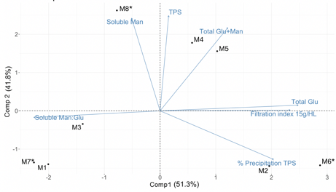

**Figure 1** *PCA analysis using MANOVA significant variables (p<0.05), according to the Duncan post-hoc test, for the 5 commercial mannoproteins used throughout the project, plus 3 others commercial mannoproteins.*

## **4.2 Sensory analysis of commercial mannoproteins**

**Figure 2** presents the results of the PCA of the sensory variables that were significant in A2 for both qualities of wine, namely warmth, sweet, and smoothness. The plot shows that all the commercial mannoproteins tested were separated from the control at a normalized dose of mannose. Among the commercial mannoproteins, MP5 was highlighted as the most different and was the only one that exhibited significant differences in all three sensory parameters compared to the control. The normalization based on mannose content allowed an effective comparison among commercial mannoproteins

## 

**Figure 2** *PCA plot of RATA (Rate All that Apply) significant sensorial variables (p<0,05), according to HSD Tukey post-hoc test.*

*.*

**4.3 Analysis of molecular weight distribution and monosaccharides of polysaccharides of commercial mannoproteins**

In parallel, in activity A3, analyses were performed on the same 5 mannoproteins to determine their molecular weight distribution and the total concentration of polysaccharides, monosaccharides, and proteins. The results are presented in **Figure 3 A-F**. The analysis revealed that certain mannoproteins had a mixture of medium (~40-50 kDa) and high (~80-150 kDa) molecular weights, while others contained only medium or low (~25 kDa) molecular weights. An important concentration of molecular weights <5kDa (Oligosaccharides) was also found for some of the mannoproteins. The above could explain the different results obtained in sensorial analysis, considering that a standardized dose of mannose was applied for both qualities of wine. Another important finding was the elevated concentration of monosaccharides structurally associated with arabic gum in mannoprotein MP3, a regulated additive in wines exported to China, a crucial market for Chilean wines.

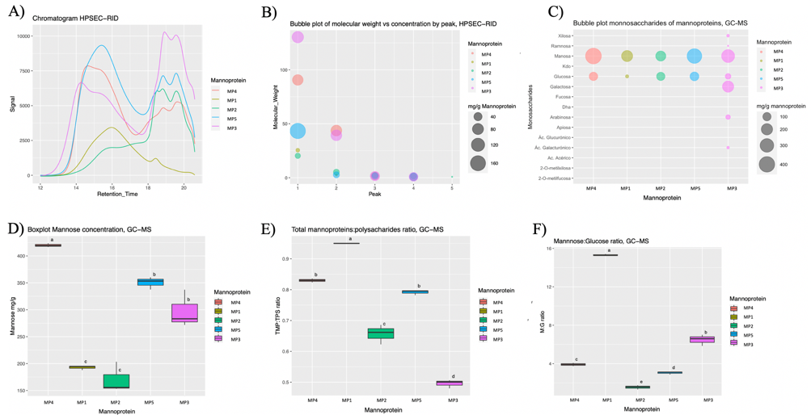

**Figure 3** *Polysaccharide and monosaccharide analysis of commercial mannoproteins by HPSEC-RID: A) Chromatogram, B) molecular weight distribution, and GS-MS: C) monosaccharides concentration, D) mannose concentration, E) Total mannoprotein to polysaccharides ratio, F) mannose to glucose ratio.*

## **4.4 Cielab analysis, MANOVA and PCA of physicochemical and volatile compound analysis**

The results of physicochemical analysis for 3 months of bottle aging of A4 are shown in the PCA of **Figures 4 a-d**, revealing a significant increase in Hue for both wines with increasing doses of selected mannoprotein MP5 when compared to the control. In addition, Blend wine quality distances itself from the control at any dosage, while Premium wine does it only at a dosage of 13.5 g/HL onwards. On the other hand, it was observed that there was a very different and opposite evolution of colour for both wine qualities, specifically in terms of % of total colour (WC) due to monomeric anthocyanins (MAC%) and % of total colour due to bisulfite stable anthocyanins (BSA%), but also in Cielab colour space L* parameter. Suggesting that different polymerization and precipitation processes took place depending on the different wine matrices and the increasing dose of mannoprotein before bottling.

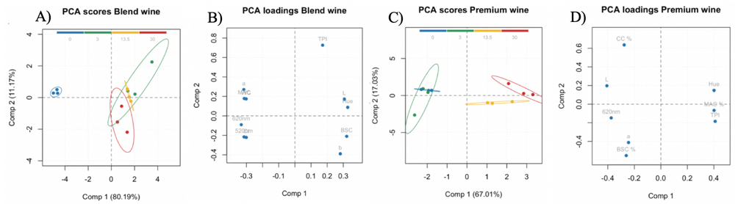

**Figure 4** Scores and loadings of*PCA analysis using physicochemical MANOVA significant variables (p<0.05), according to the Duncan post-hoc test, for each wine quality. A-D) score and loading plots for Blend and Premium quality wines. Doses: 0 (blue), 3 (green), 13.5 (yellow), and 30 (red) g/HL.*

In this sense, **Figure 5** illustrates how the dosage has a greater impact on the total colour of Blend wines, particularly at doses exceeding 3 g/HL, while having no significant effect on the total colour of Premium wines. However, it is worth noting that in the case of the last, the perceived darkness of the colour, as indicated by Cielab, may exhibit a slight increase at higher doses due to a marginal but significant reduction in L*.



**Figure 5** *Total colour according to Boulton for each dosage and wine quality. Different letters on the same line indicate statistically significant differences (p < 0.05) according to Duncan's post hoc test. The different observed colours of each bar are obtained through L*, a* and b* parameters.*

The last can be corroborated by the **Table 1** where it is shown that only in the case of Premium in doses from 13.5 g/HL and higher lead to an observed colour difference with the control, calculated according to García-Marino et al., (2013), where values above 2.7 CIELAB units indicate colour differences that are detectable to the human eye, that in this case, are explained mainly by a lower L* Cielab parameter.

**Table 1** *Colour differences (ΔE*ab) matrix between two colour points in the CIELAB*

|  |  |  |  |  |  |  |  |  |  |
| --- | --- | --- | --- | --- | --- | --- | --- | --- | --- |
|  | **Blend wine** | | | |  |  | **Premium wine** | | |
|  | **A** | **B** | **C** | **D** |  | **A** | **B** | **C** | **D** |
| **A) Control** | 0.0 | 1.9 | 1.9 | 1.7 |  | 0.0 | 1.6 | **4.7** | **4.6** |
| **B) 3 g/HL** | 1.9 | 0.0 | 0.1 | 0.6 |  | 1.6 | 0.0 | **4.4** | **4.1** |
| **C) 13. 5g/HL** | 1.9 | 0.1 | 0.0 | 0.6 |  | **4.7** | **4.4** | 0.0 | 0.4 |
| **D) 30 g/HL** | 1.7 | 0.6 | 0.6 | 0.0 |  | **4.6** | **4.1** | 0.4 | 0.0 |

On the other hand, the results of PCA shown in **Figure 6 a-d** show that the analysis of volatile compounds also presents a different response to mannoprotein dose, depending on the quality of the wine. In the case of the Blend quality, 3 g/HL showed a higher concentration of total volatile compounds, while 30 g/HL was the lowest. In the case of Premium, a grouping similar to that of the physicochemical PCA was observed, with a tendency to increase the concentration of volatile compounds at higher doses and obtain the highest total concentration of volatile compounds at the dose of 13.5 g/HL.

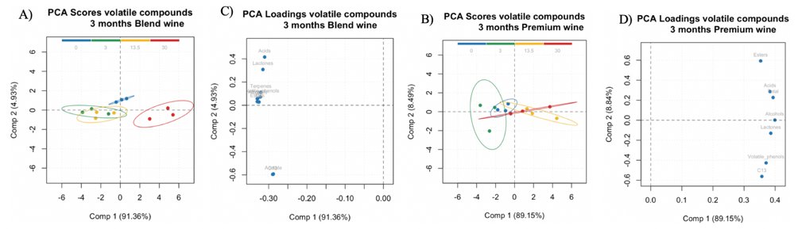

**Figure 6** Scores and loadings of*PCA using volatile compounds MANOVA significant variables (p<0.05), according to the Duncan post-hoc test, for each wine quality. A-D) score and loading plots for Blend and Premium quality wines. Doses: 0 (blue), 3 (green), 13.5 (yellow), and 30 (red) g/HL.*

## **4.5 Efficiency of mannoprotein addition according to dosage and wine quality**

Finally, as seen in **Figure 7**, there is a clear tendency to decrease the remaining mannoprotein of wines depending on the dose applied. This may mean that it is not economically worthwhile to add more than 13.5 g/HL for both qualities of wine.

## 

**Figure 7** *Applied dosage vs. remaining concentration (%) after 3 months of bottle aging.*

# **5. Conclusions and Future Perspectives**

The research found that, after 3 months of bottle aging, increasing doses of mannoprotein in the wine can significantly increase the Hue and modify the colour evolution and the concentration of volatile compounds differently depending on the wine matrix and the dosage used. Based on the information obtained, it would not be advisable to use more than 3 g/HL before bottling in the case of Blend quality and 13.5 g/HL in the case of Premium quality, which is consistent with commercial recommendations dosages for this commercial mannoprotein and these specific Cabernet Sauvignon Chilean qualities of wines. In addition to the above results, other analyses are being performed as the determination of the total concentration of anthocyanins, phenols, polysaccharides and its monosaccharides, together with sensory analysis for the first three months. On the other hand, further analysis are in progress on 6 months of bottle aging to better understand which and why a given dosage is best suited to each wine matrix in terms of physico-chemical and sensory characteristics. Understanding the differences observed will encourage the use of this natural by-product of winemaking among enologists seeking to improve red wine quality in a sustainable manner.

# **6. References**

Ayala, F., Echávarri, J. F., & Negueruela, A. I. (1997). A new simplified method for measuring the color of wines. I. Red and rose wines. *Am. J. Enol. Vitic.,* **48**(3), 357-363.

Ayestaran, B., Guadalupe, Z., & Leo n, D. (2004). Quantification of major grape polysaccharides (Tempranillo v.) released by maceration enzymes during the fermentation process. *Anal. Chim. Acta.,* **513**, 29–39.

García-Marino, M., Escudero-Gilete, M. L., Heredia, F. J., Escribano-Bailón, M. T., & Rivas-Gonzalo, J. C. (2013). Color-copigmentation study by tristimulus colorimetry (CIELAB) in red wines obtained from Tempranillo and Graciano varieties*. Food Res. Int.*, **51**(1), 123-131.

Guadalupe, Z. and Ayestarán, B. (2008) Effect of commercial mannoprotein addition on polysaccharide, polyphenolic, and color composition in red wines. *J. Agric. Food Chem.*, **56**(19), 9022–9029.

Guadalupe, Z., Martínez-Pinilla, O., Garrido, A ́., Carrillo, J. D., & Ayestar ́an, B. (2012). Quantitative determination of wine polysaccharides by gas chromatography-mass spectrometry (GC-MS) and size exclusion chromatography (SEC). *Food Chem.*, **131**, 367–374.

Meglioli, G., A. Battezzati, and C. Marchesini. (1983). L’indice di filtrabilità: Principi teorici ed applicazioni. *Ind. Bevande*, **12**, 445–450.

Rodrigues, A., Ricardo-da-Silva, J. M., Lucas, C., & Laureano, O. (2012) Effect of commercial mannoproteins on wine colour and tannins stability. *Food Chem.,* **131**(3), 907–914.

Segarra, I., Lao, C., López-Tamames, E., & De La Torre-Boronat, M. C. (1995). Spectrophotometric methods for the analysis of polysaccharide levels in winemaking products. *Am. J. Enol. Vitic.*, **46**(4), 564-570.