Biotechnological Valorisation of Residues and By-Products From Agro-Food Industries
Beatrice Cellini (beatrice.cellini2@unibo.it)
Dept. of Agricultural and Food Sciences, Alma Mater Studiorum - University of Bologna, Cesena, Italy
Tutor: Prof. Lucia Vannini

This PhD thesis dealt with the valorisation of some agro-food by-products (BPs) (i.e. pomegranate and citrus peel and seeds, and field horsetail) to use them as food ingredients. The BPs were initially characterised for their chemical (i.e. phenolic and volatile profiles) and functional (i.e. antimicrobial, prebiotic and antioxidant) properties. Citrus and horsetail fortified “Primo Sale” cheeses and a beverage added with functional lactic acid bacteria (LAB) and pomegranate BPs were then formulated. Finally, residues from clementine juices were valorised through microbial fermentation using selected yeasts and LAB to obtain an ingredient for a plant-based beverage.

Valorizzazione biotecnologica di residui e sottoprodotti dell’industria agro-alimentare
Questa tesi di dottorato ha riguardato la valorizzazione di alcuni sottoprodotti agroalimentari (bucce e semi di melograno e agrumi ed Equisetum) per utilizzarli come ingredienti. I sottoprodotti sono stati caratterizzati per le loro proprietà chimiche (profilo fenolico e molecole volatili) e funzionali (attività antimicrobica, prebiotica ed antiossidante). Sono stati poi formulati dei formaggi "Primo Sale" fortificati con residui di agrumi ed equiseto, e una bevanda addizionata di melograno e batteri lattici. Infine, i residui della produzione di succhi di clementina sono stati valorizzati mediante fermentazione microbica con microrganismi selezionati per ottenere un ingrediente per una bevanda a base vegetale.

Key words: By-products; pomegranate and citrus peels; Equisetum arvense; “Primo Sale” cheese; microbial fermentation.

1. Introduction
In accordance with the PhD thesis project previously described, this oral communication reports the main results of the following activities directed to:
A1) Chemical and functional characterization of the by-products (BPs);
A2) Use of citrus BPs and horsetail in "Primo sale" cheese production;
A3) Formulation of a probiotic beverage with added pomegranate BPs;
A4) Valorisation of clementine BPs through microbial fermentation.

2. By-products in the food industries
According to Eurostat (Agriculture, forestry and fisheries statistics, 2020), up to 14% of food produced globally undergoes quantitative food loss. Food Loss and Waste (FLW) affects the sustainability of food systems, with negative impacts on the economy, food security, nutrition, and the environment. FLW is an important global issue and is linked to the Sustainable Development Goals (SDG) 12 - Responsible consumption and production - and 2 – Zero Hunger. Nowadays, the major uses of wastes and by-products (BPs) include animal feed or energy production, as well as the extraction of some high value-added products. However, most BPs are unused and discarded (Maurya et al., 2015) despite being rich in substances which can be recovered, e.g. simple and complex sugars, lipids, proteins, micronutrients, essential oils, and dietary fibre (Mejri et al., 2018). Over the past decades, attention to diet and health has strongly increased, and the consumption of low-fat, low-calories, fibre- and antioxidant-rich foods has attracted the attention of many consumers as they significantly contribute to the reduction of cholesterol and the prevention of cardiovascular diseases and constipation (Aslam et al., 2014). The use of food processing BPs in traditional and innovative foods can improve their functional properties, e.g. by increasing their fibre content, antioxidant or prebiotic activity, as well as extending their shelf-life. In fact, the food industry is constantly looking for new strategies, including the replacement of traditional preservatives with natural compounds, to satisfy the consumer's desire for fresh and 'natural' products, while maintaining food safety, quality and stability standards.
For these reasons, two different BPs were chosen, i.e. those from the citrus fruit industry (orange and clementine peels and seeds) and those from pomegranate (peels and seeds). Citrus fruits are widely cultivated with 14.49 million tonnes produced worldwide in 2019 (FAOSTAT, 2020). Unlike other fruits, the edible portion of citrus fruits is low compared to the inedible one: in fact, the latter is about 50-60% and comprises mainly seed, peel and juice extraction residues. The world production of pomegranate turns out to be about 6 million tonnes per year of which about 40% is peel. Thanks to the recovery of antioxidant-rich extracts, many commercial applications are available for pomegranate peel derivatives, including their use in pharmaceuticals, in tinctures and foods, in anti-cancer therapeutic agents and the synthesis of copper oxide (Witt et al., 2022). In addition, a weed, Equisetum arvense or field horsetail, was also included in the PhD project as it is used for phyto-therapeutic purposes for internal use to treat inflammation of the oral cavity, tonsillitis, acne, cold sores and other afflictions due to its reported bioactivities, e.g. astringent, diuretic, anti-inflammatory, antibacterial, antimicrobial and antioxidant properties.

3. Experimental Procedure
This PhD thesis was organised into 3 different steps: i) chemical and functional characterization of the different BPs; ii) use of the BPs as ingredients directly added to “Primo Sale” cheeses or beverages; iii) set up of a biotechnological process to enhance functional characteristics of clementine BPs. The first step was essential to determine the polyphenols and volatile profiles of the different BPs, and to assess their antimicrobial and prebiotic activity. After this step, the most promising BPs were used as ingredients directly added during the production of different foods. In particular the horsetail and the orange peel were added to ‘Primo Sale’ cheeses, while the pomegranate residues were used for the production of beverages added with probiotics. Finally, the clementine BPs were fermented by different strains of bacteria and yeasts to enhance some functional and technological features, and to obtain an ingredient which can be used in a plant-based beverage.

4. Materials and Methods
The BPs samples used during my PhD thesis are listed in Table 1.
Table 1 BPs used during my PhD thesis.
Common name | Scientific name | Family | Origin | Year | Examined product | Sample Code
Orange | Citrus sinensis | Rutaceae | Emilia Romagna | 2012 | Peel-pomace | Cit12
Orange | Citrus sinensis | Rutaceae | Emilia Romagna | 2021 | Peel-pomace | Cit21
Clementine | Citrus clementina | Rutaceae | Reggio Calabria | 2023 | Peel-pomace | Clem
Field horsetail | Equisetum arvense | Equisitaceae | Emilia Romagna | 2019 | Leaves | Eq19
Field horsetail | Equisetum arvense | Equisitaceae | Emilia Romagna | 2021 | Leaves | Eq21
Edible Pomegranate | Punica granatum | Lythraceae | Emilia Romagna | 2022 | Peel | PEE
Edible Pomegranate | Punica granatum | Lythraceae | Marche | 2022 | Peel | PEM
Edible Pomegranate | Punica granatum | Lythraceae | Marche | 2022 | Pomace | AM
Ornamental Pomegranate | Punica granatum | Lythraceae | Marche | 2022 | Peel-seeds | POM

4.1 BPs characterization
Samples were air dried (Eq) or freeze-dried (Citrus and pomegranate BPs) and grinded. According to Ferioli and D’Antuono (2016), the methanolic extracts were tested for total phenolic content (TPC, Folin-Ciocalteau assay), ABTS^{•+} assay and DPPH (0.1mM) scavenging activity (Abid et al., 2017). The results were expressed as gallic acid equivalent (GAE (mg kg⁻¹)), Trolox equivalent (TEAC) and IC50, respectively. The extracts were tested against 49 strains (starters/probiotics, pathogens and yeasts) belonging to the collection of DISTAL- University of Bologna, with the agar diffusion method (Rao et al., 2016). The most sensitive ones were used to determine the Minimum Inhibitory Concentration (MIC) by microdilution broth method. The dried samples were also analysed for the volatile compound according to Tabanelli et al. (2013). Finally, the BPs were characterized for their prebiotic activity on two commercial probiotics, i.e. Bifidobacterium animalis subsp. lactis BB-12 and Lactiplantibacillus plantarum DSM 25710, by determining the prebiotic activity score (Huebner et al., 2007) and the ability of the BPs to protect and promote the probiotic growth in a simulated intestinal fluid (SIF; 0.15% w/v Oxgall bile salts in 100 mM phosphate-buffered saline pH 8 and subsequently sterilised and added with 0.1% w/v pancreatin; each BP concentration 50 mg cm⁻³).

4.2 Citrus and Eq as ingredients for ‘Primo Sale’ cheeses
‘Primo Sale’ cheeses were prepared at lab scale with pasteurised whole milk and yoghurt as starters (Lactobacillus bulgaricus and Streptococcus thermophilus). Three LAB strains (Lactiplantibacillus plantarum B39.1.4A, Pediococcus pentosaceus B39.2.2A, Enterococcus faecalis B39.2.2B) were also added to some samples ( ̴ 7 log CFU g⁻¹). After coagulation and before breaking the curd, citrus (2% w/w) and Eq (1% w/w) were added and then the cheeses were formed. The samples were monitored for the viability of the native microbiota and of the starters, the changes in the aroma and TPC, the antioxidant activity and the color over one month of storage at 4°C.

4.3 Beverages added with pomegranate peels
24 different formulations of beverages were produced by mixing (1:1) apple juice and pulp and: i) whole milk (V); ii) soy beverage (S); iii) spelt beverage (F); iv) oats beverage (A). Half of the samples were also added with the pomegranate peels powder (0.7%, w/w), while the others were used as controls. All the samples (with or without pomegranate) were inoculated with two commercial probiotics separately (Bifidobacterium animalis subsp. lactis BB-12 and Lactiplantibacillus plantarum DSM 25710; initial inoculum rate ⁓8 log CFU cm⁻³). The samples were stored at 4°C and monitored for the native microbiota and the viability of the probiotics. The samples were also analysed for TPC, antioxidant activity, prebiotic activity and for the ability to survive a simulated gastrointestinal digestion process.

4.4 Clementine peels valorisation by microbial fermentation
A mixture of grinded clementine peels and water (40:60, w/w) were inoculated with 12 LAB and 27 yeast strains (inoculum rates ⁓ 7 and 5 log CFU g⁻¹, respectively) belonging to the DISTAL Microbial Culture Collection. The growth ability of the strains, prebiotic activity, TPC, antioxidant activity (ABTS^{•+} and DPPH assay), and volatile compounds (SPME/GC-MS) of the fermented BP were evaluated.

5. Results and Discussion

5.1 BPs characterization
As previously described (Cellini, 2022), pomegranate peel extracts were the samples with the highest TPC values, while pomegranate seeds showed the lowest content with 112 GAE (mg kg⁻¹). Intermediate values were found for both Eq samples, close to 430 GAE (mg kg⁻¹) and citrus, 240 GAE (mg kg⁻¹). The TPC data were in agreement with the scavenging activity results. PEE, PEM and POM were found to be the most active BPs against all the microbial strains tested, especially against the pathogens. However, most of the tested yeasts seemed to be sensitive to Eq and Citrus, whereas LAB were not affected by the BPs. This result can be explained by considering the TPC values and the analysis of the volatile compounds of these BPs, which showed high amounts of terpenes, e.g. D-limonene in the Cit-samples and (S)-D-carvone in the pomegranate ones, which are widely recognised as antimicrobial substances (Aggarwal et al., 2002).
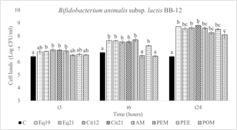
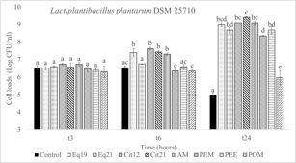
When tested for their prebiotic activity on L. plantarum DSM 25710 and B. animalis subsp. lactis BB-12, the BPs were promising in that they were able to protect and promote their growth in SIF. In particular, all the tested substances increased the viability of both the strains by approximately 3 logarithmic cycles compared with the controls. It is important to note that POM, which was however significantly different from the control (p<0.05), gave rise to a reduction in cell viability of L. plantarum after 24 hours (Figure 1).
a
b
Figure 1 Prebiotic activity in SIF of the different BPs on L. plantarum DSM 25710 (a) and B. animalis subsp. lactis BB-12 (b) after 3, 6 and 24 hours of incubation. Different letters mean significant differences between the time (p<0.05).

5.2 ‘Primo Sale’ cheese
The addition of the powdered by-products did not affect the viability of the starters, which remained above 8 log CFU g⁻¹ over storage. On the other hand, an inhibition in the growth of some microbial groups such as Enterobacteriaceae and Pseudomonas spp. was observed (Figure 2). In particular, the presence of Eq and citrus resulted in a lower growth for Pseudomonas spp. by more than 3 logarithmic cycles compared to the control with the LAB, and more than 6 Log units compared to the control without them. As a consequence, Pseudomonas spp. never attained cell loads of 7 log CFU g⁻¹, which is considered a threshold for microbial spoilage, in cheeses added with the BPs.
The addition of the citrus BP resulted increased the TPC of cheeses of approximately 50 GAE (mg kg⁻¹). compared to the control samples. Furthermore, the phenolic content of all matrices increased over time, doubling at the end of storage (from ⁓150 to 330 GAE (mg kg⁻¹)). This behaviour was also observed for the antioxidant activity being significantly different (p<0.05) between samples at different storage times. The analysis of volatile molecules showed differences for several compounds, in particular in the content of the organic acids which increased during storage in the samples with the presence of the BPs. The same result was observed for short chain fatty acids (SCFA) such as acetic, butanoic and hexanoic acids which are well known to have benefits to the host when produced by the gut microbiota. Also, some authors reported that intake of dietary SCFAs protected against high-fat diet-induced obesity in mouse model (Caetano-Silva et al., 2023). It is also relevant to point out that the citrus sample had a terpene content significantly higher (100 times) than the other samples (p<0.05), mainly due to the presence of D-limonene. Moreover, the samples with citrus had a volatile profile much richer compared with the control, which positively affected the overall aroma of the cheese.

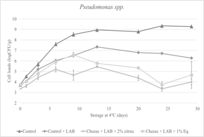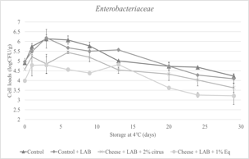
a
b
Figure 2 Cell viability of Enterobacteriaceae (a) and Pseudomonas spp. (b) in ‘Primo Sale’ cheeses during a one-month storage at 4°C.

5.3 Beverages added with pomegranate peels
No differences were detected in the viability of both B. lactis BB-12 and L. plantarum DSM 25710 5 hours after their inoculum in almost all the formulations regardless the presence of the pomegranate peel. During storage, cell loads of the probiotics remained stable (∼ 8 log CFU cm⁻³) or increased, although some differences were detected between the microbial species also in relation to the formulation. In particular, growth of B. lactis BB-12 was delayed in the oat beverage added with the pomegranate. However, following an initial adaptation it reached approximately the same level as the control sample (Figure 3a). On the other hand, L. plantarum was not affected by the presence of pomegranate (Figure 3b), not only in the formulation with whole milk, but also in the soy- and oat-based beverages. The prolonged lag-phase observed for B. lactis BB-12 may be due to a higher sensitivity to the terpenes and other components of the pomegranate BP having antimicrobial activity. In fact, according to data of the preliminary characterization, pomegranate peels were the BPs with the highest antimicrobial activity, also against the tested LAB.

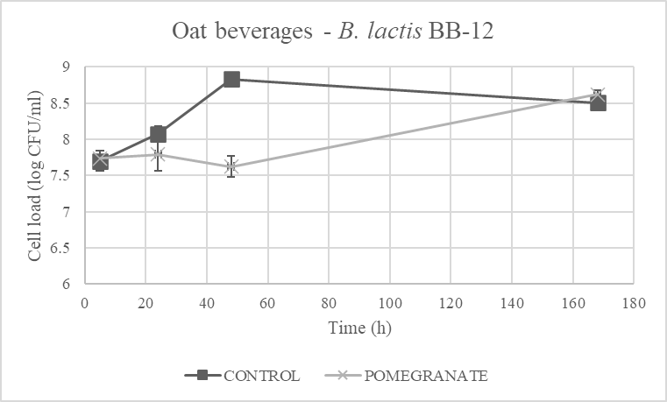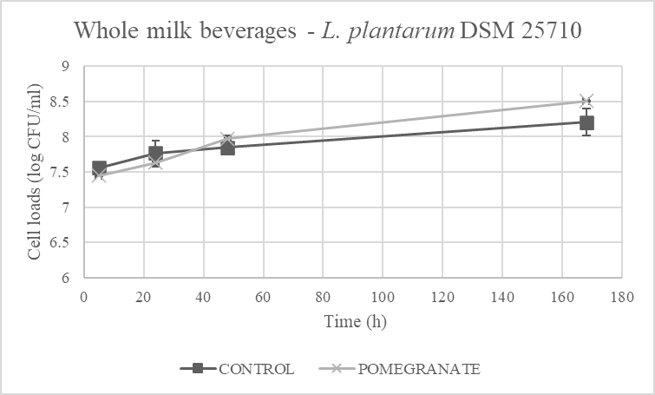
a
b
Figure 3 Cell viability of the probiotics in two different formulations: B. lactis BB-12 in oat beverage and L. plantarum DSM 25710 in whole milk with (X) and without (■) pomegranate during a 7 days storage at 4°C.

5.3 Clementine peels valorisation by microbial fermentation
A strain-dependent behaviour was observed over 7 days of fermentation. In fact, all the LAB strains and most of the yeasts (14 out of 19) were able to survive and grow with final increases of more than 2-3 log CFU g⁻¹ on clementine residues without the addition of any other nutrient also considering that such a matrix presents rather stressing characteristics for microbial growth, e.g. low pH (3.5-4.0), organic acids, essential oils, poorly fermentable carbohydrates. In general, microbial growth resulted in increases in the total phenol content, which are widely recognised to have anti-inflammatory and antimicrobial activity (Mo et al., 2022). Moreover, the fermentation with the selected strains contributed to change the aroma of the clementine BP-based matrix. In general, in the first phase of the fermentation an accumulation of several alcohols and terpenes (e.g. linalool or alpha pinene) was detected. These compounds are responsible for flavours which are generally appreciated such as floral, citrus, sweety and minty. On the other hand, after 5 days of fermentation different profiles were observed among the strains with a general decrease in the content of most of the compounds detected in the early phase; on the contrary, molecules such as α-terpineol, terpinene-4-ol and ethyl acetate were accumulated. According to literature these terpenes show antimicrobial activity in addition to having positive aromas which can be exploited by using the fermented BPs as flavouring agents.

6. Conclusions and Future Perspectives
In conclusion, these experiments highlighted some potentialities of agro-food by-products and possible strategies for their valorisation as functional food ingredients. In particular, due to their composition rich in phenols, the tested BPs can be exploited as antimicrobials being active against different microbial species both in vitro and in the real system "Primo Sale". For the latter, a strong effect against specific microbial populations, i.e., Enterobacteriaceae and Pseudomonas spp. was detected thus contributing to the extension of the shelf life of the cheeses. In addition, the presence of the functional LAB, which remained viable over storage, can provide healthy features being the probiotic activity of cheeses enhanced by the presence of the BPs.
Moreover, the possibility to include the pomegranate BP into beverages promoted the viability of the two probiotic strains, thus increasing the overall functionality of the product also due additional features such as antioxidant activity, prebiotic effect due to the increased fibre content.
Finally, the possibility to valorise the clementine residues by microbial fermentation can be a solution to the stability of this type of BP and, at the same time, improve the availability of bioactive substances or provide new features as flavour and aroma, which can be important for the formulation of an innovative product.
This work considers only a few BPs and only on a laboratory scale; it will be interesting to evaluate the process on a pilot scale to better understand if they can be a real resource for the food industry. It will also be important to evaluate through panel and consumer tests the acceptance by consumers of the products added with the functional BPs.

7. References
Abid M, Yaich H, Cheikhrouhou S, Khemakhem I, Bouaziz M, Attia Hamadi, Ayadi MA (2017) Antioxidant properties and phenolic profile characterization by LC–MS/MS of selected Tunisian pomegranate peels. J Food Sci Technol 54(9): 2890–2901.
Aggarwal KK, Khanuja SPS, Ahmad A, Santha Kumar TR, Kumar S (2002) Antimicrobial activity profiles of the two enantiomers of limonene and carvone isolated from the oils of Mentha spicata and Anethum sowa. Flavour Fragr. J 17(1): 59-63.
Aslam HKW, Raheem MIU, Ramzan R, Shakeel A, Shoaib M, Sakandar HA (2014) Utilization of mango waste material (peel, kernel) to enhance dietary fiber content and antioxidant properties of biscuit. J. Glob Innov. Agric. Soc. Sci. 2(2): 76-81.
Caetano-Silva MS, Rund L, Hutchinson NT, Woods JA, Steelman AJ, Johnson RW (2023) Inhibition of inflammatory microglia by dietary fiber and short-chain fatty acids. Sci Rep 13: 2819.
Cellini B (2022) Biotechnological valorisation of residues and by-products from agro-food industries. Proc. of 26th Workshop
on the Developments in the Italian PhD Research on Food Science Technology and Biotechnology, Asti (Italy), 19-21 September 2022, p. 220.
Eurostat (2020) Agriculture, forestry and fisheries statistics - edition 2020.
FAOSTAT (2020) The Food and Agriculture Organization of the United Nations.
Ferioli F, D’Antuono LF (2016) Evaluation of phenolics and cysteine sulfoxides in local onion and shallot germplasm from Italy and Ukraine. Genet Resour Crop Evol 63(4): 601–614.
Huebner J, Wehling RL, Hutkins RW (2007) Functional activity of commercial prebiotics. Int. Dairy J. 17(7): 770–775.
Maurya AK, Pandey RK, Rai D, Porwal P, Rai DC (2015) Waste product of fruits and vegetables processing as a source of dietary fibre: A review. Trends Biosci 8(19): 5129-5140.
Mejri F, Selmi S, Martins A, Benkhoud H, Baati T, Chaabane H, Nijm L, Serralheiro MLM, Rauter AP, Hosni K (2018) Broad bean (Vicia faba L.) pods: a rich source of bioactive ingredients with antimicrobial, antioxidant, enzyme inhibitory, anti-diabetic and health-promoting properties. Food Funct 9(4): 2051–2069.
Mo Y, Ma J, Gao W, Zhang L, Li J, Li J, Zang J (2022) Pomegranate Peel as a Source of Bioactive Compounds: A Mini Review on Their Physiological Functions. Front Nutr 9:887113.
Rao NH, Lakshmidevi N, Pammi SVN, Kollu P, Ganapaty S, Lakshmi P (2016) Green synthesis of silver nanoparticles using methanolic root extracts of Diospyros paniculata and their antimicrobial activities. Mater Sci Eng 62: 553-557.
Tabanelli G, Montanari C, Grazia L, Lanciotti R, Gardini F (2013) Effects of aw at packaging time and atmosphere composition on aroma profile, biogenic amine content and microbiological features of dry fermented sausages. Meat Sci 94(2): 177–186.
Witt EDP, Johann G, Triques CC, da Silva EA, da Silva C, Borsato D, da Silva Baumgartner TR (2022) Potential application of supercritical extract of pomegranate peel as bio‐antioxidant for biodiesel. Environ Prog Sustain 41(2): e13755.

