POSTER COMMUNICATIONS

Novel plant protein sources for the beverage sector: technological functionality, nutritional properties, sensory characteristics, and consumer acceptability
Lorenzo Barozzi (barozzi.lorenzo@spes.uniud.it)
DI4A, Università degli Studi di Udine, Udine, Italia
Tutor: Prof.ssa Lara Manzocco; Stella Plazzotta; Tutor aziendale: Dott.ssa Ada Nucci (Luigi Lavazza S.p.A.)

The aim of this Ph.D. research is to identify plant proteins (PP) suitable for the beverage sector by filling the knowledge gap about their technological and sensory performance. The first 3 activities of the Ph.D. project are: (i) development of a database on PP functionalities, through literature research and benchmark analysis, (ii) selection of PP samples and assessment of their suitability as beverage ingredients, by analyzing cold and hot water solubility and sensory properties; (iii) preliminary prototyping of a coffee beverages containing selected PP samples.

Nuove fonti proteiche vegetali per il settore delle bevande: funzionalità tecnologiche, proprietà nutrizionali, caratteristiche sensoriali ed accettabilità del consumatore
L'obiettivo di questo percorso di dottorato è quello di identificare proteine vegetali (PP) impiegabili nel settore delle bevande, colmando la carenza di informazioni relative alle loro proprietà tecnologiche e sensoriali. Le prime 3 attività del progetto sono: (i) sviluppo di un database sulle funzionalità delle PP attraverso una ricerca bibliografica e di benchmark; (ii) selezione di ingredienti proteici e valutazione della loro attitudine ad essere impiegati come ingredienti di bevande, analizzandone la solubilità in acqua calda e fredda e le proprietà sensoriali; (iii) realizzazione di prototipi di bevande a base di caffè contenenti gli ingredienti proteici selezionati.

Keywords: Plant proteins, solubility, sensory analysis, beverage, coffee.

1. Introduction
In accordance with the Ph.D. thesis project previously described (Barozzi, 2022a), this poster reports the main results of the activities concerning: (A1) Development of a database relevant to plant protein (PP) functionalities; (A2) Analysis of selected PP ingredients, chosen based on A1; (A3) Preliminary prototyping of a PP coffee-based beverage using ingredients selected based on A2.
2. Materials and Methods
A1 Development of a database relevant to plant protein functionalities
A literature review was conducted on Web of Science, Scopus, and Google Scholar to collect information on PP food-related properties. Information retrieved from more than 200 research papers was comprehensively organized in a database that collected data relevant to PP sources, extraction method, extraction yield, extract protein content, technological and sensory properties, nutritional characteristics, allergenicity, consumer acceptability, and regulatory issues. Further information about market availability and current application in beverages was obtained thanks to a benchmark analysis performed in collaboration with Lavazza using the Mintel database.
A2 Analysis of plant protein ingredients selected based on A1
PP samples, selected based on the database developed in A1, were kindly provided by Lavazza. The total protein content of these samples was evaluated through bicinchoninic acid assay (BCA). Samples were also assessed for solubility in cold water. To this aim, PP samples (0.2 g, W) were stirred for 6 h in 20 mL water at 20 ± 1 °C. The dispersions were centrifuged, and the sediment was dried and weighed. The protein content of the supernatant was analyzed through BCA (P) and used to estimate protein solubility ($S_{p}$), which was expressed as:

$S_{p}=P/W∙100$ (1)

The flavour acceptability of the PP samples was assessed by 12 judges with previous experience in sensory analysis. Cold water solubilized samples (30 mL, 1% w/w) were provided to the judges, who were asked to drink the samples and evaluate flavor acceptability on a 7-point scale anchored at 1 (unacceptable), 4 (neutral), and 7 (desirable). Samples selected based on cold-water solubility ($S_{p}$) and sensory analysis were analyzed for solubility in hot water. To this aim, 0.5 g of protein sample were inserted in a coffee filter (Melitta, Minden, Germany) and washed with 8.3 mL hot water (96 ± 1 °C). The percolated aqueous solution was analysed for total protein and protein solubility.
A3 Preliminary prototyping of a PP coffee-based beverage using protein ingredients selected based on A2
PP selected based on A2 results, were assessed for their suitability as ingredients in a simplified prototype represented by a ground coffee-based powder intended for the preparation of a beverage by hot water percolation. To this aim, PP samples were mixed at increasing concentration (0, 2, 5, 10, and 30% w/w) with 3 coffee blends having different roasting degrees. The PP-coffee mixtures (15 g) were inserted in coffee filters and washed with 240 mL hot water (96 ± 1 °C). The aqueous extracts were characterized in terms of dry matter, protein content, and protein recovery (percentage of proteins in the extract as compared to the initial protein content in the PP-coffee mixture).
3. Results and Discussion
A1 Development of a database relevant to plant protein functionalities
Fig.1 schematically represents the rationale of the experimental plan applied to select PP samples suitable for beverage production. Among the 84 PP sources initially identified by the literature review, 30 were selected based on their high solubility, no allergenicity, and availability on the market. These PP samples included protein concentrates, isolates, hydrolysates as well as protein samples prepared from pea residues (Barozzi et al., 2022b).

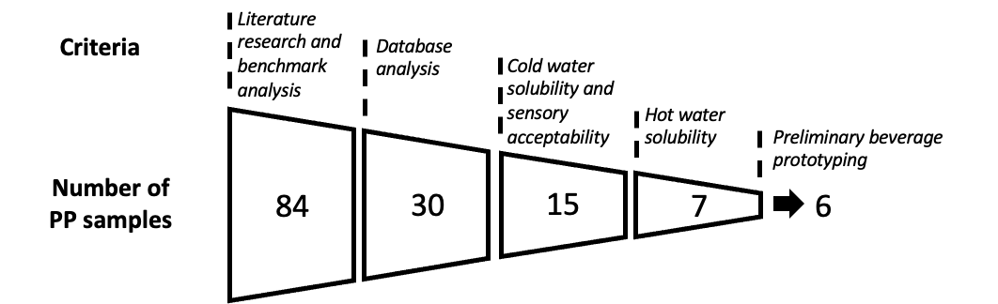
Figure 1. Schematic representation of the criteria adopted for the selection of plant protein (PP) samples suitable for beverage production.

A2 Analysis of plant protein ingredients selected based on A1
The total protein content of the selected PP, ranged from 12 to 83% w/w. Protein solubility ($S_{p}$) in cold water ranged from 5 to 52% w/w. Among all samples, protein hydrolysates having the lower molecular weight accounted for the highest protein solubility (Beaubier et., 2021). The peculiar vegetable notes of PP might hinder their use as food ingredients (Kumar et al., 2022). In fact, sensory analysis evidenced only 15 samples out of the original 30 to present an acceptable flavor. These selected samples were subjected to hot water extraction to have a first insight into their suitability as beverage ingredients. Filter clogging was observed in 8 samples, probably due to protein coagulation under the applied high-temperature conditions (Ge et al., 2021). In the remaining 7 PP samples, no clogging was observed, associated with a relatively high protein solubility. These samples were thus selected to perform preliminary beverage prototyping activities (A3).
A.3 Preliminary prototyping of a PP coffee-based beverage using protein ingredients selected based on A2
The feasibility of the 7 samples selected during A2, as possible ingredients of a PP-enriched coffee powder intended for hot beverage preparation was assessed. The roasting degree of the coffee blend had no effect on protein extraction. As expected, the higher the PP:coffee ratio in the powder mixture, the higher the protein content in the final beverage. Although no filter clogging was registered in any sample, one of them was not considered for further analysis, due to its lower solubility in the considered prototyping conditions.

4. Conclusion and future activities
A1. The developed database, accounting for a full range of functionalities and market factors, is a powerful tool for the identification of protein ingredients with the desired characteristics. A2. PP ingredients suitable for beverage production were identified based on hot water protein solubility and sensory acceptability. A3. No effect of the coffee blend was observed on the solubility of the PP ingredients, suggesting the technical feasibility of coffee-based hot beverages enriched with PP.
The next activities will be focused on the optimization of PP-coffee powder mixtures, with the aim of identifying sensory pleasant formulations feasible for the preparation of beverages via hot water percolation. This activity is being performed during the 6 months secondment at Lavazza Innovation Center.
5. References
Barozzi, L. (2022a) In Proc.s of the 26th Workshop on the Developments in the Italian PhD Research on Food Science and Technology and Biotechnology, Asti (Italy), 19-21 September 2022, pp. 37-38.
Barozzi, L., Plazzotta, S., Manzocco, L. (2022b). Recovery of legume waste into innovative aerogel-like powders for food application [Poster presentation] 2nd International Conference on Aerogels for Biomedical and Environmental Applications. Athens, Greece.
Beaubier, S., Albe-Slabi, S., Aymes, A., Bianeis, M., Galet, O., & Kapel, R. (2021). A rational approach for the production of highly soluble and functional sunflower protein hydrolysates. Foods, 10(3), 664.
Ge, J., Sun, C. X., Mata, A., Corke, H., Gan, R. Y., & Fang, Y. (2021). Physicochemical and pH-dependent functional properties of proteins isolated from eight traditional Chinese beans. Food Hydrocolloids, 112, 106288,
Kumar, M., Tomar, M., Potkule, J., Punia, S., Dhakane-Lad, J., Singh, S., ... & Kennedy, J. F. (2022). Functional characterization of plant-based protein to determine its quality for food applications. Food Hydrocolloids, 123, 106986.

