Health-promoting properties of food bioactives: the case study of quercetin. Preliminary results.
Umberto Lanza (lanza.umberto@spes.uniud.it)
Dept. of Agricultural, Food, Environmental, and Animal Sciences, University of Udine, Udine, Italy
Tutors: Prof. Maria Cristina Nicoli, Prof. Carlo Ennio Michele Pucillo
Co-tutor: Ph.D. Marilisa Alongi

The results here described are part of a wider experimental plan aimed at studying the fate of quercetin contained in model systems simulating apple or its derivatives during the gastrointestinal process. To this purpose, the effect of in-vitro digestion on quercetin antioxidant activity was assessed. Quercetin’s effect on the inhibition of intestinal α-glucosidase in a colorectal adenocarcinoma cell line Caco-2 was also investigated.

Proprietà “health promoting” di molecole bioattive presenti negli alimenti: il caso studio della quercetina.
Risultati preliminari.

Lo studio, che si inserisce in una più ampia sperimentazione, ha avuto lo scopo di studiare l’effetto sull’attività antiossidante della quercetina contenuta in alimenti modello simulanti una mela o un derivato di mela, del processo digestivo in-vitro. Parallelamente è stata anche valutata l’azione di questa molecola bioattiva sull’enzima umano α-glucosidasi nel contesto dell’assorbimento di glucosio a livello intestinale.

Keywords: antioxidant activity, in-vitro digestion, quercetin, pectin, antihyperglycemic, α-glucosidase

1. Introduction
Quercetin is a known bioactive compound that can be found in several fruits and vegetables. This polyphenol is recognized to exert several beneficial effects such as antioxidant, anti-inflammatory, and antihyperglycemic activities. Although all these effects have been repeatedly reported, literature results on quercetin’s physiological effects sound still controversial and the mechanisms by which it exerts these functions, especially when it is assumed with the diet, are far from being elucidated (D’Archivio et al., 2010). It is a matter of fact that quercetin activity is likely to be affected by the interactions among food components occurring before and during the digestion process (Alongi et al., 2023). Starting from this assumption, the study here described aims to:
A1) Understand the effect of the digestive process on the antioxidant activity of quercetin when contained in a model system mimicking an apple.
A2) Elucidate the ability of quercetin to regulate glucose absorption mechanisms at intestinal level by using Caco-2 cell lines.
The results here reported are part of a wider experimental plan whose main objective is to better understand how and in which extent food composition and structure may affect some mechanisms at the basis of quercetin physiological effects.

2. Materials and Methods

2.1 Antioxidant activity on food model system
The following apple model systems were prepared: (i) quercetin-3-glucoside (q-3-glu) in sugars solution that was obtained by dissolving q-3-glu at a concentration of 0.33 mg/mL, approximated to the total phenolic content reported for Golden delicious apples (Alongi et al., 2018), in a solution containing 15 mg/mL glucose, 30 mg/mL fructose, and 4 mg/mL sucrose, mimicking apple sugar concentration; (ii) pectin in sugars solution, which was obtained by dissolving pectin at a concentration of 2.8 mg/mL (Baker, 1997); (iii) q-3-glu and pectin in sugars solution was obtained by adding q-3-glu in the sugars-pectin solution described in (ii).
In-vitro digestion was carried out according to the INFOGEST protocol (Brodkorb et al., 2019), and subsequent analyses were carried out on the bioaccessible fraction. The antioxidant activity was assessed by the DPPH method (Manzocco, Anese and Nicoli, 1998). Data are expressed in milligrams of Trolox Equivalents per litre (mg_{TE}/L).

2.2 Inhibition of α-glucosidase in Caco-2 cells
Caco-2 cells were cultured on Transwell inserts as reported by Kan et al., 2021. The concentration tested were q-3-glu 2 µM and 25 µM. Acarbose 50 µM was used as a positive control, and sucrose 75 mM without stimuli as a negative control. To evaluate the effect of α-glucosidase, sucrose concentration in the culture media was assayed at different times (0.5, 1, 4 and 24 h). Measurements were carried out using the MEGAZYME Glucose/Fructose/Sucrose HK assay kit (NEOGEN Europe Ltd) with a BIOTEK Synergy H1 plate reader (Agilent Technologies). All the concentrations of q-3-g and Acarbose used were previously tested with CyQUANT LDH assay (Thermo Fisher Scientific, Italy), and none of them significantly affected Caco-2 cell viability.

3. Results and Discussion

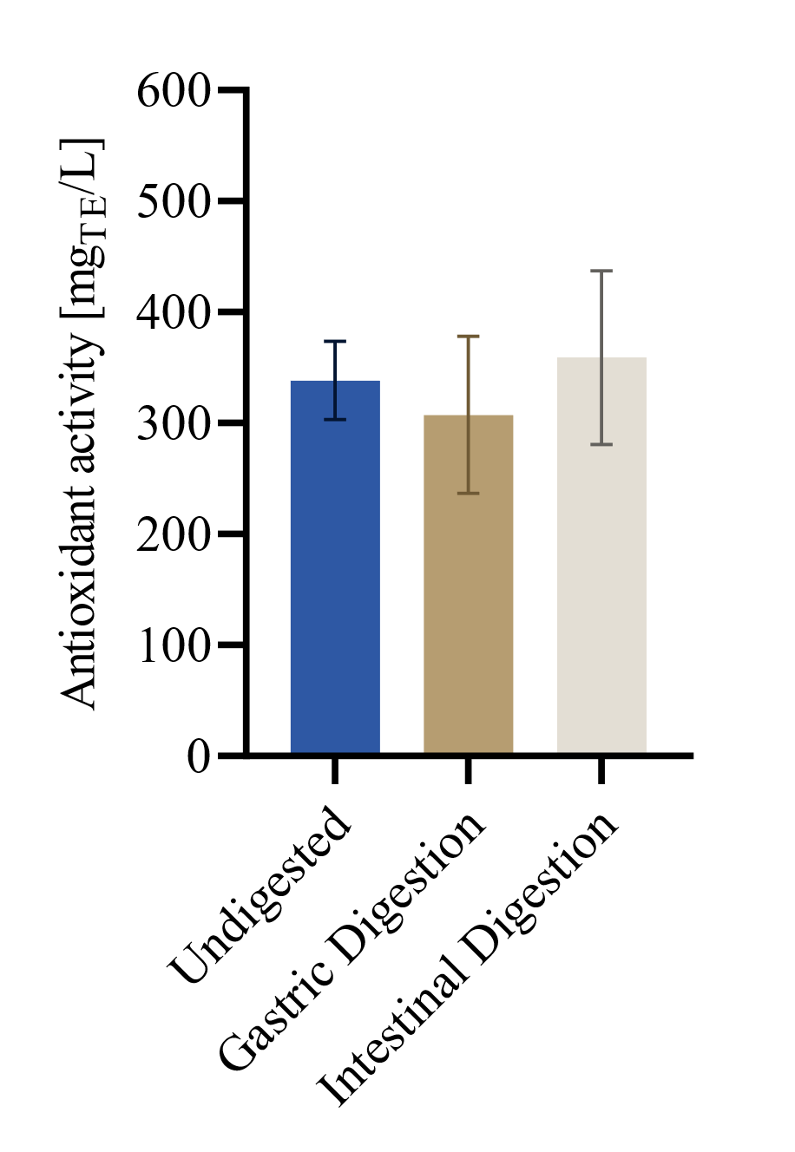
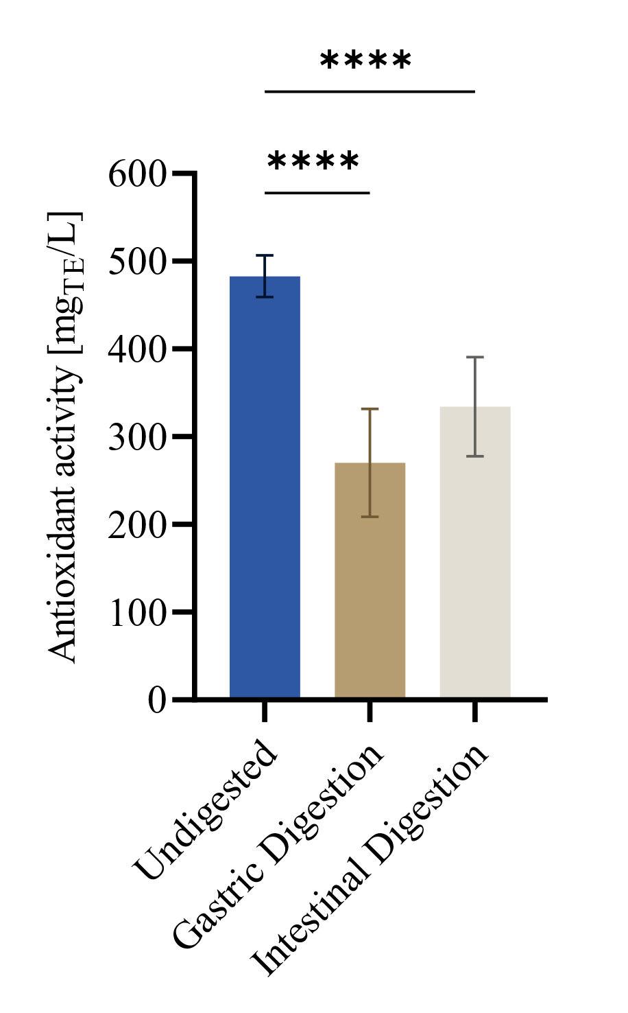
3.1 Antioxidant activity of apple model systems
B
A

Figure 1: Antioxidant activity of food model system containing: (A) quercetin-3-glucoside in sugars solution; (B) quercetin-3-glucoside and pectin in sugars solution subjected or not to in-vitro gastric and intestinal digestion.
Data expressed as mean ± SD, n = 2 biological replicates, statistically significant results are labelled (* p < 0.05, ** p < 0.01, *** p < 0.001, **** p ≤ 0.001).

Figure 1A shows the antioxidant activity relevant to food model systems before and after in vitro digestion. The only contributor to the antioxidant activity was quercetin-3-glucoside since sugars and pectin did not show any antioxidant activity (data not shown). The gastric process seems responsible for a loss of about 45% of the original antioxidant properties. No significant changes were further detected as a consequence of the intestinal digestion. When pectin was present (Figure 1B), a lower antioxidant activity was measured before in vitro digestion. It is likely that pectin generated a network able to embed quercetin, thus reducing its reactivity towards DPPH in the undigested sample. Conversely, the presence of pectin did not affect the antioxidant activity in digested samples. These results suggest that the pectin shell is modified by the gastrointestinal events, allowing quercetin to exert its bioactivity. Trials are in progress to elucidate the fate of pectin during digestion in order to confirm this hypothesis.

3.2 α-Glucosidase inhibitory activity of quercetin-3-glucoside
Figure 2 shows the percentage of residual sucrose in the culture media of Caco-2 cells treated with different concentrations of q-3-glu. Acarbose, which is a known α-glucosidase inhibitor, was used as positive control. The higher amount of residual sucrose in the culture media observed for the sample containing q-3-glu 2 µM suggest the ability of quercetin in reducing sucrose enzymatic hydrolysis. This trend is similar to that observed with acarbose. Sample containing q-3-glu 25 µM showed a negligible effect, suggesting that quercetin could inhibit α-glucosidase only in a given concentration range.
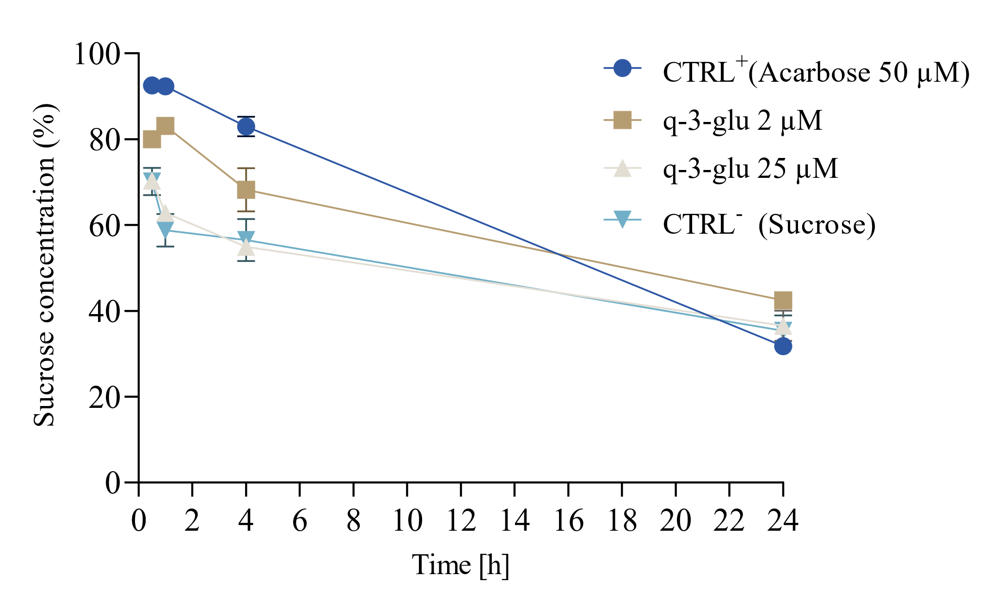

Figure 2: Percentage of residual sucrose concentration in culture media of Caco-2 cells treated with 2 and 25 µM of quercetin-3-glucoside over a time-course of 24h.
Preliminary data expressed as mean ± SD, n = 1 biological replicate.

3. References
Alongi, M. et al. (2018) ‘Effect of pasteurization on in vitro α-glucosidase inhibitory activity of apple juice’, Lwt, 98(August), pp. 366–371.
Alongi, M. et al. (2023) ‘The impact of apple destructuring and thermal treatment on bioactive compounds: the fate of dietary fibre and polyphenols in puree and homogenate’, International Journal of Food Science & Technology, 58(6), pp. 3189–3200.
Baker, R.A. (1997) ‘Reassessment of some fruit and vegetable pectin levels’, Journal of Food Science, 62(2), pp. 225–229.
Brodkorb, A. et al. (2019) ‘INFOGEST static in vitro simulation of gastrointestinal food digestion’, Nature Protocols, 14(4), pp. 991–1014.
D’Archivio, M. et al. (2010) ‘Bioavailability of the polyphenols: Status and controversies’, International Journal of Molecular Sciences, 11(4), pp. 1321–1342.
Kan, L. et al. (2021) ‘Inhibition of α-glucosidases by tea polyphenols in rat intestinal extract and Caco-2 cells grown on Transwell’, Food Chemistry, 361(February), p. 130047.
Manzocco, L., Anese, M. and Nicoli, M.C. (1998) ‘Antioxidant properties of tea extracts as affected by processing’, LWT - Food Science and Technology, 31(7–8), pp. 694–698.

