**Modifications of vegetables subjected to conventional, innovative and non-thermal technologies**

Dhenge Rohini Vijay ([rohinivijay.dhenge@unipr.it](mailto:rohinivijay.dhenge@unipr.it))

Dept. of Food and Drug, University di Parma, Italy

**Tutor**: Prof. Tommaso Ganino, Prof. Massimiliano Rinaldi

This study deals with the HPP treatment with different pressures and time profiles on vegetables to determine the physio-chemical, microstructural, antioxidant, bioactive, volatile and sugar content of pumpkin samples; subsequently, it is fundamental to explore and see how this technology impacts the vegetable characteristics.

**Analisi delle modificazioni nella microstruttura di vegetali sottoposti a tecnologie convenzionali, innovative e non termiche**

Questo studio si occupa del trattamento HPP con diverse pressioni e profili temporali su ortaggi per determinare il contenuto fisico-chimico, microstrutturale, antiossidante, bioattivo, volatile e zuccherino di campioni di zucca; successivamente, è fondamentale esplorare e vedere come questa tecnologia influisce sulle caratteristiche vegetali.

**Keywords**: HPP, Pumpkin, color-texture, Histological analysis, bioactive and volatile components

# **1. Introduction**

Food must be treated in order to extend its shelf life because it is often a perishable commodity. Thermal processing is an effective method for microbial inactivation, although it has drawbacks and side effects. This opens up a field for the investigation of non-thermal processing methods. High-pressure processing (HPP) is a non-thermal technique for food preservation with little loss in quality. The process involves the application of high pressures (up to 1000 MPa) for a short time (Chauhan et al., 2019) with the aim to reduce food pathogens at room temperature, to inactivate the deteriorative enzymes, to extend the shelf life (Zhou et al., 2014) with little impact on the nutritional and chemical composition of foods. HPP technology was used in fruit and vegetable products; results indicate an impact on texture, color and flavor, but the intensity of the changes depends on both process conditions and the type of plant tissue treated (Oey et al., 2008). From the anatomical point of view, HPP influences the microstructure (cells and tissues) too: there are many changes at the cellular and tissue level such as changes in cell shape due to loss of turgor, damage to the cell wall and membrane and formation of cracks in the plant tissues (Trejo Araya et al., 2007; Contador et al., 2014; Paciulli et al., 2021). All these changes are responsible for the loss of firmness of fruits or vegetables. In addition, Dhenge et al. (2022) observed that HPP technology has the potential for stability and availability of all bioactive components, volatiles and sugars. Thus, HPP might be used as a substitute method to improve the effectiveness of bioactive component extraction (e.g., phenolic, carotenoids, volatile compounds). In any case, the application of high-pressure processing on juices, paste, and purees is not quite the same as to whole pieces of vegetables; subsequently, it is fundamental to explore and see how this technology impacts the fruits and vegetable characteristics**.** The aim of this study is to assess the effects of HPP of selective pressures and time on pumpkin samples.

# **2. Materials and Methods**

Pumpkin ([*Cucurbita moschata*](https://en.wikipedia.org/wiki/Cucurbita_moschata)Duchesne ex Poir) samples were cut into small cubes from 1 to 1.5 cm (UNTR) and then vacuum packed in HDPE bags and subjected to high-pressure processing of selective pressures such as 200, 400 and 600 MPa for 1(A), 3(B) and 5(C) mins at 20℃. After the treatment, all samples were stored at 4°C, next day samples were used for the physical (color by Konica Minolta and texture by texture analyzer using a TA. XT2i) and chemical analyses (polyphenols and carotenoids (LC-MS)), volatiles (HS-GC-MS), sugars (HPLC) and antioxidant capacity (DPPH)). For the microstructure examination, the fixed and dyed sections were observed by means of an optical microscope at different magnifications (5, 10, 20, 40 and 63X). For the evaluation of the general structure variation, the sections were stained with toluidine blue (TBO) solution and to identify the presence of calcium inclusions in tissue sections, the sections were stained by Von Kossa (Bio-Optica Kit, Milano, Italy).

**3**. **Results and Discussion**

* 1. **Physical analysis**

Moisture, total soluble solids (TSS) and pH were measured. The Values of pH ranged from 6.03 to 6.60, the values of total sugar content ranged from 8.5 to 10.86 °Brix, while the moisture content ranged from 85.40 to 87.66 (g/100g). The data obtained showed statistically significant differences among samples.

**3.2 Colorimetric analysis**

In the **UNTR** sample, all colorimetric values (*L*, a\** and *b\**) were the highest with a great color difference compared to HPP ones. A significant difference was observed from all pressure samples whereas **HPP400B, 600A** and **600B** showed little greater color values than other HPP-treated samples (Fig. 1). This might be caused by cell disruption during HPP treatment resulting in the leakage of pigment into the intercellular space or degradation of pigment yielding a less intense color. A significant change was induced when pressures above HPP400 were applied, showing that, in our condition, extra pressure may not be a good choice for vegetable processing.

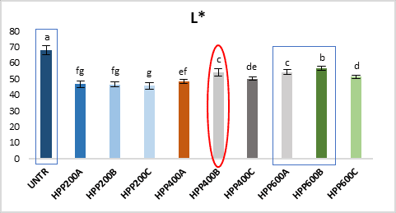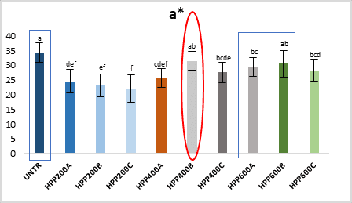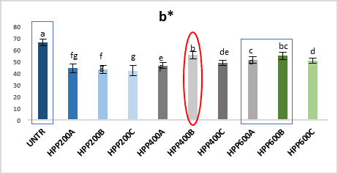

**Figure 1** *Colorimetric analysis of UNTR and HPP-treated pumpkin samples.* ***Letters****:* ***UNTR****: raw sample,* ***HPP****: pressure treated samples (200, 400 and 600MPa),* ***A*** *(1mins),* ***B*** *(3 mins) and* ***C*** *(5 mins).*

* 1. **Texture profile**

A noticeable difference was observed in **HPP400B** and **600C** samples, with a difference in terms of hardness (155.26 and 161.05 ± 3N) compared to the UNTR ones (312.96 ± 46.3 N) whereas treatments at other pressures changed the texture of the pumpkin samples, but less markedly (Table 1). The softening of the texture and decrease in the hardness of plant tissue is caused by cell wall breakdown, cell rupture, degradation of pectin and loss of turgor pressure induced by high pressure. As pressure increases, hardness decreases and enhances the activity of PME (Oey et al., 2008) which has a substantial impact on cell damage, breakdown of cell walls’ structure and release of pectin and calcium, and less adhesiveness between the cell and cell dehydration. Other textural characteristics such as resilience, cohesiveness, springiness, and chewiness indicate better texture quality retention in UNTR than HPP treated samples.

**Table 1**  *Textural parameters of UNTR and HPP-treated pumpkin samples.* ***Letters****:* ***UNTR****: raw sample,* ***HPP****: pressure treated samples (200, 400 and 600MPa),* ***A*** *(1mins),* ***B*** *(3 mins) and* ***C*** *(5 mins).*

|  |  |  |  |  |  |
| --- | --- | --- | --- | --- | --- |
| **Treatment** | **Hardness (N)** | **Resilience (%)** | **Cohesiveness** | **Springiness (%)** | **Chewiness** |
| **UNTR** | **312.96±46.3a** | **32.51±2.0a** | **0.58±0.03a** | **58.37±3.2a** | **108.53±23.4a** |
| **HPP200A** | 227.33±26.0b | 22.01±7.0bcd | 0.37±0.1bcd | 57.37±13.5a | 47.60±11.3bc |
| **HPP200B** | 232.55±43.1b | 25.24±8.5ab | 0.42±0.1b | 52.31±3.0ab | 52.61±21.6b |
| **HPP200C** | 224.43±41.6b | 25.05±5.8abc | 0.42±0.08cd | 52.43±3.7ab | 50.99±17.7b |
| **HPP400A** | 189.68±54.7bc | 19.20±4.9bcde | 0.31±0.07cdef | 44.85±5.7b | 28.86±15.5cde |
| **HPP400B** | **155.26±38.3c** | **13.24±4.2e** | **0.23±0.05f** | **46.88±11.2b** | **17.67±8.7e** |
| **HPP400C** | 206.15±47.9bc | 21.18±6.6bcd | 0.35±0.1bcde | 50.47±9.7ab | 37.74±17.2bcde |
| **HPP600A** | 210.42±53.5bc | 21.51±6.7bcd | 0.35±0.09bcde | 50.31±5.2ab | 39.08±17.2bcd |
| **HPP600B** | 183.3±48.1bc | 17.48±3.9cde | 0.27±0.05def | 45.50±4.6b | 24.41±11.2de |
| **HPP600C** | **161.05±38.0c** | **15.70±4.8de** | **0.25±0.06ef** | **45.60±5.4b** | **19.13±8.6de** |

* 1. **Microstructure analysis**

The microstructure of pumpkin samples appeared to be changed after HPP treatments. In the untreated samples (UNTR), the inner parenchyma (mesocarp) is composed of isodiametric cells with thin cell walls. Mesocarp is composed of thin-walled big and small cells with large intercellular spaces (is) (Fig. 2A). In the inner parenchyma, vascular bundles (vb) are present and its surrounded by small parenchymatic cells. Pumpkin tissue showed great structural modifications such as changes in cell size and shape, cell wall damage, increases cell wall thickness, cell detachment, cell dehydration and calcium ions deposition mainly at very high pressures (400C, 600A and 600C) **(**Fig. 2D-E-F**)** (Trejo Araya et al., 2007; Zhou et al., 2014). UNTR samples showed the highest value of maximum and minimum cell elongation, perimeter segment and more regular cell size -shape, cell wall thickness and a higher degree of cell-to-cell contact throughout the tissue whereas HPP 400C, 600A and 600C samples showed the lowest values for the same parameters (Zhang et al., 2015).

Another impact was observed regarding the calcium ion (ci) deposition in tissues. UNTR and HPP200 samples showed a scarce presence of calcium inclusions, but after the HPP400, the number of calcium inclusions (ci) increased (Fig. 3C–D). More interesting results about high calcium ions (ci) deposition were observed in HPP600A and 600C (Fig. 3E-F) mainly due to the liberation of calcium from the middle lamella which is previously bound in the pectin network. Our study reveals that as pressure increased, the presence of calcium ions in the cells increased and was liberated as a result of cell separation.

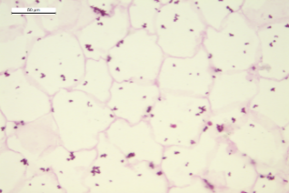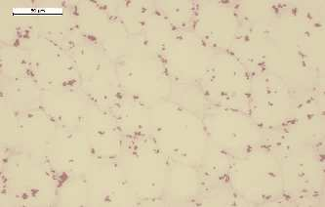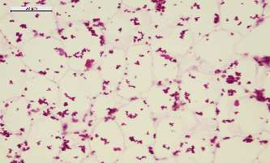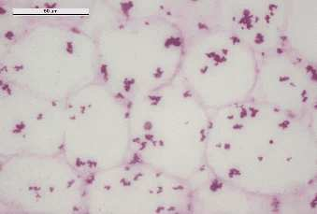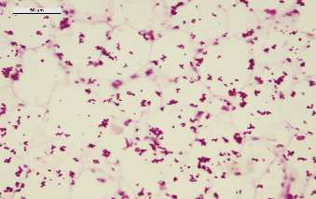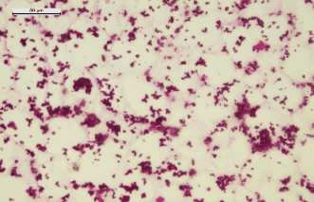

ci

ci

ci

ci

ci

ci

ci

ci

ci

ci

ci

ci

ci

ci

ci

ci

ci

ci

ci

A

B

C

D

E

F

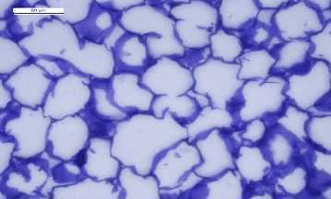

cwt

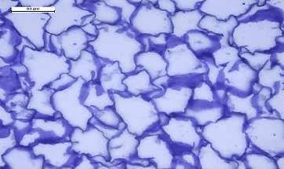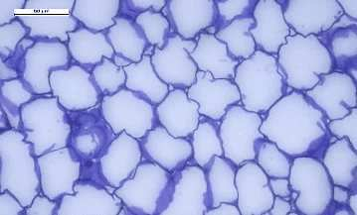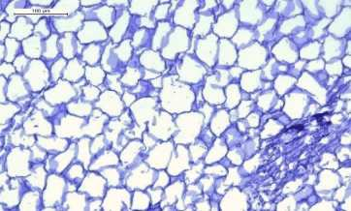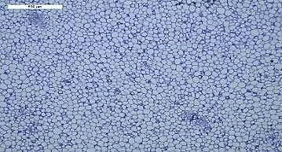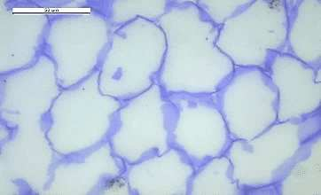

vb

vb

d

is

cwt

cd

is

cd

cwt

cd

is

CD

CD

cd

is

is

cd

CD

cwt

d

cd

CD

is

cd

d

d

cwt

cwt

cwt

A

B

C

D

E

F

**Figure 3***Light microscopy images of Violina Squash stained with Von Kossa (Bio-Optica kit, Milano) (A, B, C, D, E, and F): A-200****A*** *(1mins); B-200****C*** *(5mins); C-400****A*** *(1mins); D-400****C*** *(5mins); E-600****A*** *(1mins); F-600****C*** *(5mins) . Legends: ci = calcium ions. Letters:* ***A*** *(1mins),* ***B*** *(3 mins) and* ***C*** *(5 mins).*

**Figure 2***Light microscopy images of Violina Squash stained with TBO (Toluidine Blue) (A, B, C, D, E, and F): A-200****A*** *(1mins); B-200****C*** *(5mins); C-400****A*** *(1mins); D-400****C*** *(5mins); E-600****A*** *(1mins); F-600****C*** *(5mins). Legends: vb = vascular bundles; is = intercellular space; d = dehydration, cd = cell detachment; CD = cell damage; cwt = cell wall thickness (increase). Letters:****A*** *(1mins),* ***B*** *(3 mins) and* ***C*** *(5 mins).*

* 1. **Antioxidants and bioactive components availability**

**Antioxidant capacity (AC):** The HPP400A reported the highest equivalent value. On the contrary, the HPP significantly reduced the AC for HPP200B, 600B and 600C samples whereas HPP200C and HPP600A showed greater values but the highest AC observed in HPP400A comparison to other samples.

**Table 2**  *Antioxidant capacity by DPPH* ***Trolox eq. mmol/g dry wt. Basis*** *of UNTR and HPP-treated pumpkin samples.* ***Letters****:* ***UNTR****: raw sample,* ***HPP****: pressure treated samples (200, 400 and 600MPa),* ***A*** *(1mins),* ***B*** *(3 mins) and* ***C*** *(5 mins).*

|  |  |  |  |  |  |  |  |  |  |  |
| --- | --- | --- | --- | --- | --- | --- | --- | --- | --- | --- |
|  | UNTR | HPP200A | HPP200B | HPP200C | HPP400A | HPP400B | HPP400C | HPP600A | HPP600B | HPP600C |
| Pumpkin samples | 4.86±0.90d | 10.88±2.30abc | 6.45±1.20cd | 12.8±4.18ab | 15.14±1.96a | 8.59±0.99bcd | 11.91±2.25abc | 13.09±1.25ab | 6.67±0.31cd | 4.92±0.45d |

**Polyphenols:** Three main polyphenol derivatives (Luteolin-7-o-glucoside, 2-Rhamnosyl-glucosyl kaempferol, and Laempferol-7-o-glucoside) were detected by extraction and by squeezed. The Higher number of polyphenols was obtained in the sample from HPP400 (A and C) than in HPP600 (B and C). The content of polyphenol was higher in HPP400A its 40 mg/kg compared to HPP600. This is indicated that HPP at middle pressure like 400 At less time can have an influence on the polyphenol’s composition and composition of the extractable polyphenols from the matrix. The concentration of the squeezed number of polyphenols for HPP**400C** obtained significantly higher (275 mg/kg) compared to others. For 200B, the squeezable number of polyphenols was very similar to the concentration obtained for HPP600B.

**Carotenoids:** A higher number of extractable total carotenoids was observed at higher pressure (**HPP600C**), whereas at middle pressure was also observed higher total carotenoids content (**HPP400 A and C and 600B**) than UNTR (Fig.4). Our results show that pumpkin is a rich source of carotenoids, especially β-carotene, lutein and other derivatives, and these derivatives might be increased at moderate pressure, because at increased pressure oxidative chemical reaction was enhanced which is responsible for carotenoids degradation.

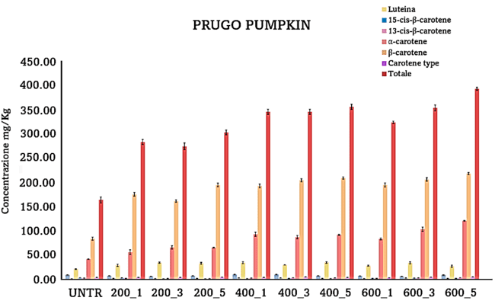

**Carotenoids Content**

**UNTR HPP200A HPP200B HPP200C HPP400A HPP400B HPP400C HPP600A HPP600B HPP600C**

Concentration mg/Kg

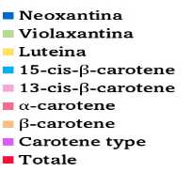

***

***

***

*

***

***

***

***

***

***

***

***

***

***

***

***

***

***

***

***

***

***

***

***

**

***

***

*

**

*

**

**

**

***

*

***

**

**

***

*

**

**

**

**Figure 4** *Carotenoids content of UNTR and HPP-treated pumpkin samples.* ***Letters****:* ***UNTR****: raw sample,* ***HPP****: pressure treated samples (200, 400 and 600MPa),* ***A*** *(1mins),* ***B*** *(3 mins) and* ***C*** *(5 mins).*

* 1. **Volatile and sugar profile**

Regarding **volatile compounds**, some compounds were identified such as 3-Hexanol (1), 4- Hydroxy-3-Hexanone (2), 2-Methylfuran (3), 1,1-Dimethoxypropane (4), 2-Pentylfuran (5) and 1-Hexanol (6) respectively. Significant differences were observed between treated versus untreated samples. The Higher number of total volatiles was obtained in the sample of HPP400A, 600B and 600C than HPP200 and UNTR (Fig. 5). The Higher number of **total sugars** was obtained in the sample from HPP400C than in UNTR and HPP600. The content of sugar was also showed higher in HPP200C and HPP400B compared to other samples (Fig. 6). This is indicated that HPP at middle pressure like 400 at little more time can have an influence on the sugar composition but it decreased with high pressure treatment (HPP600) because of the more leaching effect.

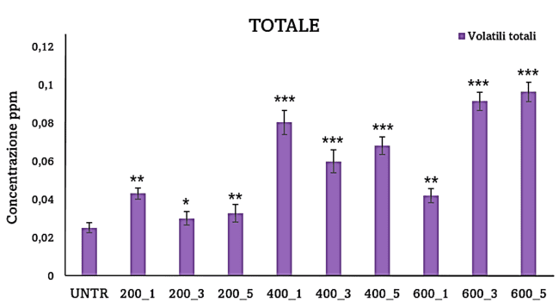

**Total Volatiles**

**UNTR HPP200A HPP200B HPP200C HPP400A HPP400B HPP400C HPP600A HPP600B HPP600C**

Concentration ppm

**Figure 5**  *The graph shows the concentration in ppm and standard deviation of volatiles identified in untreated and treated pumpkin samples.* ***Letters****:* ***UNTR****: raw sample,* ***HPP****: pressure treated samples (200, 400 and 600MPa),* ***A*** *(1mins),* ***B*** *(3 mins) and* ***C*** *(5 mins). * (p < 0.05), ** (p < 0.01), *** (p < 0.001).*

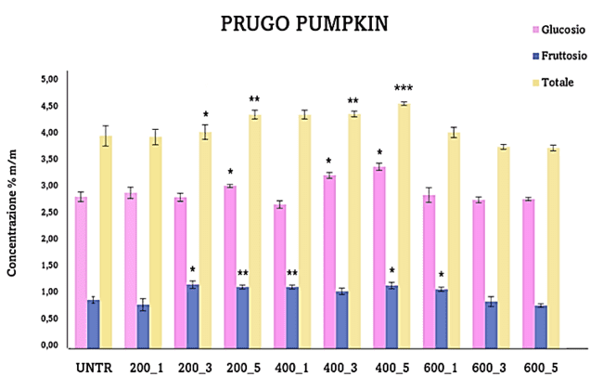

**Sugar profile**

**UNTR HPP200A HPP200B HPP200C HPP400A HPP400B HPP400C HPP600A HPP600B HPP600C**

**Glucose**

**Fructose**

**Total**

**Concentration % m/m**

**Figure 6**  *Concentration in % m/m and standard deviation of glucose, fructose and total sugars in untreated and treated samples.* ***Letters****:* ***UNTR****: raw sample,* ***HPP****: pressure treated samples (200, 400 and 600MPa),* ***A*** *(1mins),* ***B*** *(3 mins) and* ***C*** *(5 mins). * (p < 0.05), ** (p < 0.01), *** (p < 0.001).*

**4. Conclusion**

The high-pressure processing (HPP) is a valuable approach for treating foods because it allows preservation without additives or heat. In this work, we have considered pumpkin as model food and evaluated the effects of HPP process at different pressures and time profile on different structural and chemical constituents. In particular, Untreated samples didn’t show a colour, textural loss and microstructural changes. Pumpkin tissue showed great structural modifications such as changes in cell size and shape, cell wall damage, increases cell wall thickness, cell detachment, cell dehydration, and calcium ions deposition mainly at very high pressures and more time (HPP400C, 600A, B and C). High-pressure treatment from HPP200 to 400 (A and B) pressure less markedly influenced the structural quality means texture and microstructure then others. On the contrary, HPP400A showed a higher amount of antioxidants components availability. On the basis of these results data, we conclude that the treatment with intermediate pressure could ensure a higher amount of “availability” of polyphenols, carotenoids, volatiles, and total sugars in pumpkin sample. In the present study from the reported investigation we understood that the HPP at moderate pressure levels seems to be suitable for retaining stability and concentration of all some quality characterstics and additionally, its acceptable for commercial application for fresh pumpkin.

# **5. References**

Chauhan, O. P. (Ed.) (2019)  *Non-thermal processing of foods*. CRC Press.

Contador, R., González-Cebrino, F., García-Parra, J., Lozano, M., & Ramírez, R (2014) Effect of Hydrostatic High Pressure and Thermal Treatments on Two Types of Pumpkin Purée and Changes during Refrigerated Storage. *Journal of Food Processing and Preservation*, *38*(2), 704–712. <https://doi.org/10.1111/jfpp.12021>

Dhenge, R., Rinaldi, M., Ganino, T., Santi, S., Ferrarese, I., & Dall'Acqua, S (2022) Variations of polyphenols, sugars, carotenoids, and volatile constituents in pumpkin (Cucurbita moschata) during high pressure processing: A kinetic study. *Innovative Food Science & Emerging Technologies*, *78*, 103005. <https://doi.org/10.1016/j.ifset.2022.103005>

Oey, I., Lille, M., Van Loey, A., & Hendrickx, M (2008) Effect of high-pressure processing on colour, texture, and flavour of fruit-and vegetable-based food products: a review. *Trends in Food Science & Technology*, *19*(6), 320-328. <https://doi.org/10.1016/j.tifs.2008.04.001>

Paciulli, M., Ganino, T., Meza, I. G. M., Rinaldi, M., Rodolfi, M., Morbarigazzi, M., & Chiavaro, E. (2021). High pressure and thermal processing on the quality of zucchini slices. *European Food Research and Technology*, *247*, 475-484. <https://doi.org/10.1007/s00217-020-03640-7>

Trejo Araya, X. I., Hendrickx, M., Verlinden, B. E., Van Buggenhout, S., Smale, N. J., Stewart, C., & John Mawson, A (2007) Understanding texture changes of high pressure processed fresh carrots: A microstructural and biochemical approach. *Journal of Food Engineering*, *80*(3), 873–884. <https://doi.org/10.1016/j.jfoodeng.2006.08.014>

Zhang, L., Yao, J., Zhang, Y., Liao, X., Chen, F., & Hu, X (2015) Microstructural and morphological behaviors of asparagus lettuce cells subject to high pressure processing. *Food Research International*, *71*, 174–183. <https://doi.org/10.1016/j.foodres.2015.01.036>

Zhou, C. L., Liu, W., Zhao, J., Yuan, C., Song, Y., Chen, D., Ni, Y. Y., & Li, Q. H (2014) The effect of high hydrostatic pressure on the microbiological quality and physical-chemical characteristics of Pumpkin (Cucurbita maxima Duch.) during refrigerated storage. *Innovative Food Science and Emerging Technologies*, *21*, 24–34. <https://doi.org/10.1016/j.ifset.2013.11.002>