Identification of Virulence Biomarkers in a Listeria monocytogenes ST7 Strain Through Immunoproteomic and Transcriptomic Analysis
Federica D’Onofrio (fdonofrio@unite.it)
Department of Bioscience and Technology for Food, Agriculture and Environment, University of Teramo,
Teramo, Italy
Tutor: Prof.ssa Maria Schirone
Co-Tutor: Dott.ssa Mirella Luciani

The main objective of this PhD project was to identify specific virulence biomarkers of a Listeria monocytogenes 1/2a strain, cultivated under different stress conditions, and to gain insights into the proteins implicated in its pathogenesis mechanisms.

Identificazione di biomarkers di virulenza in un ceppo di Listeria monocytogenes ST7 mediante analisi di immunoproteomica e trascrittomica
Il principale obiettivo del presente progetto di dottorato è stato quello di identificare specifici biomarker di virulenza in un ceppo di L. monocytogenes 1/2a, coltivato in diverse condizioni di stress e ottenere informazioni sulle proteine chiave coinvolte nei meccanismi di patogenesi.

Key words: Listeria monocytogenes; immunoproteomics; biomarkers; transcriptional profiling.

1. Introduction
The present PhD project aimed to identify specific virulence biomarkers of a L. monocytogenes ST7 strain grown at different stress environmental conditions. L. monocytogenes causes listeriosis, a severe foodborne infection in humans. The investigation of key proteins involving in virulence mechanisms of the pathogen is crucial to develop effective control strategies of public health surveillance. In order to achieve this objective, a comprehensive analysis of a L. monocytogenes 1/2a strain immunoproteome was conducted by mean of nLC-MS/MS technique combined with an immunoinformatic approach. Furthermore, a correlation between the immunoproteome and transcriptome was studied by the development of a bioinformatics pipeline, integrating data from both immunoproteomic and transcriptional profiling analyses. By combining different omics approaches, this project aimed to improve our understanding of L. monocytogenes pathogenicity and identify specific biomarkers which can help in early detection, risk assessment, and development of targeted interventions.

2. Materials and Methods
L. monocytogenes ST7 strain was cultivated at C1 (control): T 37°C, pH 7.0, NaCl 0.5%; C2: T 37°C, pH 5.5, NaCl 7%; C3: T 12°C, pH 7.0, NaCl 0.5%; C4: T 12°C, pH 5.5, NaCl 7% (D’Onofrio et al., 2021). Biological and technical triplicates were carried out for each experimental condition. The proteins were extracted, purified, and quantified. Protein extracts were resolved by SDS PAGE and Western blotting (WB) was carried out (D’Onofrio et al., 2022). The immunogenic proteins highlighted by WB were digested in-gel. The peptide extracts were analyzed by nLC-ESI-MS/MS, identified by Proteome Discoverer v1.4.1.14 against the database “uniprot_listeria_monocytogenes”, and then analyzed by immunoinformatic pipeline (Paci et al., 2021). The proteins encoded only in C1 and C4 conditions were correlated with their respective transcripts, obtained by RNAseq analysis, using Cufflinks version 2.2.1 for transcript assembly and Tophat version 2.1.1 for transcripts abundance estimation, and differential expression analysis.

3. Results
In the present project an immunoproteomics approach combined with bioinformatics was applied to identify proteins showing differential expression in L. monocytogenes ST7 strain under different stress conditions and therefore relevant for the presence of the strain in meat products. By detecting antigen-antibody immunocomplexes (Ag-Ab ICs), potential immunogenic proteins specific to each stress condition have been predicted by different bioinformatic tools.
Through a comprehensive analysis using nLC-ESI-MS/MS-based proteome identification, a total of 226 proteins were identified. Among them, 58 proteins (28.3%) were classified as potential antigens, of which 6 membrane proteins were detected as unique in the 3 experimental stress conditions (C2, C3 and C4).
Based on the Kyoto Encyclopedia of Genes and Genomes (KEGG) database, membrane proteins were involved in the functional categories as listed below.
A1) General stress response: Q8Y3Z9 (lmo2679), O32823 (trxB), Q8YAJ3 (lmo0132).
A2) Cell morphology and motility: Q8Y942 (lmo0699), Q8Y919 (lmo0723).
A3) Carbohydrate transport and metabolism and energy production: Q8Y864 (PdhB).

3.1 Immunoblotting

Immunoblotting analysis was conducted using a L. monocytogenes positive ovine serum (Fig. 1). Specific Ag-Ab ICs were detected at 50 kDa and 40 kDa under all growth conditions. Furthermore, Ag-Ab ICs were observed at 110 and 75 kDa in C2 and C3, respectively. Then, specific Ag-Ab ICs were identified at 80 kDa in C3 and C4, and at 60 kDa in C1 and C4.

3.2 Bioinformatic
A total of 226 proteins were identified using nLC-ESI-MS/MS. To predict the subcellular localization of selected proteins, different tools were utilized, including LipoP 1.0 Server, TMHMM Server version 2.0, SignalP 4.1 Server, PSORTb version 3.0.2, and CELLO version 2.5. Among the identified proteins, 76 were non-cytosolic. These proteins were further analyzed using NetSurfP version 1.1 and BepiPred version 1.0 Server in order to assess their localization and predict epitopes exposed to solvent. Fifty-eight proteins were classified as potential antigens using Virulent Pred, Vaxign tool, and VaxiJen Server. Among them, 30 proteins were exclusively present in C1, while 6 proteins were identified in C2, C3, and C4 (Fig. 2).
A specific histidine kinase with a molecular weight (MW) of 100 kDa was found exclusively in C2. Only in C3, the flagellar motor switch protein (FliM) with a MW of 38 kDa was identified, together with lmo0723 (MW 66 kDa) encoded by the gene lmo0723.
In C4, the proteins identified were PdhB (MW 35 kDa), which bears similarity to pyruvate dehydrogenase (E1 b-subunit), thioredoxin reductase (MW 34 kDa), and lmo0132 (MW 55 kDa) involving in DNA repair and maintenance (Table 1) (Wang et al., 2016). Moreover, in C4 the expressed proteins were associated with a higher degree of stress, which could lead to cell damage and cell death. One of the identified proteins was the pyruvate dehydrogenase E1 beta-subunit (PdhB), encoded by the lmo1053 gene. PdhB is part of the pyruvate dehydrogenase enzyme complex (PDH), which played a role in carbohydrate metabolism. Another expressed protein in C4 was thioredoxin reductase, encoded by trxB. This protein is considered part of the oxidative stress response and is regulated by the peroxide operon PerR. Q8YAJ3, encoded by lmo0132 was identified in C4 condition.

3.3 Transcriptomic
The integrated analysis of immunoproteomics and transcriptomics data provided valuable insights into the activation of stress response genes in C4. Among them, gene lmo0613 encoding for lmo0613 proteins-oxidoreductase, exhibited significant upregulation. The oxidoreductases played a crucial role in increasing resistance to oxidative and antibiotic stress in bacteria (Pleitner et al., 2014). The activation of lmo0613 suggested that L. monocytogenes employed this pathway to cope with the challenging environmental conditions in C4. Another gene, lmo1525, encoding for the recombination protein RecS, also displayed pronounced upregulation in C4. Recombination proteins, such as RecS, are known to contribute to various cellular processes, including cold tolerance and DNA repair and recombination. The upregulation of lmo1525 indicated that L. monocytogenes activates DNA repair mechanisms and recombination pathways in response to the combined stressors in C4.
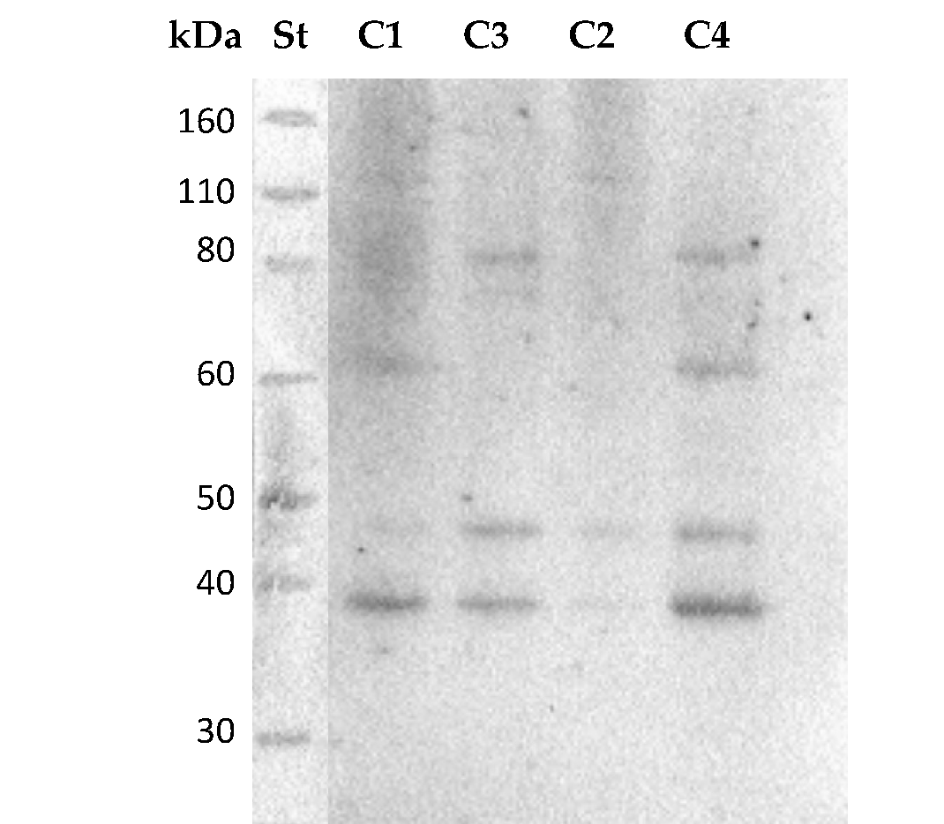

Figure 1 Immunoblotting of L. monocytogenes ST7 strain, cultivated at four different environmental conditions (St: Standard; C1: 37°C, pH 7.0, NaCl 0.5%; C2: 37°C, pH 5.5, NaCl 7%; C3: 12°C, pH 7.0, NaCl 0.5%; C4: 12°C, pH 5.5, NaCl 7%).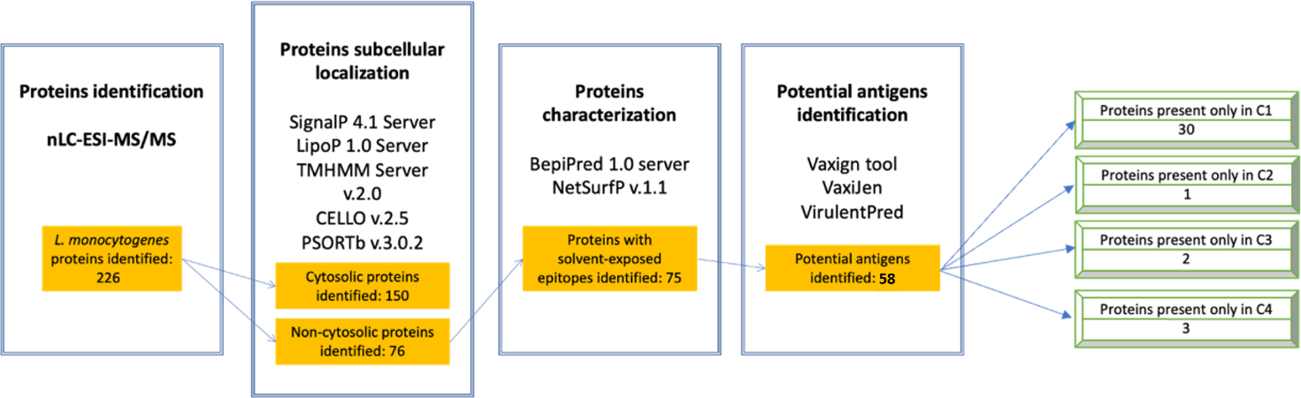
Figure 2 Identification of immunogenic proteins of L. monocytogenes ST7 cultivated at four different combinations of T, pH and NaCl %: bioinformatic workflow (St: Standard; C1: 37°C, pH 7.0, NaCl 0.5%; C2: 37°C, pH 5.5, NaCl 7%; C3: 12°C, pH 7.0, NaCl 0.5%; C4: 12°C, pH 5.5, NaCl 7%).
Table 1 List of identified L. monocytogenes ST7 immunogenic proteins (St: Standard; C1: 37°C, pH 7.0, NaCl 0.5%; C2: 37°C, pH 5.5, NaCl 7%; C3: 12°C, pH 7.0, NaCl 0.5%; C4: 12°C, pH 5.5, NaCl 7%).

Gene | Protein | Function |  | Localization | MW (kDa) |  | Condition
lmo2679 | Q8Y3Z9 | Histidine kinase | Adaptation to high-osmolarity conditions by regulating the expression of a high-afﬁnity potassium uptake system encoded by the kdpABC genes | Membrane |  | 100 |  | C2
lmo0699 | Q8Y942 | Flagellar motor switch protein - FliM | Part of the switch complex that is involved in switching the direction of the flagella rotation | Membrane |  | 38 |  | C3
lmo0723 | Q8Y919 | lmo0723 | Methyl-accepting chemotaxis protein | Membrane |  | 66 |  | C3
lmo1053 | Q8Y864 | PdhB protein | Highly like pyruvate dehydrogenase (E1 beta-subunit) | Membrane |  | 35 |  | C4
trxB | O32823 | Thioredoxin reductase | Protection against oxidative stress by regulating the expression of thioredoxins | Membrane |  | 34 |  | C4
lmo0132 | Q8YAJ3 | lmo0132 | DNA repair and mantainance | Membrane |  | 55 |  | C4

4. Discussion
Listeriosis is recognized as the fifth most frequently reported foodborne disease among humans, and its notification is mandatory in the European Union (EFSA and ECDC, 2021). Consequently, the prevention and control of L. monocytogenes continue to be of greatest importance to ensure food safety worldwide. In recent times, different omics approaches, including proteomics, genomics, and transcriptomics, have emerged as valuable tools for studying the biodiversity of L. monocytogenes strains. In particular, immunoproteomics and transcriptomics provide appreciated insights into the behavior of the pathogen under stress conditions.
In response to stressors, L. monocytogenes can undergo changes in cell morphology, motility, and metabolism to enhance their growth and survival. The present study revealed the presence of histidine kinase (Q8Y3Z9) encoding by the lmo2679 gene when the microorganism is exposed under mild acid and salt stress conditions at 37°C (C2). Histidine kinases are transmembrane proteins that play crucial roles in two-component regulatory signaling systems that induce the transcription of genes encoding membrane desaturases, thereby enhancing membrane fluidity. The expression of the histidine kinase encoded by lmo2679 could be a response to the combined stresses of acidity and salt. In C3, where the only stressor was low temperature, only 2 expressed proteins involved in cell motility were identified.
Previous studies have demonstrated that L. monocytogenes can modulate flagellar motility in response to temperature, salt stress, and pH (Horlbog et al., 2019). The genes associated with cell motility in L. monocytogenes were downregulated under stress conditions. This regulation is crucial because flagella consume energy and could trigger the immune response. In L. monocytogenes, the flagellar motor-switch protein FliM, encoded by lmo0699, is essential for motility and involved in the secretion of other flagellar-related proteins. Most strains exhibit motility below 25°C, so it is not surprising to find the expression of FliM at 12°C. However, in the presence of acid and salt stress (C4) at the same temperature, FliM (lmo0699) was not detected. This finding suggests the impact of combined stress factors on the proteome. Interestingly, another protein Q8Y919, encoded by lmo0723, was identified in C3. Q8Y919 is potentially involved in chemotaxis and motility. In C4, the expressed proteins were associated with a higher degree of stress, which could lead to cell damage and cell death. PdhB, encoded by the lmo1053, plays a role in carbohydrate metabolism. TrxB, encoded by trxB, is considered part of the oxidative stress response, and is regulated by the peroxide operon PerR. TrxB is upregulated in response to harsh environmental conditions, such as after 48 h of desiccation on stainless steel surfaces and under acid shock at pH 3.0 with HCl in highly acid-tolerant field strains (Horlbog et al., 2019). This protein is an enzyme involved in the purine biosynthesis pathway called inosine 5-monophosphate dehydrogenase. It catalyzes the synthesis of xanthosine monophosphate through the NAD+-dependent oxidation of inosine monophosphate. The upregulation of genes, involved in severe stress response and DNA repair, suggested that the cultivation conditions used in C4 induced a response to extreme environmental conditions.
The correlation between immunoproteomics and transcriptomics demonstrated the activation of numerous stress response genes under the most severe stress conditions, such as lmo0613 and lmo1525, involved in cold tolerance and antibiotic resistance, respectively. This observation highlighted a robust and coordinated cellular response by L. monocytogenes to the combined stressors present in C4.

7. Conclusions and Future Perspectives

In conclusion, the present study focused on understanding the proteome’ changes of L. monocytogenes when cultivated under sub-optimal temperature along with mild acid and salt stress conditions commonly found in meat products. Despite extensive research into the stress response of L. monocytogenes, this pathogen continues to pose a significant threat in food production environments, raising concerns for consumer safety. By studying the functions of different expressed proteins and relating them to their transcripts, this research has contributed to understanding their potential roles in the emergence or reemergence of listeriosis outbreaks. The identification of effector proteins secreted under real-time conditions has provided valuable information that can help in the development of new strategies for the treatment and prevention of listeriosis.

8. References
D’Onofrio F, Krasteva I, Schirone M, Torresi M, Tittarelli M, Pomilio F, Iannetti L, Di Febo T, Luciani M (2021) A proteomic approach of the different environmental conditions of Listeria monocytogenes. Eur J Public Health 31: 3.
D’Onofrio F, Visciano P, Krasteva I, Torresi M, Tittarelli M, Pomilio F, Iannetti L, Di Febo T, Paparella A, Schirone M, Luciani M (2022) Immunoproteome profiling of Listeria monocytogenes under mild acid and salt stress conditions. Proteomics 18: e2200082.
Horlbog JA, Stevens M, Stephan R, Guldimann C (2019) Global transcriptional response of three highly acid-tolerant field strains of Listeria monocytogenes to HCl stress. Microorganisms 7(10): 455.
Paci V, Visciano P, Krasteva I, Di Febo T, Perletta F, Di Pancrazio C, D’Onofrio F, Schirone M, Tittarelli M, Luciani M (2021) Identification of immunogenic candidate for new serological tests for Brucella melitensis by a proteomic approach. Open Microbiol J 15: 92-97
Pleitner AM, Trinetta V, Morgan MT, Linton RL, Oliver HF (2014) Transcriptional and phenotypic responses of Listeria monocytogenes to chlorine dioxide. Appl Environ Microbiol 80(9): 2951-2963.
Wang G, Xia Y, Song X, Ai L (2016) Common non-classically secreted bacterial proteins with experimental evidence. Current Microbiol 72: 102-111.

