ORAL COMMUNICATIONS

“Chimeric recombinant protein of Brucella melitensis and Immunological Evaluation for its possible use for the diagnosis of milk”
Annie C. Castillo Ochoa (161747@spes.uniud.it// 1790658@usb.ve )

Interdisciplinary Sciences, University Simon Bolivar, Venezuela
Institute of Advanced Studies Foundation (IDEA), Caracas, Venezuela
Department of Agricultural, Food, Environmental and Animal Science, University of Udine, Italy

Tutor: Prof. Jose David Rosales

Prof. Lucilla Iacumin

Brucellosis is a disease caused by intracellular Gram-negative bacteria, which belongs to the Brucella genera and is distributed worldwide. In humans, the infection is easily transmitted through the consumption of unpasteurized milk or fresh cheese. The diagnosis is based on serological methods, which are not always sensitive or specific due to cross-reactivity with other bacterial antigens. We evaluated single variable domain on a heavy chain (VHH) antibodies against the chimeric recombinant protein BruD, which contain the epitopes Omp25, Bm26 and the Omp31, in milk artificially infected using the DotBlot assay. The antibodies VHH anti-BruD recognize the strain B. abortus 1119-3 up to 60 ng, so it is promising for a better diagnostic anti-brucella test.
.

Development strategy
The aim of the work was to test antibodies of Llama against a recombinant chimeric protein, for the development of serological strategies in the diagnosis of brucellosis with application in foodborne illness. The work was developed by our group in Venezuela during the first part of my PhD. We were focused in the bioinformatics analysis in the omp31 gene, for the identification and selection of the epitopes from Brucella melitensis M15, Brucella abortus RB51 and Brucella abortus 1119 to design a chimeric protein BruD, subsequently the protein was expressed in a BL21 (DE3) system, using pET28a vector, and isolated by polyhistidine-NI affinity chromatography. The, polyclonal antibodies (VHH) against BruD were produced in Llama and evaluated by ELISA indirect and western blot against, Brucella melitensis M15 with high sensibility.

Key words: Brucella abortus, Brucella melitensis, brucellosis, milk, Indirect Methods

1. Introduction
Brucellosis is a zoonosis of food origin that is widespread worldwide, but rare in Europe, being caused by Brucella spp.. Brucella melitensis and Brucella abortus are gram-negative, facultative intracellular bacteria classified within the genus Brucella [1-3]. It is transmitted to humans through contact with infected livestock or by consumption of farm animal products. In humans, it causes weakness and debilitating febrile illness, known as an undulant fever by chronic infections, or aborts and infertility in bovines and other animals, resulting in severe economics losses and public health problems [4]. The more common methods for the detection are serological assays against bacteria’s liposaccharides as ELISA test, as well as standard tube agglutination test (STAT), and the rose bengal plate agglutination test (RBPT). In Venezuela, the RBPT is used as a serologic detection method and STAT as a confirmation method test for brucellosis´s diagnosis [5]. The RBPT is non-expensive but low specific, therefore, the development of a faster and reliable method for brucellosis detection is quite important for foodborne illness.

2. Experimental Procedure

2.1 Evaluation of the use of IgG VHH for its application in the detection of Brucella abortus 1119-3, through a DotBlot.
To perform the Dot-blot assay, we used two different hardenings: BruD recombinant protein, from 90 ng diluted 1:2 to 3 ng, and whole Brucella abortus strain 1119-3 bacteria, from 270 ng diluted 1:2 to 17 ng. Nitrocellulose membrane (0.45 mm PIERCE) cut with the following measurements: 10 cm long x 7.5 cm wide. The sensors were placed for each dilution per well and allowed to air dry, then the membrane was placed under constant agitation at room temperature for 3 hours in 0.2 M Na₂HPO₄, 0.5 M NaH₂PO₄, pH 7.5 blocking solution; 0.05 % v/v Tween 20 and 5 % w/v skimmed milk. The membrane was incubated at room temperature for 30 minutes under excitement in incubation solution with a 1:100 dilution with the main anti-BruD. It was then washed five times for 5 min using PBS-T PBS wash solution, 0.1% v/v Tween 20. The reaction with the secondary was initiated by diluting peroxidase-conjugated anti-llama IgG diluted 1:5000 in blocking solution in the same conditions, then the membrane was washed following the previous indications. Detection was performed with 10 mg diaminobenzidine in 20 ml PBS, 50 μl 1 % CaCl₂ and 7 μl 3 % H₂O₂ with gentle compression. The reaction was quenched with H₂O_{d}.

2.2 Evaluation of the use of a polyclonal anti-BruD Llama serum for its application in the detection of anti-Brucella sp. using a sandwich DotBlot.
The adequate amount of antibody to sensitize the nitrocellulose membrane was standardized, working with 10 μl of a 1:100 dilution of each positive and negative serum previously evaluated by ELISA. A concentration of 60 ng of Brucella abortus strain 1119-3 and BruD was used, a 1:1000 dilution of the anti-BruD VHH antibody and 1:5000 for the anti-llama conjugate. It was challenged with diaminobenzidine and in cases where the formation of a dark coloration was observed, it was considered a positive result (Fig 2). Clear recognition was observed with the volume of antibodies tested. In the case of the negative sample, it was established that a weak signal, such as the one shown in Figure 2, is the maximum that can be observed in a sample of this type, maintaining the membrane for 5 min in the presence of the solution. Revealed

2.3- Sandwich DotBlot against Brucella 1119-3 in skim milk
A variant of the Dot-Blot similar to the previous described was carried out, where in order to assess the usefulness of the Llama anti-BruD polyclonal antibody to capture Brucella abortus strain 1119-3 bacteria in skimmed milk artificially contaminated with the bacteria. In this assay, we used positive and negative bovine antibodies to be fixed on a nitrocellulose membrane, after blocking, we placed 20 ng of Brucella abortus 1119-3 bacteria in skimmed milk diluted to 5 %, incubated for 1 h, washed with PBS and then incubated with 100 μl of the antibody purified by BruD immunosorbent. To determine its presence, it was incubated with the anti-flame conjugate.

3. Materials and Methods
In order to evaluate the potential of Llama single chain antibodies as a tool for the detection of Brucella sp. the DotBlot assay was performed. The evaluation process of the antibodies against the bacterial suspension B. abortus strain 1119 -3 and BruD was carried out in order to verify if the method works against the antigen with which the antibodies were induced. Higher to lower concentrations of strain 1119 and recombinant BruD diluted in 5 % skim milk and PBS-Tween solution were stained on a nitrocellulose membrane. Then, the VHH anti-BruD antibody was used at a 1:1000/well dilution. To detect this antibody, 1/5000 peroxidase-conjugated anti-Llama conjugate was placed in PBS-Tween. Then developed with diaminobenzidine.

4. Results and Discussion
4.1 - Evaluation of the use of IgG VHH for its application in the detection of Brucella abortus 1119-3, through a DotBlot.

As we can see in the Figure 1, using polyclonal tools as detection manifestations in the DotBlot assay, it was able to capture or detect the antibodies present on the surface of the nitrocellulose membrane in presence of skim milk.

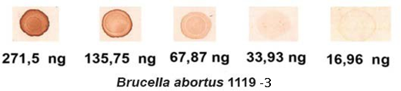

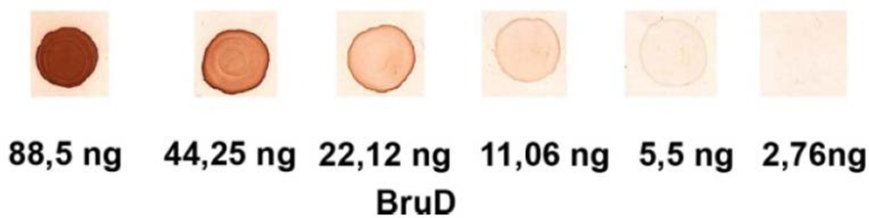
Figure 1 Dot-Blot assay. Detection test for Brucella abortus1119-3 and BruD antigen using an anti-BruD Llama polyclonal Nitrocellulose paper was sensitized from higher to lower concentrations of strain 1119-3 and BruD. Anti-Llama peroxidase conjugated antibody was used at a 1/5000 dilution. In A, recognition of Strain 1119-3 is observed up to a concentration of 17 ng and in B of BruD up to 5.5 ng.
This result means that Llama's tests confirm the epitopes of the Omp25, Bm26 proteins and the Omp31-like protein present in the bacterium Brucella abortus strain 1119-3.

4.2 Evaluation of the use of a polyclonal anti-BruD Llama serum for its application in the detection of anti-Brucella sp. using a sandwich DotBlot.
Clear recognition was observed with the volume of antibodies tested. In the case of the negative sample, it was established that a “faint” signal, such as the one shown in figure 2, is the maximum that can be observed in a sample of this type, maintaining the membrane for 5 min in the presence of the developing solution.
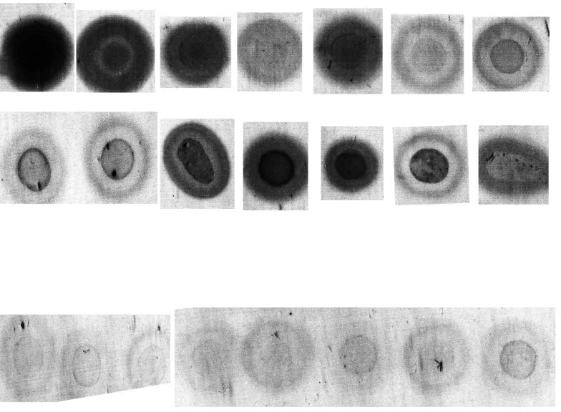
Positive Bovine Serum
Positivos Bovinos
Negative Bovine Serum
Positivos Bovinos

Figure 2 Sandwich Dot-Blot assay. Control sera previously evaluated by the ELISA test were evaluated. Positive serum give an evidently positive signal when compared to negative serum.

4.3 Sandwich DotBlot against Brucella 1119-3 in skim milk.
The Dot-ELISA technique showed to be sensitive and accessible, since it does not require specialized equipment as in the case of ELISA, Western-blot or indirect immunofluorescence, among other techniques. The interpretation of results is simple and the recombinant BruD protein can be used as antigen, the Dot-ELISA technique is a diagnostic technique that could be used as a first screening in endemic areas or for field studies. A graphic description of the technique is shown in Figure 3.
Figure 3 Graphic of a Dot Blot type immunological test using anti-Brucella sp. of bovine fixed to nitrocellulose and as antigen the strain of Brucella 1119-3 in milk artificially contaminated milk.

Figure 4 Dot Blot sandwich against Brucella abortus 119 (20ng) in skim milk. shows that positive sera clearly capture the bacteria in the presence of artificially contaminated skimmed milk, while negatives do not. It is a qualitative test that demonstrates the usefulness of "VHH" single chain antibodies for the diagnosis of Brucella sp.

6. Conclusions and Future Perspectives

The use of policlonal antibodies of Llama antiBruD could be improved in the level of specificity for being used in the development of serological assays as DotBlot. However, the use of VHH policlonal simple chain is a novelty. This achievement will undoubtedly allow commercial independence in relation to antigen production, taking a big step at the institutional level on the path towards the production of diagnostic kits against Brucella in foodborne illness.

8. References
- Abdollahi, A., Mansouri, S., Amani, J., Fasihi-Ramandi, M., & Moradi, M. (2016). Immunoreactivity evaluation of a new recombinant chimeric protein against Brucella in the murine model. Iran J.Microbiol., 8, 193-202.
- Ahmed, I. M., Khairani-Bejo, S., Hassan, L., Bahaman, A. R., & Omar, A. R. (2015a). Serological diagnostic potential of recombinant outer membrane proteins (rOMPs) from Brucella melitensis in mouse model using indirect enzyme-linked immunosorbent assay. BMC.Vet.Res., 11, 275.
- Ahmed, I. M., Khairani-Bejo, S., Hassan, L., Bahaman, A. R., & Omar, A. R. (2015b). Serological diagnostic potential of recombinant outer membrane proteins (rOMPs) from Brucella melitensis in mouse model using indirect enzyme-linked immunosorbent assay. BMC.Vet.Res., 11, 275.
- Alfano, E. F., Lentz, E. M., Bellido, D., Dus Santos, M. J., Goldbaum, F. A., Wigdorovitz, A. et al. (2015). Expression of the Multimeric and Highly Immunogenic Brucella
- Sanchez Villalobos, A. Analysis of brucellosis and tuberculosis situation in Venezuela.(2021). Revista de la Facultad de Ciencias Veterinarias. Vol 62, N.1.

