Plant growth promotion and antibiotic resistance of invading bacteria in a plant holobiont perspectives
Joa Patania (joa.patania@unimi.it)
Dept. of Food, Environmental and Nutritional Sciences, University of Milan, Italy
Tutor: Prof. Francesca Mapelli
The first two-years activities of this PhD focused on the plant holobiont response to the administration of different non-pathogenic invading bacteria considering the plant growth, the shift of the plant microbiome composition and the possible spread of emerging contaminants (i.e., antibiotic resistance genes - ARGs) in agri-food ecosystems. Firstly, the acquisition of ARGs by a plant associated bacterium has been investigated in planta. Secondly, the response of micropropagated plants and their endophytic microbiome to the inoculation of putative beneficial strains has been characterized.
Capacità di promozione della crescita vegetale e antibiotico resistenza di batteri invasori dell'olobionte vegetale
Le attività dei primi due anni di PhD si sono focalizzate sulla risposta dell’olobionte vegetale alla somministrazione di differenti batteri invasori non-patogeni, considerando la crescita della pianta, il cambiamento della composizione del microbioma vegetale e la diffusione di contaminati emergenti (i.e., geni dell’antibiotico resistenza) in sistemi agro-alimentari. È stata studiata in planta l’acquisizione di geni dell’antibiotico resistenza da parte di un batterio associato alle piante. In un secondo caso studio, sono state caratterizzate le risposte di piante micropropagate e del loro microbioma endofitico all’inoculazione di ceppi batterici descritti come possibili promotori della crescita.

Key words: plant-growth promotion, plant holobiont, antibiotic resistance spread, micropropagation, invasion.

1. Introduction
Plants and their associated microbiota can be defined as ‘holobionts’ (Trivedi et al., 2020). Till now, bacterial invasion in plants has been largely studied in relation to pathogens, while few data are available regarding this phenomenon in the frame of beneficial (i.e., Plant Growth Promoting strains) or neutral (i.e., antibiotic resistant) plant-bacteria interaction. However, the ability to successfully colonise the plant is one of the major factors limiting the application of microbial biofertilizers and biostimulants in the field, and a better understanding of invasion would benefit sustainable agriculture. Moreover, antibiotic production and/or resistance are key traits for the colonization of environmental niches, including the rhizosphere. Antibiotic resistant bacteria and Antibiotic Resistant Genes (ARGs) can enter agri-food ecosystems by different routes including water reuse after depuration (Christou et al., 2017) and horizontal gene transfer plays a crucial role in the spreading of ARGs (Santala et al., 2016) in several micro-niches, including plant surface. Given the importance of the plant microbiome and beneficial bacteria for food production, and the risk of antibiotic resistance spread through HGT in food systems, I am focusing the research activities of my PhD on the intersections with plant growth promoting and antibiotic resistant bacteria, in compliance with the One Health concept. This will be seen from a holistic approach, considering both the plant and the bacterial community response to the addition of specific bacterial strains.

2. Materials and Methods
In the first round of experiments, the environmental strain Acinetobacter baylyi BD413 was used to study the acquisition of extracellular DNA (exDNA) carrying an antibiotic resistance gene (ARG) on lettuce phylloplane, performing experiments at conditions (i.e., plasmid quantities) mimicking those that can be found in a water reuse scenario. Moreover, we assessed how the presence of a surfactant, a co-formulant widely used in agriculture, affected exDNA entry in bacteria and plant tissues, besides the penetration and survival of bacteria into the leaf endosphere. Natural transformation of A. baylyi BD413 in presence of pZR80 (gfp) plasmid was tested in planta using lettuce plants (Lactuca sativa var. Canasta) under greenhouse conditions. The experiment was conducted using four replicates, corresponding to four leaves of the same lettuce plant: the four leaves were inoculated with 10⁹ cell/mL A. baylyi BD413 cell suspension mixed with 10 ng of the pZR80 (gfp) plasmid (final volume of 100 µL). In addition, one leaf was inoculated with cell suspension (no plasmid, negative control) to assess the absence of native kanamycin-resistant bacteria on the lettuce phylloplane. Each bacterized leaf was covered using a sterile empty Petri dish to avoid environmental contamination from the greenhouse. After 24 h, the inoculated leaves were removed from the plant with a sterile scalpel and kept in the Petri dishes, where, after surface-sterilization, we isolated total and transformant A. baylyi BD413 colonies from the leaf surface and endosphere. The strain identity, and the acquisition of the gfp gene was checked by PCR to assess the occurred transformation. Detailed protocols have been published along with the study results by Riva et al. 2022.
In the second case-study, we characterized for PGP activities a collection of endophytic strains established from grapevine and lettuce collected in the field. Among the most promising strains, Rhizobium sp. GR12 and Kosakonia sp. VR04 were tagged with genes coding for fluorescent proteins and used to inoculate micropropagated grapevine cuttings. Plantlets were grown in vitro for three weeks under optimal growth conditions or on a diluted medium to mimic nutritional deficit. Afterwards the plant biomass was measured to evaluate the PGP activity of the strains, and the colonization of the plant tissues was assessed through qPCR amplification of the marker genes from the DNA extracted from plant tissues. We described the endophytic community of micropropagated grapevine plants by integrating high-throughput 16S rRNA gene sequencing and cultivation-based analyses.

3. Results and Discussion
Figure 1 Influence of heptamethyltrisiloxane on (a) the natural transformation of A. baylyi BD413 on lettuce phylloplane, expressed as transformation frequency and (b) the strain ability to enter the leaf tissue, shown as total cells and (c) for transformed ones. Letters indicate significant differences according to Student’s t-test.
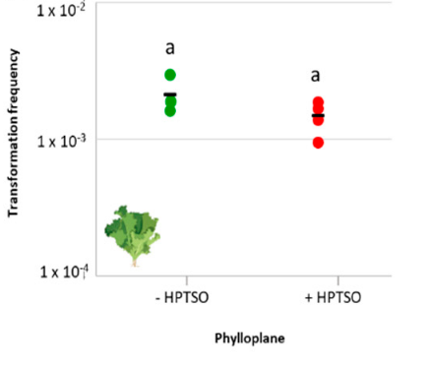
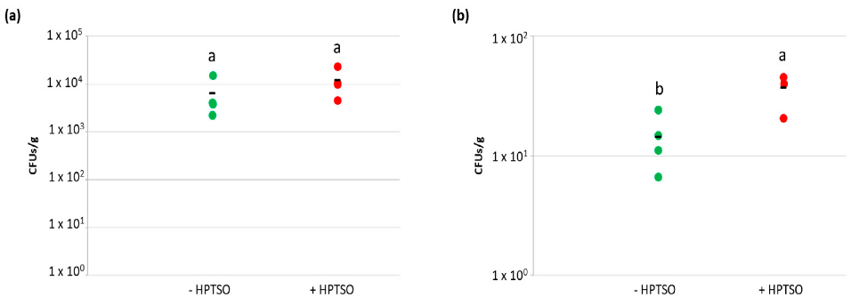
a)
b)
c)
a)

In planta natural transformation experiment was performed to determine the transformation frequency on lettuce phylloplane, in the presence and absence of HPTSO (Figure 1A). The effect of the tested surfactant on the permeability of A. baylyi BD413 cell membrane was assessed in presence of HPTSO. The bacterial cell permeability was not influenced by the presence of the surfactant in the growth medium, coherently with the lack of increased natural competence. Considering that the application of surfactant molecules may enhance the internalization of bacteria into lettuce leaves, by performing the natural transformation experiment in planta we also aimed at measuring the concentration of A. baylyi BD413 total and transformant colonies in the lettuce leaf tissues. As hypothesized, the concentrations of total and transformant A. baylyi BD413 colonies in the lettuce endosphere showed higher values in leaves treated with HPTSO (Figure 1B-C) and such difference was statistically significant for transformant colonies (p= 0.0149). The latter result could be related to a higher uptake of exDNA by plant tissues in the presence of HPTSO resulting in the occurrence of transformation events directly in the endosphere.
On the other hand, for the second case study, high-throughput 16S rRNA gene sequencing and cultivation-based analyses showed that bacterial endophytic community of grapevine cuttings differed from those generally associated to this plant species in the field. Moreover, the composition of the endophytic community was differently modulated by Rhizobium sp. GR12 and Kosakonia sp. VR04 and specific taxa were enriched or depleted in response to the invasion by these bacteria, reflecting the different plant response in terms of growth promotion.
Our results confirmed the importance of interplays between the plant microbiome members and their dependence upon the plant growth conditions, shedding a light on the previously hidden diversity of endophytic community in micropropagated grapevine plants.

4. References
Trivedi P., Leach J.E., Tringe S.G., Sa T, Singh B.K. (2020). Plant-microbiome interactions: from community assembly to plant
health. Nature Reviews, Microbiology Reviews, volume 18, november 2020
Christou A., Aguera A., Bayona J.M., Cytryn E., Fotopoulos V, Lambropoulou D., Manaia C.M., Michael C., Revitt M., Schroder P., Fatta-Kassinos D., (2017). The potential implications of reclaimed wastewater reuse for irrigation on the agricultural environment: The knowns and unknowns of the fate of antibiotics and antibiotic resistant bacteria and resistance genes - A review. Water Research, 123:448-467
Santala V., Karp M., Santala S., (2016). Bioluminescence-based system for rapid detection of natural transformation. FEMS Microbiology letters, 363.
Riva V., Patania G., Riva F., Vergani L., Crotti E., Mapelli F. (2022). Acinetobacter Baylyi strain BD413 can acquire an antibiotic resistance gene by natural transformation on lettuce phylloplane and enter the rizosphere. Antibiotics 2022, 11(9), 1231.

