POSTER COMMUNICATIONS

Evolution of green and black kombucha tea microbial consortia composition and in vitro bioactivity during six successive monthly preparations
Gloria Ghion (gloria.ghion@phd.unipd.it)
Dipartimento di Agronomia, Animali, Alimenti, Risorse Naturali e Ambiente (DAFNAE), Università degli Studi di Padova, Legnaro (PD), Italy
Tutor: Prof. Alessio Giacomini

Preliminary results of the main activities investigated during the two years of PhD are presented. Kombucha is traditionally produced from the fermentation of green or black tea by a cellulosic biofilm known as SCOBY (Symbiotic Culture of Bacteria and Yeasts), which consists of a symbiosis of acetic bacteria, lactic acid bacteria, and yeasts. The aim of the project is to study the evolution of the microbial population in both black and green kombucha drinks during a consecutive period of six months production, with monthly intervals. Furthermore, the study evaluates correlations among different consecutive production of kombucha beverages and related bioactivities, using in vitro tests.

Evoluzione della composizione microbica di kombucha verde e nero e bioattività in vitro di sei mesi consecutivi
Di seguito sono presentati i risultati preliminari delle principali attività svolte durante i due anni di dottorato. Il kombucha è tradizionalmente prodotto dalla fermentazione di tè verde o nero mediante un biofilm cellulosico, noto come SCOBY (Symbiotic Culture of Bacteria and Yeasts), che consiste in una simbiosi di batteri acetici, lattici e lieviti. Lo scopo del progetto è determinare l'evoluzione della composizione microbica di kombucha nero e verde durante un periodo consecutivo di sei mesi di produzione fatta a cadenza mensile. Inoltre, lo studio valuta le correlazioni tra diverse produzioni consecutive di kombucha e le relative bioattività, utilizzando test in vitro.

Key words: Kombucha, SCOBY (Symbiotic Culture of Bacteria and Yeasts), fermentation.

Introduction
In accordance with the PhD thesis project, the main results of the activities are reported:
  - production of black and green kombucha tea over six consecutive months;
  - characterization of green and black kombucha at the end of fermentation time trough microbiological analyses and pH measurements.

Materials and Methods
For beverage production, two sets of kombucha (green and black) were made each month during the period October 2022 – April 2023. Kombucha was produced from tea leaves according to the methodology used by Cardoso et al. (2020). Firstly, 50 g/L of sucrose were added to 1 L of sterile water. Then, for the infusion stage, black tea (Darjeeling Gielle FTGFOP1 Second Flush) and green tea (Lung Ching) were added at a concentration of 12 g/L in the water at 95 °C for 4 min and 75 °C for 1 min, respectively. After infusion, the beverage was strained through a cotton gauze and poured into sterile glass jars of 18 cm height and 10 cm diameter. The tea was kept in an ice bath to reach room temperature quickly. Then, 3% (w/v) of SCOBY (Enziquímica, Gravataí-RS, Brazil) and 100 mL/L of a previously produced kombucha batch were added (de Noronha et al., 2022). The opening of the jars was covered with a clean cotton cloth and fermentation was carried out in the dark, at 25 ± 2 °C for 5 days for green kombucha and 7 days for black kombucha. After fermentation, kombucha was used for microbiological analyses and pH measurement. The SCOBY was collected with a sterile pinzel and stored in 30 mL of kombucha in a closed tube at 5 °C for future analysis. Kombucha samples were transferred to microtubes (2 mL aliquots), centrifuged at 15,000 rpm for 15 min and stored at - 20 °C until further analysis. The pH of green and black kombucha after fermentation was measured using a bench pH-meter (Hanna Instruments, USA). Microbiological counts were done using the spread plate technique performed in triplicate. The mesophilic aerobic count was determined on Plate Count Agar (PCA), while Potato Dextrose Agar (PDA) was used for the yeasts count. Acetic acid bacteria (AAB) were analysed on Glucose Yeast Carbonate agar (glucose 50 g/L, yeast extract 10 g/L, calcium carbonate 5 g/L and agar 20 g/L), while lactic acid bacteria (LAB) were counted on Man Rogosa Sharpe (MRS) agar. Plates were incubated at 30 °C for 3 days under aerobic conditions. All the experiments were performed in triplicate. Data were analyzed using a one-way analysis of variance (ANOVA). Tukey’s test was used as a post-hoc analysis by the GraphPad Prism software (version 7, GraphPad Software, Inc., San Diego, CA, USA). Results were considered significantly different for p values lower than 0.05.

Results and Discussion
The first kombucha production (November 2022 for black tea and October 2022 for green tea) showed microbial counts significantly different from the following months, except for yeasts and AAB in black kombucha. During the successive months the average of bacterial and yeasts count showed a reduction in both green and black kombucha over time, largely detected for January. Although production conditions were maintained constant, microbial counts tended to decrease during the first 3 months and then showed an increase towards the first month values. Increase of LAB in green kombucha was particularly relevant. The pH was measured at the beginning (ranging between 4 and 4,5) and at the end of fermentation (Tab. 1).
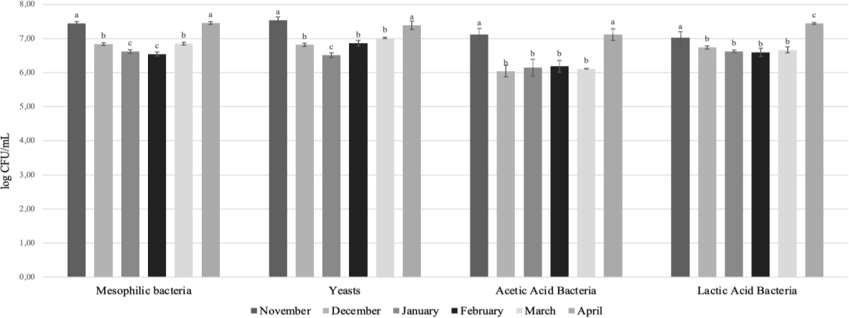

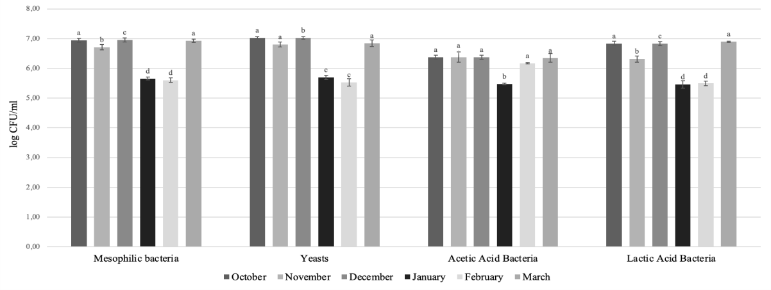

Figure 1 Microbiological characterization of green (above) and black (below) kombucha. Results were expressed as mean of three repetitions. Error bars indicate ± standard deviation. Means followed by the same letter, for the same microbial group, are not significantly different (p < 0.05).

Table 1 Green and black kombucha pH after 5 and 7 days of fermentation, respectively.

Kombucha | Month | pH | Kombucha | Month | pH
 | November | 3.31 |  | October | 3.50
 | December | 3.00 |  | November | 3.15
Green | January | 3.01 | Black | December | 3.22
 | February | 3.00 |  | January | 3.03
 | March | 2.83 |  | February | 2.90
 | April | 3.05 |  | March | 3.20

References
Cardoso RR, Neto RO, dos Santos D’Almeida CT, do Nascimento TP, Pressete CG, Azevedo L, Martino HD, Cameron LC, Ferreira MSL, de Barros FAR (2020) Kombuchas from green and black teas have different phenolic profile, which impacts their antioxidant capacities, antibacterial and antiproliferative activities, Food Res. Int. 128, 108782.
de Noronha MC, Cardoso RR, dos Santos D’Almeida CT, do Carmo MAV, Azevedo L, Maltarollo VG, Ribeiro Júnior JI, Eller MR, Cameron LC, Larraz Ferreira MS, de Barros FAR (2022) Black tea kombucha: Physicochemical, microbiological and comprehensive phenolic profile changes during fermentation, and antimalarial activity, Food Chem. 384,132515.

