Green sensors and smart services for the optimization of agri-food supply chains with a view to industry 4.0: greater sustainability of production, business competitiveness and reduction of food waste
Sara Vignati (sara.vignati@unimi.it)
Dept. of Food Environmental and Nutritional Sciences, University of Milan, via Celoria 2, Milan, Italy
Tutor: Prof. Riccardo Guidetti, Co-tutor: Prof. Roberto Beghi

The PhD project is aimed at design a portable, user-friendly, and low-cost hyperspectral (HSI) sensor that will be applied on fresh-cut products in laboratory conditions to evaluate some quality parameters. The hyperspectral prototype underwent a first calibration phase in which specific light sources were used (i.e., halogen lamp and LEDs). Secondly, the performance of the HSI camera was evaluated in controlled conditions. A first test was performed on a standard (i.e., Rubik’s cube) and then on food matrix.

Sensori green e servizi intelligenti per l'ottimizzazione delle filiere agroalimentari in un’ottica di industria 4.0: maggiore sostenibilità della produzione, competitività delle imprese e riduzione degli sprechi alimentari
Questo progetto di dottorato ha lo scopo di sviluppare un sensore iperspettrale portatile, facile da usare e a basso costo che verrà utilizzato in condizioni di laboratorio su prodotti di IV gamma per valutarne alcuni parametri qualitativi. Il prototipo iperspettrale ha subito una prima fase di calibrazione in cui sono state utilizzate specifiche sorgenti luminose (i.e., lampada alogena e LED). In un secondo momento, le performance della telecamera iperspettrale sono state valutate utilizzando un set-up di acquisizione in condizioni controllate. Un primo test è stato eseguito utilizzando uno standard (cubo di Rubik) e successivamente una matrice alimentare.

Keywords: Hyperspectral imaging, cost-effective sensor, image processing, food quality, post-harvest.

1. Introduction
In accordance with the PhD thesis project previously described (Vignati, 2022), this poster reports the main results of the first activities concerning:
(A1) the testing phase in laboratory conditions of the hyperspectral (HSI) camera prototype, in terms of calibration of the device and application of hyperspectral imaging on food matrix, thanks to the development of a software for image acquisition and elaboration in MATLAB® environment;
(A2) the application of chemometrics techniques using MATLAB® to analyse the hyperspectral data obtained.

2. Materials and Methods
Firstly, the assembled HSI prototype has been calibrated by positioning the device in an acquisition stage in order to acquire pictures of light sources which emit at predefined wavelengths (i.e., red, green and blue LEDs, and a halogen lamp). Such a critical process allows to identify the spatial position of the pixels corresponding to the wavelengths of the electromagnetic spectrum. Thus, five calibration images have been acquired:
- The first image was acquired to identify the Region of Interest (ROI) corresponding to the real image, using a halogen lamp (darkroom not needed in this case).
- The second image was acquired using the halogen lamp inside the darkroom in order to identify extension of the diffracted spectrum (first order of diffraction) from the visible (Vis) to the Near Infra-Red (NIR) spectral regions.
- The third, fourth and fifth are acquired inside the darkroom for each LED, in the Red (R), Green (G) and Blue (B) channels to identify each peak of emission with a well-known wavelength inside the visible range of the spectrum. (Salazar-Vazquez and Mendez-Vazquez, 2020).
Each emission peaks of the RGB channels were determined using a portable spectrophotometer.
Once calibrated, the performances of the prototype were evaluated using a specific set-up in order to standardize the image acquisition in lab-scale conditions. The set-up was composed by an integrating sphere (hollow hemisphere with perfectly diffusing internal surface that allows a complete reflection of the light toward the sample), a camera holder and light bulbs (halogen lamps and LEDs) inside the sphere and that can cover a spectral range from 300 to 1000 nm. The HSI camera was positioned at 70 cm from the sample, and a first test was performed using a common 3x3 Rubik’s cube (with a line of red squares, a line of blue ones and one of green) to obtain a linear scan of the image and use it to visually evaluate the accuracy of the hyperspectral device. Then, tests using a food sample were performed in order to have an initial screening of the capability of the system to detect spectral differences in the food sample.

3. Results and Discussion
All the acquired images (both of calibration and the sample ones) are composed of three parts (Fig. 1): in the middle there is the real image (i.e., the light source or the sample) or ROI, while on its sides there is the diffracted light (called “first order of diffraction”); the axes represent the chosen resolution of the camera (1280x720).
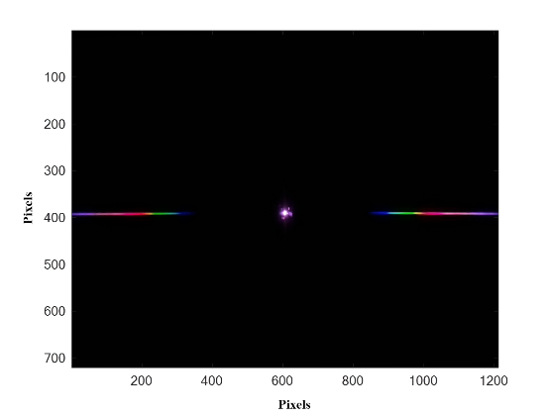
As mentioned, the calibration images were elaborated with MATLAB® in order to: (i) determine the area of the central ROI and (ii) the length of the first order of diffraction corresponding to the spectral range of 400-1000 nm, and (iii) to identify the centroids of each RGB channel based on the ROI area (Fig. 2 – on the left). Finally, at each centroid was assigned the corresponding value of the emission peak of the LED, i.e., 632 nm, 522 nm and 462 nm for R, G, and B, respectively (Fig. 2 – on the right).

Figure 1 Calibration image acquired inside the darkroom with a halogen lamp. It is composed by three parts: the ROI or real image in the centre, the first order of diffraction on the left and the first order of diffraction on the right.

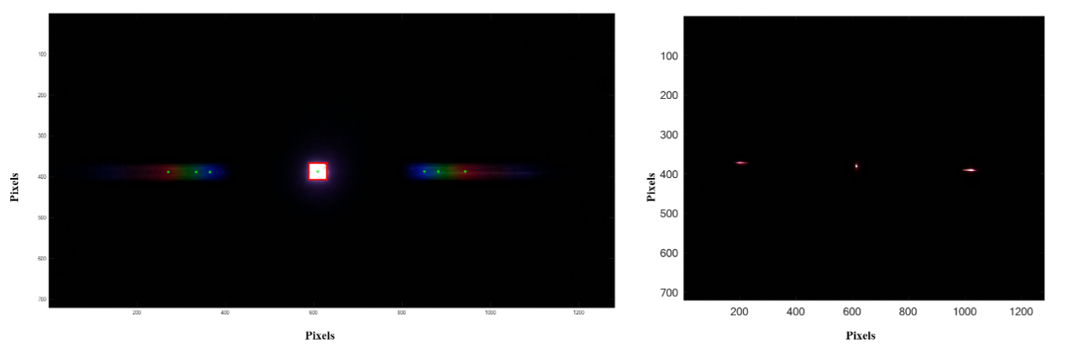
Figure 2 ROI (in red) and centroids (in green) identification in the image acquired outside the darkroom with a halogen lamp (on the left) and the image acquired inside the darkroom with the Red LED (on the right).
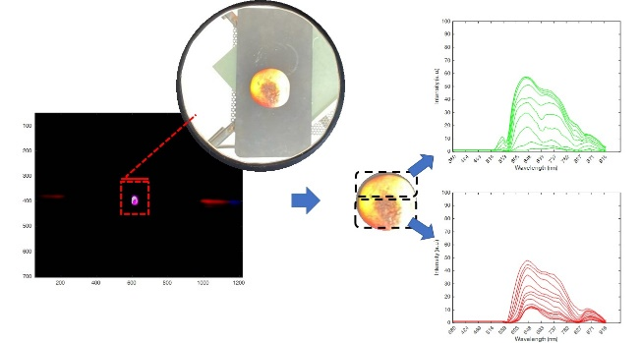
The first test was performed using a Rubik’s cube as a standard in order to compare the spectrum of each coloured face of the cube with the spectrum extrapolated from the diffracted image. Then, tests using a food matrix were performed using firstly an apple with a damaged tissue to have a first screening of the capability of the system to detect spectral differences between the sound and the damaged tissues (Fig. 3). Some differences between the two types of tissues were identified, such as the shape, intensity and presence/absence of peaks at specific wavelengths (e.g., the sound tissue has a higher peak at 630 nm, and there is a slight signal in the blue region at about 522 nm that is absent in the case of the damaged tissue). The experimental results agree with the expected ones and further tests on other food matrix are still ongoing. Thus, the PhD thesis project can proceed without any significant modification.
Figure 3 Image acquired on an apple (on the left) and the corresponding spectra of the sound tissue (in green) and of the damaged tissue (in red).

4. References
Vignati S (2022) Green sensors and smart services for the optimization of agri-food supply chains with a view to industry 4.0: greater sustainability of production, business competitiveness and reduction of food waste. In Proc.s of the 26th Workshop on the Developments in the Italian PhD Research on Food Science, Technology and Biotechnology, Asti (Italy), 19-21 September 2022, pp. 197-198.
Salazar-Vazquez J, Mendez-Vazquez A (2020) A plug-and-play Hyperspectral Imaging Sensor using low-cost equipment. HardwareX, 7: e00087

