Ready-to-Eat Food as a Vehicle of Microorganisms in the Context of the Microbial Deprivation Hypothesis
Giacomo Mantegazza (giacomo.mantegazza@unimi.it)
Dept. Food, Environment and Nutritional Sciences, University of Milan, Milan, Italy
Tutor: Prof. Simone Guglielmetti

The aim of this PhD thesis is to investigate whether different cultivation methods can affect the total load and the diversity of food associated microbes. Secondly, this PhD thesis aims to examine if food associated microbes – and especially lactic acid bacteria (LAB) – can survive the human gastrointestinal transit and arrive alive at the intestine.

Prodotti di quarta gamma come veicolo di batteri nel contesto dell’ipotesi dell’igiene
L'obiettivo di questa tesi di dottorato è quello di indagare se diversi metodi di coltivazione possono influenzare la carica totale e la diversità di microrganismi associati agli alimenti. In secondo luogo, questa tesi di dottorato mira a esaminare se i microrganismi associati agli alimenti – in particolare i batteri lattici (LAB) – possono sopravvivere al transito gastrointestinale umano e arrivare vivi nell'intestino.

Key words: Ready-to-eat salad, gut microbiota, microbial diversity, rocket salad.

1. Introduction
In accordance with the PhD thesis project previously described (Mantegazza, 2021), this oral communication reports the main results of the following activities directed to:
A1) Microbial Characterization of commercially available rocket salads, and bacterial strain library set-up;
A2) taxonomic characterization of rocket salad strains;
A3) in vitro and in vivo survival of lactic acid bacteria associated with rocket salad.

2. Food, bacteria, and diseases
Since the discovery of microorganisms, they have been primarily associated with food spoilage and disease. To combat harmful microbes, various methods for preserving and sanitizing food have been implemented, inadvertently eliminating harmless microbial populations. This unintended consequence of hygiene practices has raised concerns in light of the microbial depletion hypothesis (Scudellari, 2017), which suggests that reduced exposure to microorganisms may contribute to immune diseases and allergic disorders. Industrialization and the adoption of modern lifestyles have brought about significant changes in the human gut microbiota. The widespread use of antibiotics, extensive sanitation, and the prevalence of processed foods have led to a reconfiguration of microbial ecosystems, resulting in the rise of chronic metabolic and immune diseases (Blaser, 2016; Sonnenburg & Sonnenburg, 2019). Recent studies have shown that dietary factors commonly found in Western-style diets directly influence the structure of the gut microbiota and promote detrimental metabolic consequences. High consumption of dietary fat, simple sugars, sodium chloride, and synthetic or natural additives alters the composition and function of the microbiota, increases gut permeability, triggers inflammation, and contributes to metabolic dysregulation (Zmora et al., 2019). The role of diet in altering the gut microbiota has led to the suggestion that integrating Western-style diets with fermented foods could counteract the negative consequences of microbial deprivation. Fermented foods, rich in lactic acid bacteria (LAB), have been recognized for their health benefits (De Filippis et al., 2020). However, unfermented raw foods, such as raw vegetables, can also provide a wider taxonomic representation of microorganisms. Raw vegetables introduce microbes from their leaf microbiota and the soil into our gastrointestinal tract, potentially enhancing gut microbial diversity and immune health. Overall, this research aims to shed light on the potential contribution of raw vegetables to the gut microbiota and its implications for human health. By understanding the role of different food sources in shaping the microbiota, we can develop strategies to promote a balanced immune system and mitigate the risk of metabolic and immune diseases.

3. Materials and Methods
In this study, rocket salad samples were analysed to assess the microbial composition and survival during digestion. Commercial rocket salad products and cultivars produced through different farming methods were collected from local retailers. DNA from rocket leaves was extracted using the Qiagen PowerLyser PowerSoil kit. The V3-V4 regions of the 16S rRNA gene regions were then sequenced through Illumina MiSeq. The counts of mesophilic bacteria and lactic acid bacteria (LAB) were determined using Plate Count Agar or MRS agar at pH 5.7. LAB were isolated and taxonomically characterized using sequencing of 16S rRNA gene amplicons. Simulated gastrointestinal digestion was performed to evaluate the survival of rocket salad-associated microbes during transit through the gastrointestinal tract. To better understand if food associated microbes can survive the human gastrointestinal transit, we performed two interventional trials administering to healthy volunteers 100g of rocket salad (ready-to-eat or extensively washed wish sodium hypochlorite) for three days. Statistical analysis was conducted to compare bacterial counts, assess microbial diversity, and analyse taxonomic compositions between sample groups. The R programming language and GraphPad Prism software were used for the analysis. The unpaired t-test, α-diversity metrics, UniFrac algorithms, and the LEfSe algorithm were employed for statistical analysis and identification of significant differences in microbial compositions.

4. Results and Discussion

4.1 Taxonomic profiling of rocket salad-associated bacteria
The 16S rRNA gene profiling through Illumina MiSeq technology resulted in 4,363,400 reads (mean ± SD, 69,260 ± 21,252 reads). After processing and denoising, 1,024,011 (16,254 ± 4,942) merged reads were obtained. Chloroplast and mitochondrial sequences were removed, leaving an average of 2,984 cleaned reads per sample. Four α-diversity indices were used to evaluate bacterial taxa within each sample. Pielou's, Shannon's entropy, and observed-feature indices showed significantly lower values in vertical farming salads compared to traditional farming salads (P < 0.001). Faith's phylogenetic diversity (PD) index was higher in vertical farming salads. No significant differences were observed among traditional farming salads. This analysis indicated that vertical farming salads had reduced taxonomic richness, uneven distribution, and wider phylogenetic distance of bacterial taxa. β-diversity analysis using the weighted UniFrac algorithm revealed notable disparities in bacterial community structures between vertical and traditional farming salads. Principal-coordinate analysis (PCoA) plots showed higher intersample diversity among vertically farmed salads. The different types of traditional farming salads had lower intersample diversity and could not be distinguished based on bacterial community structures. The analysis of bacterial abundances showed distinct patterns between vertical and traditional farming samples. Eubacteriales, Bacteroidales, and Lactobacillales dominated vertical farming salads, while Pseudomonadales, Burkholderiales, Flavobacteriales, and Actinomycetales were predominant in traditional farming salads. At the genus level, Eubacteriales, Lactobacillus, and Bacillus were most abundant in vertical farming samples, whereas Pseudomonas and Flavobacterium were dominant in traditional farming samples. Comparing conventional and organic/integrated farming samples using the LEfSe algorithm, we identified 26 bacterial taxa significantly more abundant in organic rocket salads and 22 taxa overrepresented in conventional salads. Organic farming samples had higher abundances of Flavobacterium, Streptococcaceae, Ruminococcaceae, and Sutterella, while conventional farming salads had higher abundances of Dermabacteraceae, Micrococcaceae, and Rhodobacteraceae. Organic/integrated farming samples had different amplicon sequence variants (ASVs) assigned to the genus Pseudomonas compared to conventional farming samples. Overall, the analysis indicated that the microbiota associated with vertical farming rocket salads had different bacterial community structures compared to traditional farming salads. Farming practices may impact the taxonomic composition of bacterial communities in rocket salads.
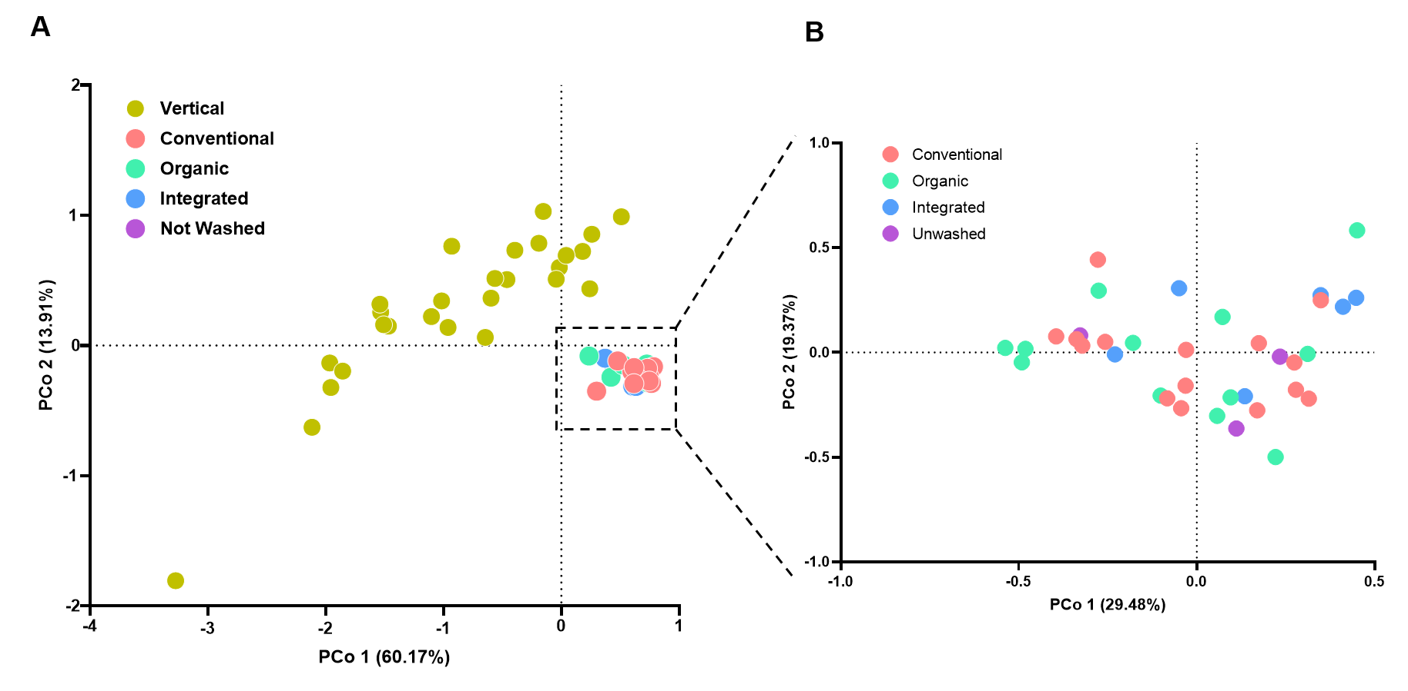

Figure 1 Inter sample (β -) diversity of the microbiota in mouse intestinal sites shown as principal coordinates analysis of Weighted UniFrac distances based on amplicon sequence variants (ASVs) abundances. A, analysis performed with all investigated rocket salad samples; B, analysis performed with rocket samples from traditional farming only. The ﬁrst two coordinates (PoC1 and PCo2) are displayed with the percentage of explained variance in brackets.

4.2 Viable counts of rocket salad-associated bacteria
The results of agar plate count experiments showed that rocket salads grown through vertical farming had significantly higher levels of bacteria compared to rocket salads from traditional farming. This was observed by counting the number of colonies on plate count agar (PCA) and de Man-Rogosa-Sharpe (MRS) media. The mean number of colonies per gram for PCA was 7.41 ± 0.60 CFU/g for traditional farming and 4.77 ± 0.59 CFU/g for vertical farming (P < 0.001). For MRS media, it was 1.88 ± 1.24 CFU/g for traditional farming and 0 CFU/g for vertical farming (P < 0.05) (Fig. 1). When comparing different traditional farming methods, no significant differences were found in viable cell counts on PCA. The counts were 7.41 ± 0.56 CFU/g for conventional farming, 7.18 ± 0.67 CFU/g for organic farming, 7.70 ± 0.29 CFU/g for integrated farming, and 7.74 ± 0.86 CFU/g for unwashed rocket salads. In terms of lactic acid bacteria (LAB) counts, unwashed rocket salads had more colonies (3.37 ± 0.41 CFU/g) compared to conventional farming (1.61 ± 1.08 CFU/g [P < 0.05]) and integrated farming (1.08 ± 1.22 versus 3.37 ± 0.41 CFU/g [P < 0.05]), but not organic farming (2.20 ± 1.03 CFU/g [P = 0.16]). Overall, the viable cell counts indicated that rocket salads from vertical farming had a significantly lower bacterial load and no detectable viable LAB. Additionally, unwashed rocket salads from conventional farming had a bacterial load comparable to that of ready-to-eat rocket salads from traditional farming, but they had significantly more LAB.
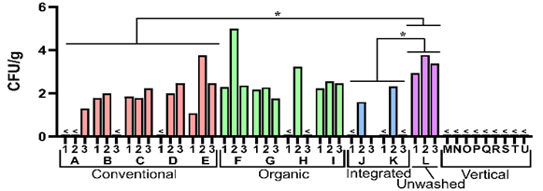
Figure 2 Viable cell count of bacteria associated to rocket salads as determined on de Man, Rogosa and Sharpe (MRS) agar, expressed as number of colony formant units (CFU) per g of salad. <, under detection limit (10 CFUs per gram of rocket salad). Statistics according to unpaired Student t test; *, P<0.05.

4.3 Taxonomic characterization of lactic acid bacteria isolated from rocket salad
To determine the distribution of viable LAB in rocket salad, we isolated 237 colonies from MRS agar plates. These colonies were obtained from different types of rocket salads: conventional (95 colonies), organic (84 colonies), integrated (18 colonies), and unwashed (43 colonies). By sequencing the 16S rRNA gene of each isolate, we found that all of them belonged to LAB species, except for two isolates from an organic farming salad that were identified as Herbaspirillum huttiense, a Proteobacteria species. The most common genus among isolates from conventional, organic, and unwashed rocket salads was Leuconostoc, accounting for 76%, 59%, and 49% of the isolates, respectively. In contrast, Levilactobacillus and Weissella were the predominant genera in isolates from integrated farming rocket samples. Other less frequent genera included Latilactobacillus, Lactococcus, Lactiplantibacillus, and Paucilactobacillus. Overall, we identified 18 different LAB species among the isolates, but none of them were present in all samples. Only four species were found in all types of salads: Latilactobacillus sakei, Leuconostoc mesenteroides, Leuconostoc miyukkimchii, and Weissella soli. Principal-component analysis revealed that the presence of certain LAB species could distinguish conventional salads from the others. Latilactobacillus graminis, Leuconostoc citreum, Leuconostoc holzapfelii, Paucilactobacillus oligofermentans, and Paucilactobacillus nenjiangensis were characteristic of conventional salads, while Leuconostoc rapi and L. carnosus were associated with organic salads. Integrated salads were characterized by Levilactobacillus brevis and Weissella oryzae, and unwashed salads were associated with Weissella koreensis and W. cibaria. The majority of the isolates (96%) were LAB taxa, with Leuconostoc being the most prevalent genus (60% of isolates). The distribution of LAB species varied among salad samples and could be partially attributed to different farming practices. Among the isolates, Leuconostoc mesenteroides, which accounted for over 20% of all LAB isolates, has demonstrated probiotic activities both in vitro and in vivo. Weissella species, constituting about 14% of the isolates, have also shown promising health-promoting activities, such as treating halitosis in the oral cavity. Other LAB species isolated in this study, including Lactiplantibacillus plantarum, Lactococcus lactis, Latilactobacillus sakei, and Levilactobacillus brevis, are recognized for their probiotic capabilities and ability to survive gastrointestinal transit. Importantly, a simulated digestion experiment indicated that rocket-associated LAB had a significantly higher survival rate compared to other members of the gut microbiota. This suggests that LAB consumed with rocket salad can reach the human gut alive and potentially contribute to microbiome activities, influencing host health.

4.4 Effect of in vitro gastrointestinal transit on rocket salad associated LAB
In order to evaluate the potential of bacteria found in rocket salads to survive the journey through the digestive system, we conducted a study where we measured the number of viable bacteria in rocket samples before and after simulating digestion using the INFOGEST protocol (Brodkorb et al., 2019). To quantify the viable bacteria associated with two types of commercially available ready-to-eat rocket salads produced through conventional and organic farming, we utilized PCA and MRS agar following ISO protocols. The simulated digestion process led to a significant decrease in viable bacteria in both conventional and organic rocket salads when assessed using PCA. However, the number of viable LAB quantified using MRS agar was less affected by the simulated digestion process. We also performed the same protocol on two LABs isolated from rocket salad: Weissella cibaria and Leuconostoc lactis, with or without washed rocket salad. When inoculated together with the rocket salad, the two bacteria showed a survival rate [17.93 ±2 .06% (p = 0.11) and 12.47 ± 6.59% (p = 0.051) respectively] when compared with the same bacteria without rocket salad [0.003 ± 0.0018% (p = 0.033); 0.002 ± 0.00002% (p = 0.0007), respectively]. Overall, our findings demonstrate that various taxonomically distinct bacteria associated with ready-to-eat rocket salad have the ability to survive the digestive transit, with LAB exhibiting a particularly enhanced survival capability. Additionally, we can speculate that rocket salad has a protective effect on the bacteria naturally associated with it, allowing them to arrive alive to the human intestine.

4.5 Impact of rocket salads on faecal bacterial communities
Metataxonomics based on 16S rRNA gene profiling was employed to examine the bacterial community structure of faecal samples collected before (F1) and after (F2) a three-day rocket administration phase. The analysis of α-diversity did not show significant changes in the richness or evenness of the faecal bacterial communities following the short-term consumption of rocket. However, the analysis of β-diversity using weighted and unweighted UniFrac algorithms revealed a slight shift in the bacterial community structure for each individual subject across different time points. These changes were smaller compared to the variability observed between subjects and could not be directly attributed to rocket consumption or washing. Next, we conducted a statistical analysis of the metataxonomic data to investigate the influence of rocket consumption and washing on the abundance of individual bacterial taxa. We performed three levels of analysis: (i) a comparison of all faecal samples collected before and after rocket consumption, regardless of washing or rocket type; (ii) a separate comparison of faecal samples collected before and after rocket consumption for each intervention, independent of washing; (iii) a comparison of faecal samples collected before and after rocket consumption, differentiating between individuals who consumed unwashed or washed rocket, and conducted separately for each intervention. The initial analysis revealed modifications in 13 bacterial taxa, with 10 of them belonging to the Clostridia class. The taxa that exhibited an increase included Acinetobacter schindleri, an unidentified species from the family Christensenellaceae, Flavonifractor, and Methanobrevibacter. When analysing the data separately for the two rocket interventions, a larger number of significantly altered bacterial taxa was observed. For R1, 17 taxa were identified, and for R2, 26 taxa were identified. In both interventions, the majority of the modified taxa belonged to the Clostridia class. However, the only alteration common to both interventions was the reduction of an unidentified species belonging to the genus Roseburia. Finally, the statistical analysis of bacterial abundances for each intervention, considering washed and unwashed rocket consumption, showed significant modifications. For R1, 7 bacterial taxa changed after consumption of unwashed rocket, and 38 after consumption of washed rocket. For R2, 18 and 14 significantly changed bacterial taxa were identified for unwashed and washed rocket, respectively. There were no common changes between the two interventions with unwashed rocket or between those with washed rocket, except for a decrease in the genus Roseburia after consumption of washed rocket in both interventions. Overall, the metataxonomic analysis did not show any significant changes in the bacterial community structure that could be attributed to the rocket consumption treatments. Although no associated lactic acid bacteria (LAB) were found in washed rocket salad, there was no significant difference in LAB quantity in the faeces of volunteers after interventions with washed or unwashed rocket salad. This can be explained by the fact that ready-to-eat rocket salad may not provide a sufficient amount of LAB to significantly alter the existing LAB quantity in the human gut. In our study, the LAB quantities in the two rocket salads used were 4.1 log CFU/g for the first intervention (R1 rocket salad) and 2.3 log CFU/g for the second intervention (R2). Even considering a daily intake of 100 g of rocket salad for three consecutive days, the number of LAB cells introduced with rocket salad in our interventions was at least two log units lower than the LAB already present in volunteers' faeces in this study (estimated based on an average amount of 150 g of faeces per defecation).

43.6 Effect of rocket consumption on LAB levels in faecal samples
During the intervention studies, we collected faecal samples to measure the presence of lactic acid bacteria (LAB) by diluting the samples and culturing them on MRS agar medium. The amount of LAB in the faeces varied between 1.0×10⁹ and 1.6×10⁵ colony-forming units (CFU) per gram, with a median of 1.2×10⁷ CFU/g. Interestingly, the viable count of LAB did not show any significant changes in any of the subgroups during the rocket interventions. To further investigate the dominant LAB genera in the rocket salads, namely Leuconostoc and Weissella, we conducted quantitative PCR assays using specific probes. The DNA extracted from colonies collected from the MRS agar plates was used as a template for these assays, which provided information about the quantity of viable cells of the targeted bacterial taxa. The results indicated that the number of viable cells of Leuconostoc spp. did not significantly change with either unwashed or washed rocket intervention. However, there was a significant increase in Weissella spp. following consumption of unwashed rocket but not washed rocket (Fig. 2). This increase was particularly evident in the second faecal sample collected after the end of rocket consumption, but it was no longer apparent in the subsequent sample. Furthermore, the metataxonomic analysis of faecal bacteria after rocket consumption showed no significant changes in the bacterial community structure attributed to the treatments. This result can be attributed to the limited number of participants in the study and the considerable variability of the human gut microbiota among individuals. Although it is known that the composition of the human gut microbiota can change within a few hours, the short duration of our intervention may have influenced the observed results. As we were unable to find any other studies in the scientific literature that assessed the effects of rocket salad on the gut microbiota, it is necessary to conduct further research with larger sample sizes and longer intervention periods to gain a more comprehensive understanding of the potential effects of rocket salad on the human gut microbiota.
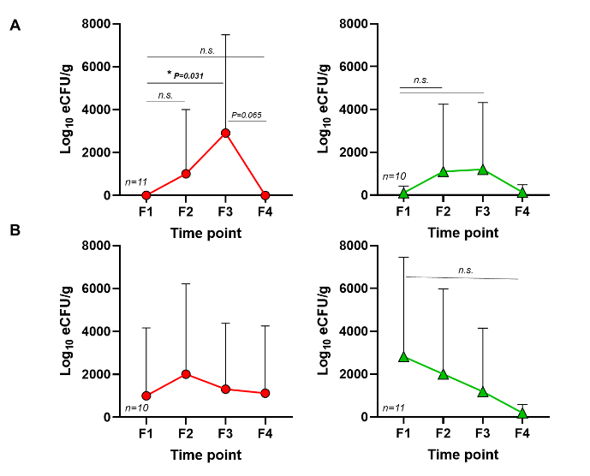
Figure 3 Estimation of Weissella spp. and Leuconostoc spp. in agar plates of diluted faecal samples. (A) Estimation of Weissella spp. after the consumption of unwashed rocket salad (left) or washed (right). estimation of Leuconostoc spp. after the consumption of unwashed rocket salad (left) or washed (right).

5. Conclusions and Future Perspectives
Experimental data suggests that modern Western diets, low in naturally occurring microorganisms, may harm health by depleting key microbial taxa in the gut. However, consuming fresh rocket salad from ready-to-eat products could potentially counteract this depletion by providing live bacteria that can survive the digestive system. This hypothesis may apply to all raw plant foods. Further research is needed to confirm the role of raw foods, especially vegetables, in shaping and maintaining the gut microbiota. It should be noted that this PhD thesis focused on fresh-cut commercial rocket salad, and results may vary with different varieties of rocket or other vegetables. The short duration of the study may not fully reveal the benefits of live bacteria in rocket on gut microbiota, necessitating larger-scale and longer-term research. To the best of our knowledge, the interventional study we performed during my PhD, is the first intervention study supporting the idea that raw plant products can serve as a source of live bacteria for the human gut. These findings highlight the importance of investigating the microbial component of raw, non-fermented foods and their potential impact on the human intestinal microbiome.

6. References
Blaser MJ (2016). Antibiotic use and its consequences for the normal microbiome. Science 352(6285): 544–545.
Brodkorb A, Egger L, Alminger M, Alvito P, Assunção R, Ballance S, Bohn T, Bourlieu-Lacanal C, Boutrou R, Carrière F, Clemente A, Corredig M, Dupont D, Dufour C, Edwards C, Golding M, Karakaya S, Kirkhus
B, Le Feunteun S, … Recio I (2019). INFOGEST static in vitro simulation of gastrointestinal food digestion. Nature Protocols, 14(4): 991–1014.
De Filippis F, Pasolli E, Ercolini D (2020). The food-gut axis: Lactic acid bacteria and their link to food, the gut microbiome and human health. FEMS Microbiology Reviews 44(4): 454–489.
Mantegazza G (2021) Ready-to-Eat Foods as a Vehicle of Microorganisms in the Microbial Deprivation Hypothesis. First Virtual Workshop on the Developments in the Italian PhD Research on Food Science, Technology and Biotechnology, Palermo (Italy), 15-16 September 2021, p. 114-115 (Poster Presentation)
Scudellari M (2017). Cleaning up the hygiene hypothesis. Proceedings of the National Academy of Sciences 114(7): 1433–1436.
Sonnenburg JL, & Sonnenburg ED (2019). Vulnerability of the industrialized microbiota. Science 366(6464).
Zmora N, Suez J, Elinav E (2019). You are what you eat: diet, health and the gut microbiota. Nature Reviews Gastroenterology and Hepatology 16(1): 35–56.

