Valorisation of South Tyrolean Food Products Through the Study of Their Antioxidant Behaviour
Lucrezia Angeli (luangeli@unibz.it)
Faculty of Agricultural, Environmental, and Food Sciences, Free University of Bolzano, 39100, Italy
Tutor: Prof. Matteo Scampicchio

This PhD thesis dealt with the assessment of the antioxidant behaviour of different food products typical in South Tyrol. The antioxidant behaviour depends on both the antioxidant activity and capacity of a matrix, nevertheless its analytical composition. A novel DPPH• kinetic model was developed to precisely study the antioxidant activity and capacity of analytical standards and was then validated on food extracts. Further analyses with a coulometric detector (CAD) were employed to investigate which molecules in the matrix were responsible for the antioxidant properties.
Valorizzazione dei Prodotti Alimentari Altoatesini Attraverso lo Studio del Loro Comportamento Antiossidante
Questa tesi di dottorato ha trattato lo sviluppo di un modello cinetico per studiare il comportamento antiossidante di diversi prodotti alimentari tipici dell’Alto Adige. Il comportamento antiossidante dipende sia dall’attività sia dalla capacità antiossidante di una matrice e dalla sua composizione analitica. È stato sviluppato un innovativo modello cinetico basato sul DPPH• per studiare l’attività e capacità antiossidante di standard analitici prima e di estratti alimentari dopo. Sono poi state eseguite successive analisi con detector coulometrico (CAD) per determinare quali molecole presenti in un estratto avesse effettivamente proprietà antiossidanti.

Key words: DPPH•; kinetics; antioxidant activity; LC-MS, apples, herbs, fruit juices.

1. Introduction
In accordance with the PhD thesis project previously described (Angeli, 2022), this oral communication reports the main results of the following three activities directed to:
A1) develop a simple but efficient kinetic model based on the DPPH• radicals that involved not only the main reaction described in literature, but also a side reaction whose presence was demonstrated with mass spectrometry. The model was applied on officinal herbal extracts.
A2) optimize the developed kinetic model for very fast antioxidants, i.e., ascorbic acid, whose reaction ended within 2 s, with a stopped-flow apparatus and apply it on fruit juices.
A3) study the antioxidant activity and capacity of three different apple varieties with the developed model; investigate the antioxidant composition of the extracts with the triple detector (LC-UV-MS-CAD) to determine which molecules were responsible for the different behaviour of the apples.

2. What Do South Tyrolean Food Products Have in Common?
South Tyrol is a region in the North of Italy, where the Italian mixes with the Austrian culinary tradition. The alpine environment encourages the cultivation of officinal herbs at high altitudes, as well as apples and other fruits (Ceci et al. 2021). These food products that are major ingredients in the South-Tyrolean kitchen share the high content in micronutrients, such as vitamins and phenolic compounds. These constituents are important not only for human health, but also to preserve the quality of a food product in terms of antioxidant properties (Ding et al. 2022).

3. DPPH• Kinetics Vs the Conventional Spectrophotometric Assay
2,2-Diphenyl-1-picrylhydrazyl (DPPH•) is a stable free radical that is commonly used to characterize the antioxidant capacity of methanolic extracts in the so-called DPPH• assay. DPPH• is widely used thanks to the velocity of the reaction, the facility in the measurement and the stability of the radical. The conventional protocol is based on the single-point measurement of the absorbance of DPPH• at its maximum (usually 515 nm) after 30 min or 1 h reaction. A limitation of the common assays is that they fail to provide temporal information that can be used to distinguish the rate at which different antioxidants produce their antioxidant effect (Foti et al. 2004). The rate constant decreases in aprotic solvents and increases in alcohols, demonstrating that a main electron-transfer mechanism is involved rather than H-atom transfer. Several new and alternative approaches have been revised in recent years, underlining the drawbacks of the lack of a standardized method. For this reason, this work aimed at proposing a method suitable for the analysis of antioxidant standards that could be applied also to food extracts.

3.1 The DPPH• kinetic model
The mechanism involved in the reaction between the DPPH• radical and the antioxidant molecule is described in Equation (1):

$AH+{DPPH}^{•} \underset{→}{k_{1}} A^{•}+DPPH-H$ (1)

where all symbols are given in section 9.
However, the possible side reactions occurring between the transient radicals (A•) generated in the first reaction with DPPH• have not been fully considered yet. Such radicals are generally able to quench another DPPH radical, as illustrated in Eq. (2):

$A^{•}+{DPPH}^{•}\underset{→}{k_{2}} Products$ (2)

This reaction is largely underestimated and could explain the variability of the results reported in the literature. Recently, Foti and colleagues accounted for this side reaction. They measured the reactivity of antioxidants with the DPPH• radical applying a kinetic model of pseudo-first (when antioxidants are in excess) or second order (when the concentration of DPPH• is equal to or higher than that of antioxidants). The authors were able to deduce the presence of side reactions graphically by following the DPPH• decay over time. However, proof of this side reaction based on a mechanistic model was still not demonstrated.
Moreover, a comprehensive model also considering the stoichiometric factor, n (Eq. 3), has not been proposed before (Angeli et al. 2021).

$\text{n}\text{ = }\frac{\left[{DPPH}_{0}^{•}\right] - \left[{DPPH}^{•}\right]}{\left[{AH}_{0}\right]}$ (3)

3.2 DPPH• kinetics for fast antioxidants: optimization with a stopped flow system
Kinetic methods are difficult to be applied for studying fast antioxidants, like, for example, ascorbic acid. Despite its widespread use, the radical scavenging activity of ascorbic acid is not well characterized, likely, because its reaction with radicals, is so fast that the reaction goes to completion within a few seconds. This makes difficult to perform kinetic studies with spectroscopic measurements, i.e., performed with classical glass cuvettes. In such cases, the reduced form of ascorbic acid falls rapidly to zero even during its mixing with radicals, like DPPH•. To overcome such limitations, the kinetic-based DPPH• method could be greatly improved if implemented with a stopped-flow technique. A stopped flow apparatus is especially suitable for studying fast reactions, in which two or more reactants can be rapidly mixed, and delivered through a flow cell detector with a dead time of just a few microseconds (Angeli et al. 2023).

4. Application of the Model to South Tyrolean Food Products
One of the strengths of the kinetic model is its standardization. Since the rate constant decreases with the increase of the antioxidant concentration, the food extracts were all standardized to 30 µM of GAE. The model was successfully applied to eight herbal extracts provided by the local company Naturalsalus®, among which, Moringa oleifera, Harpagophytum Procumbens, Turnera aphrodisiaca, Urtica dioica, Rhodiola rosea, Melissa officinalis, Fraxinus excelsior and Filipendula Ulmaria (Angeli et al. 2021). The antioxidant activity of three ricotta whey vinegars produced by the local company Algunder Sennerei® was determined using the DPPH• kinetic model and discussed in a master thesis project. The model was tested also on fruit juices, helping to understand their antioxidant activity and capacity (Angeli et al. 2023). And finally, it was applied to study the antioxidant behavior in a non-browining (“Majda”) and a red-flesh (Kissabel rouge) apple variety versus a control variety (Golden delicious) (Cebulj et al. 2023).

5. Who and How is Responsible for the Antioxidant Activity and Capacity? From the DPPH• Kinetics to the LC-MS-CAD
The DPPH• kinetics is a very useful tool to study the antioxidant behaviour of a food item, but the employment of more sophisticated techniques is necessary to understand which molecules in the extracts are responsible for it. Therefore, liquid chromatography coupled to mass spectrometry and the coulometric detector was used to identify and quantify the molecules showing a redox behaviour in the three apple varieties.

6. Materials and Methods
Methanol, DPPH•, Folin reagent, Na₂CO₃, and standards reagents (ascorbic acid, α-tocopherol, Trolox, catechin, epicatechin, quercetin, rutin, tannic, ellagic, 3,4-dihydroxybenzoic, and syringic acid) were all purchased from Sigma Aldrich (St. Louis, MO, USA) at the highest available grade. Phloretin with a purity higher than 98% was purchased from Tokyo Chemical Industry (Zwijndrecht, Belgium). Stock solutions of each antioxidant were prepared in methanol at a final concentration of 10 mM. Stock solutions of DPPH• were prepared in methanol at the concentration of 2.5 mM. All solutions were prepared daily.
The kinetic-based DPPH• method was performed with a stopped-flow system (RX2000, Applied Photophysics, Leatherhead, UK) equipped with a pneumatic pump, a quartz flow-cell and a Cary 60 UV–VIS spectrophotometer (Agilent Technology, Santa Clara, CA, USA). The stopped-flow system had two syringes, one loaded with 200 μM DPPH• solution, and the other with the antioxidant at concentrations between 20 and 200 μM. It should be noted that the DPPH• and antioxidant solutions were prepared at a doubled concentration than the one desired, since there is a 1:1 dilution after the mixing of the two reagents. The concentration of the food extracts was therefore standardized at 60 μM of GAE. Priming was performed before every run by flowing the two reagents in the system. As soon as the pneumatic drive was pressed, equal volumes of the two solutions were mixed and transferred into the quartz flow cell, with a max delay of 6 ms. The resulting absorbance of the reaction mixture was recorded every 18 ms, at a wavelength of 515 nm, by the UV spectrophotometer. Simulation and fitting of the reaction kinetic data were performed with the software Copasi (version 4.29).
Total phenolic content (TPC) was estimated with the Folin–Ciocalteu’s reagent using the method of Singleton et al. with slight modifications17. Briefly, a volume of the juice sample (130 μL) was mixed with distilled water (1 mL) and the Folin reagent (130 μL). After 5 min, 130 μL of Na₂CO₃ solution (20%) were added. The mixture was vortexed, incubated for 2 h in the dark at 25 °C and transferred in a microplate well (UV-StarR microplate, 96 wells, Greiner Bio one, Frickenhausen, Germany). The absorbance was read at 765 nm with the spectrophotometer (Infinite M Nano+ , Tecan, Mannedorf, Switzerland). Results were expressed as mg/100 mL of gallic acid equivalents (GAE) from a calibration curve built with standard solutions of gallic acid.
HPLC couple to mass spectrometry and coulometric detector was employed for antioxidant molecules identification, as described in (Ding et al. 2022; Ding et al. 2023). The advantages of the coularray detector has been previously discussed (Razem et al. 2022).

7. Results and Discussion

7.1 Application of the DPPH• kinetic model to standard analytes
The DPPH• kinetic model was first applied to standard analytes, as reported in Table 1. Overall, from the comparison of the results obtained with or without the side reaction, it is evident that the side reaction improves the fitting of the kinetic model. Even more importantly, the side reaction can be used to obtain stoichiometric factors that are predictable from the chemical structure of the antioxidants. When the side reaction was not included in the model, the resulting k₁ was underestimated.
Table 1 Observed rate constants, k1 and k2 (M-1s-1), R2 values and stoichiometric factors, n, for the reaction of DPPH• 100 µM with antioxidants (2–7) 10 and 100 µM at 25 °C in methanol, without and with side reaction. The values obtained are the mean of at least three repetitions, with a standard deviation of max 20%.
Antioxidants | Results without Side Reaction |  |  | Results with Side Reaction
 | k₁  (10³ M⁻¹s⁻¹) | R² | n | k₁  (10³ M⁻¹s⁻¹) | k₂  (M⁻¹s⁻¹) | R² | n
2 gallic acid | 0.42–0.57 | 0.987 | 4.9 | 1.13–0.66 | 145–23 | 0.997 | 2.9
3 caffeic acid | 0.7–0.24 | 0.985 | 2.6 | 0.81–0.51 | 4–110 | 0.993 | 2.4
4 chlorogenic acid | 0.19–0.04 | 0.999 | 2.3 | 0.2–0.04 | 0.6–8 | 0.999 | 2.1
5 ferulic acid | 0.11–0.08 | 0.984 | 1.3 | 0.33–0.15 | 45–26 | 0.998 | 0.8
6 ascorbic acid | 11.5–3.63 | 0.996 | 1.9 | 11.5–3.63 | - | 0.996 | 1.9
7 Trolox | 0.54–0.39 | 0.999 | 2.2 | 0.54–0.39 | - | 0.999 | 2.2

7.2 Demonstration of the side reaction
The DPPH• kinetic model was validated with the finding of the unknown products of Eq. (2) with LC-HRMS for only those standards that showed the side reaction in the kinetic model. The fragmentation spectra of the products show the typical fragments of DPPH• at m/z 225.9984 and 196.0011.

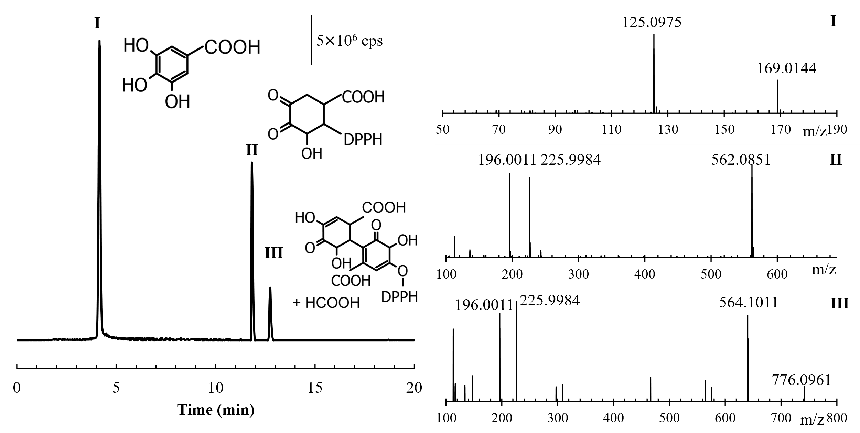
Figure 1 Extracted ion chromatographic peaks with the corresponding proposed molecular formulas for gallic acid after the reaction with DPPH•. On the right, the dd-MS² spectra presenting the characteristic fragment ions are reported.

7.3 Optimization of the model with the stopped flow apparatus
Figure 2 shows the transient signal of DPPH• (100 μM) after the rapid mixing with A- 10 μM of vitamin C and B - 50 μM of (a) phloretin and equimolar concentrations (10 μM) of, (b) α-tocopherol, (c) catechin, (d) epicatechin, (e) quercetin, (f) ellagic acid, and a diluted solution of (g) tannic acid (2 μM). These antioxidants were chosen because they represent different classes of antioxidants of food interest (i.e., hydrophilic vitamins, lipophylic vitamins, polyphenols). Table 1 sums up their kinetic parameters, also in comparison with % of inhibition obtained with the classical DPPH• assay. All compounds were much slower antioxidants than ascorbic acid as their rate constants were from 10 to 500 times lower than that of ascorbic acid.

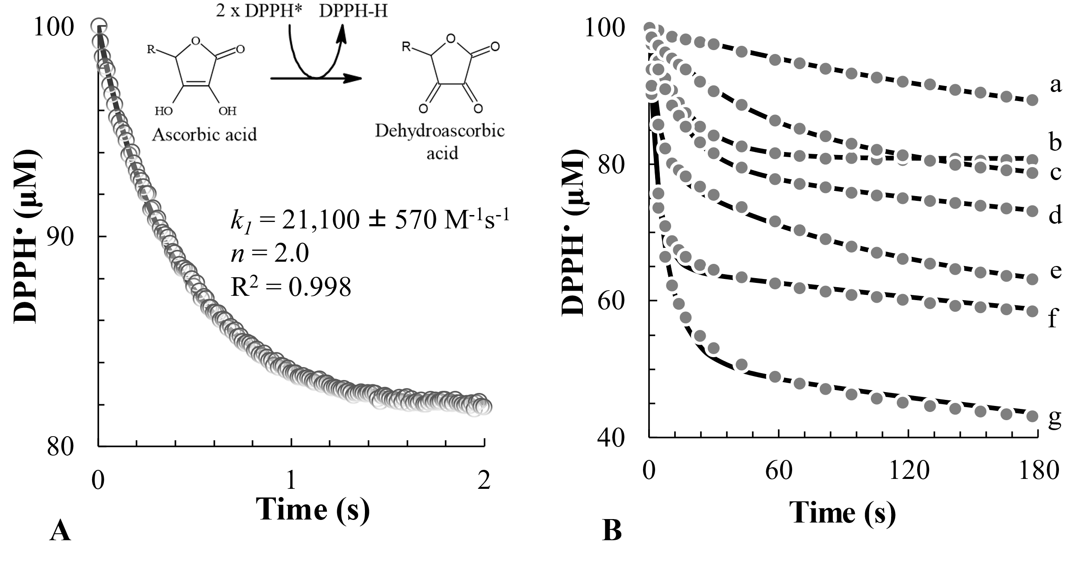
Figure 2 A – DPPH• absorption decay in the reaction with 10 µM of vitamin C; B – kinetic curves for the reactions between DPPH and phloretin (a), vitamin E (b), catechin (c), epicatechin (d), quercetin (e), ellagic acid (f), and tannic acid (g).

Ascorbic acid was the fastest (k₁ = 21,100 ± 540 M⁻¹s⁻¹), while phloretin the slowest (k₁ = 45 ± 9 M⁻¹s⁻¹), while tannic acid showed the highest capacity (n = 24), followed by ellagic acid (n = 3.7). The DPPH• kinetic model can rank antioxidant standards according to their activity and capacity.

7.4 Application of the kinetic model on South Tyrolean foods
The standards are necessary to determine the robustness of a method, but it needs to work on matrices to prove its efficiency. Thus, the DPPH• kinetic model was applied and tested on several South Tyrolean food extracts, such as aromatic herbs, fruit juices and, of course, apples. All the extracts were standardized for the initial concentration of phenolic compounds prior to analysis, so that results could be compared. Three different applications are reported in figure 3.

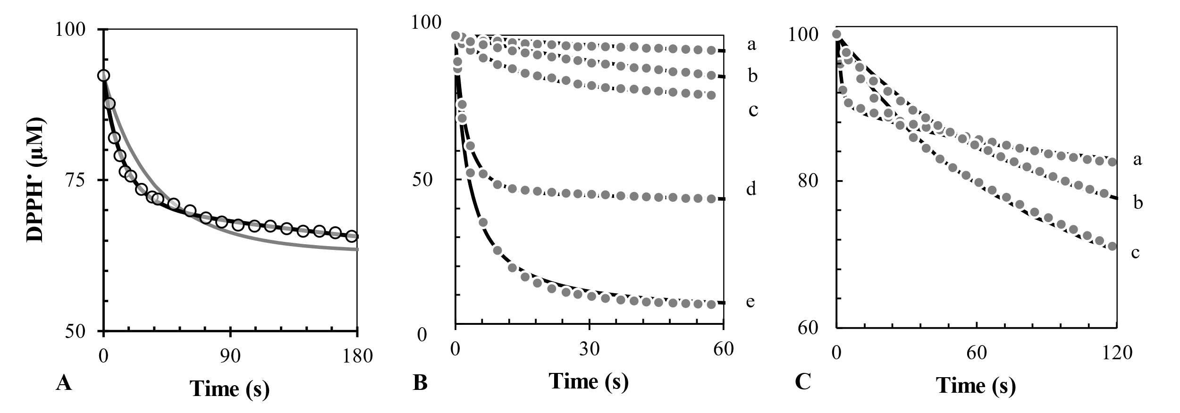

Figure 3 A – kinetic curve for the reactions between DPPH• and 30 µM GAE of Harphagophytum Procumbens extract: fitting with the side reaction (dark line) vs fitting without the side reaction (light line); B – kinetic curves for the reactions between DPPH• and apple (a), red plum (b), peach (c), strawberry (d), and kiwi (e); C – kinetic curves for the reactions between DPPH• and Majda apple (a), Kissabel (b), and Golden (c).

The model successfully described the antioxidant behavior of all the food products tested. Overall, this approach could represent a novel tool to describe the quality of a natural extract. However, it gives no information about the composition in antioxidant compounds and which molecule is more responsible for the antioxidant behavior.

7.5 A more in-depth look: from food products to antioxidant compounds
The utility of the DPPH• kinetic model is that it can describe the antioxidant behavior, but other more sophisticated techniques, such as mass spectrometry and electrochemistry, should be employed to determine what are the compounds responsible of such characteristic. In the case of the three apples, the non-browning variety showed the lowest amount in phenolic compounds, but higher antioxidant activity than the red-flesh variety and Golden. Instead, the k₁ and k₂ values for Kissabel and Golden were not significantly different. For this reason, their composition was investigated. Apparently, the non-browning variety had a lower amount of phenolics, but its content in vitamin C was 4-5 times higher than in the other varieties. This finding explains the highest antioxidant activity of Majda with respect to the other varieties (Cebulj et al. 2023). Moreover, the anthocyanins responsible for the color in the red-flesh variety showed no reactivity in the electrochemical detector, explaining the similarities with Golden in the kinetic parameters.

8. Conclusions and Future Perspectives
The present study proposed a new fast, standardized and robust approach to assess the antioxidant activity and capacity of south Tyrolean food products. Moreover, the DPPH• kinetics combined with more complex tools, such as mass spectrometry and electrochemistry represents a comprehensive way to analyse the antioxidant behaviour of a food item. Thus, not only the overall activity and capacity of a matrix can be assessed, but also the determination of the molecules responsible for it. This research could help food industry to assess the quality of a product through the study of its antioxidant behaviour. Future studies should focus on the research of interaction mechanisms between the molecules.

9. Nomenclature
DPPH• = 2,2-diphenyl-1-pycrylhydrazyl; TPC = total phenolic content; AH = antioxidant; A = oxidized form of the antioxidant; DPPH-H = reduced form of the DPPH radical; GAE = gallic acid equivalents; LC = liquid chromatography; MS = mass spectrometry; CAD = coularray detector.

10.References
Angeli L, Imperiale S, Ding Y, Scampicchio M, Morozova K (2021) A Novel Stoichio-Kinetic Model for the DPPH• Assay: The Importance of the Side Reaction and Application to Complex Mixtures, Antioxidants (Basel, Switzerland), 10: 7.
Angeli L, Morozova K, Scampicchio M (2023) A kinetic-based stopped-flow DPPH• method, Scientific Reports, 13: 1, 7621.
Cebulj A, Populin F, Masuero D, Vrhovsek U, Angeli L, Morozova K, Scampicchio M, Costa F, Busatto N (2023) A multifaced approach sheds light on the molecular details underlaying the mechanism preventing enzymatic browning in ‘Majda’ apple cultivar (Malus domestica Borkh.), Scientia Horticulturae, 318: 112137.
Ceci AT, Bassi M, Guerra W, Oberhuber M, Robatscher P, Mattivi F, Franceschi P (2021) Metabolomic Characterization of Commercial, Old, and Red-Fleshed Apple Varieties, Metabolites, 11: 6.
Ding Y, Morozova K, Angeli L, Gasparini A, Ferrentino G, Scampicchio M (2023) Effect of extraction treatments on the functional properties of free and bound phenols in apple seeds, Food Bioscience, 53: 102602.
Ding Y, Morozova K, Imperiale S, Angeli L, Asma U, Ferrentino G, Scampicchio M (2022) HPLC-Triple detector (Coulometric array, diode array and mass spectrometer) for the analysis of antioxidants in officinal plants, LWT, 162: 113456.
Foti MC, Daquino C, Geraci C (2004) Electron-transfer reaction of cinnamic acids and their methyl esters with the DPPH(*) radical in alcoholic solutions, The Journal of Organic Chemistry, 69: 7, 2309–2314.
Razem M, Ding Y, Morozova K, Mazzetto F, Scampicchio M (2022) Analysis of Phenolic Compounds in Food by Coulometric Array Detector: A Review, Sensors (Basel, Switzerland), 22: 19.

