Integrated Green Strategies for the Management, Recovery, and Recycling of Waste in a Dairy Factory

Stefano Gerna (stefano.gerna@unimi.it)

Dept. of Food, Environmental and Nutritional Sciences, University of Milan, 20133 Milan, Italy

Tutor: Prof. Luisa Pellegrino Co-Tutor: Dr. Paolo D’Incecco

A casein-based biofilm with tailored mechanical, thermal and vapour-barrier properties was developed using Sodium caseinate (NaCas). Casein was obtained by isoelectric precipitation from expired pasteurized milk with subsequent washing, solubilization with alkali and lyophilisation. A commercial NaCas was used as control. The two NaCas were used to prepare film forming solutions including glycerol. The casting method on silicon molds was used for film production followed by drying under controlled conditions. Structure of films was characterized by confocal laser scanning microscopy with image analysis, while FT-IR was used to investigate the changes at the protein network. Finally, preliminary mechanical tests were carried out.

Strategie Green Integrate per la Gestione, il Recupero e il Riciclo di Sottoprodotti nell’Industria Lattiero-casearia

È stato sviluppato un biofilm a base di caseina con adeguate proprietà meccaniche, termiche e di barriera al vapore, utilizzando sodio caseinato (NaCas). La caseina è stata ottenuta per precipitazione isoelettrica da latte pastorizzato scaduto, seguita da lavaggio, solubilizzazione con alcali e liofilizzazione. NaCas commerciale è stato utilizzato come controllo. Le due polveri sono state utilizzate per preparare soluzioni, comprensive di glicerolo, per la formazione di film. I film sono stati prodotti mediante casting su stampi in silicone e successiva essiccazione in condizioni controllate. La struttura dei film ottenuti dai due tipi di NaCas è stata caratterizzata mediante microscopia a scansione laser confocale con analisi delle immagini, mentre la tecnica FT-IR è stata utilizzata per indagare le modifiche del network proteico. Infine, sono stati effettuati test meccanici preliminari.

**Key words**: Milk, casein, biofilm, sustainability, protein network, fat globules.

# **1. Introduction**

# Unsold pasteurized milk that reaches the expire date is no longer suitable for human consumption and it is downgraded to “Special Category III waste”. Casein has, however, unique technological properties and can be easily recovered from milk by isoelectric precipitation and addition of alkali to obtain soluble caseinate (NaCas). Recently, the use of NaCas for preparing biofilms has been proposed [1]. Like other protein-based films, casein films have positive characteristics, including good mechanical and gas barrier properties but, on the other hand, some weaknesses like high water-vapor permeability (WVP) [2]. Additives can be used in film formulation, such as glycerol, to improve the flexibility of the protein network, while hydrophobic components like beeswax or oils can improve WVP. Furthermore, formation of covalent crosslinks in the casein network through treatment by microbial transglutaminase or tannic acid may help as well [1]. Solution casting is the most used technique to obtain films at lab scale [3]. Based on this background, this PhD project focuses on the production of a casein film having suitable performances for various non-food uses, in order to give a novel high-valued destination to milk wasted from the food chain. Possible approaches for casein modification and additives that can be added to the formulation for the improvement of the film’s characteristics will be studied. Finally, a deep chemical, mechanical and thermal characterisation of the film will be done to find the most appropriate applications in real situations.

# **2. Materials and Methods**

**2.1 NaCas production and characterization**: Casein was isolated from expired (7-day old) pasteurized milk by isoelectric precipitation, washing for lactose and fat removal, alkali (NaOH) neutralisation to obtain soluble NaCas (NaCas A’) and lyophilisation. A centrifugation step at 40 °C was applied to NaCas A’, with the aim of preparing a caseinate with lower fat content (NaCas A). Finally, a commercial NaCas was used as a control sample (NaCas C). The gross composition of the three NaCas was evaluated using the ISO standard methods.

**2.2 Production and development of the biofilms**: NaCas was solubilized in water (10% w/v) and heat treated at 90 °C for 30 min under stirring. Glycerol (33% w/w on protein content) was added, the solution was stirred for another 10 min and then cooled to room temperature. Film-forming solution was poured on silicon moulds and let dry in a climatic chamber at 23 °C and 55% RH for 48 hours. After drying, the film was peeled off and maintained at ambient conditions. This procedure was used to produce films from NaCas A’, A, and C.

**2.3 Characterization of the biofilms**:

* *Confocal Laser Scanning Microscopy:* CLSM was carried out on films to evaluate the behaviour of fat within the film matrix. Fat structures were characterized by image analysis (ImageJ software).
* *Fourier Transform Infra-Red Spectroscopy:* FT-IR analysis was performed using attenuated total reflectance (ATR. Measurements were carried out with a resolution of 4 cm-1 and 64 scans. This analysis had the aim to investigate the possible changes that have occurred to the film structure during production.
* *Mechanical Properties:* analyses were performed using a texture analyzer, following the method ASTM D882, with a load cell of 50 kg. Only film C and Film A have been analyzed so far.

# **3. Preliminary Results and Discussion**

**3.1 Characterisation** **of NaCas samples**

The additional fat removal step allowed to obtain NaCas A with a lower fat content (23.3% vs 30.9%).

**Table 1** Chemical composition of NaCas samples.

|  |  |  |  |
| --- | --- | --- | --- |
|  | **NaCas C** | **NaCas A’** | **NaCas A** |
| **Protein** (g/100g) | 96 | 60.7 ± 0.6 | 66.1 ± 0.8 |
| **Fat** (g/100g) | ~ 0 | 30.9 ± 0.1 | 23.3 ± 0.2 |
| **Moisture** (g/100g) | 3 | 5.43 ± 0.1 | ND |

**3.2 Confocal Microscopy and Image analysis**

Film structure was investigated by CLSM (Fig. 1). Film A’ showed large heterogeneity in size and shape of fat structures having an average diameter of 1.35 µm and few structures up to 60 µm. Fat was also unevenly allocated within the film. After the additional fat removal step, fat organization in Film A improved, with structures similar in size and more regularly distributed (Fig. 1b, 1d). Fat organisation was completely different in Film C, where small fat structures of 0.60 µm in diameter and higher circularity than in the other films were seen. Film C also showed insolubilized protein particles originating from NaCas C (Fig. 1c arrows) and possibly caused by the industrial manufacturing process. Since all films were produced from NaCas containing homogenized fat (particle size ̴1 µm), large fat structures in Films A’ and A derive from fat coalescence during film making.

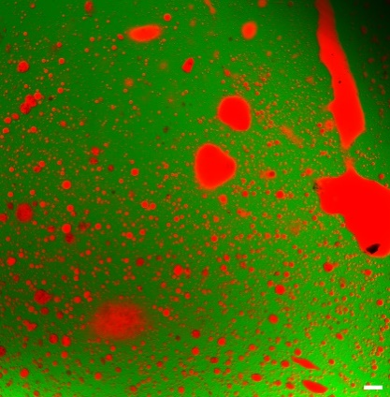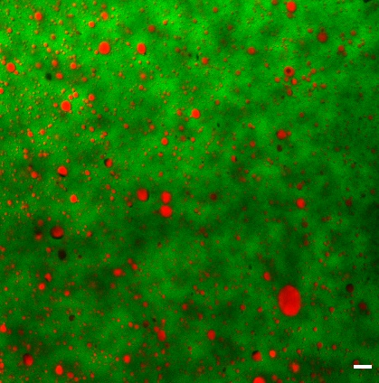

**b**

**c**

**a**



b

b

b

a

b

b

a

a

b

**d**

**Figure 1** CLSM images of protein (green) and fat (red) in Film A’ (a), Film A (b) and Film C (c). Bar in panels a, b, c, is 10 µm in length. Panel d) shows the results of image analysis related to image a) (black column), image b (orange column) and image c (grey column).

**3.3 FT-IR**

Functional groups of the films are observed with FT-IR analysis. Fig. 2 shows spectra recorded for Film C and A. Typical casein bands are in the range 3400-2800 cm-1 for -OH and -NH groups, while bands in the range 1700-1500 cm-1 are related to amide I° and II° groups. Significant changes can be attributed to the bands related to fat functional groups, confirming CLSM hints. The bands at 2930-2900 cm-1 can be attributed to stretching of C-H groups, bands at 1167-1050 cm-1 to stretching of C-O groups, and bands at 1740-1735 cm-1 to the stretching of C=O groups. These bands have higher intensity in Film A than in Film C due to the higher free fat content.

**Figure 2** FTIR spectra of Film C (Black) and A (Red).

**3.4 Mechanical Properties**

Material integrity under stress condition that could occur during lifespan of the film can be evaluated with tensile strength (TS) and elongation at break (EAB). TS was 5.9 ±0.8 MPa for Film A and 7.1 ±1.0 MPa for Film C, EAB was 120.8 ±19.2% for Film A and 102.1 ±20.5% for Film C. The lower TS of Film A (p < 0.05) is likely due to a weaker casein network caused by the higher presence of fat structures, compared to Film C. The same reason can explain higher EAB in Film A (p < 0.05), where fat structures make the matrix of the film more extensible.

**4. References**

[1]. Gerna S, D’Incecco P, Limbo S, Sindaco M, Pellegrino L (2023). *Foods*, 12, 1271.

[2]. Daniloski D, Petkoska A T, Lee N A, Bekhit A E, et al. (2021). *Trends in Food Science & Technology*, 111,688-705.

[3]. Chevalier E, Assezat G, Prochazka F, Oulahal N (2018) *Food Hydrocolloids*, 75, 182-191.

***Progetto finanziato nell’ambito PON: “Ricerca e Innovazione” 2014-2020, asse IV “Istruzione e ricerca per il recupero” con riferimento all’Azione IV.4 “Dottorati e contratti di ricerca su tematiche dell’innovazione e dall’Azione IV.5 “Dottorati su tematiche green”. DM 1061/2021***