A “green path” strategy for complete recovery of buckwheat processing byproducts
Anna Ramona Speranza (anna.speranza@unimi.it)
Dept. of Food, Environmental and Nutritional Sciences, University of Milan, Milan, Italy
Tutor: Prof.ssa Stefania Iametti Co-tutor: Prof.ssa Sara Limbo

The aim of this Ph.D. project is to set up a sustainable recovery process to valorize as much as possible residuals from buckwheat processing. Buckwheat husk has a high content of polyphenolic compounds and dietary fibres. We propose a sequential approach. A first step is the extraction of compounds to be used as functional ingredients in the formulation of novel foods. A second step plans to recover the cellulosic fraction from the residual lignocellulosic material, and to evaluate its applications in various fields due to its mechanical properties, reinforcing capacity, and biodegradability.

Un approccio "green" per la valorizzazione dei sottoprodotti: una proposta per il recupero completo dei sottoprodotti della lavorazione del grano saraceno
Il presente progetto di dottorato mira a valorizzare lo scarto residuo derivante dalla lavorazione del grano saraceno attraverso processi che hanno un basso impatto ambientale. La pula di grano saraceno presenta un alto contenuto di composti polifenolici e fibre alimentari. Proponiamo un approccio sequenziale che prevede come primo step l'estrazione di composti che possono essere utilizzati nella composizione di nuovi alimenti come ingredienti funzionali. La frazione lignocellulosica residua sarà utilizzata tal quale o per il recupero della frazione cellulosica che trova applicazioni in diversi campi, grazie alle sue proprietà meccaniche, capacità di rinforzo e biodegradabilità.

1. State-of-the-Art
Buckwheat is a summer-growing pseudocereal belonging to the Polygonaceae family, that complete its life cycle in less than 3/4 months, it has a good climate adaptability, with a preference for cool summers. Among the many buckwheat species, only two are cultivated for human consumption: common buckwheat (Fagopyrum esculentum) and tartary buckwheat (Fagopyrum tataricum), the latter characterized by a bitter taste and smaller seed (Siracusa et al. 2017). Buckwheat is an healty gluten-free grain, so it is suitable for the diet of people suffering from celiac disease or other gluten related disorders. Buckwheat has a high nutritional value and health beneficial properties, is a source of edible fibres, minerals, low-digestibility carbohydrates, proteins with high biological value, vitamins such as B1, B2 and B6 and essential amino acids (Mota et al. 2017; Dziedzic et al. 2018). The other bioactive ingredients of this pseudocereal include phytosterols, squalene, phagopyritols, polyphenols and flavonoids. Unlike other cereals in which the phenols are mainly attached to cell wall components, the flavonoids in tartary buckwheat, including rutin, quercetin and quercitrin, are commonly present in the free form (Siracusa et al. 2017). Food and agro-industrial buckwheat processing results in a number of byproducts. Husk is a high-volume byproduct of decortication - the first step of buckwheat processing - and is a valuable source of bioactives, including polyphenols and dietary fibers. Husk has a much higher antioxidant activity than dehulled seeds, making its addition to novel formulations beneficial to humans (Dziadek et al. 2016) and to the food industry. However, implementing such a strategy implies production of bioactive-enriched materials without the intrinsic limitations of the original husk. Studies on the industrial-scale recovery of bioactive fractions in this context are relatively scarce, and the application of “green” procedures has been explored on a very sporadic and semi-empirical basis.

2. PhD Thesis Objectives and Milestones
The work will involve six main activities, as listed in what follows.
A1) Literature research: research, reading and comprehension of the most recent publications related to the project.
A2) Macromolecular and micromolecular characterization of byproducts. The hulk biomass will be ground and sifted for assessing the total dietary fibers content (A2.1). The same materials will be used for extraction of phenolics in acidified water, concomitantly with either ultrasonic treatment (Ultrasonic Aassisted Extraction, UAE) or Microwave Assisted Extraction (MAE) (A2.2).
A3) Polyphenolic fraction characterization. Total phenolics in the different samples will be assessed by the Folin-Ciocalteau assay. The total antioxydant activity will be measured through two different radical scavenging method, DPPH and ABTS. The phenolics profile of the extracts will be determined by HPLC (A3.1). Subsequently, the potential protective effect of the extracts on cell inflammation will be evaluated on an established Caco-2 cell model, along with the inhibitory capacity against enzymes responsible for glucose metabolism. (Abbasi-Parizad et al. 2020, Capraro et al. 2021) (A3.2). The possible use of the solid residual from phenolics extraction as an ingredient of fiber-enriched gluten-free extruded product will be tested on blends with maize or rice, and products will be evaluated in terms of consistency, water retention capacity, viscosity, flavour quality and sensory traits (A3.3).
A4) Recovery of specific macromolecules by mechanical and biotechnological treatments. Mechanical and/or biotechnological treatments will be used to recover other valuable compounds, with a specific focus on cellulose fibrils (A4.1). Physical properties of the cellulose fibers will be assessed to provide guidelines for their use as ingredient in packaging and non-packaging products (A4.2).
A5) Definition of prototype end products and of their potential. Development of prototype product from isolated cellulose fibril and solid residual fraction, for obtaining environmentally friendly and biocompatible products in packaging and non-packaging field.
A6) Data dissemination of the obtained data in scientific papers and conference. PhD thesis writing.

Table 1 Gantt diagram for this PhD thesis project.
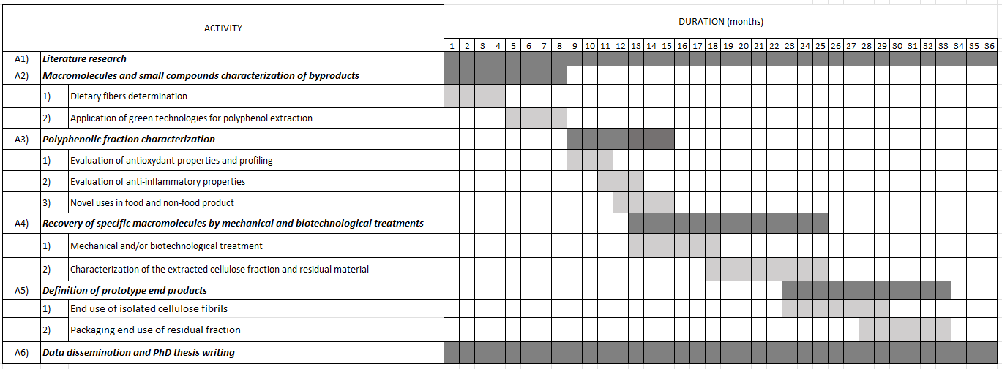

3. Selected References
Abbasi-Parizad P, De Nisi P, Adani F, Pepé Sciarria T, Squillace P, Scarafoni A, Iametti S, Scaglia B (2020) Antioxidant and anti-inflammatory activities of the crude extracts of raw and fermented tomato pomace and their correlations with aglycate-polyphenols, Antioxidants 9: 179.
Capraro J, De Benedetti S, Heinzl GC, Scarafoni A, Magni C (2021) Bioactivities of pseudocereal fractionated seed proteins and derived peptides relevant for maintaining human well-being, Int. J. Mol. Sci. 22: 3543.
Dziedzic K, Górecka D, Szwengiel A, Sulewska H, Kreft I, Gujska E, Walkowiak J (2018) The content of dietary fibre and polyphenols in morphological parts of buckwheat (Fagopyrum tataricum) Plant Foods Hum. Nutr. 73: 82-88.
Dziadek K, Kopeć A, Pastucha E, Piątkowska E, Leszczyńska T, Pisulewska E, Witkowicz R, Francik R (2016) Basic chemical composition and bioactive compounds content in selected cultivars of buckwheat whole seeds, dehulled seeds and hulls J. Cereal Sci. 69: 1-8.
Mota C, Santos M, Mauro R, Samman N, Matos AS, Torres D, Castanheira I (2016) Protein content and amino acids profile of pseudocereals Food Chem. 193: 55–61.
Siracusa L, Gresta F, Serlinga E, Ruberto G (2017) Effect of sowing time and soil water content on grain yield and phenolic profile of four buckwheat (Fagopyrum esculentum Moench.) varieties in a Mediterranean environment J. Food Compost. Anal. 62: 1-7.

