Combining chemical and sensory data to study the acceptability of single-varietal wines (Pinot Gris and Pinot Noir) from different geographical origins
Aakriti Darnal (Aakriti.darnal@student.unibz.it)
Faculty of Agricultural, Environmental, and Food Sciences, Free University of Bozen-Bolzano, 39100, Italy
Tutor: Prof. Emanuele Boselli
Co-tutor Dr. Edoardo Longo

The main objectives of the Ph.D. project are 1) The characterization of the sensory profile and the chemical profiles (volatile and phenolic compounds) of the single variety Pinot Gris and Pinot Noir wines from seven different origins. 2) The study of the chemical and sensory profiles with explorative statistical methods to see the correlation among them and to understand which were the most interesting sensory and chemical attributes influencing the overall sensory quality of the wines. The sensory test was carried out by two different regional panels.

Combinazione di dati chimici e sensoriali per lo studio dell’accettabilità di vini monovarietali (Pinot grigio e Pinot nero) di diverse provenienze geografiche

Gli obiettivi principali del progetto di dottorato sono: 1) la caratterizzazione del profilo sensoriale e dei profili chimici (composti volatili e fenolici) di vini monovarietali Pinot grigio e Pinot nero di sette diverse provenienze internazionali. 2) l’elaborazione con metodi statistici esplorativi dei dati per studiare la correlazione tra di essi e per capire quali siano gli attributi sensoriali e chimici più interessanti che influenzano la qualità sensoriale complessiva dei vini. Il test sensoriale è stato eseguito da due panel regionali diversi.

Key words: Pinot Gris, Pinot Noir, MRATA (Modified Rate-All-That-Apply), HPLC-MS, HS-SPME-GCxGC

1. Introduction
In accordance with the PhD thesis project, this poster reports the main results of the first two activities concerning:
(A1) the generated sensorial (aroma, taste and flavour) attributes of both Pinot Gris and Pinot Noir wines;
(A2) the analysed volatile and phenolic compounds and their influence in the overall sensory quality (OQJ) in both Pinot Gris and Pinot Noir wines.

2. Materials and Methods
Both Pinot Gris and Pinot Noir bottles were provided by FruitService S.r.l. (Bolzano). The sensory analysis was performed in three phases: one round table, two training sessions (1 hour each), and two MRATA (Modified Rate All That Apply) sessions (Nishida et. al., 2021). Cysensy- an SQL binding sensory analysis web software developed in collaboration with the Engineering Faculty of the Free University of Bozen-Bolzano was used during the training and the MRATA sessions. The panel was recruited on a voluntary basis and included the staff and students from the university. The panellists for Pinot Gris included 10 people, 40% male and 60% female, aged between 25 ± 2 years old; for Pinot Noir, the sensory panel included 11 people, 55% females and 45% males also aged between 25 ± 2 years old. In addition, sensory test was also performed by a local German panel in an accredited laboratory for wine testing (DIN EN ISO/IEC 17025:2018). The round table was performed using a collaborative online whiteboard (Jamboard, Google). The university panel was trained for specific aroma, taste and flavour that characterized the products in the two training sessions. For the identification of the phenolic compounds, UHPLC-DAD-QqQ/MS (Ultra High Performance Liquid Chromatography) coupled with diode array detection (DAD) and mass spectrometry detector (MS) were used according to published methods (Dupas de Matos et al., 2020). Head Space Solid-Phase Microextraction combined with Comprehensive Two-Dimensional GC coupled to Time-Of-Flight Mass Spectrometry (HS-SPME-GCxGC-ToF/MS) using a Flow-Modulated interface between the two capillary columns in a Pegasus® Flux BT 4D (LECO Corporation, Germany) was used (Poggesi et. al., 2022).

3. Results and Discussion

3.1 Sensorial attributes of Pinot Gris and Pinot Noir wines
The averaged results for the significant sensory attributes for both Pinot Gris and Pinot Noir wines are given below. For Pinot Gris the significant attributes were “green colour”, “yellow colour”, and “floral” aroma. Wines from New Zealand (Marlborough) had the highest score for green colour intensity. Yellow colour intensity was the highest for wines from South Africa (irrigated land) and the floral aroma was the highest in wines from New Zealand (Gisborne).
For Pinot Noir the significant sensory attributes were “violet red colour”, “red brown colour”, “licorice aroma” and “warmness”. Violet red colour was the most intense in the South African (Western Cape) wines and less intense in the wines from Chile (Central Valley). The “red brown colour” and “warmness” score was higher for wines from Argentina. Although the average score for “licorice aroma” was relatively low compared to other attributes, it was a significant attribute highest in the wines from New Zealand (Marlborough).

3.2 Correlation among sensory and chemical profiles
Multiple factor analysis (MFA) was used to fuse different datasets for both Pinot Gris and Pinot Noir samples that included the basic oenological parameters, sensory attributes, volatile compounds, phenolic compounds, proanthocyanidins and also anthocyanins (for Pinot Noir) into a single computation for an extrapolated overview of the correlations between the variables and the also various trends among the observations (Poggesi et. al., 2022). Only the wines and the sensory variables that correlate with the overall quality score (OQJ) are mentioned here. For Pinot Gris, the observation plot showed well separation of wine samples from different countries along both PC1 and PC2. The wines from New Zealand (Gisborne) were characterized by attributes, such as floral aroma, stone-fruit flavour, yellow colour, caramelized aroma, and tropical aroma, which showed a positive correlation with OQJ. The German panel also preferred the wine samples from New Zealand (Gisborne), since they found them to be more characteristic of green-yellow, typical and bright, slightly fruity and aromatic and discreetly acidic attributes.
For Pinot Noir, the wine samples were not as clearly separated as Pinot Gris samples, with some wine replicates far from each other. But, the wine sample with the highest quality score according to the university panel was the wine from Chile (Central Valley) that was characterized by the sensory attributes - cloves aroma, fresh wood aroma, red fruit flavour, cherry aroma and spicy flavour. On the other hand, the German panel preferred the wines from Argentina (Mendoza) which were more characterized by attributes such as dark red, bright, subtle, and light wood aroma notes, rich, light fruit and woody flavour, and slightly tannic taste.
These preliminary observations of correlations between sensory and chemical profiles could provide useful information to both the wineries and the trader companies for making optimal decisions for marketing these products according to the acceptance behaviour of consumers around the world.
2
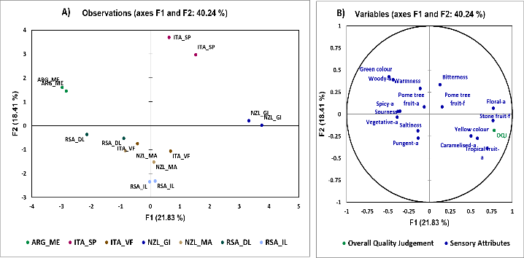  1) | 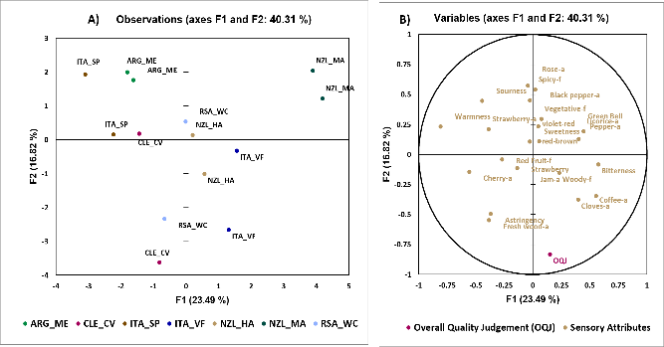

Figure 1&2 MFA for Pinot Gris and Pinot Noir dataset. (A) shows the observation plot. (B) shows the sensory analysis variables.

4. References
Dupas de Matos, A., Longo, E., Chiotti, D., Pedri, U., Eisenstecken, D., Sanoll, C., Robatscher, P. and Boselli, E., 2020. Pinot blanc: Impact of the winemaking variables on the evolution of the phenolic, volatile and sensory profiles. Foods, 9(4), p.499.
Nishida, M., Lestringant, P., Cantu, A. and Heymann, H., 2021. Comparing classical descriptive analysis with modified descriptive analysis, modified rate‐all‐that‐apply, and modified check‐all‐that‐apply. Journal of Sensory Studies, 36(5), p.e12684.
Poggesi, S., Darnal, A., Ceci, A.T., Longo, E., Vanzo, L., Mimmo, T. and Boselli, E., 2022. Fusion of 2DGC-MS, HPLC-MS and Sensory Data to Assist Decision-Making in the Marketing of International Monovarietal Chardonnay and Sauvignon Blanc Wines. Foods, 11(21), p.3458.
Poggesi, S., Dupas de Matos, A., Longo, E., Chiotti, D., Pedri, U., Eisenstecken, D., Robatscher, P. and Boselli, E., 2021. Chemosensory Profile of South Tyrolean Pinot Blanc Wines: A Multivariate Regression Approach. Molecules, 26(20), p.6245.

