Novel Insights on the Functional and Nutritional Features of the Foods Based on Cereals and Legumes
Arianna Ressa (arianna.ressa@uniba.it)
Department of Soil, Plant and Food Sciences (DISSPA), University of Bari “Aldo Moro” Bari, Italy
Tutor: Prof.ssa Calasso Maria

This research project aims to improve foods' nutritional and functional characteristics based on cereals and legumes, using biotechnological strategies to exploit unconventional matrices. First, type I sourdough obtained from sprouted wheat grains and lentils were studied. The second activity concerned the study of gluten-free bread (GF) obtained using type II sourdough and enriched in an artichoke by-product. Finally, self-structuring drinks obtained from the combination of plant protein isolates (soy, pea, lentil) and hydrocolloids (hydroxypropyl-methylcellulose, xanthan, guar gum, sodium alginate, pectin) were studied.

Nuovi approfondimenti sulle caratteristiche funzionali e nutrizionali degli alimenti a base di cereali e legumi
Questo progetto di ricerca ha come obiettivo uno studio sul miglioramento delle caratteristiche nutrizionali e funzionali di alimenti a base di cereali e legumi, utilizzando strategie biotecnologiche per sfruttare matrici non convenzionali. Inizialmente, sono stati studiati lieviti naturali di tipo I ottenuti da granelle germinate di frumento e lenticchia. La seconda attività ha riguardato lo studio di pani senza glutine (GF) ottenuti utilizzando lievito naturale di tipo II e arricchiti con sottoprodotto della lavorazione del carciofo. Infine, sono state studiate bevande auto-strutturanti ottenute combinando isolati proteici vegetali (soia, pisello, lenticchia) con idrocolloidi (idrossipropilmetilcellulosa, xantano, gomma guar, sodio alginato, pectina).

Key words: sourdough; germination; legumes; artichoke; plant-protein isolate

1. Introduction
Cereals, legumes and related foods are an important source of energy, as well as a range of non-nutrient bioactive components that provide health benefits. The main challenges for the near future include the exploration of non-conventional matrices and the implementation of processing and biotechnological strategies (such as germination and fermentation) finalized to improve their functional and nutritional properties. In accordance with the PhD thesis project, this communication reports the main results of three activities concerning:
(A1) Evaluation of physicochemical, microbiological, metagenomics, metatranscriptomics and metabolomics parameters during the preparation and propagation of firm and liquid sourdoughs obtained by traditional fermentation (type I sourdough) and backslopped over 10 days with sprouted and non-sprouted flours in order to assess its potential use in bread making;
(A2) Nutritional and functional evaluation of gluten-free bread obtained by using type II sourdough and enriched in an artichoke by-product;
(A3) Application of hydrocolloid technology for developing self-structuring beverages plant-protein based.

2. Materials and Methods

2.1 Characterization of firm and liquid sourdough from sprouted and non-sprouted grains
Two different grains were considered in this study: a first made of a cereal (wheat, Triticum durum var. Simeto), and a second composed of a legume (lentil, Lens culinaris). Cereals and legumes were purchased from local markets. The wheat and lentil sprouting processes were performed according to Montemurro et al., (2019) with some modifications described by Perri et al., (2021). Sprouted wheat and lentil grains were milled into smaller particle sizes (< 500 µm) by using a laboratory mill (Ika-Werke M20 GMBH, and Co. KG, Staufen, Germania), without removing the rootlets thus obtaining the whole sprouted wheat and whole sprouted lentil flours using to obtain sprouted wheat and sprouted lentil sourdough (SW, SL). The non-sprouted wheat flour was obtained from whole non-sprouted wheat grains through the same laboratory mill in order to obtain non-sprouted wheat sourdough (NSW). In addition, sourdough obtained from commercial refined wheat flour (RW) was used. The preparation of dough and propagation of sourdough was performed by a traditional protocol without the addition of starter cultures or baker's yeast. Spontaneous wheat and lentil sourdough fermentations were carried out through backslopping, both in firm and liquid conditions (dough yield 160 and 280 respectively). Based on previous work (Rizzello et al., 2014), a flour composition has been selected to produce sprouted wheat-lentil sourdough (SWSL). Culture-dependent microbiological characterization by using plate count and the study of community-level physiological profile (CLPP) by using OmniLog MicroStation was studied in the dough before fermentation (D0) after the first fermentation of 24h (D24) and after 3, 6, and 10 days of refreshments. Biochemical (pH, total titratable acidity (TTA), lactic acid, acetic acid, fermentation quotient) and nutritional characterization (total phenolic concentration, antioxidant activity and antinutritional factors (phytic acid and raffinose)) of dough and sourdoughs at D0, D24 and R10, were carried out. For metagenomic analysis, 16S rRNA gene amplicons of the bacterial communities of doughs and sourdoughs using primers 350F/814R, targeting the region V1-V3 of Firmicutes were sequenced by Illumina 2×300bp paired-end MiSeq platform. 16S sequencing-derived fastQ files were checked for quality using FastQC software. In silico bioinformatics analyses, including denoizing, taxa assignment and alpha and beta diversity, relied on the QIIME2 (Bolyen et al., 2019) microbiome platform (version 2020.8). Quantification of total bacteria and specific species was performed on the D0, D24 and R10 collected samples, by qPCR following the method reported in Pontonio et al., (2017) and Kwok et al., (2014) with some modifications. qPCR was performed on a 7300 Real-Time PCR System (Applied Biosystem, Forter City, CA USA). Metatranscriptomics analysis was carried out on all mature sourdoughs (R10) by using Illumina NextSeq 500 sequencing platform (Illumina, San Diego, CA, USA). The raw metatranscriptomic sequencing data (reads) of all sourdough at R10 were analysed in silico using SqueezeMeta pipeline Version 1.0, July 2019 together with other ad hoc utilities developed to manage assembly and annotation in order to obtain taxonomic information and metabolic pathways involved. Metabolomics profile was also detected and data analysis is still ongoing. Based on metadata sample stratification a two-group Welch corrected test was used for group pair comparisons and only statistically significant results were kept. All performed analyses were corrected for multiple tests by applying the Benjamini-Hochberg procedure. Error bar plots have been obtained by using the STAMP software (Parks et al., 2014).

2.2 Nutritional and functional evaluation of gluten-free bread enriched in an artichoke by-product
Type II sourdough (tIISD) dough yield 200 (DY200) was obtained by using commercial rice flour. Leuconostoc pseudomesenteroides (DSM20193) was inoculated at cell density approx. 10^7 CFU/g. Four different gluten-free bread (DY200) were prepared. In detail: i) gluten-free leavened bread without the addition of sourdough and artichoke extract (YB), ii) gluten-free leavened bread with the addition of artichoke extract (YB-AE), iii) gluten-free bread leavened with tII-SD (SB), iv) gluten-free bread with tII-SD and addition of artichoke extract (SB-AE). All the loaves were baked at 210°C for 30min. The loaves were subjected to in vitro digestion to evaluate the predictive glycemic index (PGI), according to Liljeberg et al., (1996). For the evaluation of the antioxidant activity DPPH (2,2-diphenyl-1-picrylidrazyl), methanol extracts (ME) were first obtained from each sample, according to Perri et al., (2021). Then, ABTS [2,2′-azino-bis (3-ethylbenzothiazoline-6-sulfonic acid)] test was conducted as a control. Microbiota and volatile profiling of fermented faecal batches were carried out. To perform the ex vivo experiments, two different human cell lines were used, both provided by the National Institute for Cancer Research of Genoa (Italy). Specifically, the cell lines were Caco-2 (colon adenocarcinoma) ICLC HTL97023 and the human keratinocytes NCTC 2544. The viability of cells tested for toxicity has been assessed. In addition, the pro-inflammatory contribution of bread digests was evaluated by estimating levels of TNF-α and interleukin 1-β expressed in Caco-2 cells.

2.3 Application of hydrocolloid technology for developing self-structuring beverages plant-protein based
The following activity is part of a period of study and research abroad (still ongoing) at the Department of "Nutritional and Food Science" of University College Cork. The activity involves the development of innovative laboratory-scale satiety-enhanced beverages with high protein/fibre content.

3. Results and Discussion

3.1 Ecology dynamics in spontaneous sourdoughs made from native and sprouted wheat and lentil flour
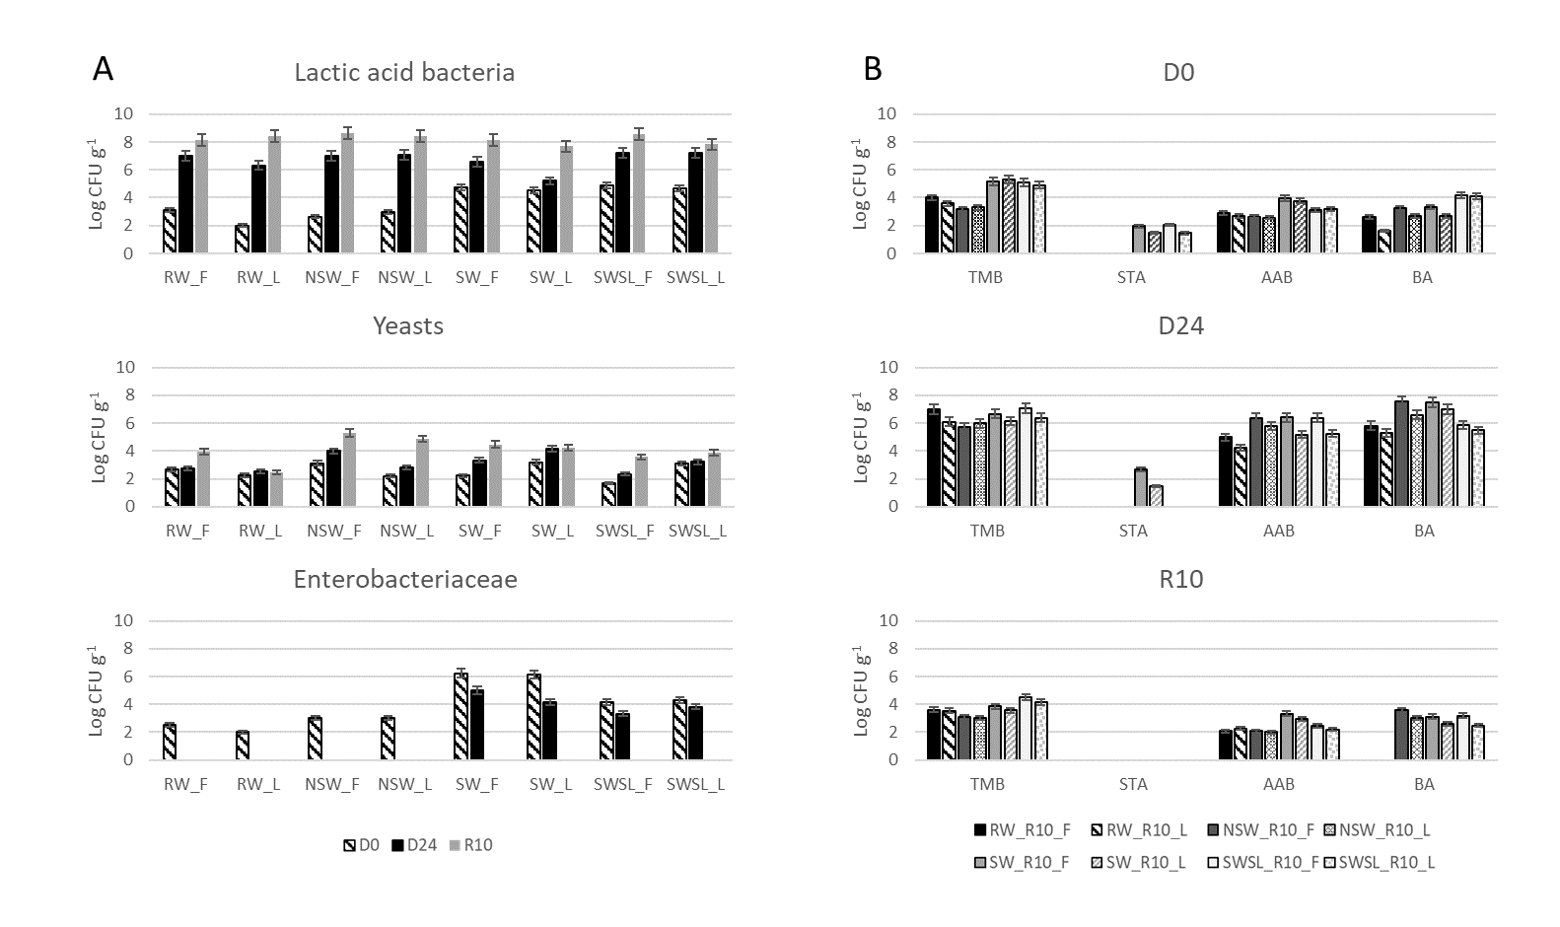
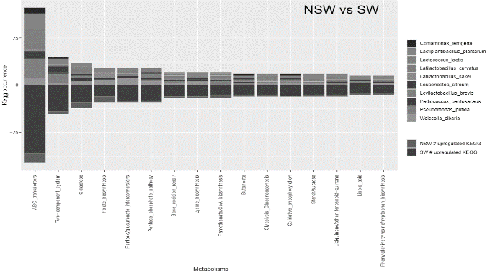
With the aim of ascertaining the impact of the sprouting process and the dough yield condition on sourdoughs, all the obtained replicates corresponding to the starting point (D0), the first day of backslopping at 30°C (D24) and the 10th day of refreshment at 30°C (R10), have been inspected in terms of culture-dependent, biochemical, nutritional, metataxonomic metatranscriptomics and metabolomics profile. Culture-dependent approaches are shown in Fig. 1A. The cell density of the main microbial groups was affected by matrix, time of collection and condition of propagation. LAB cell densities at D0 were 2 or 3 log cycles highest in doughs made by flours obtained from sprouted grains. The yeast’s initial cell density increased during propagation and reached 5.0 ± 0.29 log CFU/g at the end of the 10th daily refreshment. Sprouted sourdoughs harboured a higher number of yeasts. A similar trend was previously observed in the spontaneous fermentation of sprouted lentil flour alone or in a mix with cereal flour (Perri et al., 2021). In line with Ercolini and co-workers (Ercolini, 2013), presumptive Enterobacteriaceae were enumerated in each dough which results higher in sprouted samples (p < 0.05) and were no longer detected on day 10 of sourdough propagation. When CLPP profiles were checked, the sprouted matrices revealed an increase in the metabolisms related to carbohydrates at the 10th refreshment time point. Furthermore, when compared with RW, the SWSL matrix showed a higher amino acid metabolism profile. Prior to the fermentation, higher pH and lower TTA values in liquid samples were observed when compared with firm ones. Moreover, despite not being supported by statistical significance, we noticed a decreasing pH trend for liquid sourdoughs till the end of the fermentation process with pH values lower than 4.5. These results agree with previous evidence (Di Cagno et al., 2014), stating how liquid sourdoughs obtained only from raw wheat showed lower pH values at the end of the fermentation. By inspecting the sprouted group, sprouted samples showed higher pH values at the 10th refreshment. Moreover, when SW and SWSL were both compared against RW, a lower amount of organic acids (acetic and lactic) marked sprouted samples, as evidenced by the lower fermentation quotient measured at the end of the fermentations. The total phenolic concentration and the antioxidant activity reported a not significant increase (p > 0.05) at the end of the 10 daily propagation. A lower amount in sprouted samples of raffinose, a fermentable sugar included in the class of fermentable oligosaccharides, disaccharides, monosaccharides and polyol (FODMAP), would prevent gastrointestinal symptoms (Curiel et al., 2015). At the same time, phytic acid which chelates divalent minerals and reduces their bioavailability, was detected at lower amounts in sprouted and mature sourdough (Curiel et al., 2015). Although we found only a lowering trend describing the phytic acid decrease at the end of fermentation, our data revealed a statistically significant lower value of raffinose in sprouted than non-sprouted samples. It is known that different strains of lactic acid bacteria (LAB) belonging to the Lactobacillus genus, can produce in sourdough the α-Galactosidase enzyme useful to reduce the raffinose family oligosaccharides (RFO’s) content in different products (Yoon & Hwang, 2008). qPCR results detected several species of lactobacilli whose presence could justify raffinose level reduction in mature sourdoughs (R10). As evidenced by alpha and beta diversity estimates, we noticed how both the Welch and PERMANOVA relative statistics proved a different distribution of taxa based on the matrix stratification. A higher relative abundance of Pediococcus genus was found in the SWSL when metagenomic data were inspected. NSW was found to be significantly enriched in Empedobacter. A significantly increased relative abundance of Weissella in NSW was also found. A significant abundance of Enterococcus faecalis emerged from the comparison of both SW and SWSL against RW. The results on sourdough are in line with our previous evidence on SW-germinated flour Perri et al., (2020). Enterococcus faecalis exerts an important role in the production of γ-aminobutyric acid (GABA) (Khanlari et al., 2021), an aspect that deserves further investigation. Regarding metatranscriptomics, starting from the raw sequencing data (raw reads), it is possible to perform assembly and annotations in the file "ORF table" (SQM project) that will allow the creation of database taxa/ specific functions. The inspection of the annotation data through different filters has been fundamental for the recovery of unique/shared functions up to the taxonomic level of the species and to different levels of metabolic pathways of the KEGG. Fig. 1B shows the comparison between NSW (non-sprouted wheat) and SW (sprouted wheat) matrices. It emerged that oxidative phosphorylation metabolism is exclusive to the sprouted matrix. The ABC transporters metabolism has a greater occurrence of KEGG while less occurrence of KEGG characterized the lipoic acid metabolism and in the phenylalanine/tyrosine/tryptophan biosynthesis metabolism. The microbial profile associated with each metabolism appears significantly different: Comamonas terrigena, Lactiplantibacillus plantarum, Lactococcus lactis, Latilactobacillus curvatus, Latilactobacillus sakei, Leuconostoc citreum, Levilactobacillus brevis, Pediococcus pentosaceus, Pseudomonas putida, Weissella cibaria. The ABC complex transporters metabolism showed a high KEGG occurrence associated with Lactiplantibacillus plantarum while Pediococcus pentosaceus do not present KEGG occurrence. Based on high-resolution metabolomics and metatranscriptomics merged results we were confident in detecting the contribution of statistically significant altered transcript at the species level. Metabolic sub-pathways belonging to carbon (starch/sucrose/galactose metabolism, pentose phosphate pathway, pentose glucuronate interconversion) and nitrogen (arginine/lysine/glycine) metabolisms, as well as, cell-cell communication (two-component system and quorum sensing), were checked also in terms of metabolites by reconstructing the step-by-step reaction flow.
B

Figure 1 A) cultivable bacteria and yeast cell density (log CFU g⁻¹) for each analysed sample. RW, NSW, SW, and SWSL density in firm and liquid conditions (F, L) at three collection times (D0, D24 and R10): microbial growth trends for the group of presumed lactic acid bacteria, yeasts and Enterobacteriaceae. B) Bar plot obtained from comparing the ORF table data between two matrices (NSW non-sprouted wheat and SW sprouted wheat). The graph shows each species' significant occurrence values of KEGG (Y-axis) for a given metabolism (X-axis).

3.2 Nutritional and functional evaluation of gluten-free bread enriched in an artichoke by-product
This study aimed to modify a traditional food consumed daily to support patients with gluten-related disorders (GrD) and those with proven celiac disease (CeD). The predicted glycaemic index (PGI) was calculated on digested bread samples. Values between 62.8-111.3 (Fig. 2A) were found in SB and YBAE, respectively. A decrease in PGI was found in samples containing tII-SD (p < 0.004) since microbial fermentations are well-known as a good way to metabolize sugar-containing substrates (De Vuyst et al., 2021). The presence of AE significantly increases PGI in SB-AE. By setting a water-based extraction protocol, Garcia-Castello et al., (2022) enlightened how it was possible to recover 60% of the polyphenolic quantity and 56% antioxidant activity from the solid waste of artichoke by-products. As shown in Fig. 2B, the paired comparison of bread with AE against bread without AE shows DPPH values 15 times higher in AE bread (p <0.001). A comparison of SB-AE and YB-AE shows that the first bread has higher antioxidant activity (p = 0.02). ABTS test confirms the DPPH test. Fig. 2C shows the principal component analysis (PCA) results concerning the microbiota analysis of the faecal batches fermented at 20 and 42h. Based on the PC1 results, samples at T20 and T42 are plotted in the positive and negative quadrants, respectively, indicating a partial grouping in time. At T20, samples show increased viability of total bacteria (aerobic and anaerobic TBC), Enterobacteriaceae and LAB. At T42, it increases the viability of Streptococcus, Clostridium and Bifidobacterium. Few differences were found in AE-containing bread. At T42, Bifidobacterium and Clostridium are abundant in YB, and adding AE does not change the trend. Instead, SB mainly hosts LAB and streptococci without significant differences with the addition of AE. The metabolic profile of the faecal batches after 20 and 42h of incubation was different in qualitative and quantitative terms. 59 volatile compounds have been identified in the following classes of chemical compounds: alcohols (5), aldehydes (10), esters (6), hydrocarbons (6), indoles (2), ketones (8), organic acids (14), phenols (2) and terpenes (2). In addition, 4 compounds not belonging to the above classes have been identified: 3-Ethyl-3-methylheptane; 1H-pyrrole-2,5-Dione; 3-ethyl-4-methyl, 8-methyl nonanoic acid; γ-Dodecalactone. Specifically, after 20 hours of faecal fermentation, we distinguish SB from YB by the presence of the latter of aldehydes and hydrocarbons, without significant differences resulting from the addition of AE. High levels of hydrocinnamic acid were detected in SB-AE-T20, one of artichoke's most representative phenolic compounds (Pandino et al., 2012). The VOCs profile changed partially after another 22 hours of incubation. In fact, at 42h a wide spectrum of organic acids, phenols and indoles has characterized samples containing AE differently. Based on ex vivo experiments, SB and AE combined decreased the cellular TNF-α and IL1-β expression.

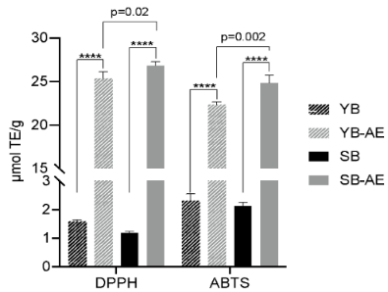
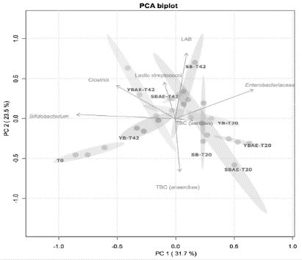
C
B

Figure 2 A) predicted glycemic index (PGI) of digested breads made with or without type-II sourdough (S and Y, respectively) and with or without a powdered artichoke extract (AE); B) radical scavenging activity, based on DPPH and ABTS assays, of breads. Results were expressed as μmol of Trolox equivalent (TE)/g. “****” means p-value < 0.001; C) Biplot of principal component analysis (PCA) on the microbial density of faecal batches fermented with four different loaves (YB; YB-AE; SB; SB-AE) in two fermentation times (20 and 42 hours, T20 and T42, respectively). The cell density of the investigated microbial groups is also shown. Abbreviations: total bacterial count (TBC), lactic acid bacteria (LAB).

3.3 Application of hydrocolloid technology for developing self-structuring beverages plant-protein based
Since we live in an obesogenic world, it is known that foods with satiety sensations furnished have obvious benefits for weight management and could improve the health of consumers. The aim of the research is to create ingredients that could provide nutritional enrichment to the finished product. Prototypes of smoothies will be developed using hydrocolloids and plant protein isolate which can develop with self-structure within the gastrointestinal tract providing a greater sense of gastric stuffing. It will be necessary to characterize the stability of the beverage formulation in response to different environments (pH, salt conditions, temperature). Data analysis is still ongoing.

4. Conclusions

The preliminary data shows how we could ascertain the better nutritional quality and relative shelf-life throughout the sprouted grain and mixed samples. In addition, we have seen how using by-products such as artichoke leaf extract could be a functional ingredient for developing new gluten-free products with better biological properties. This PhD project will conclude with the study results of a gluten-free smoothie prototype for its use as an ingredient with high nutritional value.

5. References
Bolyen E, Rideout JR, Dillon MR, Bokulich NA, Abnet CC, Al-Ghalith GA, Alexander H, Alm EJ, Arumugam M, Asnicar F, Bai Y, Bisanz JE, Bittinger K, Brejnrod A, Brislawn CJ, Brown CT, Callahan BJ, Caraballo-Rodríguez AM, Chase J, Caporaso JG (2019) Reproducible, interactive, scalable and extensible microbiome data science using QIIME 2. Nat Biotech 37(8): 852–857.
Curiel JA, Coda R, Centomani I, Summo C, Gobbetti M, Rizzello CG (2015) Exploitation of the nutritional and functional characteristics of traditional Italian legumes: The potential of sourdough fermentation. Int J F M 196: 51–61.
De Vuyst L, Comasio A, Kerrebroeck SV (2021) Sourdough Production: Fermentation Strategies, Microbial Ecology, and Use of Non-Flour Ingredients. Crit Rev Food Sci Nutr 1–33.
Di Cagno R, Pontonio E, Buchin S, De Angelis M, Lattanzi A, Valerio F, Gobbetti M, Calasso M (2014) Diversity of the Lactic Acid Bacterium and Yeast Microbiota in the Switch from Firm- to Liquid-Sourdough Fermentation. App Env Micr 80(10): 3161–3172.
Ercolini D (2013) High-Throughput Sequencing and Metagenomics: Moving Forward in the Culture-Independent Analysis of Food Microbial Ecology. App Env Micr 79(10): 3148–3155.
Garcia-Castello EM, Mayor L, Calvo-Ramirez A, Ruiz-Melero R, Rodriguez-Lopez AD (2022) Response Surface Optimization of Inulin and Polyphenol Extraction from Artichoke (Cynara Scolymus (L.)) Solid Wastes. Appl Sci 12: 7957.
Khanlari Z, Moayedi A, Ebrahimi P, Khomeiri M, Sadeghi A (2021) Enhancement of γ-aminobutyric acid (GABA) content in fermented milk by using Enterococcus faecium and Weissella confusa isolated from sourdough. J of Food Proc Pre 45(10): e15869.
Kwok L, Zhang J, Guo Z, Gesudu Q, Zheng Y, Qiao J, Huo D, Zhang H (2014) Characterization of Fecal Microbiota across Seven Chinese Ethnic Groups by Quantitative Polymerase Chain Reaction. PLOS ONE 9(4): e93631.
Liljeberg H, Åkerberg A, Björck I (1996) Resistant Starch Formation in Bread as Influenced by Choice of Ingredients or Baking Conditions. Food Chem 56: 389–394.
Montemurro M, Pontonio E, Gobbetti M, Rizzello CG (2019) Investigation of the nutritional, functional and technological effects of the sourdough fermentation of sprouted flours. Int J F M 302: 47–58.
Pandino G, Lombardo S, Mauro RP, Mauromicale G (2012) Variation in Polyphenol Profile and Head Morphology among Clones of Globe Artichoke Selected from a Landrace. Sci Hortic 138: 259–265.
Parks DH, Tyson GW, Hugenholtz P, Beiko RG (2014) STAMP: Statistical analysis of taxonomic and functional profiles. Bioinformatics (Oxford, England) 30(21): 3123–3124.
Perri G, Calabrese FM, Rizzello CG, De Angelis M, Gobbetti M, Calasso M (2020) Sprouting process affects the lactic acid bacteria and yeasts of cereal, pseudocereal and legume flours LWT – Food Sci Tech 126: 109314.
Perri G, Coda R, Rizzello CG, Celano G, Ampollini M, Gobbetti M, De Angelis M, Calasso M (2021) Sourdough fermentation of whole and sprouted lentil flours: In situ formation of dextran and effects on the nutritional, texture and sensory characteristics of white bread. Food Chem 355: 129638.
Pontonio E, Di Cagno R, Mahony J, Lanera A, De Angelis M, van Sinderen D, Gobbetti M (2017) Sourdough authentication: Quantitative PCR to detect the lactic acid bacterial microbiota in breads. Scientific Rep 7(1): Art. 1.
Rizzello CG, Calasso M, Campanella D, De Angelis M, Gobbetti M (2014) Use of sourdough fermentation and a mixture of wheat, chickpea, lentil and bean flours for enhancing the nutritional, texture and sensory characteristics of white bread. Int J F M 180: 78–87.
Yoon MY, Hwang HJ (2008) Reduction of soybean oligosaccharides and properties of α-d-galactosidase from Lactobacillus curvatus R08 and Leuconostoc mesenteriodes JK55. Food Micro 25(6): 815–823.

