Dual Approaches to Investigate the Infant Food Microbiome and Listeria monocytogenes Behaviour under Severe Acidic Conditions
Dimitra Tsoureki (dimitra.tsoureki@unito.it)
Department of Agricultural, Forest and Food Sciences, University of Turin, Grugliasco, Italy
Tutor: Prof. Kalliopi Rantsiou

The aim of this PhD thesis research project was to implement untargeted (metataxonomic analysis) and targeted (culturing and qPCR) approaches to decipher the distribution of pathogens and how they persist inside a complex microbial community of an infant food processing line through time and space. Furthermore, a comprehension of the behavioural mechanisms (phenotypes, gene expression) of a Listeria monocytogenes pathogenic strain after adaptation at low acidic conditions led to conclusions on possible predictive models for the benefit of food safety. This PhD is part of the European Project “SAFFI - Safe Food for Infants in the EU and China”.

Doppio Approccio per Studiare il Microbioma degli Alimenti per Infanzia e il Comportamento di Listeria monocytogenes in Condizioni di Elevata Acidità
L’obiettivo di questo progetto di ricerca di tesi di dottorato è stato quello di implementare approcci non mirati (analisi metatassonomica) e mirati (colturali e qPCR) per definire la distribuzione dei patogeni e il modo in cui essi persistono all'interno di una complessa comunità microbica come quella di una linea di trasformazione di alimenti per l’infanzia, sia nel tempo che nello spazio. Inoltre, la comprensione del comportamento (i fenotipo, espressione genica) di un ceppo patogeno di Listeria monocytogenes dopo l'adattamento a condizioni di bassa acidità ha portato a conclusioni su possibili modelli predittivi a vantaggio della sicurezza alimentare. (SAFFI)

Keywords: infant food, pathogens, DNA, real-time PCR, metataxonomic analysis, in vitro, behaviour, severe acidity, adaptation, stress.

1. Introduction
In line with the previous year’s manuscripts this oral communication reports the main results obtained following the activities directed to:
A1) detect targeted pathogens by combining culture dependent and culture independent methods.
A2) find out routes of transmission and determine the microbial taxonomic composition, focusing on its protagonist’s associations (co - exclusion / co - existence), in other words of correlations between the most abundant taxa and the targeted pathogens.
A3) determine the microbial response of Listeria monocytogenes under acidic conditions by evaluating the robustness gained through a survival under severe acidity, through phenotype and transcriptomics.
All these aspects are relevant matters of great interest as foodborne pathogens and foodborne diseases, are still a significant public health issue worldwide and an immense challenge for food industries (World Health Organization, 2017, 2015; Zwirzitz et al., 2020).

2. Culture - dependent and Culture - independent Methods
Both approaches are directed by the same aim of detecting targeted pathogens. Culture - dependent approaches include the classical microbiological analysis and the analysis of whole - genome sequencing (WGS). Classical microbiological analysis consists by the traditional culture methods in generic and selective medium and under optimal incubation conditions, in order to let the time to the agent to grow and in position to be culturable. WGS is a molecular subtyping method eventually used in routine pathogen surveillance. Permits to evaluate and establish whether isolates derive from a same persistent clone inside different compartment along a food chain, as well as validates the causative agent related to a multi - country outbreak (Koutsoumanis et al., 2020, 2019; Kovac, 2019).
Culture - independent approaches mainly refer to real - time PCR, 16S rRNA - gene amplicons sequencing (metataxonomics) and shotgun sequencing (metagenomics). Firstly, real - time PCR is used as a targeted method for the detection of pathogens in the whole DNA of a complex sample matrix (Kralik and Ricchi, 2017). Moreover, both metataxonomic analysis and metagenomics, as untargeted methods, are able to investigate uncultivable microorganisms inside the whole genetic content of communities. Amplicon sequencing is making possible to profile the succession of entire microbial populations over time at various taxonomic levels and have an overview on the taxonomy, composition and diversity of bacterial communities. Metagenomics offer insight into the metabolic pathways and the community genetic signatures (antimicrobial resistance genes, virulence genes) of a microbiome and can direct track the presence of unculturable organisms (even at the strain level) and as well predict potential functions encoded by the microbial communities (Jagadeesan et al., 2019).

3. Listeria monocytogenes and Acid Stress
Listeria monocytogenes is a foodborne pathogen, ubiquitously present thanks to its extreme adaptability under a wide range of environments and food - vehicles. It can easily pass from the saprophytic state to the invasive (intracellular) one, causing severe infections (listeriosis), mainly to immunocompromised members of the population (Buchanan et al., 2017; Freitag et al., 2009). L. monocytogenes is known to persist over long periods of time within food production facilities, colonising favourable niches. Furthermore, the processing environments to a large degree are characterised by severe conditions, like nutrients scarcity, acidic pH, high osmolarity, heat shock and ecological competitions that can impose various levels of stress resulting in lethal (irrevocable microbial cells damage) or sublethal (survival permission) stresses (Ferreira et al., 2014).
Low acidity is mainly characterising production lines that include products from fruit and vegetable derivatives (such as fruit purees and juices) but also a condition during the cleaning and sanitisation process, where acids are commonly used. Weak acids have been used as food preservatives and their mode of action is represented at Figure 1. Briefly weak organic acids can present in parallel their dissociated and undissociated state, depending on their acidic group state and the pH of the environment. The undissociated form is able to freely diffuse into the microbial cytoplasm till to reach an equilibrium (equal internal and external concentration). In this way the intracellular pH is reduced, the osmolarity of the cytoplasm is increased and general metabolic perturbations are observed (Hirshfield et al., 2003).

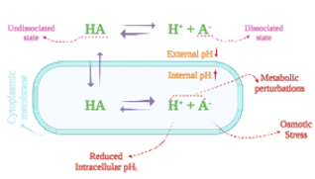
Figure 1 Dissociation Equilibrium of Weak Organic Acids on the Cell.
Listeria monocytogenes adaptation to sublethal conditions, increases its resistance that results in significant gene and protein expression profile changes mainly associated with the mobilisation of cellular mechanisms that deal with acids. L. monocytogenes responds to the acidic stress conditions through the production of various Acid Stress response Proteins (ASPs), such as proteins involved to the respiration (dehydrogenases (GuaB, PduQ, lmo0560) – reductases (YcgT)), osmolyte transport (GbuA), protein folding and repair (Chapronin, GroEL, ClpP), flagella synthesis (FlaA) and metabolism (Pfk, GalE) (Soni et al., 2011). Furthermore, Lm possesses various acid adaptive mechanisms including the Adaptive Acid Tolerance Response (ATR), the Glutamate Decarboxylase (GAD) system and the Arginine Deaminase (ADI) system that help the microorganism regulate the internal cytoplasmic pH and in general overcome the acidic environments (NicAogáin and O’Byrne, 2016).

4. Materials and Methods
From October 2021 to December 2022 a total number of two hundred and thirty - five samples were collected during various stages of an infant food process line and more in specific powdered cereal based infant food. Four types of samples were investigated: Raw Material (RM), Intermediate (IP) and Final (FP) Products, as well as Environmental swabs (ENV). Moreover, longitudinally the sampling period has been conducted in four campaigns: C01 (October 2021 - January 2022), C02 (January 2022 - June 2022), C03 (June 2022 - October 2022), C04 (October 2022 - December 2022).
The presence of five targeted foodborne pathogens - Listeria monocytogenes (Lm), Salmonella spp. (S), Staphylococcus aureus (Sa), Bacillus cereus (Bc) and Clostridium perfringens (Cp) - was examined through traditional culturing methods prior and subsequent to twenty - four hours of generic enrichment, whereupon pathogens isolation took place in selective media. On each sample molecular techniques, with focus on the whole DNA, were followed. Specifically, 16S rRNA amplicon - based sequencing was performed, mainly investigating the Amplicon Sequence Variants (ASVs) distribution and in parallel real - time PCR used to enhance the detection of the targeted pathogens.
What concerns the Listeria monocytogenes behaviour under acidic conditions, a single strain (10403S) was chosen as a well monitored case. A weak organic acid was used to reach the requested acidic conditions and that was citric acid. A preculture of L. monocytogenes was cultivated at Tryptone Soya Broth supplemented with Yeast Extract (TSBYE) till the stationary phase and then was inoculated at three theses: thesis 1 - control TSBYE at pH 7.2, thesis 2 - TSBYE at pH 5.5 and thesis 3 - TSBYE at pH 5.2. The three cultures let to adapt till twenty - four hours of growth under continuous agitation at thirty - seven degrees Celsius. The capacity of each of the thesis to adapt and increase acid resistance was measured at four time points during growth (t0, t6, t12, t24) by performing lethal acidic shock at pH 2 for thirty minutes. The capacity of the cultures to survive this shock was investigated phenotypically (counts) and at RNA expression level, by sequencing the whole transcriptome (RNA - seq).

5. Results and Discussion

5.1 Bacterial Communities Structure and Metataxonomic Composition
Considering as a factor the type of sample (RM, IP, FP, ENV) there is no clear segregation in between the microbial communities. If the focus is put upon time, then most of the microbiota variability is explained (PERMANOVA, P[FDR] < 0.001, R² = 0.4), making time the major driver of the biodiversity of the samples (Figure 2). The impact of time is also seen through the α - diversity measures, where a wave - like pattern is observed along the fourteen months of sampling.

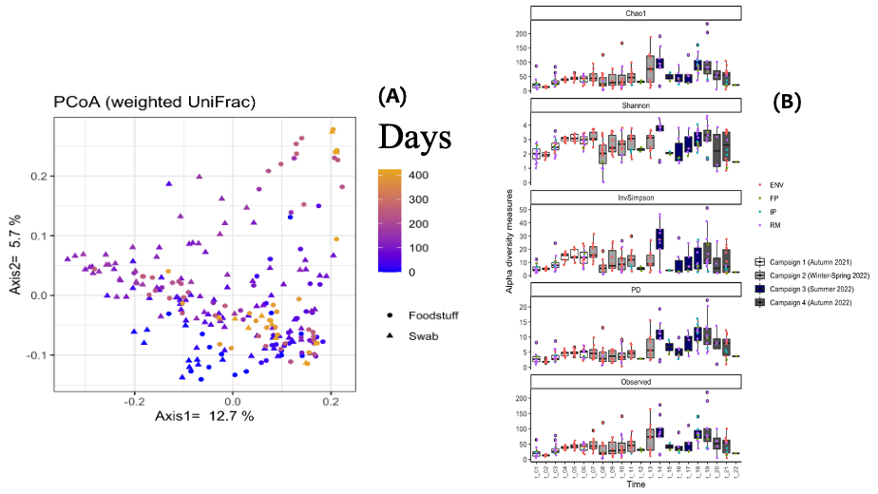
Figure 2 Alpha - diversity (B) and Beta - diversity (A) Measures of Bacterial Communities. (A) PCoA plot based on weighted UniFrac β - diversity distance (PERMANOVA, R2 = 0.35, P[FDR] < 0.001). (B) Box plots of α - diversity metrics display the fourteen months of sampling in twenty-two blocks and four campaigns (Kruskal - Wallis, P < 0.001).

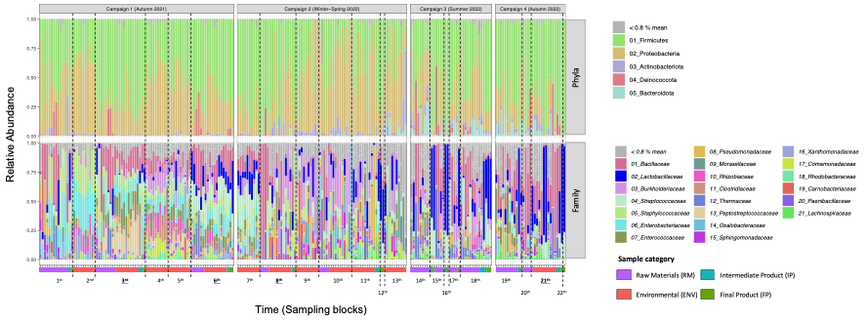
Figure 3 Overview of the Microbiota Composition at Phyla and Family Level. Stacked bar plots representing the microbiota composition - relative abundance - in phylum and family taxa ranks with colour coding keys. The samples are grouped following the temporal sampling order and thus are divided by sampling blocks. The legends contain the taxa sorted from the most to the least abundant and only taxa >0.8 % of average abundances are displayed.
In Figure 3 is represented the microbiota distribution in relation to the sampling time, divided in sampling campaigns and subsequently by sample type. The phyla Firmicutes, Proteobacteria, Actinobacteriota, Deinococcota and Bacteroidota are predominant and ubiquitously distributed in all samples. Furthermore, there is an evident temporal succession of families during time and more in particular when comparing the microbial composition of the four campaigns. For instance, Enterobacteriaceae and Staphylococcaceae are predominant in the first campaign, while Lactobacillaceae, Lachnospiraceae and Enterococcaceae abundances tend to increase along time.

5.2 Shared Taxa
The taxa distribution both at family and genus / species level were investigated through Venn diagrams (Figure 4) in order to identify the core taxa shared between the sample types (RM, IP, FP, ENV). Within the fifty - six core families it was possible to detect Bacillaceae, Clostridiaceae, Enterobacteriaceae and Staphylococcaceae, while Listeriaceae was shared between RM, IP and ENV but was not detected in the FP. At the highest taxonomic level, the distribution for the targeted pathogen species or belonging genus was confirmed, except for Salmonella spp. that was not detected among the Enterobacteriaceae family.

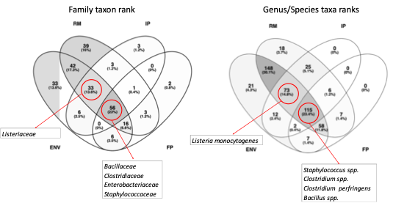
Figure 4 Venn Diagram - Shared Taxa. Display of the number of shared taxa at the family and genu / species levels among the four sample types. Only taxa present in more than four samples are considered and the presence of families and genus / species of interest are highlighted.

5.3 Targeted Pathogens Detection
The two spore forming bacteria were the most present followed by Staphylococcus aureus, Listeria monocytogenes and Salmonella spp. There are samples that contain more than one targeted pathogen. From their presence in the different sample types, it could be assumed that Bacillus cereus and Clostridium perfringens are introduced to the production through the RM and the other three pathogens through the ENV. From the networks (Figures 5 & 6) can be observed the straight correlation in presence between samples of the same production period but as well a certain degree of overlapping between the two targeted methods (qPCR in matrices and isolation).
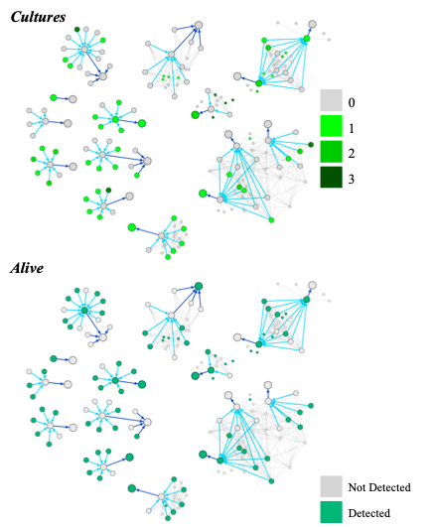
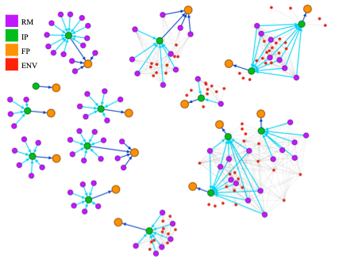

Figure 5 Network Displaying Links among Samples. Nodes with different colours are representing the type of sample and edges are showing the connections and directions in between the samples in relation to the process flowchart.

Figure 6 Detection of Bacillus cereus Correlating Results of Isolation (Cultures) and real - time PCR (Alive) in matrices. The upper colour scale represents number of isolates and the lower colour scale detection or not in matrices.

5.4 Listeria monocytogenes Behaviour under Acidic Conditions
Listeria monocytogenes strain 10403S gained robustness after a long - term acid adaptation (LTAA) and more specifically the theses 2 (pH 5.5) and 3 (pH 5.2) showed significantly (T - test: P[FDR] < 0.001) higher resistance in comparison to the control (pH 7.2) when reaching the stationary phase, at twenty-four hours of growth. In the Figure 7 are represented the four points of interest, where the phenotypes and the response to the lethal shock were monitored. Moreover, observing the bar plots is clear the variation in robustness between the different phases of growth, as for example at hour six where the cells of all the theses are at the exponential phase there is no resistance. From the twelfth hour of growth, it appears a slight resistance at the thesis 2 as is reaching the early stationary phase, while the thesis 3 is still at the exponential phase and in fact resistance was not presented. The data from RNA - seq (Figure 8) showed a difference in the GC content profile, where the treated (thesis 2 & 3) cases had higher GC content in comparison with the control at twelfth and twenty fourth hour.

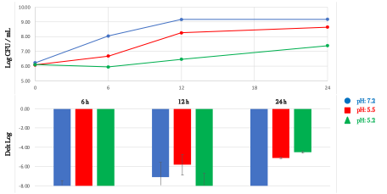
Figure 7 LTAA Model of L. monocytogenes 10403S Behaviour at the three Theses. The four points of interest (t0, t6, t12, t24) that were further examined through RNA - seq are represented. The line plot is showing the dynamics of growth (logCFU/mL) and the bar plot the response to the lethal acid shock (Delta Log).
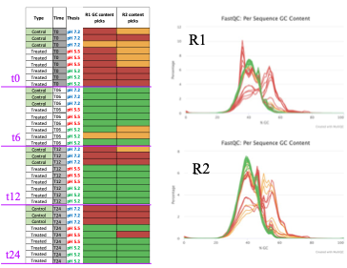
Figure 8 GC Content profiles of RNA - seq Raw Data (Illumina paired - end reads). For the colour lines in the graph of GC content distribution (R1 &2) refer to the heatmap.

6. Conclusions and Future Perspectives
The infant food process line showed a high biodiversity through the time, given the nature of the microbiome present in such a habitat. The monitoring of both the environment and the foodstuff during the fourteen months of sampling made possible the more in - depth investigation of the routes of transmission of the targeted pathogens, shedding light on prevalence and correlation dynamics. Correlations between the different approaches showed the way in which these methods can be utilised in order to give accurate responses on given issues at the food industry and enhance the food safety aspects. Furthermore, the research on behavioural dynamics of a pathogen, made possible to understand factors and conditions that permit resistance. To that scope further research activities containing analytical techniques (volatile compounds - biomarkers) could give a more complete prospective of the metabolic pathways and a faster detection method. Of course, further investigations of stress conditions, given the complexity of the cell system, could lead to an updated hurdles perspective.

8. References
Buchanan, R.L., Gorris, L.G.M., Hayman, M.M., Jackson, T.C., Whiting, R.C., 2017. A review of Listeria monocytogenes: An update on outbreaks, virulence, dose-response, ecology, and risk assessments. Food Control 75, 1–13. https://doi.org/10.1016/j.foodcont.2016.12.016
Ferreira, V., Wiedmann, M., Teixeira, P., Stasiewicz, M.J., 2014. Listeria monocytogenes persistence in food-associated environments: Epidemiology, strain characteristics, and implications for public health. J. Food Prot. 77, 150–170. https://doi.org/10.4315/0362-028X.JFP-13-150
Freitag, N.E., Port, G.C., Miner, M.D., 2009. Listeria monocytogenes - From saprophyte to intracellular pathogen. Nat. Rev. Microbiol. 7, 623–628. https://doi.org/10.1038/nrmicro2171
Hirshfield, I.N., Terzulli, S., O’Byrne, C., 2003. Weak organic acids: a panoply of effects on bacteria. Sci. Prog. 86, 245–269. https://doi.org/10.3184/003685003783238626
Jagadeesan, B., Gerner-Smidt, P., Allard, M.W., Leuillet, S., Winkler, A., Xiao, Y., Chaffron, S., Van Der Vossen, J., Tang, S., Katase, M., McClure, P., Kimura, B., Ching Chai, L., Chapman, J., Grant, K., 2019. The use of next generation sequencing for improving food safety: Translation into practice. Food Microbiol. 79, 96–115. https://doi.org/10.1016/j.fm.2018.11.005
Koutsoumanis, K., Allende, A., Alvarez-Ordóñez, A., Bolton, D., Bover-Cid, S., Chemaly, M., Davies, R., De Cesare, A., Hilbert, F., Lindqvist, R., Nauta, M., Peixe, L., Ru, G., Simmons, M., Skandamis, P., Suffredini, E., Jenkins, C., Malorny, B., Ribeiro Duarte, A.S., Torpdahl, M., da Silva Felício, M.T., Guerra, B., Rossi, M., Herman, L., 2019. Whole genome sequencing and metagenomics for outbreak investigation, source attribution and risk assessment of food-borne microorganisms. EFSA J. 17. https://doi.org/10.2903/j.efsa.2019.5898
Koutsoumanis, K., Alvarez-Ordonez, A., Bolton, D., Bover-Cid, S., Chemaly, M., Davies, R., De Cesare, A., Herman, L., Hilbert, F., Lindqvist, R., Nauta, M., Peixe, L., Ru, G., Simmons, M., Skandamis, P., Suffredini, E., Jordan, K., Sampers, I., Wagner, M., Felicio, M.T.D.S., Georgiadis, M., Messens, W., Mosbach-Schulz, O., Allende, A., 2020. The public health risk posed by listeria monocytogenes in frozen fruit and vegetables including herbs, blanched during processing. EFSA J. 18, 1–102. https://doi.org/10.2903/j.efsa.2020.6092
Kovac, J., 2019. Precision Food Safety: a Paradigm Shift in Detection and Control of Foodborne Pathogens. mSystems 4, 1–5. https://doi.org/10.1128/msystems.00164-19
Kralik, P., Ricchi, M., 2017. A basic guide to real time PCR in microbial diagnostics: Definitions, parameters, and everything. Front. Microbiol. 8, 1–9. https://doi.org/10.3389/fmicb.2017.00108
NicAogáin, K., O’Byrne, C.P., 2016. The role of stress and stress adaptations in determining the fate of the bacterial pathogen listeria monocytogenes in the food chain. Front. Microbiol. 7, 1–16. https://doi.org/10.3389/fmicb.2016.01865
Soni, K.A., Nannapaneni, R., Tasara, T., 2011. An overview of stress response proteomes in Listeria monocytogenes. Agric. Food Anal. Bacteriol. 1, 66–85. https://doi.org/10.5167/uzh-60457
World Health Organization, 2017. The Burden of Foodborne Diseases in the WHO European Region. World Health Organization, Copenhagen.
World Health Organization, 2015. WHO Estimates of the Global Burden of Foodborne Diseases, World Health Organization. World Health Organization, Geneva.
Zwirzitz, B., Wetzels, S.U., Dixon, E.D., Stessl, B., Zaiser, A., Rabanser, I., Thalguter, S., Pinior, B., Roch, F.F., Strachan, C., Zanghellini, J., Dzieciol, M., Wagner, M., Selberherr, E., 2020. The sources and transmission routes of microbial populations throughout a meat processing facility. npj Biofilms Microbiomes 6, 1–12. https://doi.org/10.1038/s41522-020-0136-z

