Antioxidant compounds formed in Maillard reaction of glucose and glycine

Sara Bolchini (sbolchini@unibz.it)
Faculty of Agricultural, Environmental, and Food Sciences, Free University of Bolzano-Bozen, Italy
Tutor: Prof. Matteo Mario Scampicchio

The identification of some antioxidant Maillard reaction products has been carried out in the first part of the PhD. Some MRPs have been reported as antioxidants, although their identification remains still unclear. Therefore, the study aimed to monitor their evolution during heating a model solution of glucose and glycine. NMR was used to monitor the transient changes of MR reactants and products during time. The antioxidants were studied using HPLC coupled with a triple detector. Three antioxidant MRPs have been identified: 2-acetylpyrrole and dehydrate 1- and 3-deoxyglucosones. The antioxidants have been included in the updated kinetic model developed in literature.

Molecole antiossidanti prodotte dalla reazione di Maillard su una soluzione di glucosio e glicina

È stata effettuata l'identificazione di alcuni prodotti antiossidanti della reazione di Maillard. La loro attività antiossidante è nota, ma l’identificazione rimane incompleta. Pertanto, questa prima parte del dottorato si proponeva di studiare l’evoluzione dei MRP antiossidanti durante il riscaldamento di una soluzione modello di glucosio-glicina. L'NMR è stato utilizzato per monitorare i cambiamenti di reagenti e prodotti della MR nel tempo. Gli antiossidanti prodotti sono stati studiati mediante HPLC accoppiato a triplo detector. Sono stati identificati tre principali MRP antiossidanti: il 2-acetilpirrolo e 1- e 3-deossiglucosone deidratati. L'evoluzione di questi è stata inclusa nel modello cinetico aggiornato sviluppato in letteratura.

Key words: Antioxidants, Maillard reaction, high resolution mass spectrometry, coulometric detector, nuclear magnetic resonance, kinetic modelling

1. Introduction
In accordance with the PhD thesis project presented, this poster reports the main results of the first activities concerning:
(A1) the identification and quantification of antioxidant MRPs produced in a solution of glucose and glycine heated at 90°C for 4 hours;
(A2) the update of a kinetic model of the reaction developed in literature (Martins and Van Boekel, 2005) with the production of antioxidants.

2. Materials and Methods
The study has been developed starting from the model of the reaction proposed by van Boekel (Martins and Van Boekel, 2005), which species (glucose, glycine, acetic acid, formic acid and melanoidins) and their transient changes were monitored (NMR) and spectrophotometric assays. Then, using a novel approach based on (Ding et al., 2022), which consisted in HPLC coupled with three different detectors, antioxidant MRPs were studied. The detectors used are: a diode array (DAD), a coulometric array (CoulArray™: CAD), which is selective towards antioxidants, and high resolution mass spectrometer (HRMS). DAD allowed the detection of the molecules present in our samples and the optimization of their separation through the chromatographic column. CAD, which is a multi-channel electrochemical detector, measures the current signals generated from antioxidant analytes that enter the detector. Since coulometric analyses are principally governed by Faraday’s law, it allowed the quantification of the analytes, more as well as their detection. This consequentially allowed the update of the kinetic model of the reaction. Using HRMS, then, it was possible to identify the antioxidants previously detected.

3. Results and Discussion

3.1 Antioxidant activity of MRPs and their identification
Antioxidant MRPs have been detected, identified and quantified using Coularray detector and HRMS. In Figure 1(a) three main peaks have been detected and they corresponded to 2-acetylpyrrole and deydrathed version of 1- and 3- deoxyglucosones, as shown in Figure 1(b).

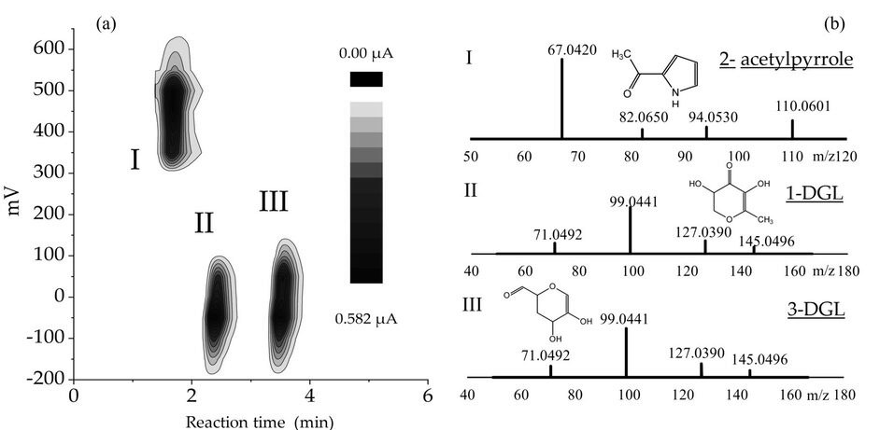

Figure 1 :(a) Contour plot of CAD signal (sum of the signals obtain from the 16 channels) of glucose-glycine MR sample after 150min at 90°C.

3.2 Kinetic model update
NMR spectroscopy has been used to quantify reactants (glucose and glycine) and some products (acetic acid and formic acid) along the reaction, to check if their kinetics are the same as the ones obtained by Van Boekel. In Figure 2 and Figure 2 are shown the ¹H-NMR spectra of acetic acid and formic acid. In details: both the signals are increasing along the MR, which let us conclude that both of them are produced during the MR, confirming the literature (Martins and Van Boekel, 2005).
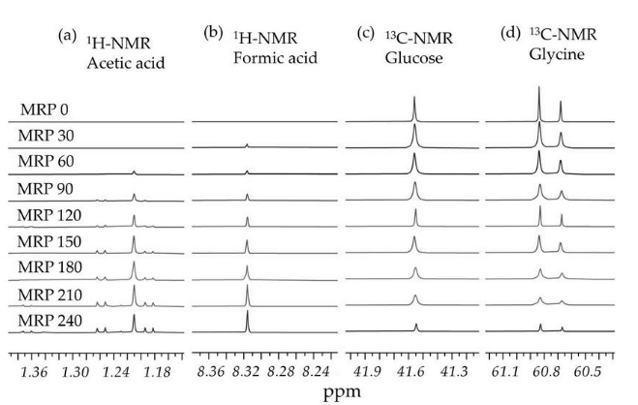

Figure 2 :(a) and (b) Stacked $​^{1}H$-NMR peak corresponding to acetic acid and formic acid obtained analyzing MR samples incubated for 0, 30, 60 … 240 minutes at 90°C; (c) and (d) Stacked $​^{13}C$-NMR peak corresponding to glucose and glycine obtained analyzing MR samples incubated 0, 30, 60 … 240 minutes at 90°C.

Starting from this model and including the results obtained regarding the antioxidants developed during the reaction and their mechanism of production confirmed with the literature (George and Milton, 1983)(Hayas, Bong Kim and Kato, 1985), it was possible to update the kinetic model of the reaction as reported in Figure 3.
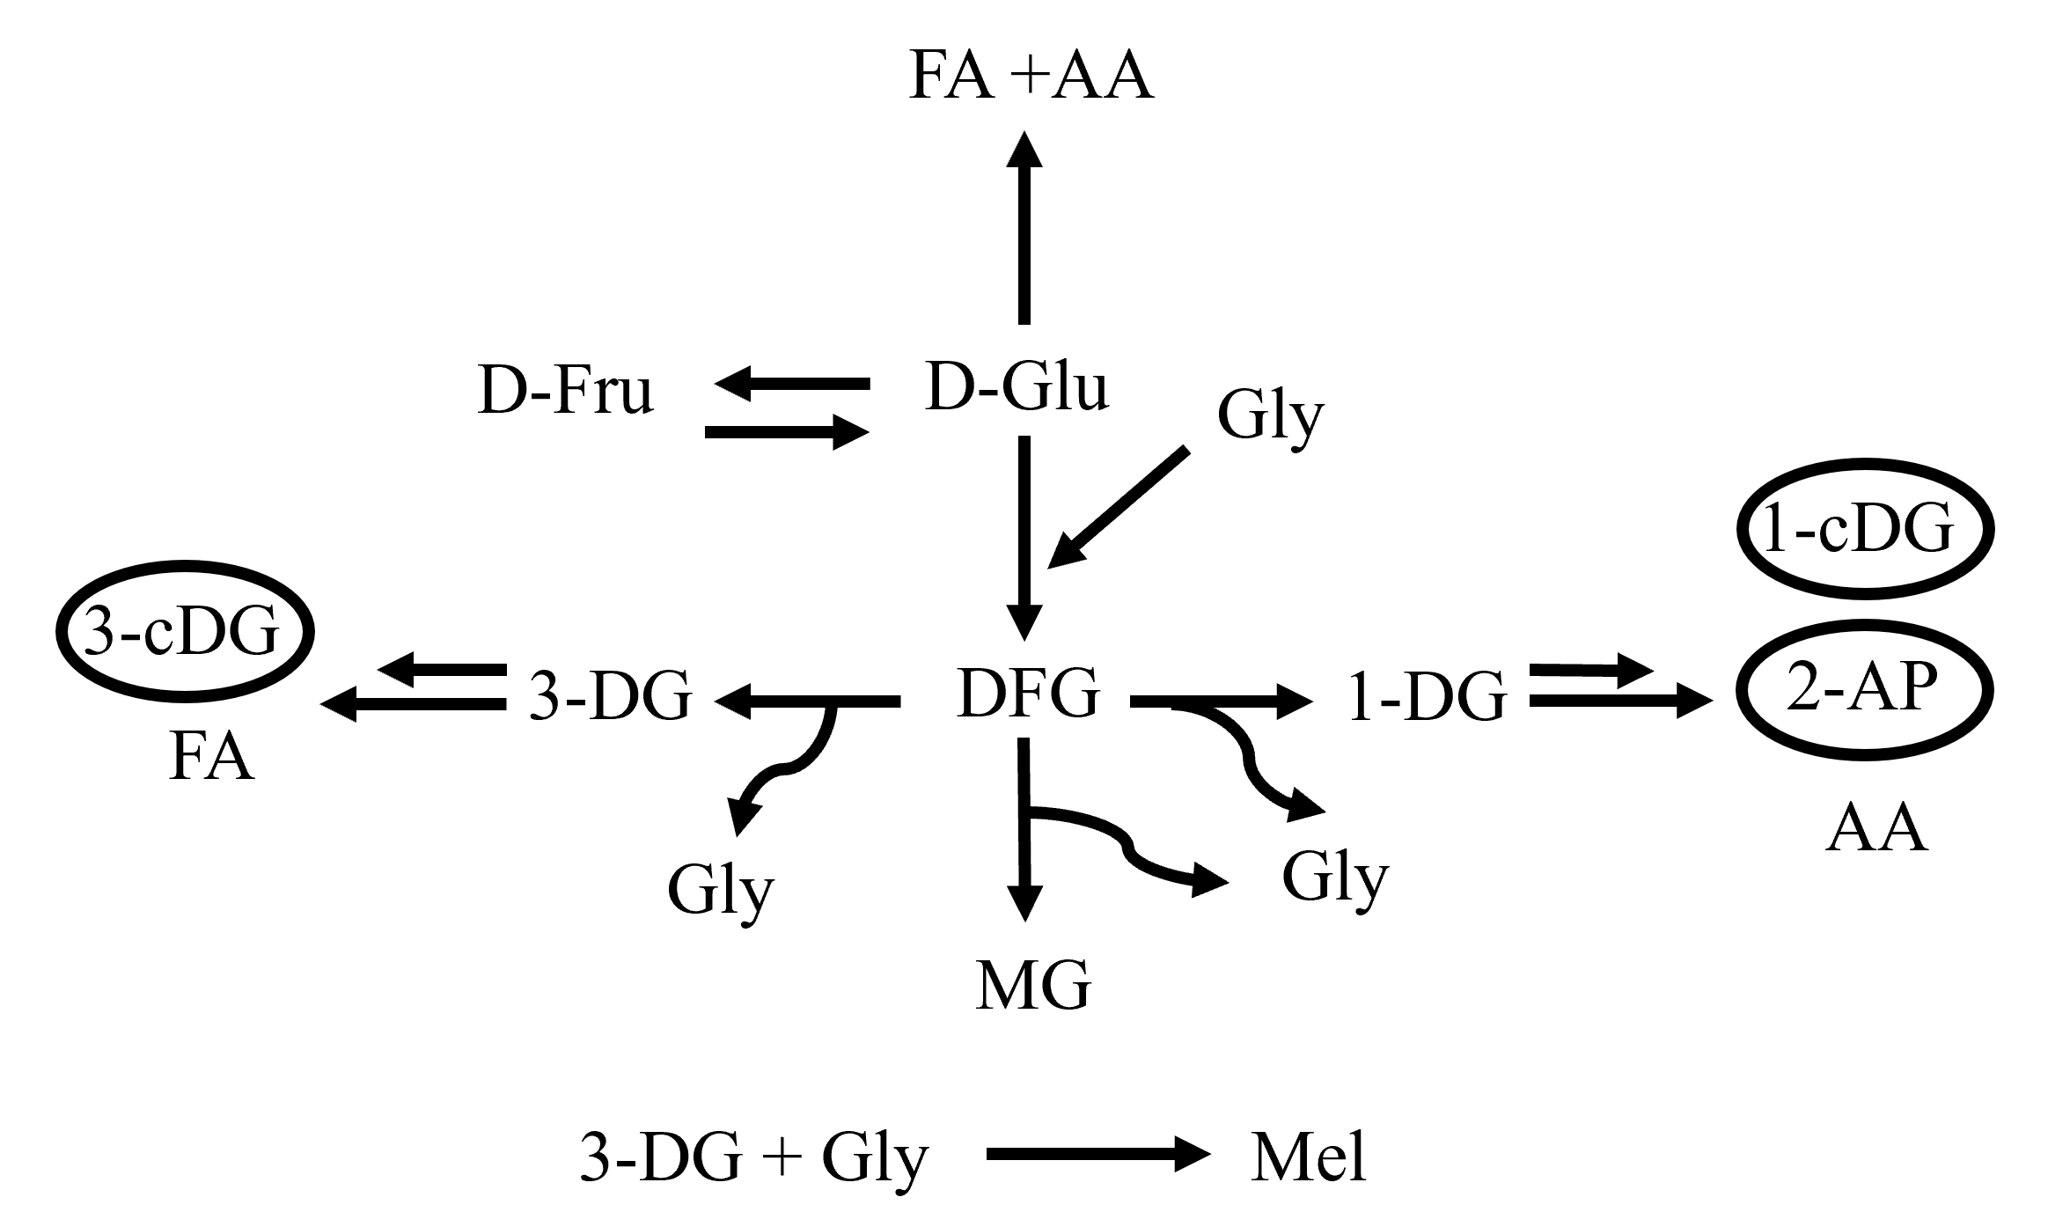

Figure 3: Updated model of MR based on Van Boekel’s one. Circled in blue, the species added.

4. References
Ding, Y. et al. (2022) ‘HPLC-Triple detector (Coulometric array, diode array and mass spectrometer) for the analysis of antioxidants in officinal plants’, Lwt, 162(April), p. 113456.
George, R. W. and Milton, S. F. (1983) The Maillar in Foods and Nutrition, Acs Symposium Series.
Hayas, F., Bong Kim, S. and Kato, H. (1985) ‘Maillard reaction products formed from d-glucose and glycine and the formation mechanisms of amides as major components’, Agricultural and Biological Chemistry, 49(8), pp. 2337–2341.
Martins, S. I. F. S. and Van Boekel, M. A. J. S. (2005) ‘A kinetic model for the glucose/glycine Maillard reaction pathways’, Food Chemistry, 90(1–2), pp. 257–269.

