Study of microencapsulation technologies for the development of powdered food-grade hop extracts as innovative ingredient
Simona Tatasciore (statasciore@unite.it)
Department of Bioscience and Technology for Food Agriculture and Environment, University of Teramo,
Via Renato Balzarini 1, 64100 Teramo, Italy
Tutor: Prof. Paola Pittia and Lilia Neri

The first activities of the PhD thesis project are described. Firstly, hop cones were subjected to solid-liquid ultrasounds assisted extraction by the use of a food-grade hydroalcoholic solvent. Secondly, hop extracts were microencapsulated by freeze-drying and spray-drying using two different coating materials (Maltodextrin and Arabic gum). The microencapsulated hop extracts were characterised for their chemical properties (moisture content) physicochemical properties (water activity, solubility, flowability), and encapsulation efficiency was evaluated through the retention of α-acids, β-acids and antioxidant compounds.
Studio di tecnologie di incapsulamento per lo sviluppo di estratti di luppolo in polvere da utilizzare come ingrediente innovativo
Vengono descritte le prime attività del progetto di tesi di dottorato. I coni di luppolo sono stati inizialmente sottoposti ad una estrazione solido-liquido assistita da ultrasuoni con l’utilizzo di un solvente idroalcolico ad uso alimentare. Successivamente, gli estratti sono stati microincapsulati mediante liofilizzazione e essiccazione per atomizzazione utilizzando due diversi materiali strutturanti (maltodestrina e gomma arabica). Le polveri microincapsulate sono state caratterizzate per le loro proprietà chimiche (umidità), fisico-chimiche (attività dell'acqua, solubilità, resistenza allo scorrimento) e l’efficienza di incapsulamento valutata attraverso la ritenzione del contenuto di α-acidi, β-acidi e composti antiossidanti.

Keywords: hop extracts; bioactive compounds; microencapsulation; freeze-drying; spray drying, gum arabic; maltodextrin
1. Introduction
In accordance with the PhD thesis project previously described (Fddff, 2022), this poster reports the main results of the following activities:
(A1.1) production of food-grade hop extract by ultrasounds assisted extraction
(A2.1) extract’s characterization and antioxidant activity evaluation
(A3) production and evaluation of microencapsulated hop powders obtained by freeze drying and spray drying
2. Materials and Methods
Microencapsulation was carried out by using two different hop-concentrated extracts, obtained from hop cones (cv. Herkules) of two different years, 2021 and 2022 (CE₂₀₂₁ CE₂₀₂₂) (P.A.B. S.r.l. Mr. Malt, Pasian di Prato-Udine, Italy) according to the extraction method reported in Santarelli et al. (2022). Briefly, 0.2 g of ground cones were added to 10 ml of hydroalcoholic solution (ethanol: water 50:50 v/v) and treated by ultrasounds (100 Watt and 50 kHz) for 30 min using an ultrasound bath (Falc Instruments, Treviglio, Bergamo, Italy). After centrifugation, hop extracts were concentrated by a rotary evaporator (Buchi R-100) at 45 °C and characterized for: total phenolic content (TPC) expressed as gallic acid equivalent (GAE) per g of concentrated extract; antioxidant activity (AOA) evaluated by ABTS assay (µmoles of Trolox equivalents,TEAC) per g of concentrated extract; and bitter acids content (total α-acids and total β-acids) expressed as %w/w (Santarelli et al.,2022).
Two microencapsulation technologies based on solvent removal, freeze-drying (FD) and spray-drying (SD) were carried out on both hop extracts. Before formulation, CE₂₀₂₁ was resuspended in a 0.02% w/w Tween 20 solution, while CE₂₀₂₂ in a 5% (v/v) ethanol solution. Thus, the resuspended hop extracts were formulated with Maltodextrin (MD) and Arabic Gum (GA) at 12% w/v using an extract: wall material ratio of 1:9. The FD was carried out using a Labogene (Allerød, Den-mark) Scanvac Coolsafe freeze-dryer set up at 0.316 hPa, increasing the temperature of the shelves from −40 °C to 17 °C in 24 h. SD was performed using the Büchi mini Spray Dryer B-290 (nozzle diameter of 0.7 mm, inlet temperature: 150°C; feed rate: 7.5mL/min; aspirator: 100%). The resulting microencapsulated hop powders (FD_MD, FD_GA, SD_MD and SD_GA) were then characterized by water activity, moisture content, solubility, and flowability using the Carr Index (CI), TPC, total α-acids, total β-acids and ABTS assay according to Tatasciore et al. (2023). Results were expressed as load yield (Y%) of polyphenol (TPC Y%), total α-acids (α Y%), total β-acids (β Y%) and antioxidant activity (AOA Y%). For each analysis, Y% was calculated as the percentage ratio between the initial values determined in the concentrated hop extracts and the theoretical values determined in the microencapsulated extracts. Data were reported as the mean and standard deviation of three independent measurements and additionally analyzed by one-way ANOVA using STATISTICA for Windows (StatSoftTM, Tulsa, OK, USA) software. Significant differences were calculated by the Tukey (HSD) test at a significance level of p < 0.05.
3. Results and Discussion
3.1 Chemical characterization of concentrate hop cones
CE₂₀₂₁ and CE₂₀₂₂ showed respectively a TPC of 158 and 111 GAE g⁻¹ dm and a TEAC of 757 and 635 µmol g⁻¹ dm. As for bitter acids, a content of 40% w/w of α-acids and a 7.5% w/w of β-acids was determined in CE₂₀₂₁ while 27% w/w of α-acids and 6% w/w of β-acids were found in CE_{2022.} Total phenolic content and the antioxidant activity of hop extracts were similar or higher than other spices and plant foods considered to be rich sources of antioxidant compounds (Pellegrini et al. 2006).
3.2 Physicochemical characterization of encapsulated hop extracts
In Figure 1 moisture content and water activity of the differently microencapsulated hop extracts were reported.
All the samples were characterized by very low water content and water activity values. The lowest contents were found in the powders obtained by SD. Among the FD powders, the sample containing Arabic gum showed the highest (p˂0.05) moisture content and a_{w} values. Powders’ solubility was higher than 99% irrespective of the carrier and the microencapsulation technology. In terms of CI, according to the classifications reported by Jinapong et al.(2008), FD powders are characterised by bad flowability with CI values between 39 and 46 while SD powders showed fair flowability with values between 21 and 23.
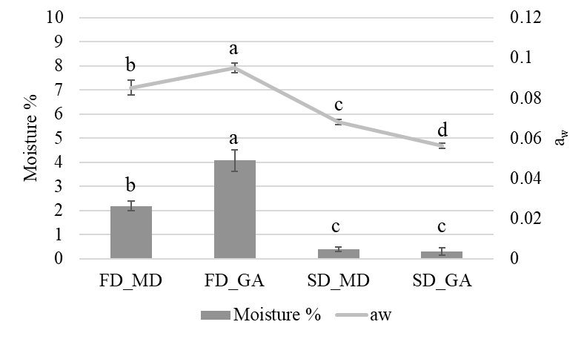
Figure 1 Moisture content, and water activity (a_{w}) of differently microencapsulated hop extracts. FD_MD: freeze-dried hop extract with maltodextrin; FD_GA: freeze-dried hop extract with Arabic gum; SD_MD: spray-dried hop extract with maltodextrin; SD_GA: spray-dried hop extract with Arabic gum. Data with different letters are statistically different at p level < 0.05.

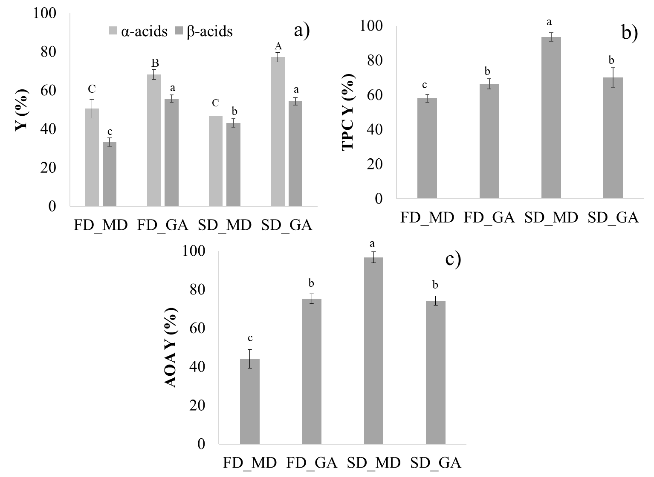
In Figure 2, α Y% and β Y%(a), TPC Y% (b), and AOA Y% (c) are reported. Observing the results (Fig. 2a), in general, values ranged from 50% to 80% and from 30% to 60% for α and β-acids, respectively. Irrespective of microencapsulation technology highest values of α-acids and β -acids were retained when Arabic gum was used as wall material. Polyphenols load yield (Fig. 2b) ranged from 60 to 90. Among all samples, SD_MD showed the highest TPC Y% while no significant differences were highlighted in the other samples. The same trend was observed for AOAY% (Fig.2c). The combined use of SD technology with MD as carrier material enabled to produce hop powders with the highest TPC Y% and AOA Y% while the highest retention of bitter acids was achieved when GA was used as wall material with both FD and SD microencapsulation technology. This result could be due to the higher solubilization and dispersion degree of the bitter acids, promoted by the emulsifying properties of Arabic gum (Yadav et al. 2006).
Figure 2. a) α and β acids load yield; b) TPC load yield; c) AOA load yield of differently microencapsulated hop extract. FD_MD: freeze-dried hop extract with maltodextrin; FD_GA: freeze-dried hop extract with Arabic gum; SD_MD: spray-dried hop extract with maltodextrin; SD_GA: spray-dried hop extract with Arabic gum. Data with different letters are statistically different at p level < 0.05
4. References
Jinapong N, Suphantharika M, Jamnong P. (2008). Production of instant soymilk powders by ultrafiltration, spray drying and fluidized bed agglomeration. J. Food Eng, 84(2), 194-205.
Pellegrini N, Serafini M, Colombi B, Del Rio D, Salvatore S, Bianchi M, Brighenti F (2003). Total antioxidant capacity of plant foods, beverages and oils consumed in Italy assessed by three different in vitro assays. J nutr, 133(9): 2812-2819.
Santarelli V, Neri L, Carbone K, Macchioni V, Pittia P (2022). Use of conventional and innovative technologies for the production of food-grade hop extracts: focus on bioactive compounds and antioxidant activity. Plants, 11(1): 41.
Tatasciore S, Santarelli V, Neri L, González Ortega R, Faieta M, Di Mattia, CD, Di Michele A, Pittia, P (2023). Freeze-drying microencapsulation of hop extract: effect of carrier composition on physical, techno-functional, and stability Properties. Antioxidants, 12(2): 442.
Yadav MP, Igartuburu JM, Yan Y, Nothnagel EA (2007). Chemical investigation of the structural basis of the emulsifying activity of gum arabic. Food Hydrocoll, 21(2), 297-308.

