Identification of aggregate phenolic metabotypes after an Oral (Poly)phenol Challenge Test (OPCT) and their association to the cardiometabolic health status of 300 subjects
Cristiana Mignogna (cristiana.mignogna@unipr.it)
Dept. Food and Drug, University of Parma, Parma, Italy
Tutor: Prof. Pedro Mena
This PhD thesis project aims at identifying aggregate metabolic phenotypes (metabotypes) for the main dietary (poly)phenols, evaluating the determinants of inter-individual variation leading to different metabolic profiles and building predictive algorithms for a faster identification of metabotypes. Three hundred volunteers underwent an oral (poly)phenol challenge test (OPCT) in the form of 3 (poly)phenol-rich tablets, also providing personal information on their health status as well as biological samples to assess urinary phenolic excretion, gut microbiota composition and genetic polymorphisms. This intervention study will allow to find associations between cardiometabolic health and (poly)phenol metabolism.
Identificazione dei metabotipi fenolici aggregati a seguito di una challenge nutrizionale per lo studio del metabolismo dei (poli)fenoli e la loro associazione allo stato di salute cardiometabolico di 300 soggetti
Questo progetto di tesi di dottorato mira ad identificare i fenotipi metabolici aggregati (metabotipi) per i principali (poli)fenoli della dieta, valutare i fattori della variabilità inter-individuale che portano ai diversi profili metabolici e costruire algoritmi predittivi per una più rapida identificazione dei metabotipi. Trecento volontari si sono sottoposti ad una challenge nutrizionale (OPCT) consumando 3 compresse ricche di (poli)fenoli, fornendo informazioni personali sul proprio stato di salute nonché campioni biologici per valutare l'escrezione fenolica urinaria, la composizione del microbiota intestinale e la genotipizzazione. Questo studio di intervento permetterà di trovare un'associazione tra la salute cardiometabolica e il metabolismo dei (poli)fenoli.
Key words: metabotypes, dietary challenge, (poly)phenols, cardiometabolic health.

1. Introduction
Increasing evidence suggests that modest long-term intakes of (poly)phenols can reduce the risk of chronic diseases, especially cardiovascular diseases and type 2 diabetes (Rodriguez-Mateos et al., 2014). Nevertheless, the role of (poly)phenols in cardio-metabolic protection has not been consistently demonstrated yet (Gibney et al., 2019). The inter-individual variability plays an important role in the physiological response, mainly influenced by differences in the absorption, distribution, metabolism, and excretion (ADME) of (poly)phenols (Gibney et al., 2019), along with other factors, including genetic background, gut microbiota, sex, age, ethnicity, lifestyle (diet, smoking, and physical activity), (patho)physiological status and medication (Gibney et al., 2019; Cassidy & Minihane, 2017). After ingestion, (poly)phenols reach the colon, where they undergo modifications by the gut microbiota, being converted to smaller catabolites, principally as conjugated phase II metabolites, which can act as mediators of diet-induced effects on health (Del Rio et al., 2013). The inter-individual differences in gut microbial composition and functionality can lead to quantitative and qualitative differences in the production of specific metabolites, influencing the bioactivity of (poly)phenols in the host (Manach et al., 2017). The different catabolite production patterns may be related to metabolic phenotypes (the so called metabotypes).
This acute human intervention study is directed to understand the association between aggregate metabolic phenotypes for the main dietary (poly)phenols and the factors determining their formation.

2. Materials and Methods
An intervention study was carried out on 300 volunteers who met specific inclusion and exclusion criteria. Recruited subjects were healthy adults (18-74 y) with a BMI ranging between 18.5 and 35.0 kg/m², free from cardiometabolic diseases and impairments mostly related to the gastro-intestinal tract, renal and liver functionality. During Visit 1, after signing the informed consent, they were asked to provide dietary and lifestyle information and to undergo anthropometric measurements. Clinical data and biological samples (blood, urine, and faeces) were delivered at Visit 2 when subjects underwent a standardised oral (poly)phenol challenge test (OPCT) consisting in an acute supplementation of up to 15 classes of dietary (poly)phenols in the form of 3 tablets. Urine samples collected during the following 24-h were analysed through UPLC-IMS-HRMS to assess the individual urinary excretion of phenolic metabolites, allowing clustering according to aggregate metabotypes. Blood samples were analysed to determine common cardiometabolic health biomarkers (total cholesterol, HDL-cholesterol, triglycerides, glucose, insulin, etc.) and for whole-genome genotyping focused on genetic polymorphisms (SNPs). Faeces were subjected to microbial profiling to determine gut microbiota composition at species level. Cardiometabolic risk scores were also assessed.

3. Results and Discussion

Up to 298 volunteers finished the study. Preliminary analyses showed that the cohort was made up of 57% of women, having an average age of 40.7 y (SD ± 16.3); regarding anthropometric measures, 73% of the sample had a normal weight, 22% was overweight and 5% obese. The mean values of the clinical data concerning cardiometabolic health ranged within the reference values. A preliminary targeted approach was performed on 187 subjects for the identification of more than 100 (poly)phenol metabolites and to allow population clustering according to different metabotypes. The preliminary results showed two main metabotypes defined by differences related likely to the gut microbiota composition; indeed, among all the phenolic metabolites identified, the most discriminating ones were those of colonic origin (e.g., enterolactones, phenyl-ƴ-valerolactones) (Figure 1 and 2). Final data on metabotypes and cardiometabolic risk will be presented in the poster.

Individuals metabolise dietary (poly)phenols in different ways and the interlink among different families of (poly)phenols has been described. Further analyses are ongoing to provide a deeper knowledge on inter-individual variability determinants involved in metabotype formation and its relation to the cardiometabolic health status.
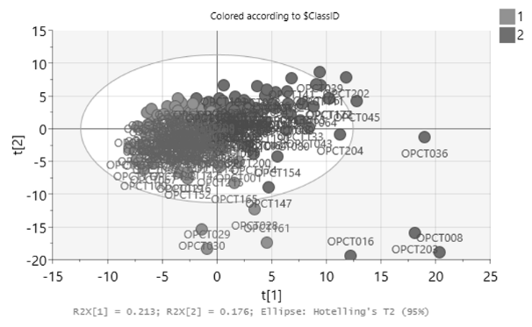
Figure 1. Partial least squares-discriminant analysis (PLS-DA) highlighting two main metabotypes.

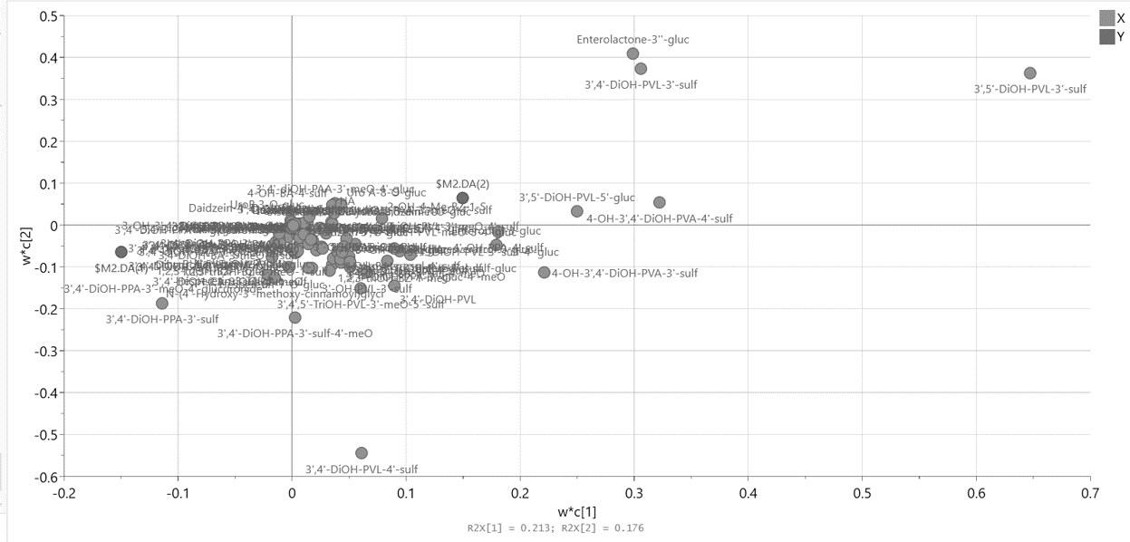
Figure 2. Partial least squares-discriminant analysis (PLS-DA) showing the urinary excretion of colonic phenolic metabolites (phenyl-γ- valerolactones and enterolactones).

4. References
Cassidy, A., & Minihane, A. M. (2017). The role of metabolism (and the microbiome) in defining the clinical efficacy of dietary flavonoids. The American journal of clinical nutrition, 105(1), 10–22.
Del Rio, D., Rodriguez-Mateos, A., Spencer, J. P., Tognolini, M., Borges, G., & Crozier, A. (2013). Dietary (poly)phenolics in human health: structures, bioavailability, and evidence of protective effects against chronic diseases. Antioxidants & redox signaling, 18(14), 1818–1892.
Gibney, E. R., Milenkovic, D., Combet, E., Ruskovska, T., Greyling, A., González-Sarrías, A., de Roos, B., Tomás-Barberán, F., Morand, C., & Rodriguez-Mateos, A. (2019). Factors influencing the cardiometabolic response to (poly)phenols and phytosterols: a review of the COST Action POSITIVe activities. European journal of nutrition, 58(Suppl 2), 37–47.
Manach, C., Milenkovic, D., Van de Wiele, T., Rodriguez-Mateos, A., de Roos, B., Garcia-Conesa, M. T., Landberg, R., Gibney, E. R., Heinonen, M., Tomás-Barberán, F., & Morand, C. (2017). Addressing the inter-individual variation in response to consumption of plant food bioactives: Towards a better understanding of their role in healthy aging and cardiometabolic risk reduction. Molecular nutrition & food research, 61(6), 1600557.
Rodriguez-Mateos, A., Vauzour, D., Krueger, C. G., Shanmuganayagam, D., Reed, J., Calani, L., Mena, P., Del Rio, D., & Crozier, A. (2014). Bioavailability, bioactivity and impact on health of dietary flavonoids and related compounds: an update. Archives of toxicology, 88(10), 1803–1853.

