Production, Composition and Sensory Characterization of New Flavoured Oils: Focus on Sustainability
Celeste Lazzarini (celeste.lazzarini3@unibo.it)
Dept.of Agricultural and Food Sciences, Alma Mater Studiorum - Università di Bologna, Cesena, Italy
Tutor: Prof. Tullia Gallina Toschi; co-tutors: Prof. Enrico Valli, Dr. Matilde Tura

The activities of this PhD project concern, firstly, the characterization of specific tomato and hemp by-products and the application of sustainable technologies to obtain from them stable raw materials/ingredients which can be involved in the production of flavoured oils. In particular, a tomato pomace has been dried out with a sustainable approach and essential oils have been extracted from a hemp biomass. Secondly, vegetable oils (cold pressed hemp seed oil and virgin olive oil) have been flavoured with such vegetable matrices, as well as by using commercial powders made of tomato and orange by-product.

Produzione, composizione e caratterizzazione sensoriale di nuovi oli aromatizzati: focus sulla sostenibilità
Le attività del progetto riguardano, in primo luogo, la caratterizzazione di specifici sottoprodotti del pomodoro e della canapa e l’applicazione di tecnologie sostenibili per la produzione, da queste matrici, di ingredienti stabili che possano essere utilizzati nella formulazione di oli aromatizzati. In particolare, il sottoprodotto del pomodoro è stato essiccato mediante un approccio sostenibile mentre dalla biomassa di canapa è stato ottenuto un olio essenziale. Successivamente, oli vegetali (olio vergine di oliva e olio di semi di canapa spremuti a freddo) sono stati aromatizzati con tali matrici e con polveri commerciali a base di pomodoro e sottoprodotto di arancia.

Key words: flavoured vegetable oils, hemp, tomato, orange, by-products, valorization.

1. Introduction
This contribution reports the main results of the following activities:
(A1) the characterization of specific hemp and tomato by-products and the applications of sustainable technologies, in particular non-thermal drying and distillation to promote the durability of these matrices.
(A2) the production of flavoured vegetable oils and their evaluation in terms of quality related parameters, such as free acidity, sensory profile, volatile compounds, oxidative stability, cannabinoids content, as well as the assessment of consumers’ perception, liking and acceptability.

2. Materials and Methods
(A1) The tomato pomace, made of skin and seeds, has been dried out using a non-thermal drier prototype, which functions with a flux of air at room temperature, able to mix and dry these vegetable matrices inside of its two chambers. Humidity (with a gravimetric approach) and water activity (Aqualab, Decagon Devices Inc., Pullman, USA) have been assessed. It has been chosen to test the action of the prototype with two different settings: with and without the use of compressed air. For what concerns the production of hemp essential oils, 20 g of a specific hemp by-product, derived from the industrial production of cannabidiol (CBD) by extraction, has been hydrodistilled using a lab distillatory prototypal system.
(A2) Tomato flavoured olive oil has been produced at lab scale by co-malaxation of olives with tomato pomace using the lab scale mill Abencor® (MC2 Ingeniería y Sistemas S.L, Sevilla, Spain), while hemp flavoured hemp seed oil has been obtained by the addition of hemp essential oil to a commercial cold pressed hemp seed oil. Free acidity (EU regulation 2022/2104) and volatile compounds profile (analytical conditions described in Aparicio-Ruiz et al., 2023) have been evaluated for both the flavoured oils and the related control samples, while the oxidative stability (Rancimat®) has been assessed only for the hemp seed one, such as the cannabinoids content and the peroxide values. A commercial orange powder, made of orange pomace and another marketed tomato powder have been added during the malaxation to produce a flavoured olive oil whose composition is going to be analysed. In addition, two other flavoured olive oils have been produced by infusion (for 72 h), favoured by the use of a sonic bath (Ultrasonic Cleaner 2200 S3, Milan, Italy), of canned tomatoes and an orange by-product manually produced from juicing. Consumer tests on the abovementioned hemp-seed oils have been carried out to assess the sensory profile (CATA, Check All That Apply) and the consumers’ perception of specific attributes (JAR, Just About Right scale) as well as their liking (9-points hedonic scale) and preference (2-AFC, 2-alternative-forced-choice). Moreover, a joint sensory-biometric analysis is ongoing to assess their liking, specific attributes intensity (JAR scale) and how information regarding the assessed vegetable oils (tomato flavoured olive oil, orange flavoured olive and hemp flavoured hemp seed oil) production and sustainability may influence the perception.

3. Results and Discussion

3.1 (A1) Determination of a_{w} in the dried tomato pomace; yield assessment in the hemp essential oil
It has been chosen to stop the drying process of the tomato pomace after 3h of treatment since the a_{w} has reached levels around 0.4 and 0.5 for the batches dried with and without the use of compressed air, respectively. The levels reached during this study are sufficient since around these values of a_{w} the growth of most microorganisms and moulds is very limited (Labuza, 1980).
Concerning the production of hemp essential oils, a prototypal distillation system has been used and its collection, as a flavouring technique, is now under the evaluation of the UNIBO Knowledge Transfer Office for a possible patent. The obtained yield (0.19%) of essential oil is coherent with the literature (Zheljazkov et al., 2020).

3.2 Flavoured vegetable oils: quality parameters
The produced oils have been tested to evaluate their quality; several sensory and compositional parameters are now under investigation (e.g. consumer tests to evaluate preferences, total phenols content, carotenoids content, …). Free acidity has been evaluated for each vegetable oil sample, including the test samples, and each of them has shown values below the limits in the regulations and standard (Codex Stan 210-1999 and EU regulation 2022/2104), with values ranging from 0.17 ± 6.7*10⁻⁵ % to 0.22 ± 0.001 % of oleic acid for olive oils, and 1.3 ± 0.1 mg KOH/g of oil for hemp seed oils.
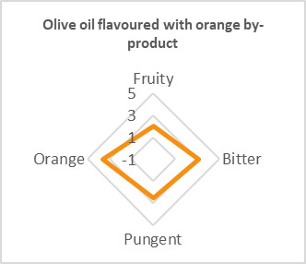
Flavoured olive oils are not included in the commercial categories extra virgin, virgin or lampante, since they are “dressings based on olive oil”: they do not meet the definition stated in EU regulation 2022/2104; the levels of free acidity, in this case, provides anyway information regarding their quality.
From preliminary results the flavoured olive oils appear to be of high quality with peculiar sensory notes, assessed by descriptive analysis, derived from the added vegetable matrices (example in Fig. 1).
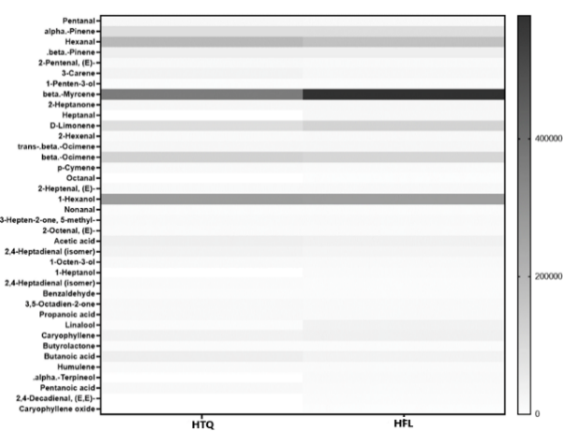
Preliminary semi-quantitative analysis of the volatile compounds profiles has been carried out and for what concerns hemp seed oil and flavoured hemp seed oil, it has been possible to highlight some differences related to the presence of the essential oils from hemp by-product. In particular, from the heat map shown in Fig. 2, some terpenes (monoterpenes and sesquiterpenes) appear at higher concentrations in the flavoured hemp seed oil.
Figure 1 Radar graph: intensity of the main and secondary positive attributes of a produced olive oil flavoured with orange pomace.
These compounds, such as β-myrcene, linalool, limonene, α-terpineol and β-caryophyllene are related to fruity, floral, sweet and sensory notes and for which anti-inflammatory and antioxidant properties have been found (Surendran et al., 2021; Tura et al., 2023).
In addition, from the preliminary results of consumer tests, the hemp-flavoured hemp seed oil appeared to be more liked, considering its aroma (mean score = 6.7) rather than the control one (5.8). Moreover, participants were asked to identify their favourite sample in a 2-AFC test, which significantly results the flavoured one (p = 0.0033, α = 0.05). These results suggest that the aroma of the EOs, extracted from the hemp by-product, might be a driver of preference such oils, thus positively affecting the subjects’ liking. This finding, among others, will be verified with the further consumer tests data elaboration.
Figure 2 Heat map comparing the content of the volatile compounds in the two hemp seed oils (HTQ, control sample of hemp seed oil, and HFL, flavoured hemp seed oil).
The same evaluations will be also carried out for the other produced flavoured oils.

4. References

Aparicio-Ruiz R, Casadei E, Oritiz-Romero C, García-González DL, Servili M, Selvaggini R, Lacoste F, Escobessa J, Vichi S, Quintanilla-Cases B, Tres A, Golay PA, Lucci P, Moret E, Valli E, Bendini A, Gallina Toschi T (2023) Method for the analysis of volatile compounds in virgin olive oil by SPME-GC-MS or SPME-GC-FID. Methodsx 10: 101972.
Codex Alimentarius Commission (1999) International Food Standards, Codex Standards for Named Vegetable Oils (CODEX STAN 210-1999). Geneva, Switzerland.
EU, Commission Delegated Regulation, 2022/2104 of 29 July 2022. Available online: http://data.europa.eu/eli/reg_del/2022/2 104/oj (accessed on 28 May 2023).
Labuza TP, (1980) The effect of water activity on reaction kinetics of food deterioration. Food Technol (USA) 34: 36-41.
Surendran S, Qassadi F, Surendran G, Lilley D, Heinrich M (2021). Myrcene-What are the potential health benefits of this flavouring and aroma agent? Front Nutr 19(8): 699666.
Tura M, Mandrioli M, Valli E, Dinnella C, Gallina Toschi T (2023) Sensory wheel and lexicon for the description of cold-pressed hemp seed oil. Foods 12: 661.
Zheljazkov VD, Sikora V, Dincheva I, Kačániová M, Astatkie T, Semerdjieva IB, Latkovic D (2020) Industrial, CBD, and wild hemp: how different are their essential oil profile and antimicrobial activity? Molecules 25: 4631.

