Study on the modulation of the intestinal microbiota induced by nutraceutical preparations designed to improve immune and metabolic function
Robin Duncan (robin.duncan@unimi.it)
Department of Food, Environmental and Nutrizionali Sciences, Università degli Studi di Milano, Italy
Tutor: prof. Simone Domenico Guglielmetti (Università degli Studi di Milano)

This project aims to explore the effects of plant extracts (PEs) used as dietary supplements, gut microbiota and gastrointestinal health. The objective is to determine if these not only alleviate symptoms but also improve overall health and prevent other conditions without adverse effects on gut microbiota. The project begins with in vitro testing using colonic fermentations to evaluate PEs' effects on gut microbiota populations and growth tests on single strains will assess their impact on health-promoting bacteria. The most promising PE will be selected for a human study to investigate its prebiotic effect and influence on health biomarkers.

Studio sulla modulazione del microbiota intestinale indotta da preparazioni nutraceutiche progettate per migliorare la funzione immunitaria e metabolica

Questo progetto mira a esplorare gli effetti di estratti vegetali (PE), usati come integratori alimentari, sul microbiota intestinale, sulla salute gastrointestinale e determinare se questi non solo alleviano i sintomi, ma possono migliorare lo stato di salute senza effetti negativi sul microbiota intestinale. Il progetto prevede test in vitro utilizzando fermentazioni coloniche per valutare gli effetti dei PE sulle popolazioni del microbiota intestinale e test di crescita per valutare l’impatto su singole specie batteriche intestinali note per la loro attività benefica. Il più promettente sarà selezionato per un feeding trial per indagare effetto prebiotico e influenza su biomarker della salute.

1. State-of-the-Art
Plant extracts (PEs) have the ability to affect members of the gut microbiota. This impact can be either negative, targeting beneficial bacteria, or positive, by acting against harmful bacteria or pathogens. For instance, this can be attributed to the antimicrobial or prebiotic activity of certain compounds found in the extracts. While commercially-available prebiotics are typically carbohydrates, non-carbohydrate compounds such as polyphenols can also confer health benefits through their metabolization by intestinal microorganisms. Polyphenols have been observed to increase the levels of Akkermansia spp., bifidobacteria, and lactobacilli in mice. Flavonols derived from plant sources like cocoa and green tea have also exhibited prebiotic activity (Neri-Numa et al., 2020). Health can also be influenced by the production of microbial metabolites, which is impacted by food intake. For example, short-chain fatty acids (SCFAs) and trimethylamine N-oxide (TMAO). SCFAs play a critical role in gut health by providing energy to epithelial cells, supporting nutrient absorption, reducing gut inflammation, and maintaining the gut barrier. Elevated TMAO levels are associated with an increased risk of cardiovascular diseases, as it promotes inflammation, impairs cholesterol metabolism, and affects platelet function. Analysing the prebiotic effect and modulation of the microbiome in vivo poses significant challenges. This is primarily due to the unique nature of each individual's microbiota, making it difficult to make predictions at a population level. To overcome this, techniques have been developed to simulate an active microbiota. One common approach involves using a standardized pool of faecal samples as an inoculum, which is then subjected to anaerobic conditions to initiate "colonic fermentations." Another crucial aspect to consider is the viability of the microorganisms in the faecal inoculum (Liu et al., 2021). Using glycerol-supplemented faecal samples prepared under anaerobic conditions, helps maintain up to 95% viability of the microbial populations for six months (Smirnova, 2019). In the context of simulating the microbiota, the in vitro digestion protocol proposed by INFOGEST provides us with a standardized tool to simulate the impact on the human gut microbiota when applied to the food under investigation (Brodkorb et al., 2019). Furthermore, population shifts analyses have notably advanced in the last decade, particularly with the increasing effectiveness and accessibility of next-generation sequencing techniques. For instance, metataxonomics by 16S rRNA gene profiling can now provide taxonomic community structure in complex ecosystems and offer a detailed understanding of the prokaryotic composition at the family, genus, and even species levels, along with their respective abundances. Giving us new tools to exploit along the classical microbiology and molecular biology ones. While in vitro data holds value, conducting human feeding trials is essential to acquire more reliable knowledge regarding the impact on human health. A human feeding trial on one PE will be an integral part of this project to ensure comprehensive understanding and an accurate evaluation.

2. PhD Thesis Objectives and Milestones
The main activities of the project are divided into the two work packages (WP) described below.
A) Screening of PEs: • Select the PEs for investigation. • Conduct in vitro digestion of PEs following the INFOGEST protocol. • Prepare a standardized faecal sample. • Perform "colonic fermentations" using digested and non-digested PEs. • Analyse changes in microbial populations using 16S rRNA gene profiling.
• Evaluate growth parameters of notable bacteria promoting host health in the presence of PEs.
B) In vivo human intervention trial: • Identify the most promising PE for the feeding trial. • Develop and present the trial protocol to the ethics committee. • Recruit healthy individuals to participate. • Conduct a placebo-controlled, randomized, double-blind, cross-over feeding study with the selected PE. • Collect faecal and urine samples at various timepoints. • Perform targeted and untargeted metabolomics analyses on the samples, focusing on specific targets relevant to the investigated plant extract (PE). • Analyse microbial population shifts in the subjects using 16S rRNA gene profiling.
This study aims to thoroughly examine the impact of PEs on gut microbiota and the resulting metabolite production. It will significantly contribute to our understanding of how PEs affect gut health and their broader implications for overall well-being. The collected data will help assess the safety of these products concerning the microbiome and gut health, potentially revealing new applications based on observed effects.
Table 1. Gantt diagram of the project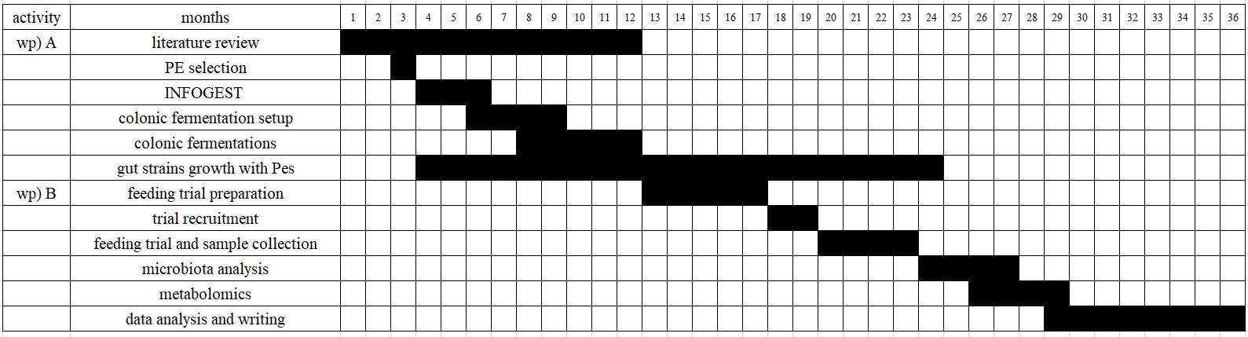
3. Selected References
Brodkorb, A., Egger, L., Alminger, M., Alvito, P., Assunção, R., Ballance, S., Bohn, T., Bourlieu-Lacanal, C., Boutrou, R., Carrière, F., Clemente, A., Corredig, M., Dupont, D., Dufour, C., Edwards, C., Golding, M., Karakaya, S., Kirkhus, B., Le Feunteun, S. and Lesmes, U. (2019). INFOGEST static in vitro simulation of gastrointestinal food digestion. Nature Protocols, 14. https://doi.org/10.1038/s41596-018-0119-1.
Liu, C., Du, P., Cheng, Y., Guo, Y., Hu, B., Yao, W., Zhu, X. and Qian, H. (2021). Study on fecal fermentation characteristics of aloe polysaccharides in vitro and their predictive modeling. Carbohydrate Polymers, 256, p.117571. https://doi.org/10.1016/j.carbpol.2020.117571
Neri-Numa, I. A., Arruda, H. S., Geraldi, M. V., Maróstica Júnior, M. R., & Pastore, G. M. (2020). Natural prebiotic carbohydrates, carotenoids and flavonoids as ingredients in food systems. In Current Opinion in Food Science (Vol. 33, pp. 98–107). Elsevier Ltd. https://doi.org/10.1016/j.cofs.2020.03.004
Smirnova, D.V., Zalomova, L.V., Zagainova, A.V., Makarov, V.V., Mezhevikina, L.M., Fesenko, E.E. and Yudin, S.M. (2019). Cryopreservation of the human gut microbiota: Current state and perspectives. International journal of medical microbiology: IJMM, 309(5), pp.259–269. https://doi.org/10.1016/j.ijmm.2019.06.001.

