Use of chitosan from sustainable sources to reduce the sulphur dioxide use in wine production

Francesco Tedesco (francesco.tedesco@unibas.it)
School of Agricultural, Forest, Food, and Environmental Sciences, University of Basilicata, Potenza, Italy
Tutor: Prof. Angela Capece; Co-tutor: Dott. Rosanna Salvia

The first three activities of the PhD thesis project are described. Firstly, a screening for SO₂ and chitosan resistance was performed among 65 non-Saccharomyces strains, belonging to species present in vinification, such as Metschnikowia pulcherrima, Zygosaccharomyces bailii, Torulaspora delbruekii, Hanseniaspora spp., Lachancea thermotolerans, Candida zemplinina, Pichia spp. In the second step, selected strains were tested for chitosan resistance in laboratory scale fermentation, whereas in the third step the same strains were evaluated for resistance to commercial and insect-based chitosan on agarized grape must medium.

Utilizzo del chitosano da fonti sostenibili per ridurre l’impiego dell’anidride solforosa nella produzione del vino
In questo lavoro vengono descritte le prime tre attività del progetto di tesi di dottorato. In primo luogo, è stato effettuato uno screening di resistenza alla SO₂ e al chitosano tra 65 lieviti non-Saccharomyces, appartenenti alle specie presenti in vinificazione, come Metschnikowia pulcherrima, Zygosaccharomyces bailii, Torulaspora delbruekii, Hanseniaspora spp, Lachancea thermotolerans, Candida zemplinina, Meyerozyma caribbica, Pichia spp. Nella seconda fase, i ceppi selezionati sono stati testati per la resistenza al chitosano in fermentazione su scala di laboratorio, mentre nella terza fase gli stessi ceppi sono stati valutati per la resistenza al chitosano commerciale e da insetto su terreno a base di mosto d'uva agarizzato.

Key words: Chitosan, resistance screening, non-Saccharomyces yeasts, antimicrobial activity, sustainable sources.

1. Introduction
In accordance with the PhD thesis project previously described (Tedesco, 2022), this poster reports the main results of the first three activities concerning:
(A1) the resistance screening to 150 mg/L of SO₂ and 100 mg/L of commercial chitosan among non-Saccharomyces yeast strains, belonging to UNIBAS yeast collection (University of Basilicata – Italy) and including the species most frequent in winemaking;
(A2) the laboratory scale fermentations in pasteurised grape must, inoculated with selected strains, and added with 50 mg/L of SO₂; 100 mg/L of chitosan and 20 mg/L of SO₂ + 100 mg/L of chitosan;
(A3) the resistance tests on agarized grape must, added with 100, 200, 300 and 400 mg/L of both commercial and insect-based chitosan.

2. Materials and Methods

In the first screening, sixty-five non-Saccharomyces yeast strains were tested. The resistance test was carried out in 96-well microtiter plates, containing the Yeast Nitrogen Base medium (Capece et al., 2020), added with 150 ppm of SO₂ and 100 ppm of chitosan. The inoculum level for each strain was set at 1x10⁶ cells/mL and the strain growth level was followed by OD₆₀₀ evaluation.

On the basis of the first screening, twenty-two yeast strains were selected and tested in laboratory scale fermentations (inoculum level of 1x10⁴ cells/mL) using pasteurized grape must, added with the antimicrobial compounds. The tested conditions were the following: (a) 50 mg/L of SO₂, the amount frequently used during cellar fermentations; (b) 100 mg/L of chitosan, the amount authorized by the OIV (oiv-eno-338a-2009); (c) 20 mg/L of SO₂ and 100 mg/L of chitosan, in order to try to reduce the use of sulphur dioxide; (d) without antimicrobial compounds (positive control); (e) without inoculum and antimicrobials (negative control). In order to study the influence of antimicrobials on the inoculated non-Saccharomyces strains, the kinetic of fermentation and the yeast viability were monitored after 48 h of incubation.
The same selected yeasts strains were tested for plate resistance, using agarized grape must added with the following doses of commercial and insect-based chitosan 100; 200; 300 and 400 mg/L. The growth level was monitored after 48 h of incubation.

3. Results and Discussion

3.1 Preliminary screening
The resistance level to SO₂ and chitosan was determined by the ratio between strain growth in broth with and without the antimicrobial compounds. The test showed that the assayed non-Saccharomyces strains exhibited a high variability to sulphur dioxide and chitosan tolerance. Strains like M. pulcherrima, Mey. caribbica, L. thermotolerans showed high susceptibility to chitosan, while the others are more resistant to both antimicrobial compounds, although a strain variability was observed (Fig. 1).
Based on the obtained results, twenty-two strains were selected, by choosing those chitosan-sensitive and SO₂-resistant and SO₂-sensitive and chitosan-resistant.

Figure 1 Resistance to SO₂ and commercial chitosan of 65 non-Saccharomyces strains
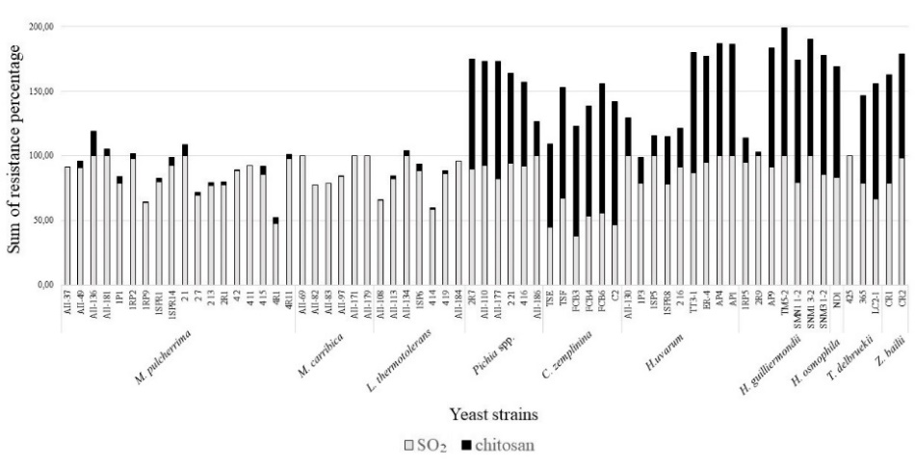

3.2 Chitosan resistance of selected strains
The resistance level of selected strains during lab-scale fermentations were calculated monitoring the cells growth level after 48h of incubation. Resistance to tested antimicrobials was calculated as the ratio between the number of generations in grape must with and without the antimicrobials. The results showed that, in some cases, the chitosan has a higher antimicrobial activity than SO₂ (i.e. Metschnikowia) and vice versa. In few cases, the better action is given by the combined use of both, as reported in Table 1.
As the evaluation of chitosan resistance on agarized medium, the tolerance level was reported as the maximum doses allowing the strain growth. The results showed that strains exhibit different levels of chitosan resistance, and, in some cases, the use of a lower dose of insect chitosan showed better antimicrobial activity (Tab. 1).

Table 1 Strain resistance to antimicrobials evaluated in fermentation (reported as percentage of survival to antimicrobials) and as growth on agarized grape must (expressed as the highest tolerated dose)
 |  | Grape must fermentation |  |  |  | Agarized grape must
Strain | Species | SO₂  (%) | Chitosan  (%) | SO₂ + chitosan (%) |  | Commercial chitosan (mg/L) | Insect chitosan (mg/L)
AII-136 | M. pulcherrima | 17,9 | 18,7 | 16,2 |  | 200 | 200
4-11 | M. pulcherrima | 74,9 | 19,4 | 44,8 |  | 200 | 200
4R1 | M. pulcherrima | 75,4 | 37,1 | 29,3 |  | 200 | 200
CR-1 | Z. bailii | 92,4 | 83,2 | 80,8 |  | 300 | 200
CR-2 | Z. bailii | 100 | 100 | 89,5 |  | 400 | 300
425 | T. delbruekii | 72,5 | 48,2 | 48,5 |  | 400 | 400
LC2-1 | T. delbruekii | 93,8 | 74,5 | 96,5 |  | 400 | 400
AP1 | H. uvarum | 0 | 81,1 | 16,7 |  | 200 | 300
1P3 | H. uvarum | 76,9 | 100 | 100 |  | 300 | 300
2R9 | H. guilliermondii | 23,3 | 100 | 86,2 |  | 200 | 200
TM5-2 | H. guilliermondii | 6,4 | 59,1 | 60,4 |  | 200 | 300
ND1 | H. osmophila | 56,3 | 82,2 | 73,3 |  | 400 | 400
AII-134 | L. thermotolerans | 22,3 | 100 | 59,4 |  | 300 | 300
4-14 | L. thermotolerans | 41,9 | 80,2 | 58,4 |  | 300 | 300
TSE | C. zemplinina | 90,5 | 100 |  | 100 | 300 | 300
FCB6 | C. zemplinina | 52,2 | 100 |  | 78,9 | 400 | 400
AII-171 | M. caribbica | 59,1 | 29,4 |  | 29,9 | 100 | 100
AII-82 | M. caribbica | 91,5 | 59,2 |  | 33,1 | 200 | 100
AII-177 | P. kudriavzevii | 74,5 | 87,4 |  | 75,5 | 400 | 400
4-16 | P. kudriavsevii | 61,6 | 85 |  | 79,1 | 400 | 400
AII-110 | P. kluyveri | 66,5 | 68,6 |  | 83,8 | 400 | 400
AII-186 | P. anomala | 76 | 83,2 |  | 84 | 200 | 200

4. References
Tedesco F (2022) Use of chitin and its derivatives obtained from sustainable sources as an alternative to the use of chemical additives in the food production. In Proc.s of the 26th Workshop on the Developments in the Italian PhD Research on Food Science and Technology, Asti (Italy), 19-21 September 2022, pp. 191-192.
Capece A, Pietrafesa R, Siesto G, Romano P (2020) Biotechnological Approach Based on Selected Saccharomyces cerevisiae Starters for Reducing the Use of Sulfur Dioxide in Wine. Microorganisms 8(5), 738.

