**Investigation at the boundaries between food processing and nutritional attributes of cereal-based products**

PhD Student: Luigi Moriconi

School of Biosciences and Veterinary Medicine, University of Camerino, Camerino (MC), Italy

Tutor: Prof.ssa Elena Vittadini

This PhD thesis aims at investigating the effect of transformation processes on the technological, nutritional and biochemical characteristics of cereal-based products. In particular, this thesis has evaluated:

1. the effect of soft wheat milling (roller vs. stone milling) on technological/rheological and nutritional (special emphasis on inflammatory activity) quality of flours;
2. physical-chemical characteristics of acorn and wheat flours, the dough making potential of their mixtures, the effect of acorn flour on bread quality;
3. the impact of sorghum fermentation and fortification with bottle gourd seeds (germinated or not), on technological properties, nutritional value, starch and protein digestibility of sorghum porridge.

**Indagine ai confini tra la trasformazione alimentare e le caratteristiche nutrizionali dei prodotti a base di cereali**

Questa tesi indaga l'effetto dei processi di trasformazione sulle caratteristiche tecnologiche, nutrizionali e biochimiche dei prodotti a base di cereali. In particolare, è stato valutato:

1. l'effetto della macinazione (cilindri vs. pietra) del grano tenero sulle qualità tecnologiche/reologiche e nutrizionali (in particolare l’attività infiammatoria) delle farine;
2. le caratteristiche fisico-chimiche delle farine di ghianda e frumento, il potenziale di formazione dell’impasto delle loro miscele e l'effetto sulla qualità del pane;
3. l'impatto della fermentazione e della fortificazione del sorgo con semi di zucca (germinati o meno), sulle proprietà tecnologiche, valore nutrizionale, digeribilità dell'amido e delle proteine del porridge di sorgo.

**Key words**: cereal-based products, milling, nutritional quality, inflammation, digestibility.

**Figure 1** *Gantt diagram representing this PhD thesis.  activities done,  activities to be done.*



Although all projects will be described in this report, more details will be given on the sorghum porridge project, that was object of the third year research.

**I – “Soft wheat milling” project**

Even if roller milling (RM) dominates in the food industry (Cappelli et al., 2020), interest has grown in the use of SM, due to the widespread opinion that SM flours have a better nutritional profile than RM flours. As the number of small stone mills has increased, it is important to understand if there is a real difference between flour obtained by these milling systems. Few studies compare the effect of RM and SM on flour quality are present in the literature and the findings could be ascribable to the use of different wheat batches. RM and SM effect was, therefore, studied using a single soft wheat variety (Bologna). RM and SM apply different physical forces (RM generates shear, compression and tearing forces, while SM generates shear, compression and abrasion forces) and temperatures to the flour (higher heat generation in SM), influencing flour properties, in particular protein stability through oxidative stress. The alteration in the protein stability can affect the technological qualities and the amylase-trypsin-inhibitors (ATIs), that have been associated with non-celiac wheat sensitivity (NCWS) (Volta et al. 2019).

The aim of this project was to evaluate how RM and SM affect rheological-structural-nutritional properties, attitude for breadmaking (bread volume, specific volume, texture profile analysis and moisture content), hygienic quality, and ATIs’ extractability, oxidative state and, possibly, their pro-inflammatory activity, of whole grain flour (WGF). All flours showed high hygienic quality (mycotoxin below LOD and LOQ). WGF from RM had larger particle size than WGF from SM; more refined flours had smaller particle size. Dough development time, crumb hardness and moisture content were significantly higher in RM WGF, whereas bread volume, specific volume, springiness and resilience were higher in SM WGF. As for flours from the same mill, WGF was significantly higher in dough tenacity/extensibility ratio, water absorption and crumb hardness than more refined flours, whereas it was lower in resilience. Alkylresorcinols content was significantly higher in SM WGF than RM WGF, and inversely related to the refinement degree. On the other hand, although RM and SM of wheat grains resulted in comparable levels of total ATIs, the two milling types differently affected the oxidative state of proteins, with SM flours showing higher levels of 3-nitrotyrosine, dityrosines and carbonyls compared with RM. In turn and interestingly, increased levels in these biomarkers were associated with a higher release of pro-inflammatory cytokines upon treatment of intestinal epithelial cells (Caco-2) with ATIs enriched extracts.

**II – “Acorn in bread” project**

Acorns are a neglected and sustainable food source that should be given more attention due to its interesting content of bioactive substances (Beltrão Martins, 2020). Application of acorn flour (AF) in leavened products is currently limited. The aim of this research was to examine physical-chemical properties of acorn and wheat flours, the ability of their mixtures to make dough, and the impact of acorn flour (0-50%) on bread quality (volume, texture, and moisture). Acorn flour contained 56% carbohydrates, 6.6% protein, 6.0% fiber and 20.1% fat. Compared to wheat flour (WF), AF showed higher water (69,6%) and oil holding (45,5%) capacity, a higher gelatinization temperature (72°C), and a lower peak viscosity (324 BU, visco amylograph). AF-WF mixtures formed workable doughes up to 20% substitution (Farinograph analysis) with increased water absorption, development time and comparable stability as compared to WF. AF addition to wheat in bread enhanced bread crumb hardness, darkness, moisture content, and decreased specific volume and cohesiveness. AF addition accelerated hardening and retarded cohesiveness loss of bread crumb during storage. Addition of an extra 3% water in bread formulation increased dough development time and stability, resulting in a softer bread with higher specific volume. In the coming weeks the in vitro starch digestibility and the composition of the bio-active substances will be evaluated. The effect of sourdough processing in acorn-enriched bread will also be evaluated.

**III – “Sorghum porridge” project**

# **Introduction**

Sorghum porridge is a common homemade complementary food in Africa, but it frequently lacks essential amino acids and is often too thick, making it difficult to swallow and digest for infants 6-12 months (Oladiran and Emmambux, 2020). This project aims at improving sorghum porridge properties for complementary food by means of endogenous sorghum fermentation (to break down phytates and induce textural thinning) and bottle gourd seeds fortification (rich in essential amino acids; also germinated [increase protein digestibility, α-amylase thinning action]). Complementary sorghum porridge was characterised for functional, nutritional/anti-nutritional properties.

# **Methodology**

**Figure 2** *Samples preparation and analyses. SS: Sorghum slurry, FSS: Fermented SS, CnGS: Composited SS (fermentation + non-germinated seed flour), CGS: Composited SS (fermentation + germinated seed flour). SP: Sorghum porridge, FSP: Fermented SP, CnGP: Composited SP (fermentation + non-germinated seed flour), CGP: Composited SP (fermentation + germinated seed flour).*

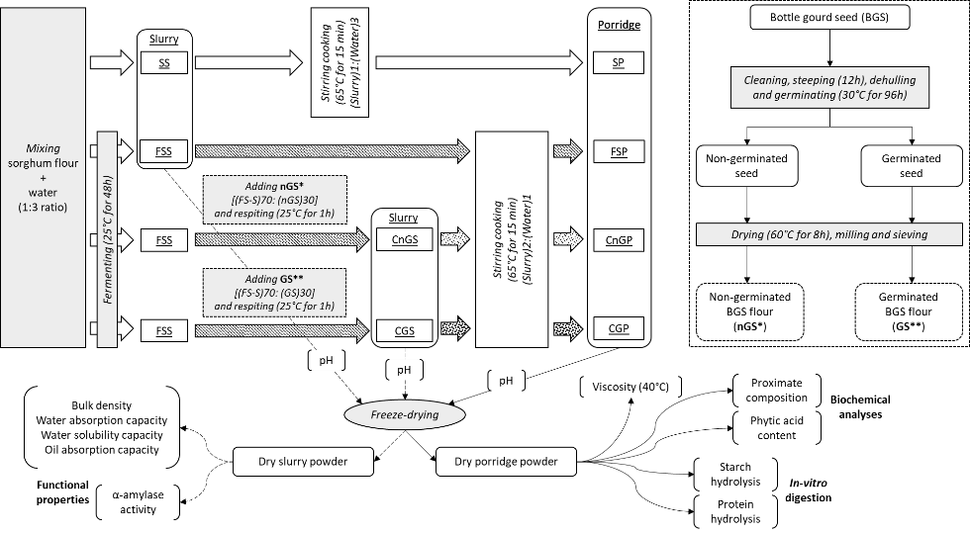

# **Results and Discussion**

## **3.1 Functional properties**

Only CnGS significantly reduced the water absorption capacity (WAC) (Table 1). Oil absorption capacity (OAC) was not significantly different among samples.

The extent of water solubility capacity (WSC), of CnGS and CGS suggest high digestibility of food, which is ideal for infant foods. Fermentation and germination significantly reduced the bulk density (BD) of the composited samples for both fermented and blended flour. Germination and fermentation significantly reduced the pH and significantly increased α- amylase activity. It is evident that microbes during fermentation and hydration activation during germination cause an increase in endogenous α-amylases. The partial hydrolysis of carbohydrates during the processes improves energy sources for lactic acid bacteria and subsequent reduction in pH (Chaves-López et al., 2020), representing an efficient way to inhibit food-borne pathogens for the designed infant food.

**Table 1** *Functional properties of blended flour samples.* *SS: Sorghum slurry, FSS: Fermented SS, CnGS: Composited SS (fermentation + non-germinated seed flour), CGS: Composited SS (fermentation + germinated seed flour). WAC: water absorption capacity, WSC: water solubility capacity, OAC: oil absorption capacity, BD: bulk density.*

|  |  |  |  |  |  |  |
| --- | --- | --- | --- | --- | --- | --- |
| Slurry | WAC (g/g) | WSC (g/g) | OAC (g/g) | BD (g/ml) | pH | α-amylase activity |
| SS | 5.38 ± 0.75b | 3.01±0.20a | 1.70±0.04a | 0.86±0.03b | 6.33±0.03c | 0.31±0.15a |
| FSS | 5.02 ± 0.17a,b | 4.74±1.83b | 1.92±0.11a | 0.71±0.02a | 3.84±0.07a | 3.37±1.33b |
| CnGS | 4.40 ± 0.33a | 5.57±0.82b,c | 1.72±0.04a | 0.74±0.06a | 4.42±0.01b | 3.12±0.44b |
| CGS | 4.94 ± 0.26a,b | 6.94±0.40c | 1.84±0.08a | 0.71±0.03a | 4.51±0.05b | 2.84±0.42b |

## **3.2 Biochemical properties**

The combined treatments increased the ash content of the samples (Table 2), which is expected to parallel the mineral contents, which are crucial for infant wellbeing. There was no significant difference for fibre (presence not preferable in complentatry food due to its dietary bulk and indigestibility). The protein content of the combined treatments samples was significantly higher than that of only fermented samples, while the carbohydrate content of only fermentation was higher than the fermentation-germination combination. The reduction in carbohydrates was expected due to the activation of α-amylase content and because they are the main source of nutrients for microorganisms during the glycolysis pathway (Simwaka et al., 2017). The fat content of the combined treatments is higher when compared to fermentation alone. The reduction in crude fat for germination was expected because of the biochemical and physiological changes such as increased lipolytic enzyme activity for hydrolysis of triglycerides to fatty acids and glycerol (Simwaka et al., 2017).

**Table 2** *Proximate composition of porridge samples. SP: Sorghum porridge, FSP: Fermented SP, CnGP: Composited SP (fermentation + non-germinated seed flour), CGP: Composited SP (fermentation + germinated seed flour). nGS: non-germinated seed, GS: germinated seed.*

|  |  |  |  |  |  |  |  |
| --- | --- | --- | --- | --- | --- | --- | --- |
| Porridge | Nutritional composition g/100g | | | | | | Energy  kJ/100 g |
| Moisture | Fibre | Ash | Protein | Fat | Carbohydrate |
| SP | 9.43±1.06c | 1.92±0.36a | 0.25±0.13a | 10.63±0.4a | 2.04±0.12a | 74.37±1.06c | 1497.8±20.3a |
| FSP | 6.84±1.52b | 1.91±0.12a | 0.83±0.99a | 9.84±2.2a | 2.81±0.85a | 76.40±2.15c | 1547.6±40.7b |
| CnGP | 4.18±1.40a | 1.78±0.19a | 1.08±0.19a | 17.94±0.96b | 14.86±1.01c | 58.66±1.35a | 1839.6±44.4d |
| CGP | 3.69±0.19a | 2.08±0.75a | 1.61±1.30a | 18.25±0.82b | 10.68±1.21b | 62.50±0.74b | 1751.7±28.3c |
| nGS | ND | 10.53±1.54b | ND | 35.63±0.82c | 48.55±2.05d | ND | ND |
| GS | ND | 14.8±2.55c | ND | 35.18±2.15c | 36.69±0.82e | ND | ND |

The combined treatments allowed to achieve an increase in energy content, while CnGP showed higher energy density than CGP corresponding to the fat content of the same. In addition to that, CnGP had higher α-amylase which hydrolyses the amylose and amylopectin to dextrins and maltose, thus causing the simultaneous increase in energy density. The energy content of all the porridges fell within the recommended values for children 9-11 months for a once-a-day consumption. Feeding frequency is also important in determining the extent to which energy and nutrient requirements are met. The calculated estimates for three-times-a-day consumption (Table 3) point that a higher frequency of servings of the porridge blend would meet the RNI for children in the weaning age groups. This suggested that bottle gourd seed flour could be added to increase energy content for 6-11 months children, and to increase protein and fat content for 6-24 months children.

**Table 3** *Estimated protein and energy intakes of infants (6-24 months) of porridge samples**. SP: Sorghum porridge, FSP: Fermented SP, CnGP: Composited SP (fermentation + non-germinated seed flour), CGP: Composited SP (fermentation + germinated seed flour). BME: Breast milk energy, RDI: Recommended daily intake.*

|  |  |  |  |  |  |  |  |  |
| --- | --- | --- | --- | --- | --- | --- | --- | --- |
| Porridge | Energy  (kJ/100g) | Energy intake (kJ/day) | | | Protein intake (g/day) | | | |
| 6-8 months | 9-11 months | 12-24 months | 6-8 months | 9-11 months | 12-24 months | |
| SP | 1497.8±20.3a | 1865.1 | 2134.8 | 2584.2 | 13.24 | 15.15 | | 18.35 |
| FSP | 1547.6±40.7b | 1927.2 | 2205.8 | 2670.2 | 12.25 | 14.02 | | 16.97 |
| CnGP | 1839.6±44.4d | 2290.8 | 2622.0 | 3173.9 | 22.34 | 25.57 | | 30.96 |
| CGP | 1751.7±28.3c | 2181.4 | 2496.7 | 3022.4 | 22.72 | 26.01 | | 31.48 |
| RDI Average BME | | 1490.0 | 2004.0 | 3230.0 | 2.00 | 3.10 | | 5.00 |

## **Functional properties - Viscosity**

Viscosity of the blended porridge samples is shown in Figure 3A. Viscosity decreased in the order FSP> CnGP> CGP~SP. The viscosity of all samples decreased with increasing shear rate (0.1-100s-1) indicating that the porridges exhibited pseudo-plastic behaviour also known as shear thinning behaviour. Typically, during fermentation and germination, amylose and amylopectin are hydrolysed, resulting in significant absorption of water and reduced viscosity when preparing porridge. The reduced viscosity increases the nutrient density in weaning foods (Chaves-López et al., 2020). However, the current formulation has an inappropriate viscosity for children 6-9 month. The limited decrease in viscosity is suitable for children 10 months and older.

## **Biochemical properties - Phytic acid**

The phytic acid content of fermented-germinated porridge blends is presented in Figure 3B. The trend in lowered phytic acid contents was in the order CnGP > CGP > SP> FSP. The phytic acid content was higher when bottle gourd seed was blended in the porridge. It is noted that the phytic acid decreased with germination and fermentation, confirming that these processes cause significant phytic acid reduction. The reduction in phytic acid is crucial as it enables the adequate availability of protein and minerals which are of paramount importance especially when designing complementary foods (CFs) that can mitigate the malnutrition challenges. However careful consideration should be given if the reduction is not also a result of insoluble complexes between phytate and other nutrients such as phytate-protein-mineral (Siddhuraju and Becker, 2001), which can have a negative effect on the CFs design.

## **In-vitro digestion**

### *Starch hydrolysis*

Figure 3C reports the kinetics of in-vitro starch digestion of porridges. Starch in-vitro digestibility was in the order FSP>SP>CnGP>CGP. All samples showed a digestibility of less than 25% and this could be explained by the presence of polymeric tannins which have an effect on the physical properties of starch influencing its digestibility (Amoako and Awika, 2016).

CnGP and CGP had the highest phytic acid content which contributes to the reduction in digestibility of carbohydrates. The fact that fermentation-germination samples had higher protein content can affect the functional properties of starch by influencing the digestibility of both nutrients and also could have been responsible for their lower starch enzyme susceptibility. Protein bodies encapsulating starch granule surfaces can be an extra barrier to the availability of starch to amylase in-vitro thus decreasing digestibility (Rovalino-Córdova et al., 2019). Chlorogenic acid, a phenolic compound identified in BGS, has been reported to inhibit enzyme activity by reducing the number of binding sites for enzymes during starch digestion (Karim et al., 2017).

### *Protein hydrolysis*

The combination of technologies fermentation-germination increased protein digestibility as observed in Figure 3D. In-vitro protein digestibility was in the order CnGP>CGP>SP>FSP. The results that germination treatment did not improve the protein digestibility of the seed flour in the combined treatments were unexpected. Such differences can be attributed to enzyme specificity during digestion, mode of action and conformational state of proteins (Rovalino-Córdova et al., 2019). The protein digestibility for CGP was higher than SP and FSP, probably due to increased protease hydrolysis activity, and protein solubility because of the hydrolysis of complex storage protein to more soluble amino acids by fermentation-germination and removal of protease inhibitors.

Unblended sorghum samples SP and FSP had the lowest protein digestibility probably due to the interaction of sorghum proteins with non-protein components protein-tannin complexes, enzyme inhibitors or changes in protein structural characteristics (Duodu et al., 2003; Rodríguez-España et al., 2022). Together the combined treatments proved to be an effective processing approach to add nutritional value for CFs.

**Figure 3** *Viscosity, phytic acid, starch hydrolysis and protein hydrolysis of blended porridge samples. SP: Sorghum porridge, FSP: Fermented SP, CnGP: Composited SP (fermentation + non-germinated seed flour), CGP: Composited SP (fermentation + germinated seed flour).*

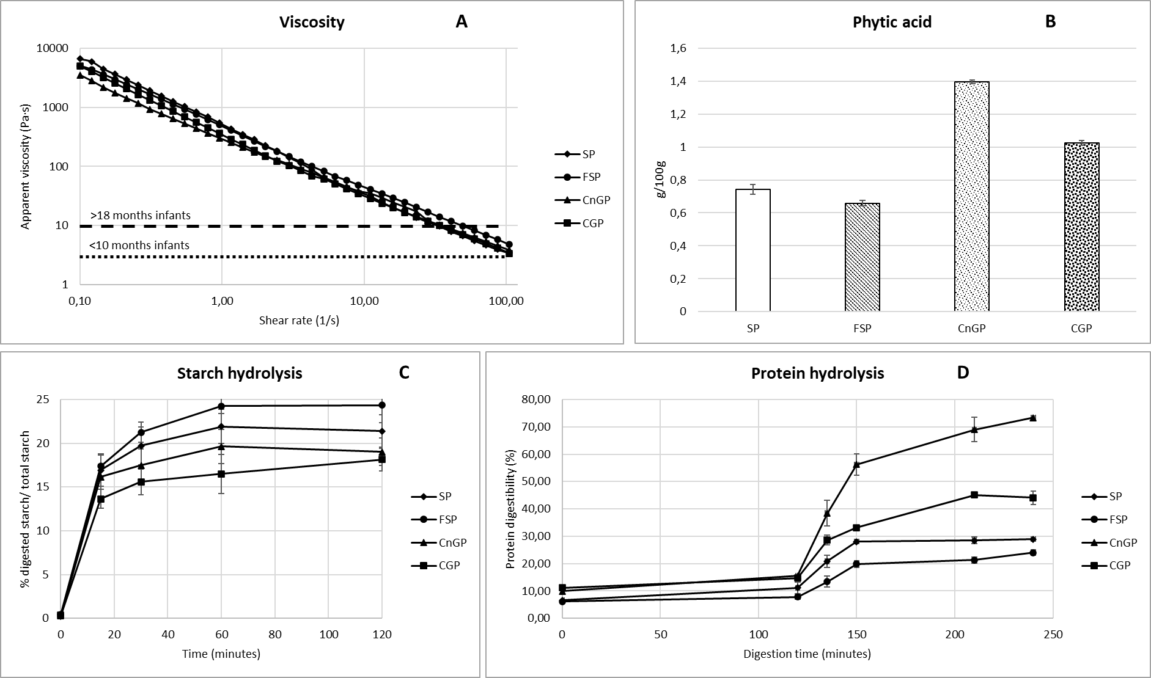

# **Conclusion and Recommendations**

The combination of processing technologies, fermentation and germination, improved the functional properties of the flour blend and subsequent nutritional and physical properties consolidating the applicability in infant complementary foods production. Neither fermentation nor germination alone is optimal in improving the target product functionalities of sorghum and bottle gourd seed flour blend. Furthermore, the synergistic effect of “combination processing treatments” and the “effect of ingredient macronutrients on functionality” is a useful tool for the exploration of the design of affordable and diversified new complementary infant foods.

Therefore, before undertaking in-vivo or human studies, further research is recommended on (i). Interrelationships of processes when using highly nutritious underutilized crops from different regions, (ii). A detailed investigation into functionalities of various ingredients and target compounds and (iii). Design of a traditional complementary foods using the combinations, that suit infants below 10 months.

# **References**

Amoako DB, Awika JM (2016) Polymeric tannins significantly alter properties and in vitro digestibility of partially gelatinized intact starch granule. *Food chemistry*.

Beltrão Martins R, Gouvinhas I, Nunes MC, Alcides Peres J, Raymundo A, Barros A (2020) Acorn Flour as a Source of Bioactive Compounds in Gluten-Free Breadz. *Molecules*.

Cappelli A, Oliva N, Cini E (2020) Stone milling versus roller milling: A systematic review of the effects on wheat flour quality, dough rheology, and bread characteristics. *Trends in Food Science & Technology*.

Chaves-López C, Rossi C., Maggio F, Paparella A, Serio A. (2020) Changes Occurring in Spontaneous Maize Fermentation: An Overview. *Fermentation*.

Duodu KG, Taylor J.R.N, Belton P.S, Hamaker B.R. (2003) Factors affecting sorghum protein digestibility. *Journal of Cereal Science*.

Karim Z, Holmes M, Orfila C (2017) Inhibitory effect of chlorogenic acid on digestion of potato starch. *Food Chemistry*.

Oladiran DA, Emmambux NM (2020), Locally Available African Complementary Foods: Nutritional Limitations and Processing Technologies to Improve Nutritional Quality - A Review. *Food Reviews International*.

Rodríguez-España M, Figueroa-Hernández CY, Figueroa-Cárdenas JD, Rayas-Duarte P, Hernández-Estrada ZJ. (2022) Effects of germination and lactic acid fermentation on nutritional and rheological properties of sorghum: A graphical review. *Current Research in Food Science*.

Rovalino-Córdova AM, Fogliano V, Capuano E (2019) The effect of cell wall encapsulation on macronutrients digestion: A case study in kidney beans. *Food Chemistry*.

Siddhuraju P, Becker K (2001) Effect of Various Domestic Processing Methods on Antinutrients and in Vitro Protein and Starch Digestibility of Two Indigenous Varieties of Indian Tribal Pulse, Mucuna pruriens Var . utilis. *Journal of Agricultural and Food Chemistry*.

Simwaka JE, Chamba MVM, Huiming Z, Masamba KG, Luo Y (2017) Effect of fermentation on physicochemical and antinutritional factors of complementary foods from millet, sorghum, pumpkin and amaranth seed flours. *International Food Research Journal*.

Volta U, De Giorgio R, Caio G, Uhde M, Manfredini R, Alaedini A (2019) Non-Celiac Wheat Sensitivity: An Immune-Mediated Condition with Systemic Manifestations. *Gastroenterology Clinics of North America*.