Flat breads: past, present and future
Francesca Vurro (francesca.vurro@uniba.it)
Dept. Soil, Plant and Food Sciences, University of Bari Aldo Moro, Bari, Italy
Tutor: Prof. Antonella Pasqualone; Co-Tutor: Prof. Carmine Summo

The initial activities of this PhD project have been focused on the study of the flat breads typical of the Mediterranean basin and then the innovation of selected products with legume protein. Preliminarily, a survey was conducted by collecting information in a database of all flat breads of the nine countries involved in the FlatBreadMine Project. Subsequently, a gluten-free focaccia has been formulated, with the design of experiments approach, to study the effect of the dry-fractionated pea protein, rice and corn flour on the physicochemical and sensory properties, to obtain a product with a good texture, organoleptic and nutritional profile.

Pani piatti: passato, presente e futuro
Le prime due attività del progetto di dottorato hanno riguardato lo studio dei pani piatti tipici del bacino del Mediterraneo e l'innovazione di prodotti selezionati con proteine dei legumi. Preliminarmente, è stata condotta un'indagine per raccogliere in un database le informazioni di tutti i pani piatti dei nove Paesi coinvolti nel progetto FlatBreadMine. Successivamente, è stata formulata una focaccia senza glutine, con l’approccio del disegno sperimentale, per studiare l'effetto delle proteine di piselli dry-fractionated, farina di riso e mais sulle proprietà fisico-chimiche e sensoriali, per ottenere un prodotto con una buona consistenza, profilo organolettico e nutrizionale.

Key words: Flat bread; Mediterranean basin; focaccia; legume protein; dry fractionation; mixture design.

1. Introduction
In accordance with the PhD thesis project, this poster reports the main results of the first two activities concerning:
(A1) the valorization of the flat bread typical of Croatia, Egypt, France, Greece, Italy, Jordan, Lebanon, Malta and Spain, involved in the FlatBreadMine Project, and the analysis of the technical and cultural features;
(A2) the innovation of gluten-free focaccia, formulated with dry-fractionated pea protein, to study how the different ratios of ingredients influenced the quality of flat breads.

2. Materials and Methods
The information on flat breads to include in the database has been collected as reported in Pasqualone et al (2022).
To formulate a gluten-free focaccia, preliminary trials were carried out to define the experimental domain. A simplex-centroid mixture design was planned, considering rice flour (RF) (15 ≤ RF≤ 30 g); corn flour (CF) (15 ≤ CF ≤ 30 g); dry-fractionated pea protein at 55% of protein content (PP) (0 ≤PP ≤ 15 g) (Table 1). The sum of the components was 45 g/100 g, whereas the other 55 g/100 g were constituted by water (50 g), yeast (1 g), salt (1.5 g), psyllium husk powder (2.5 g) and were kept constant. The image analysis of the focaccia was carried out with the procedure described by De Angelis et al. (2023). Three replicates were carried out. The firmness was evaluated by a texture profile analysis (TPA), according to Pasqualone et al. (2019). Four replicates were carried out. The typical odor associated with legumes and corn was evaluated by a trained sensory panel of eleven people (5 male, 6 females, age 23-55 y) and the intensity was scored on an anchored 0 - 9 scale (not perceived - highly perceived). The optimal formulation has been identified considering the global results. Then, the nutritional composition of the optimized focaccia has been evaluated, according to the AOAC Official methods, conducting the analyses in triplicate. The responses were modelled according to the postulated special cubic model and the regression coefficients (R²), the adjusted coefficients of determination (R² adj), as well as their significance (p≤0.05) were calculated by the software Design-Expert 11 (StatEase Inc., Minneapolis, USA).

3. Results and Discussion

3.1 Flat bread database
The information on flat breads has been included in an online available database (https://flatbreadmine.eu/resources/) reporting, for each flat bread, the original area, the diffusion, the ingredients, the raw material characteristics, the type of yeast, the additional ingredients, the production process, the characteristics of bread, and the sources of information. The database is organized in an Excel file and has 27 columns and 143 rows in which are catalogued 51 single-layered flat breads, 15 double-layered, 66 garnished and 11 fried (Pasqualone et al., 2022). Italy has a large number of products, principally garnished, which often are recognized with Quality Marks (70 out of 91). In particular, three are Protected Geographical Indications (Piadina Romagnola; Schuttelbrot; Focaccia di Recco), one is a Traditional Specialty Guaranteed and Intangible Heritage of Humanity (UNESCO) (Neapolitan pizza), one is Slow Food Presidium (Testarolo Pontremolese), sixty-three are Traditional Agri-Food Products (PAT) and two are Municipal Denominations (De.Co.) (Crostolo di Urbania; Farinata di Imperia). Finally, seven flat breads are in the Slow Food Ark of Taste, an expression of tradition and endangered history (Pasqualone et al., 2022). Considering the ingredients, wheat flour is the most used, but also other cereals, legumes and chestnut flour were recorded (Pasqualone et al., 2022). The most used leavening agent is baker's yeast, however, about 9% of the breads are formulated with chemical yeast and about 20% are unleavened. An interesting aspect to consider is baking: sixteen different traditional baking techniques have been surveyed, some of which have very ancient origins (Pasqualone et al., 2022).

3.2 Optimized gluten-free focaccia formulation
The properties of focaccia varied among the seven trials, being significantly affected by the ratio of the ingredients, as reported by other authors in gluten-free bread (Ziobro et al., 2016). The crumb of the flat breads prepared with PP was characterized by the presence of numerous cells of small dimensions (Figs. 1a and 1b). The results suggested that the increasing percentage of PP increases the firmness of bread (Fig. 1c).
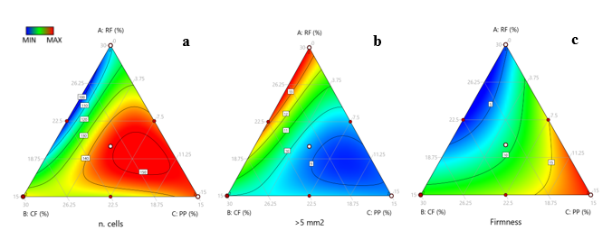
Table 1 Formulation of the samples according to the simplex-centroid mixture design. RF = rice flour; CF = corn flour; PP = pea protein. *Replicates
Sample | RF | CF | PP
1 | 30 | 15 | 0
2 | 20 | 20 | 5
3 | 15 | 15 | 15
4 | 22.5 | 15 | 7.5
5* | 15 | 15 | 15
6* | 30 | 15 | 0
7 | 22.5 | 22.5 | 0
8 | 15 | 30 | 0
9 | 15 | 22.5 | 7.5
10* | 15 | 30 | 0
Figure 1 Contour plots of the number of cells (a); percentage of cells > 5 mm² (b); firmness (c) of the crumb of flat breads.
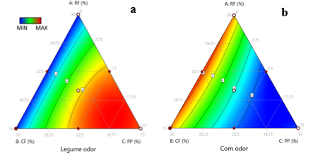
Fig. 2 shows the sensory properties (legume odor and corn odor) of the gluten-free focaccias. As attended, the higher percentage of PP increased the perception of legumes in the focaccia sensory profile, while the odor of corn was perceivable but partly masked by the legume odor brought by PP. Focaccia added of 5% PP was identified as optimal, considering the balancing of nutritional aims and the textural and sensory features. The focaccia presented 40.53±1.21% of moisture, 8.27±0.34% of proteins, 0.73±0.01% of lipids, 50.48±1.37% of carbohydrates, 3.92±0.22% of fibers and 233.7±5.0 kcal/100 g. This optimized focaccia fulfilled the EC Reg. 1924/06 for the nutritional claims “source of protein” (>12% of the energy value provided by proteins), “source of fiber” (>3 g/100 g) and “low-fat” (<3 g/ 100 g). Figure 2 Contour plots of legume (a) and corn odor(b)

4. References
De Angelis D, Vurro F, Santamaria M, Garzon R, Rosell C M, Summo C, Pasqualone A (2023) Effect of dry-fractionated pea protein on the physicochemical properties and the nutritional features of gluten-free focaccia flat bread. LWT 182:114873.
Pasqualone A, De Angelis D, Squeo G, Difonzo G, Caponio F, Summo C (2019) The effect of the addition of Apulian black chickpea flour on the nutritional and qualitative properties of durum wheat-based bakery products. Foods 8:504.
Pasqualone A, Vurro F, Summo C, Abd-El-Khalek MH, Al-Dmoor HH, Grgic T, Le-Bail P (2022) The large and diverse family of Mediterranean flat breads: A database. Foods 11: 2326.
Regulation (EC) No 1924/2006 of the European Parliament and of the Council of 20 December 2006 on nutrition and health claims made on foods (2006) Off J Eur Union 404: 9-25.
Ziobro R, Juszczak L, Witczak M, Korus J (2016) Non-gluten proteins as structure forming agents in gluten free bread. Food Sci Technol 53: 571-580.

Acknowledgments: This paper is supported by the PRIMA program under grant agreement No. 2031, project Flat Bread of Mediterranean area: INnovation & Emerging process & technology (Flat Bread Mine). The PRIMA program is an Art.185 initiative supported and funded under Horizon 2020, the European Union’s Framework Programme for Research and Innovation. The results and content found on this paper reflects only the author’s view. The PRIMA Foundation is not responsible for any use that may be made of the information it contains.

