Exploring the use of plant-based flours and fermentation for the production of a legume-avocado based vegan cream cheese
Palatzidi Anastasia (apalatzidi@unibz.it)
Faculty of Agricultural, Environmental and Food Science, Free University of Bozen-Bolzano, 39100, Italy
Supervisor: Prof. Marco Gobbetti​
External Co – Supervisor: Prof. Effie Tsakalidou,
Internal Co – Supervisor: Olga Nikoloudaki, PhD

This PhD project aims to use flours derived from various plant sources to make a vegan cream cheese in which oil source has been replaced with fresh avocado. After the selection of the flours, a fermentation step also took place, and the product was evaluated, concerning nutritional and textural parameters, compared to the control non-fermented one.

Esplorazione dell'uso di farine vegetali e della fermentazione per la produzione di un formaggio cremoso vegano a base di legumi e avocado
Questo progetto mira a utilizzare farine derivate da diverse fonti vegetali per produrre un formaggio cremoso vegano in cui l'olio è stato sostituito da avocado fresco. Dopo la selezione delle farine è stata effettuata anche una fase di fermentazione. Il prodotto finale fermentato è stato valutato in termini di parametri nutrizionali e di texture, e confrontato con il corrispondente prodotto non fermentato (controllo).

1. Introduction
Cheese is considered a highly nutritional food, with cow’s milk being an essential component of the human diet. However, sustainability is becoming an important consideration for industry and thus, there is a growing need for the production of plant-based prototypes (Grossmann & McClements, 2021). Along with the nutritional features, fermentation allows us to optimize the flavor, appearance, and overall quality and safety of these products. This project is divided into three different steps. The first one is dealing with the selection of the flour and flour-water ratio, the second one with the selection of the combination of starter cultures, and the last one with the evaluation of final cheese attributes.

2. Materials and Methods
As a first step, chickpea, red lentils, quinoa, and fava flours were tested in different percentages, and cheeses were evaluated for their textural and sensory attributes. For the selection of the best-performing flours and the percentage that is going to be used in the recipe, a commercial stracchino vegan cream cheese was used as a control. Vegan cheeses were prepared based on a patent proposed by Ferawati et al. (2021) with some modifications. As a second step, different species of lactic acid bacteria (LAB), such as Lactococcus lactis, Lactiplantibacillus pentosus, Lacticaseibacillus paracasei, Apilactobacillus kunkeei, and Lacticaseibacillus rhamnosus together with a commercial starter, were evaluated for their ability to ferment the different cheese matrices. Unfermented samples including the same ingredients and following the same process were used as controls. Based on the results, different clusters were created, and from each of these, a representative strain was selected to create the best combination of starters for each cheese matrix. As a last step, vegan cheeses made from the selected flours were fermented with the selected combination of LAB starters. Texture, color, and sensory characteristics were evaluated, along with further characterization concerning peptides, free amino acids, and free fatty acid formation, volatile organic compounds, dietary fibers, polyphenols, starch hydrolysis, and antinutritional factors.

3. Results and Discussion
After the screening of the four flours, we decided to proceed with the red lentil and chickpea flours since they gave us a more similar textural profile with respect to our control sample (commercial cheese). Additionally, the two above-mentioned flours were the most preferable ones among all, according to their sensory attributes.
Different starter cultures were evaluated by measuring the pH, organic acid production, cell density, viscosity and spreadability together with the evaluation of sensory attributes. Based on the results from the screening, control sample (without fermentation) and sample of spontaneous fermentation were grouped in the same cluster while strains were grouped in three different clusters. Lactiplantibacillus pentosus, Lacticaseibacillus paracasei, Lacticaseibacillus rhamnosus and Apilactobacillus kunkeei, Lactiplantibacillus pentosus, Lacticaseibacillus paracasei were selected as representative strains from each cluster, for chickpea and red lentil, respectively (Figure 1).
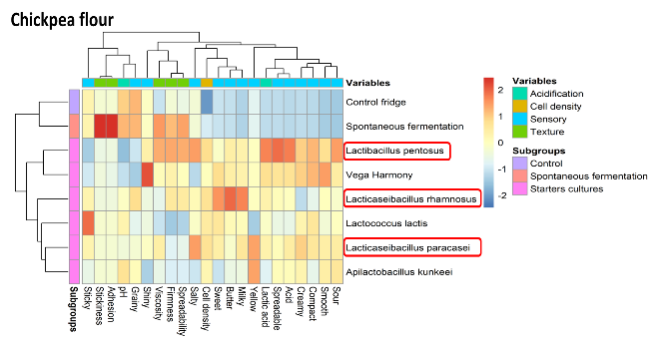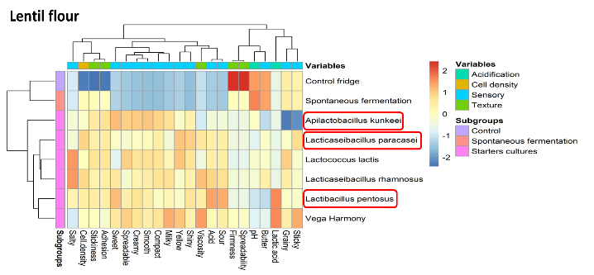
Figure 1. Heatmaps of the chickpea and red lentil vegan cream cheeses showing the acidification, cell density, sensory and texture results after fermentation with different strains of lactic acid bacteria.
Final plant-based cheese samples were fermented with different combinations selected for chickpea and red lentil separately. The evaluation of the nutritional and textural attributes of the final cheeses led to different profiles between fermented and nonfermented ones. Concerning the antinutritional factors such as phytic acid, raffinose, and saponins, both chickpea and red lentil cheeses showed lower values (15.1± 0.1, 26.5± 0.1, 34.0± 1.0 mg/g of dry matter for chickpea and 6.2± 0.1, 15.5± 0.1, 17.9± 1.0 mg/g of dry matter for red lentil, respectively) in the fermented samples compared to the unfermented ones (15.7± 0.1, 30.6± 0.1, 42.2± 1.0 mg/g of dry matter for chickpea and 6.8± 0.1, 21.8± 0.1, 26.6± 1.0 mg/g of dry matter for red lentil, respectively). Additionally, compared to the control, fermented samples had less content of starch indicating the impact of the starter cultures on starch hydrolysis. With respect to dietary fibers, once again there was a statistical difference (P < 0.05) between the fermented and not fermented ones, with the last ones having higher values. Phenolic compounds and free fatty acids were found in both cheeses, proving the nutritional impact of the presence of avocado. Finally, the results of the in vitro protein digestibility and the total free amino acids, together with all the above cases, confirmed the positive effect of lactic acid fermentation in both samples (Filannino, P., et al., 2020).

4. Upcoming work
A non-destructive method will be utilized with an AR-G2 controlled stress rheometer to analyze changes in texture during the six hours of fermentation by measuring G', G'', and tan(delta). After six hours, samples will be subjected to a creep-recovery test to determine their viscoelastic qualities. Turbiscan will be used to evaluate emulsifying activity and stability as a final step.

5. References
Grossmann, L. and McClements, D.J., 2021. The science of plant-based foods: Approaches to create nutritious and sustainable plant-based cheese analogs. Trends in Food Science & Technology, 118, pp.207-229.
Ferawati, F., Hefni, M., Östbring, K. and Witthöft, C., 2021. The application of pulse flours in the development of plant-based cheese analogues: Proximate composition, color, and texture properties. Foods, 10(9), p.2208.
Filannino, P., Tlais, A.Z., Morozova, K., Cavoski, I., Scampicchio, M., Gobbetti, M. and Di Cagno, R., 2020. Lactic acid fermentation enriches the profile of biogenic fatty acid derivatives of avocado fruit (Persea americana Mill.). Food chemistry, 317, p.126384.

