Insight into in-vitro digestibility of leavened baked goods
Federica Mastrolonardo (FMastrolonardo@unibz.it)
Food Science and Technology, Free University of Bozen- Bolzano
Supervisor: Prof. Marco Gobbetti
Internal co-supervisor: Olga Nikoloudaki, PhD
Co-supervisor: Prof. Carlo Rizzello (Sapienza University, Roma)

A Type I sourdough was prepared using traditional methods. It was fermented for 72 hours at 30°C with Lactiplantibacillus plantarum CR1, Furfurilactobacillus rossiae CR5, and Saccharomyces cerevisiae E10. The mature sourdough was used to make sourdough bread. A control bread was made with 1.5% (w/w) baker's yeast and fermented for 2 hours at 30°C. The sourdoughs were analyzed for pH, total titratable acidity (TTA), and organic acids. An in vitro simulation of the upper gastrointestinal tract was used to digest both bread samples and monitor nutrient mapping. This protocol (by PRODIGEST) includes specific enzymes and processing parameters that mimic in vivo digestion optimally.
Approfondimenti riguardo la digeribilità in vitro dei prodotti da forno lievitati
È stato preparato un lievito madre di tipo I utilizzando un protocollo tradizionale inoculando Lactiplantibacillus plantarum CR1, Furfurilactobacillus rossiae CR5 and Saccharomyces cerevisiae E10. L'impasto ha fermentato per 72 ore in tutto. L’impasto maturo è stato usato per produrre il campione di pane a lunga fermentazione, che è stato poi confrontato con un pane preparato con 1,5% di lievito birra. Gli impasti sono stati analizzati in base ai valori di pH, acidità totale titolabile (TTA) e acidi organici e sottoposti ad una simulazione in vitro del processo digestivo. Il protocollo imita il processo di digestione in vivo, includendo specifici enzimi digestivi e considerando diversi parametri.

Key words: Sourdough, baked goods, digestibility.

1. Introduction
In accordance with the papers of Rizzello et al. (2019) and Da Ros et al. (2021), this poster shows the main results of the first two activities concerning:
(A1) Preparation of experimental sourdough and baker’s yeast breads. Sourdough fermentation and characterization in terms of pH values, total titratable acidity (TTA), and organic acids and bread making;
(A2) In vitro pre-digestion process of bread samples. The static in vitro simulation of human gastrointestinal digestion consists of 3 phases: the oral phase, the gastric phase and the small intestine phase;
(A3) TWINSHIME® (UGent/ProDigest) experiment. Configuration consisting of three consecutive bioreactors simulating stomach and small intestine together, and proximal (PC) and descending (DC) colon

2. Materials and Methods
Type I sourdough was made and propagated using Lactiplantibacillus plantarum CR1, Furfurilactobacillus rossiae CR5 and Saccharomyces cerevisiae E10. The inoculum corresponded to ca. 5 × 10⁷ and ca. 5 × 10⁶ cfu/g for lactic acid bacteria and yeasts, respectively. The dough, with a Dough Yield of 160, was incubated at 30 ◦C for 16 h. Further the first fermentation, four back slopping steps were carried out, mixing 20% of the previously fermented dough with flour and water and incubating at 30 ◦C for 8 h. A final refreshment was carried out at 30°C for 24 h with the same parameters of inoculum and DY. During each refreshment, sourdough aliquots were analysed in terms of pH, TTA and organic acids (lactic and acetic acids) by High Performance Liquid Chromatography (HPLC) with an UV detector operating at 210 nm. Baker’s yeast and sourdough bread samples were manufactured according to Rizzello et al. (2019). The in vitro simulation of human gastrointestinal digestion consisted of 3 phases: the oral phase, the gastric phase and the small intestine phase. The oral pre-digestion included food dilution with simulated salivary fluid and the exposure (2 min) to salivary amylase. Then, the oral bolus was diluted with simulated gastric fluid and gastric enzymes (pepsin and gastric lipase) and incubation lasting at 37 ˚C for 2 h, using a pH gradient from 6.0 to 2.0. Finally, the gastric chyme was diluted with simulated intestinal fluid, bile salts and pancreatic enzymes and incubation at pH 7 was extended for further 3 h at 37 ˚C under static dialysis with a membrane of 14 kDa. Samples were further analyzed using the SHIME® (the Simulator of the Human Intestinal Microbial Ecosystem) to evaluate the effect of breads on the gut microbiota functionality. The set-up was a TWINSHIME® (UGent/ProDigest) configuration consisting of three consecutive bioreactors simulating stomach and small intestine together, and proximal (PC) and descending (DC) colon. Before starting, all the bioreactor that mimic the colon tracts were inoculated with a representative healthy fecal sample from the same donor. Samples have been collected from the SHIME® bioreactors at T₃ fecal material collected from ascending colon tract, at T₄ from traversal colon tract and at T₅ from descending colon tract.

3. Results and Discussion

3.1 Biochemical characteristics of sourdough
After the last fermentation, the mature sourdough reached the value of pH of 3.59 ± 0.005. Resulting pH for each fermentation was time dependent. The longer the duration of fermentation, the lower was the value of pH. Values of TTA resulted to be in line with the organic acids produced.
The concentration of acetic acid was 20.5 ±0.3 mM after each fermentation steps. In comparison, the content of lactic acid was higher after 16 and 24 h of fermentation (64.2 mM and 53.5 mM, respectively). The fermentation quotient ranged from 3.5 and 4.8.

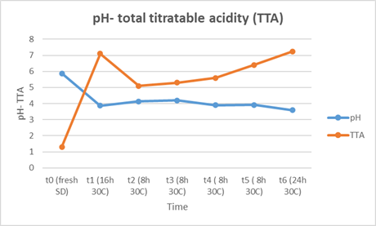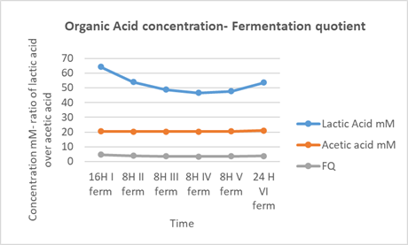

Figure 1. Physico- chemical and biochemical characteristics of the sourdough. pH, total treatable acidity (TTA) (mL of NaOH /pH 8.3), organic acid concentration and fermentation quotient of the sourdough at each back slopping steps.

3.2 Sampling
The in vitro static simulation of the upper gastrointestinal tract and colon tract allowed for the acquisition of all the necessary samples for subsequent analysis, enabling the mapping of factors that influence the digestibility of sourdough breads and their impact on the human gut microbiome and metabolome. Specifically, bolus samples were collected following the oral phase of in vitro digestion, chyme samples following the gastric phase and chyle and permeate samples following the small intestine phase. The kilo, from the last step of the in vitro simulation of the upper gastrointestinal tract, was tested in the SHIME® in order to continue with macronutrients mapping even into the large intestine simulation. The SHIME® experiment proceeded with a stabilization and control phase of the microbial community in the bioreactors, followed by a one-week treatment period where the gut microbiota was nourished with a media that simulated daily meals supplemented with digested sourdough bread. During this phase, faecal lumen samples were collected for subsequent biochemical analysis.
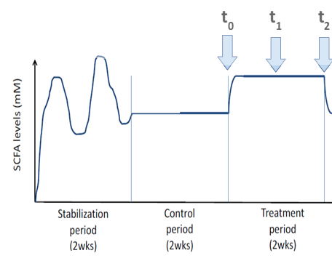

Figure 2. Timing SHIME® experiment
4. Description of the research work outlook of the following year
Investigating factors influencing bread digestibility, the human gut microbiome, and metabolome, and studying the metabolic fate of macronutrients and nutritional factors along the gastrointestinal tract using in vitro digestion and the SHIME® model.

5. References
Rizzello C, Portincasa G, Montemurro P, Di Palo M, Lorusso D.M, De Angelis M.P, Gobbetti M (2019) Sourdough fermented breads are more digestible than those started with baker’s yeast alone: An in vivo challenge dissecting distinct gastrointestinal responses. Nutrients 2954:11(12).
Da Ros A, Polo A, Rizzello C, Acin-Albiac G, Montemurro M, Di Cagno R, Gobbetti M (2021) Feeding with sustainably sourdough bread has the potential to promote the healthy microbiota metabolism at the colon level. Microbiology spectrum 9(3): e00494-21.
ProDigest Gastrointestinal Expertise, Dialysis for Twinshime® installation and operating manual.

