Exploiting wine lees to improve nutritional features of biscuits
Roberta Miolla (roberta.miolla@uniba.it)
Dept. of Food Soil and Food Sciences (DiSSPA), University of Bari Aldo Moro, Bari, Italy
Tutor: Prof. Francesco Caponio; Co-Tutor: Dott.ssa Graziana Difonzo

Wine lees flour was used in the production process of biscuits to enrich them in fibres, proteins, and phenolic compounds, thus improving their nutritional value. Control biscuits were compared with biscuits obtained by replacing refined flour with 10 or 20% wine lees flour. The results of the analytical determinations showed that the experimental biscuits were richer in fibres, proteins, ashes, and phenolic compounds, resulting in an increase in antioxidant activity. Sensory analysis, however, showed that astringency, bitterness, and acidity increased in proportion to the amount of wine lees flour used.

Valorizzazione delle fecce di vino per migliorare le caratteristiche nutrizionali dei frollini
La farina di fecce di vino è stata utilizzata nel processo produttivo di frollini per arricchirli in fibre, proteine e composti fenolici, al fine di migliorarne il valore nutrizionale. Frollini controllo sono stati confrontati con quelli ottenuti sostituendo la farina raffinata con la farina di fecce di vino nella misura del 10 e 20%. I risultati delle determinazioni analitiche hanno dimostrato che i frollini sperimentali erano maggiormente ricchi in fibre, proteine, ceneri e composti fenolici, con conseguente incremento dell’attività antiossidante. L’analisi sensoriale, invece, ha evidenziato che astringenza, amaro e acidità si incrementavano proporzionalmente al quantitativo di farina di fecce utilizzato.

Key words: Oenological by-products, wine lees flour, biscuits, dietary fiber, antioxidant activity, polyphenols.

1. Introduction
Oenological by-products are becoming increasingly important in the context of food applications; in fact, scientific evidence suggests their properties, functionality, and benefits that promote human health when administered in food formulations (Sharma et al., 2015). In particular, wine lees are known to be rich in dietary fiber and phenolic substances with antioxidant properties (Sharma et al., 2022). Therefore, this work aims to enhance the value of wine lees by using them as a source of bioactive molecules for the fortification of baked goods. The choice of fortifying the biscuits was dictated by the need to improve their nutritional composition because in most cases conventional biscuits are made using refined flours, sugars and fats that give high caloric power and fibres poverty (Devi et al., 2016). This poster presents the main results of the activities regarding treatment of wine lees, the formulation of biscuits enriched with wine lees flour and their characterization.

2. Materials and Methods
2.1 Wine lees flour
Wine lees were freeze-dried, reaching moisture values of 3% or less. Flour production was carried out by mixing and subsequent passing in a hammer mill (Dietz-motoren KG). Then, the sieving by vibrating (Giuliani, Turin, Italy) at 300 rpm for 40 min was conducted.
2.2 Biscuits formulation and characterization
The classic recipe for this type of product was used as a control sample (F0) and in experimental biscuits wine lees flour (WLF) replaced 10% (F10) and 20% (F20) of wheat flour. The recipe was as follows: wheat flour (F0, 250 g; F10, 225 g; F20, 200 g), wine lees flour (F0, 0 g; F10, 25 g; F20, 50 g), semi-skimmed milk (80 g), olive oil (70 g), sugar (70 g), and ammonium bicarbonate (3 g). Then, after kneading, rolling, and forming, the biscuits were baked in a ventilated electric oven for 16 minutes at 160 ºC. The moisture content was measured using a thermobalance (MAC 110/NP). The proteins, ashes, lipids, and total dietary fibres (TDF) contents were determined using the methods 979.0, 923.03, 945.38 F and 985.29, respectively (AOAC, 2006). Carbohydrates were determined by subtracting the values of proteins, ashes, lipids, and moisture from 100. The polyphenols extraction from biscuits was carried out according to the protocol described by Leal et al. (2020) with some modifications. Extracts were utilized for determination of antioxidant activity (AA), by ABTS and DPPH tests, and total phenol content (TPC) by Folin-Ciocalteu according to Noviello et al. (2022). All analysis mentioned were carried out in triplicate. A panel group of 10 people at the University of Bari Aldo Moro was trained to conduct the sensory analysis of the biscuits. Visual and tactile analyses was evaluated through biscuits colour (0= yellow; 9= light brown/violet) and friability (0= very hard; 9= very crumbly), respectively. The gustatory attributes subjected to evaluation were sweetness, saltiness, acidity, bitterness, astringency, and off taste intensity according to the following score (0= unperceived; 9= very intense). Finally, the material attributes perceived upon tasting was assessed by evaluating the following parameters: hardness (0= soft; 9 =hard), dryness (0= humid; very dry), and granularity (0= no perceived particle; 9= many particles of various sizes). The hardness (N) of biscuits was evaluated also using a texture analyser (Z1.0 TN, Zwick Gmbh & Co., Ulm, Germany). The method applied was the 3-point bending test using 1 KN load cell, the distance between the distance bars was 4 cm with a probe speed of 5 mm/min. Six replicated were made for each sample.
2.3 Statistical analysis
Statistical processing was carried out using Minitab 17 (Minitab Inc., State College, PA, USA) subjecting the data to analysis of ANOVA variance and Tukey test for multiple comparisons.

3. Results and Discussion
Table 1 shows proximate composition, antioxidant activity, total phenol content and hardness of biscuits. A significant increase in proteins and ashes in fortified biscuits was observed compared to the control one due to the addition of wine lees rich in these components (data not shown). The proteins increase was in line with the results obtained by Sharma et al. (2022) in yogurt enriched with wine lees. In addition, TDF was significantly higher in F10 and F20 than in F0, allowing the nutrition claim "fibre source" to be obtained due to fibre content greater than 3 g/100 g in F10 and "high fibre content" due to the presence of TDF exceeding 6 g/100 g in F20. As a result, higher humidity was also observed in the experimental biscuits than in the control, probably due to the greater fiber content brought by wine lees and having affinity towards the components of water allow it to be retained inside the matrix (Maner et al., 2017). Consequently, carbohydrates significantly decrease in the experimental biscuits. The results obtained from the characterization of biscuits showed a dose-dependent increase of TPC and AA with a higher rate of replacement of the wine lees flour in biscuits formulation. These results agree with the literature where the increase of phenols and the antioxidant activity observed in ice cream (Sharma et al., 2015) are linked to the addition of wine lees. Phenols and anthocyanins analysis for HPLC showed that in experimental biscuits, as well as in WLF, ellagic acid, malvidin 3-glucoside and malvidin 3-acetyl-glucoside were the most abundant. Finally lower hardness was found in experimental biscuits (F10, F20) than in the control sample (F0), probably due to the dilution of gluten caused by WLF which does not contain gluten.

Table 1. Proximate composition, antioxidant activity, total phenol content and texture profile analysis of biscuits.
Sample | F0 | F10 | F20
Moisture (g/100 g) | 4.80 ± 0.03 ^{b} | 9.05 ± 0.06 ª | 9.23 ± 0.20 ª
Proteins (g/100 g) | 8.46 ± 0.00 ^{b} | 9.94 ± 0.15 ª | 9.57 ± 0.32 ª
Lipids (g/100 g) | 16.50 ± 0.15 ^{b} | 17.82 ± 0.29 ª | 17.25 ± 0.04 ^{ab}
Total dietary fiber (g/100 g) | 2.67 ± 0.09 ^{c} | 4.70 ± 0.12 ^{b} | 8.04 ± 0.33 ª
Ashes (g/100 g) | 0.44 ± 0.01 ^{c} | 1.53 ± 0.04 ^{b} | 2.68 ± 0.01 ª
Carbohydrates (g/100 g) | 67.12 ± 0.02 ª | 56.97 ± 0.02 ^{b} | 53.23 ± 0.91 ^{c}
ABTS (µmol TE/g) | 1.16 ± 0.09 ^{c} | 2.43 ± 0.08 ^{b} | 4.27 ± 0.08 ª
DPPH (µmol TE/g) | 0.47 ± 0.00 ^{c} | 2.63 ± 0.05 ^{b} | 4.77 ± 0.13 ª
TPC (mg GAE/g) | 0.25 ± 0.03 ^{c} | 0.70 ± 0.05 ^{b} | 1.45 ± 0.01 ª
Hardness (N) | 53.28 ± 2.03 ª | 25.70 ± 0.26 ^{b} | 22.93 ± 0.30 ^{c}

F0, control biscuits without wine lees; F10, F20 biscuits with 10% and 20% wine lees flour. Data are represented as means ± SD of three lots and different letters in the same row mean a significant difference at p < 0.05.

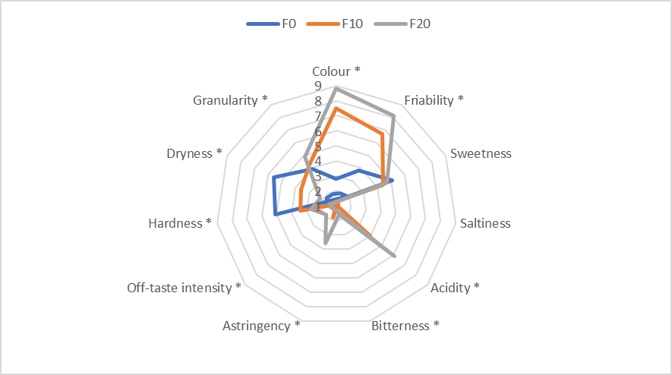
The sensory properties of experimental biscuits were strongly influenced by the addition of wine lees. Panellists reported an increase in violet colour proportional to the addition of wine lees. The WLF addition led to a friability increase directly proportional to the increase in the percentage of substitution. The perception of acidity, bitterness, astringency, and off-taste intensity significantly increased with higher levels of WLF added. As expected, the acidic taste found in experimental biscuits is due to the acids contained in WLF. The bitterness and astringency sensation can be attributed to the presence of polyphenols in WLF flour due to the interaction that occurs between polyphenols and saliva (Davidov-Pardo et al., 2012). Finally, texture attributes as hardness, dryness and granularity were influenced by WLF addition. Specially, the lower hardness of the experimental biscuits (F10, F20) compared to the control sample (F0), agrees with the instrumental results (hardness). Similarly, the dryness of F10 and F20 was less than control; this could be associated with the increased humidity of the experimental biscuits. Although richer in fiber and phenolic compounds, panellists rated F20 with a higher perception of acidity, bitterness, astringency, and taste than F10.
Figure 1. Results of the sensory analysis of biscuits; data are represented as means ± SD of ten panellists.

4. References

AOAC International (2006) Official Method of Analysis, 17th ed.; AOAC International: Gaithersburg, MD, USA.
Davidov-Pardo G, Moreno M, Arozarena I, Marín-Arroyo MR, Bleibaum RN, Bruhn CM (2012) Sensory and consumer perception of the addition of grape seed extracts in cookies. J Food Sci 77: 12.
Devi A, Khatkar BS (2016) Physicochemical, rheological and functional properties of fats and oils in relation to cookie quality: a review. J Food Sci Technol 53: 3633–364.

Leal C, Costa C, Barros AI, Gouvinhas I (((2020) Assessing the relationship between the phenolic content and elemental composition of grape (Vitis Vinifera L.) stems. Waste Biomass Valorization 12: 1313-1325.
Maner S, Sharma AK, Banerjee KK (2017) Wheat flour replacement by wine grape pomace powder positively affects physical, functional, and sensory properties of cookies. Proc Natl Acad Sci 87: 109-113.
Noviello M, Caputi AF, Squeo G, Paradiso VM, Gambacorta G, Caponio F (2022) Vine Shoots as a Source of Trans-Resveratrol and Ɛ-Viniferin: A Study of 23 Italian Varieties. Foods 11: 553.
Sharma AK, Kumar R, Azaz Ahmad Azad ZR, Adsule PG (2015) Use of wine lees for value addition in ice cream. J Food Sci Technol 52: 592-596.
Sharma AK, Aglawe MK (2021) Addition of processed fine wine lees of Cabernet Sauvignon to improve nutraceutical properties of yogurt. Proc Natl Acad Sci 92: 141-147.

