The role of root exudates in promoting beneficial interactions and rhizoremediation potential of polychlorinated biphenyls (PCBs)-degrading bacteria
Elisa Ghitti (elisa.ghitti@unimi.it)
Department of Food, Environmental and Nutritional Sciences (DeFENS), Università degli Studi di Milano, Italy
Tutor: Prof.ssa Sara Borin

This PhD thesis investigates the crosstalk between plants and soil bacteria mediated by root exudates, in the context of soil contamination by Persistent Organic Pollutants (POPs) like polychlorinated biphenyls (PCBs). The work addresses the role that flavonoids, plant secondary metabolites, play in influencing rhizocompetence traits, necessary for root colonization, in a model PCB-degrading bacterial strain. The results obtained contribute to improve the knowledge of plant beneficial interaction with PCB degrading bacteria, potentially improving the effectiveness of soil phyto-rhizoremediation strategies for PCBs removal.

Ruolo svolto dagli essudati radicali nella promozione delle interazioni benefiche e nella capacità di biorisanamento di batteri degradatori di policlorobifenili (PCB)
Questa tesi di dottorato studia le interazioni pianta-microrganismo mediate dagli essudati radicali, in particolare nel contesto della contaminazione del suolo da parte di inquinanti organici persistenti come i policlorobifenili (PCB). Il lavoro si concentra sul ruolo che i flavonoidi, metaboliti secondari delle piante, svolgono nell'influenzare i tratti di rizocompetenza in un ceppo batterico modello che degrada i PCB, necessari per la colonizzazione delle radici. I risultati ottenuti contribuiscono a migliorare la conoscenza delle interazioni benefiche delle piante con i batteri degradatori, potenzialmente migliorando l'efficacia delle strategie di fitorisanamento del suolo per la rimozione dei PCB.

Key words: Root exudates; flavonoids; root colonization; plant holobiont; PCBs; phyto-rhizoremediation.

1. Introduction
In line with the objectives of the PhD project previously illustrated (Ghitti, 2021), this oral communication reports the main results obtained during the doctorate studies, aimed at:
A1) The critical analysis of scientific literature on the role of root-exuded secondary metabolites in shaping bacterial communities with degradative potential in contaminated soils, with a special focus on flavonoids;
A2) Investigating the different root exudation profile of the model plant A. thaliana in presence and absence of PCB stress and its impact on PCB-degrading bacteria activity and metabolism;
A3) Investigating the role of specific flavonoids on the model PCB-degrading bacterium Paraburkholderia xenovorans LB400, focusing on the improvement of traits necessary for efficient root colonization;
A4) Generation of fluorescent-tagged bacteria to analyze the root colonization profile under PCB stress.

2. “Cry-for-help” mediated by root exudates in contaminated soils
Plants live in close association with a multitude of microorganisms coevolving together as a unique meta-organism defined as the plant holobiont. The crosstalk between plant and microorganisms, particularly those colonizing the rhizosphere and the endosphere, is carried out through root-exuded primary and secondary metabolites that act as essential chemical signals to maintain the health status of the holobiont (Vandenkoornhuyse et al., 2015). Root chemistry shapes a rhizospheric microbial community that can provide benefits for the holobiont: it was hypotesized that, when exposed to stress due to the presence of phytopathogens, the plant enacts a ‘cry-for-help’ by exuding specific metabolites necessary for the recruitment of beneficial microorganisms to counteract the attack (Rolfe et al. 2019). The same mechanism was hypothesized as part of the adaptation strategy for plants exposed to abiotic stresses like the presence of phytotoxic xenobiotic contaminants, such as polychlorinated biphenyls (PCBs), in soil. Since plants often lack the catabolic enzymes needed for complete degradation of PCBs, they can resort to the exudation of specific metabolites to recruit PCB-degrading bacteria that could degrade recalcitrant contaminants and decrease their phytotoxicity (Rolli et al. 2021). Flavonoids are root-exuded secondary metabolites that are among the most promising molecules acting as inducers or co-metabolites to trigger the expression of the catabolic genes for biphenyl aerobic degradation, encompassed by the bph operon (Pham et al. 2015; Zubrova et al. 2021). This mechanism could be exploited to improve the degradation and removal of PCBs from the environment through phyto-rhizoremediation.

3. Plant secondary metabolites influence bacterial root colonization
Root exudates are necessary to establish close and stable associations with plant growth promoting bacteria, that contribute to the holobiont fitness by alleviating nutritional shortages, producing phytohormones necessary for plant development or by acting as biocontrol agents. Among these metabolites, flavonoids are well known for their involvement as chemical prompts in initiating rhizobia-legume symbioses but were also studied for their role in interacting with other soil microorganisms and influencing bacterial root colonization. For instance, some beneficial soil bacteria can metabolize plant flavonoids and use them as carbon sources (Pillai and Swarup 2002) while for others, flavonoids are involved in the modulation of rhizocompetence traits like bacterial motility (Yu et al. 2020) or biofilm formation (He et al. 2022) for the stable colonization of root surfaces. Although emerging evidence about flavonoids’ role in plant interaction with non-rhizobia microorganisms was observed, these is still a lack of knowledge about the mechanisms underlying these relationships.

4. Materials and Methods

4.1 In vitro assays to test rhizocompetence traits
Bacterial metabolism and features involved in root colonization were investigated on three PCB-degrading bacterial strains through adapted in vitro assays previously reported in literature using pure metabolites. Bacterial growth stimulation by flavonoids was tested as reported by Huang et al. (2019) by adding µM concentrations of pure flavonoids to a diluted growth medium. Swimming motility was assayed in plates containing semi-solid 0.25% agar medium supplemented with flavonoids, as well as chemotaxis motility, tested as reported by Reyes-Darias et al. (2015) using a gradient plate medium assay. Biofilm formation was tested in 96 well plates using the crystal violet staining method to test bacterial adhesion (Yoshioka and Newell 2016).

4.2 Generation of fluorescence-labelled bacteria
Two fluorescent bacterial strains were engineered and used to observe Arabidopsis root colonization pattern. Paraburkholderia xenovorans LB400 was tagged chromosomally with the red fluorescent protein mScarlet, expressed under a constitutive promoter, through filter-mating conjugation, using as donor the E. coli S17-1 helper strain carrying the pMRE-Tn5-145 transposon delivery plasmid (Schlechter et al., 2018). The strain Pseudomonas alcaliphila JAB1 was engineered with the plasmid pUCP18-CmR-IR_GntR-egfp, kindly donated by prof. Ondřej Uhlík (UCT Prague), to obtain a biosensor. The plasmid harbored an inducible eGFP gene putatively regulated as the bphA gene, that encodes for the protein necessary for the first step of the aerobic biphenyl degradation pathway. Furthermore, P. alcaliphila JAB1 biosensor was tagged with a constitutive mScarlet by conjugation to observe the bacterial root colonization profile.

5. Results and Discussion

5.1 PCB stress induces a shift in Arabidopsis root exudation profile

The root exudates of Arabidopsis thaliana (ecotype Col-0) were collected 2 days after the induction of stress with 70 µM PCB and analyzed through metabolomics. The abundance of 62 compounds was found statistically different in PCB-treated root exudates compared to the untreated control and five of these metabolites were further identified. The coumarin scopoletin and N-(2-hydroxyethyl)-β-alanine decreased their relative abundance in presence of PCB, while hypoxanthine and two dipeptides (L-seryl-L-phenylalanine and L-arginil-L-valine) were exuded in higher amount. Reduced exudation of scopoletin under PCB stress might be due to the antimicrobial activity often exerted by coumarins (Voges et al. 2019), that could affect negatively the growth of beneficial PCB-degrading bacteria. Indeed, when supplemented at increasing concentrations (0.25 mM-2 mM) to the bacterial strains Acinetobacter calcoaceticus P320 and P. alcaliphila JAB1, scopoletin inhibited cell growth while enhancing the ability of both the strains to form a biofilm, possibly activating this quorum sensing-mediated lifestyle to allow survival under stress. The identified exudates that increased their abundance in response to PCB-18 stress showed to sustain bacterial growth and enhance traits related to rhizocompetence: JAB1 and LB400 used hypoxanthine as unique carbon source and hypoxanthine also increased biofilm formation in JAB1. L-seryl-L-phenylalanine and L-arginil-L-valine were both utilized by LB400 as sole nitrogen sources.

5.2 Flavonoids improve traits involved in P. xenovorans LB400 rhizocompetence and early root colonization
Selected plant flavonoids were investigated to assess their influence on some rhizocompetence traits of the PCB-degrading bacterium P. xenovorans LB400, which are essential features to establish a stable association with the plant (Allard-Massicotte et al. 2016). As reported in the heat-map in Figure 1a, the assayed flavonoids selectively modulate the growth of strain LB400: in presence of naringin, the bacterial cells proliferated faster at all assayed concentrations, with the higher maximum growth rate (+13.4%) at 50 µM compared to the control. Flavonoid-mediated improvement in the growth parameters corresponded to an increased bacterial biomass reached at the stationary phase after 24/30 hours of growth (Figure 1b). The higher yields were recorded for 20 µM flavanone and flavone (+9.2 and 15.3%, respectively), for 50 µM naringin and naringenin (+27.8 and 17.3%, respectively) and for 50 µM quercetin (+ 40.1%) compared to control.
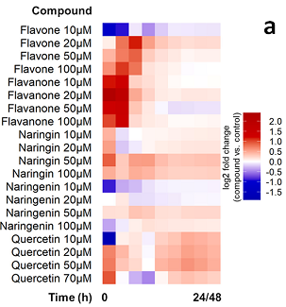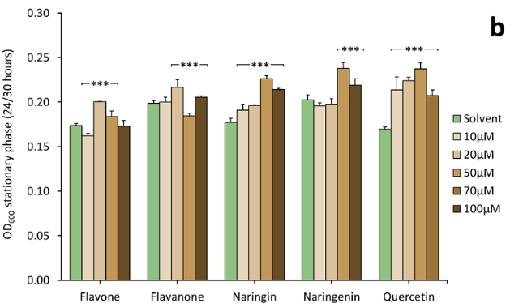

Figure 1 (a) Relative growth of LB400 during 24/48 hours in presence of selected concentrations of flavonoids compared to the negative controls; red colour indicates positive increment of the log2 fold change while blue colour indicates decrement. (b) Bacterial biomass reached at stationary phase is expressed as OD₆₀₀. Bars represent the average ± standard deviation of 3 independent experiments. Statistical analysis was performed using Mann-Whitney test (***: p ≤ 0.001).

The flavonoids involved in growth stimulation of the strain also influenced functional traits, potentially stimulating the early recruitment of the bacterial cells by the plant and their adhesion to the root. Naringin at 50 µM was shown to influence bacterial swimming motility in vitro by increasing the swimming motility halo diameter by 6.6% compared to control, while flavone and quercetin inhibited the strain motility at the same concentrations. Interestingly, 50 mM quercetin and 50-100 mM naringenin had instead a role as chemo-attractants for LB400 revealed through gradient plate chemotaxis assay (Figure 2a). As reported in Figure 2b, biofilm formation ability, necessary for a stable colonization of the root over time (Knights et al. 2021), significantly increased 24h from inoculation in presence of 100 µM naringin and naringenin (+47% and +44% CV/OD₆₀₀, respectively).
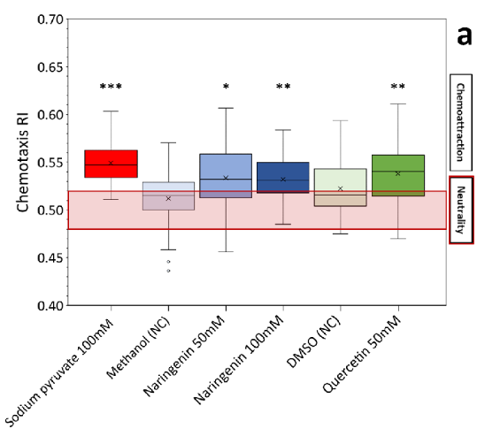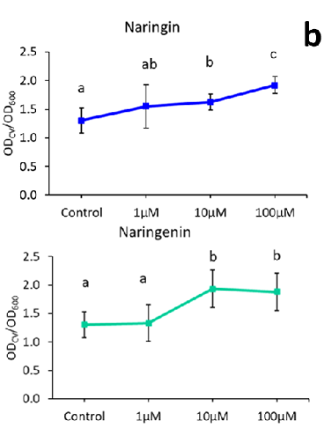

Figure 2 (a) LB400 chemotaxis response index (RI) in presence of flavonoids, of negative controls (methanol and DMSO) and of 100 mM sodium pyruvate as positive control. The graph reports data from at least 3 independent experiments. Statistical analysis was performed using Tukey-Kramer’s post-hoc test (*: p ≤ 0.05, **: p ≤ 0.01). (b) Biofilm formation of LB400 expressed as ratio between the crystal violet OD and the OD₆₀₀ as index of bacterial growth. The graph reports data from 3 independent experiments. Statistical analysis was performed using Dunn’s post-hoc test and letters indicate statistically different groups (p ≤ 0.05).

Considered flavonoids’ influence in enhancing rhizocompetence traits of LB400, an early colonization assay was set up by dipping 6 days-old Arabidopsis plantlets for 1 hour in a bacterial solution containing 10⁷ cells/mL. The results showed that the Arabidopsis mutant tt8, that over-accumulates flavonoid aglycones, including quercetin and naringin (Narasimhan et al. 2003), was significantly more colonized (1.09x10⁴ cells/mg plant) than the null flavonoid mutant tt4 (5.42x10³ cells/mg plant), while in the WT the colonization efficiency recorded was 5.57x10³ cells/mg plant, potentially demonstrating a positive role of flavonoids in inducing bacterial early plant colonization.

5.3 Pseudomonas JAB1 biosensor preparation and validation
The PCB-degrading strain Pseudomonas JAB1 was engineered with a plasmid containing a green fluorescent protein (eGFP) gene regulated by the promoter of the bph operon, which is involved in PCB degradation, obtaining a strain expressing fluorescence as a proxy for the activation of the PCB biodegradation pathway. The biosensor strain was validated by inducing the expression of the eGFP fluorescent protein with different concentrations of biphenyl (1 µM to 250 µM). By relating the relative fluorescence units (RFUs) measured through a spectrophotometer, to the bacterial growth (OD₆₀₀), it was observed that 2 hours after the induction the biosensor showed a significantly different emission of fluorescence compared to the non-induced control. This data suggested that the biosensor sensitivity is achieved with 10 µM biphenyl. Furthermore, the induction ratio of JAB1 biosensor (calculated as the ratio between RFU/OD₆₀₀ of the induced cells and of the prior-to-induction cells) was seen to correlate linearly to the biphenyl concentrations tested. The induction of the expression of bphA by biphenyl was also verified via RT-qPCR, confirming a peak of relative expression at 2 hours after the treatment with biphenyl.
5.4 Analysis of the colonization pattern of Arabidopsis roots with fluorescent PCB-degrading bacteria
5.4.1. P. alcaliphila JAB1 supports the ‘cry-for-help’ hypothesis and preferentially colonizes Arabidopsis root tip.
The strain JAB1 was tested for growth on Arabidopsis Col-0 root exudates and was observed capable of utilizing compounds present in root exudates as growth substrates. Moreover, the results of this experiment contributed to support the ‘cry-for-help’ hypothesis since the root exudates of plants exposed for 7 days to PCB stress promoted the growth of JAB1 more than the exudates released in control conditions, suggesting that the plant modulates its root exudation to counteract the stress and recruit beneficial bacteria. To understand the involvement of flavonoids, reported as key exudates for inducing the bacterial degradation of PCBs, on JAB1 biosensor root colonization ability, WT Arabidopsis (ecotype Ler) and the flavonoid iper-producing mutant tt8 were used. By observing the colonization pattern using fluorescence microscopy, the roots exposed to 20 µM PCB during in vitro plant growth resulted more intensely colonized than the non-stressed controls. Furthermore, the strain colonized more efficiently the tt8 mutant, if compared with WT Arabidopsis, implying an involvement of flavonoids in recruiting the bacterium. The eGFP signal, indicating the induction of the biphenyl degradation pathway, was particularly visible in the root tip of PCB-stressed plants, as further confirmed by re-isolation of the strain from specific root sections. Confocal microscopy showed that JAB1 was peculiarly localized on the root cap, an unusual localization for plant-associated bacteria (Gamalero et al. 2005), indicating that the bacterium is adapted to this ecological niche. Moreover, the intense eGFP signal observed indicates that the root cap releases specific compounds that could induce the biphenyl catabolic pathway and potentially play a role in bacterial-driven PCB removal.
5.4.2. P. xenovorans LB400 promotes Arabidopsis but its long-term root colonization pattern is not influenced by flavonoid exudation.
The interaction between the PCB-degrading bacterium P. xenovorans LB400 and WT Arabidopsis (ecotype Ler) and Arabidopsis mutants with an altered flavonoid exudation pattern was assayed in vitro in presence of 20 µM PCB-18 stress or in control conditions (acetone). The mutants included tt4, a null flavonoid producer, and two flavonoid overproducing lines, tt8 (accumulating flavonoids aglycones in the roots) and ttg1 (accumulating flavonoids and their conjugates). The results concerning plant fresh weight at day 14 of growth onto PCB-spiked medium showed that the stress caused by the contaminant had a major effect on the roots by significantly decreasing their fresh weight for all Arabidopsis lines (Figure 3a represents only the WT values, as an example). The shoot instead was not dramatically affected, especially in WT and tt4 plants (Figure 3b). The presence of the bacterium induced growth promotion similarly for all the mutants compared to the mock control (no inoculation of LB400): plant root and shoot fresh weight was significantly higher in plants colonized by LB400 and generally corresponded also to an enhanced root length at day 7, both in presence and absence of PCB stress.
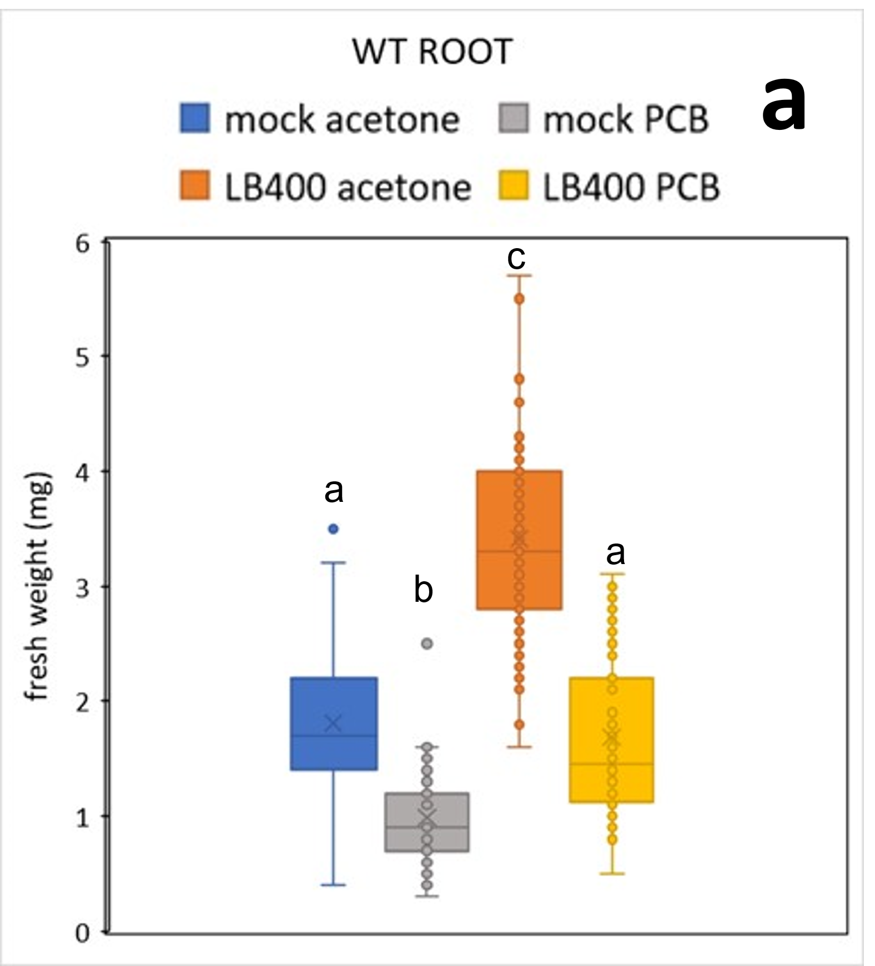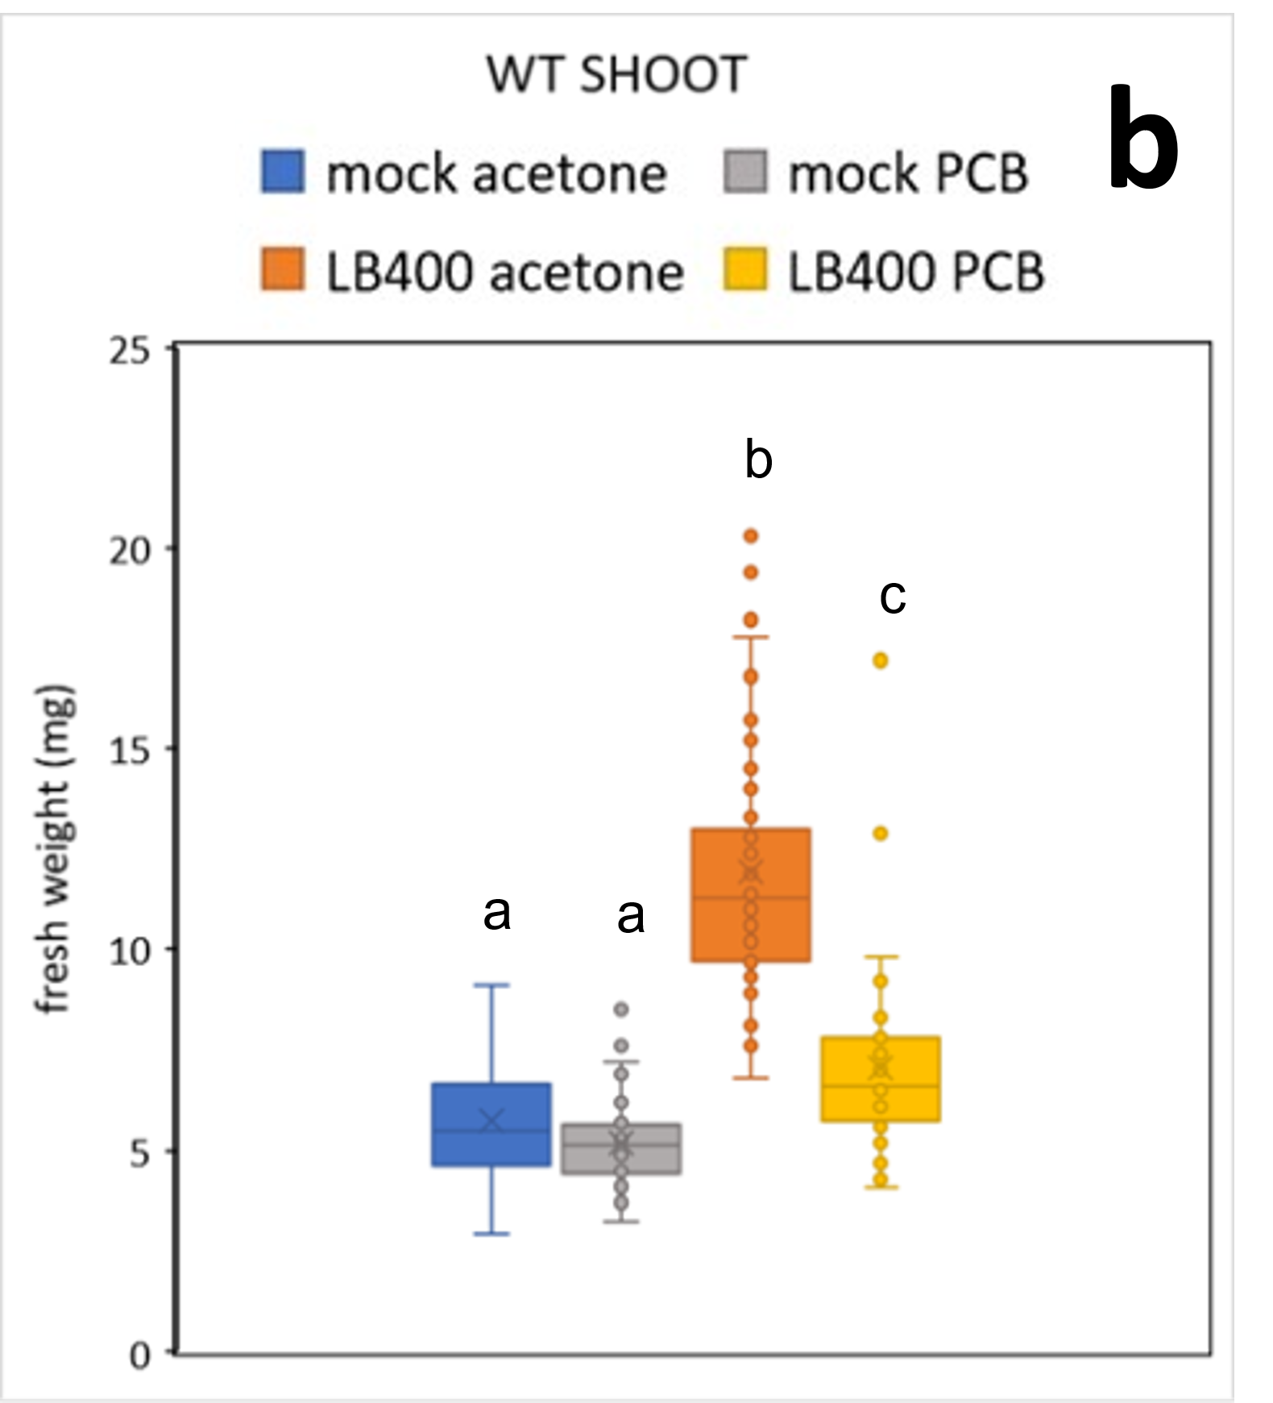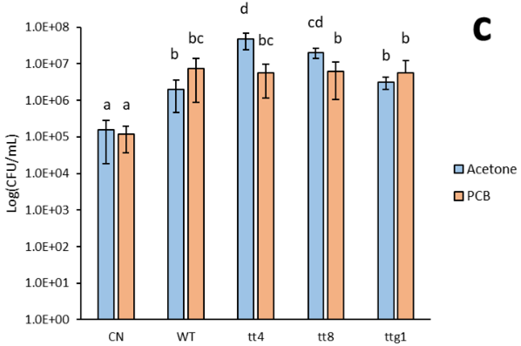

Figure 3 Total root (a) and shoot (b) fresh weight of WT Arabidopsis in presence of PCB or in the untreated control (acetone) and in presence or absence (mock) of LB400. The graph reports data from 3 independent experiments. (c) LB400 growth on root exudates collected from WT Arabidopsis and flavonoid metabolic mutant lines at day 7 of treatment with PCB or acetone (untreated control). LB400 was inoculated at 5x10⁴cells/mL and grown for 3 days. CN indicates ½ MS medium containing only acetone or 20 µM PCB-18. The bars represent the average ± standard deviation of 3 independent experiments. For all figures: letters indicate statistically different groups (Dunn’s post-hoc test with p ≤ 0.05).

Overall, these results suggest that LB400 exerts a growth-promoting activity when associated to Arabidopsis, but this does not depend on flavonoid exudation. When analyzing the colonization rate of LB400 on Arabidopsis lines at day 7 and at day 14 by re-isolation, no significant differences were visible between the mutant lines. Fluorescence microscopy observations using the mScarlet-tagged LB400 strain highlighted the ability of the bacterium to colonize diverse root zones in the WT and flavonoid mutants. These results are consistent with the in vitro tests analyzing the effect of flavonoids on rhizocompetence traits: flavonoids might in fact have an exclusive role in early colonization phases by having a priming effect, influencing bacterial motility and inducing chemotaxis. The long-term colonization might be uniform between all Arabidopsis lines because, once established on the rhizoplane, LB400 persistence on the roots could be tuned to other metabolites than flavonoids exuded by Arabidopsis mutants, that could reshape and influence LB400 abundance. For instance, tt4 mutants do not release flavonoids but over-accumulate other secondary metabolites such as organic acids that could play a role in LB400 sustainment (Zhalnina et al. 2018). By testing the growth of LB400 on exudates collected from PCB-stressed or untreated Arabidopsis roots, results showed indeed that tt4 exudates were also effective at supporting the growth of the bacterium (Figure 3c).

6. Conclusions and Future Perspectives
The mechanisms that underlie the root-exudate mediated interactions between the host plant and the associated microbiota in the holobiont are not yet well understood. This knowledge could be useful in the perspective of applying bacteria that can promote plant growth or contribute effectively in boosting phyto-rhizoremediation strategies. In this work the role of flavonoids, key secondary metabolites released by the plant and well known to be involved in plant-rhizobia early interaction, was elucidated. Flavonoids can act as regulators of rhizocompetence-related traits during early root colonization also for non-rhizobia beneficial microorganisms, as the PCB-degrader P. xenovorans LB400. In addition, the results obtained allowed for a deeper understanding of the interactions between plants and beneficial bacteria, especially under stress conditions caused by PCBs, and to observe a case of putative ‘cry-for-help’ mechanism given by the presence of a soil contaminant, a topic not yet widely explored in literature. This knowledge could enable more targeted approaches in PCBs rhizoremediation, often affected by a limited efficiency, by providing useful insights for the possible exploitation of natural metabolites released by plant roots. Future research should be addressed at characterizing plants with specific root exudation patterns that could be used for in vivo rhizoremediation studies together with specific PCB-degrading bacteria to evaluate their efficacy in PCB clean-up.

7. References
Allard-Massicotte R et al. (2016) Bacillus subtilis Early Colonization of Arabidopsis thaliana Roots Involves Multiple Chemotaxis Receptors. mBio Nov 29;7(6):e01664-16.
Gamalero E et al. (2005) Colonization of Tomato Root Seedling by Pseudomonas fluorescens 92rkG5: Spatio–temporal Dynamics, Localization, Organization, Viability, and Culturability. Microb. Ecol. 50, 289–297.
Ghitti E (2021) Exploiting beneficial interactions between plants and bacteria: PCB biodegradation by soil microbiome upon stimulation by root exudates. In Proceedings of the XXV Workshop on the Developments in the Italian PhD Research on Food Science, Technology and Biotechnology, Palermo (Italy), 14-15 September 2021, pp. 140-141.
Ghitti E et al. (2022) Flavonoids Are Intra- and Inter-Kingdom Modulator Signals. Microorganisms 10, 2479.
He et al. (2022) Flavonoid-attracted Aeromonas sp. from the Arabidopsis root microbiome enhances plant dehydration resistance. ISME J. 16, 2622–2632.
Huang AC et al. (2019) A specialized metabolic network selectively modulates Arabidopsis root microbiota. Science 364, 546.
Knights HE et al. (2021) Deciphering bacterial mechanisms of root colonization. Environ. Microbiol. Rep. 13(4), 428–444.
Narasimhan K et al. (2003) Enhancement of Plant-Microbe Interactions Using a Rhizosphere Metabolomics-Driven Approach and Its Application in the Removal of Polychlorinated Biphenyls. Plant Physiol.132:146-153.
Pham et al. (2015) Optimizing Polychlorinated Biphenyl Degradation by Flavonoid-Induced Cells of the Rhizobacterium Rhodococcus erythropolis U23A. PLoS ONE 10(5): e0126033.
Pillai BVS and Swarup S (2002) Elucidation of the Flavonoid Catabolism Pathway in Pseudomonas putida PML2 by Comparative Metabolic Profiling. AEM 68:1 143–151.
Reyes-Darias JA et al. (2016) Identification and Characterization of Bacterial Chemoreceptors Using Quantitative Capillary and Gradient Plate Chemotaxis Assays. Bio-protocol 6(8): e1789.
Rolfe SA et al. (2019) Crying out for help with root exudates: adaptive mechanisms by which stressed plants assemble health-promoting soil microbiomes. Curr. Opin. Microbiol.49:73–82.
Rolli E et al. (2021) ‘Cry-for-help’ in contaminated soil: a dialogue among plants and soil microbiome to survive in hostile conditions. Environ. Microbiol. 23(10), 5690–5703.
Schlechter RO et al. (2018) Chromatic Bacteria – A Broad Host-Range Plasmid and Chromosomal Insertion Toolbox for Fluorescent Protein Expression in Bacteria. Front. Microbiol. 9:3052.
Vandenkoornhuyse P et al. (2015) The importance of the microbiome of the plant holobiont. New Phytol. 206: 1196–1206.
Voges MJEEE et al. (2019) Plant-derived coumarins shape the composition of an Arabidopsis synthetic root microbiome. PNAS 116 (25) 12558-12565.
Yoshioka S and Newell PD (2016) Disruption of de novo purine biosynthesis in Pseudomonas fluorescens Pf0-1 leads to reduced biofilm formation and a reduction in cell size of surface-attached but not planktonic cells. PeerJ 4:e1543.
Yu et al. (2020) Flavonoids repress the production of antifungal 2,4-DAPG but potentially facilitate root colonization of the rhizobacterium Pseudomonas fluorescens. Environ. Microbiol. 22, 5073–5089.
Zhalnina K et al. (2018) Dynamic root exudate chemistry and microbial substrate preferences drive patterns in rhizosphere microbial community assembly. Nat. Microbiol. 3: 470–480
Zubrova A et al. (2021) Biphenyl 2,3-Dioxygenase in Pseudomonas alcaliphila JAB1 Is Both Induced by Phenolics and Monoterpenes and Involved in Their Transformation. Front. Microbiol. 12:657311.

