Development of an electrochemical sensor to detect micro and nanoplastics in environmental and agri-food samples
Giulia Elli (giulia.elli@student.unibz.it)
Faculty of Agricultural, Environmental and Food Sciences, Free University of Bolzano, Bolzano, Italy
Tutor: Prof. Paolo Lugli

This PhD project dealt with the development of a sensor for micro and nanoplastics detection. Electrolyte-gated Field-effect-transistor (EG-FET) was the sensor of choice; carbon nanotubes (CNTs) were employed as the semiconductor material (i.e., active layer) of the sensor. The possible interaction between CNTs and nanoplastics was exploited; in fact, in EG-FETs, rearrangements of the CNTs network (upon interaction with an analyte) lead to changes in the measured current. Morphological, electrical and chemical characterizations were performed on the devices to confirm our hypothesis.
Sviluppo di un sensore elettrochimico per il rilevamento di micro e nanoplastiche in campioni ambientali
Lo scopo del progetto di dottorato è di sviluppare un sensore per la rilevazione di micro-nanoplastiche. Un sensore basato su un transistore ad effetto di campo è stato scelto; i nanotubi di carbonio (CNTs) sono stati usati come materiale semiconduttivo. La possibile interazione tra CNTs e nanoplastiche è stata studiata e sfruttata per il sensore; infatti nei transistori, perturbazioni e quindi una possibile riorganizzazione nel network di CNTs (dovute alla presenza di un analita), risultano in un cambiamento della corrente misurata. Per confermare l’ipotesi, caratterizzazioni morfologiche, elettriche e chimiche sono state effettuate sui sensori sviluppati.

Key words: EG-FET; nanoplastics; carbon nanotubes; electrochemical sensors; contaminants.

1 Introduction
The goal of the PhD project was to develop a sensor to detect micro and nanoplastics (NPs); the sensor of choice was the Electrolyte-gated Field-effect-transistor (EG-FET), which is nowadays started to being used for studies related to environmental monitoring and protection (Elli et al, 2022). Here, we are presenting an EG-FET sensor for NPs detection, overcoming the limitations of standard spectroscopic techniques, such as high cost and longtime processing. In accordance with the PhD project, here are reported the practical activities carried out and developed during the three years of PhD:
- Optimization of the fabrication process of the EG-FET based sensor (such as photolithography parameters and carbon nanotubes (CNTs) spraying parameters);
- Stability test with only deionized water (DI-water) and artificial seawater, on the fabricated EG-FETs;
- Test with different polystyrene (PS) NPs concentrations to assess the device response. Both using DI-water and artificial seawater as electrolyte solution;
- Test with polyethylene terephthalate (PET) NPs, to compare two different plastic materials;
- Studies on the interaction between PS NPs and other contaminants, such as metal ions and pesticides.

2 Materials and Methods

2.1 Device fabrication
EG-FET devices were fabricated on glass substrate, by employing negative photolithography, to pattern the desired design. This was followed by thermal evaporation of Chromium (Cr, 10nm) and Gold (Au, 50nm) and lift-off step in acetone, as described in Shkodra et al. (2022). Semiconducting CNTs were spray coated on top of the interdigitated contacts followed by 1 hour of treatment in nitric acid (2.9 M) to remove the solvent.

2.2 Device stability
The electrical response of the devices to water was first tested (at probe station - Keysight B1500A semiconductor device parameter analyzer); a plastic microchamber was put on top of the interdigitated contacts and the gate electrode, as a way of incapsulating the liquid solution. The stability of the devices in DI-water was tested, and transfer curves (drain to source current (I_{DS}) measured, with fixed V_{DS} of -100 mV and V_{GS} swept from 500 to -500 mV) were taken every 5 minutes for 2 hours. Output curves were taken after 7 minutes of the test, fixed V_{GS} (5 different values, from 0 to -800 mV with a step of -200 mV), with a sweep in V_{DS} from 0 to -500 mV. Subsequent four additions of more volume of DI-water were done, and transfer curves were taken every 5 minutes with the same parameters. To compare different devices, I_{D}ON (at V_{GS} -800 mV) and I_{D}OFF (at V_{GS} 400 mV) (of the transfer curves) were normalized with the following equations:

$Normalized I_{D}ON {(\%)}_{x}= \frac{I_{D}{ON}_{X}}{I_{D}{ON}_{5min}}*100$ (1)

$Normalized I_{D}OFF {(\%)}_{x}= \frac{I_{D}{OFF}_{X}}{I_{D}{OFF}_{5min}}*100$ (2)

The same test was performed with artificial seawater (Utex, Bio Labs 218, UT Austin; Austin, Texas, USA), which has a pH of 8.19 and conductivity of 31.8 mS/cm. The only difference was that the extra additions of water were only two and not four like for DI-water.

2.3 Nanoplastics tests
PS test was performed to study the interaction of PS NPs with CNTs. PS nanobeads with 100 nm diameter (Alpha Nanotech Inc., Canada), were used. First, 92 minutes of stabilization in DI-water was performed, where transfer curves were taken every 5 minutes with the same parameters as in 2b. Then PS solution was added in the microchamber, every 25 minutes (90 µl every time), while transfer curves were taken every 5 minutes (and output curves after 7 minutes) with the same parameters as in 2b. Six concentrations of PS were tested: 0.05, 0.1, 0.25, 0.5, 1 and 2 mg/ml. For the stabilization part, I_{DS} was normalized using equations 1 and 2; for the PS solution part, these equations were instead used:

$Normalized I_{D}ON {(\%)}_{x}= \frac{I_{D}{ON}_{X}}{I_{D}{ON}_{92min}}*100$ (3)

$Normalized I_{D}OFF {(\%)}_{x}= \frac{I_{D}{OFF}_{X}}{I_{D}{OFF}_{5min}}*100$ (4)

ON/OFF ratios were obtained by simply dividing I_{D}ON (at V_{GS} -800 mV) by I_{D}OFF (at V_{GS} 400 mV).
The same test was performed with artificial seawater instead of DI-water as electrolyte solution; for this test, artificial seawater was always used in a 1:5 dilution with DI-water. A similar test was conducted also with PET NPs. In this case, PET NPs were fabricated in IIT (Istituto Italiano di Tecnologia) using a method called laser ablation, as described in Magrì et al. (2018). PET NPs are heterogenous in size and shape, so to compare with PS, the concentrations were converted to particles/ml. Only the three lower concentrations of PS were used for the test with PET, because of the low availability of the material.

2.4 Morphological and chemical characterization
Atomic force microscope (Nanosurf CoreAFM, Nanosurf AG, Switzerland) images of the interdigitated contacts were taken before and after NPs test (NPs solution was removed and devices were rinsed with DI-water). Scanning electron microscope (SEM) was also used to take images on interdigitated contacts before and after PS NPs test. X-ray photoelectron spectroscopy (XPS) was performed using an electron spectrometer (Lab2, Specs, Berlin, Germany) equipped with a monochromatic X-ray source (set at 1486 eV) and with a hemispherical energy analyzer (Phoibos, HSA3500, also from Specs). The samples were analyzed in the interdigitated contacts; spectra of these samples were acquired: gold + CNTs, gold + PS NPs (drop-casted), gold + CNTs + PS NPs (after PS NPs test).

2.5 PS interaction with contaminants
The ability of PS to adsorb different environmental contaminants on its surface, and create PS-contaminant complexes was studied. The contaminants of choice were mercury ions (Hg²⁺) and glyphosate (a pesticide). The experimental setup was the same for both contaminants: 1 ml of PS suspension in Milli-Q water (300 μg/ml) was pelleted by centrifugation at 21460 xg for 30 min at 25°C. The supernatant was removed (but collected for further analysis) and substituted with the same volume (1 ml) of Milli-Q water solutions of glyphosate (40 μg/ml) or of Hg²⁺ (25 μg/ml) (all chemicals supplied by Sigma-Aldrich). The suspensions were then incubated for 48 h under shaking (around 450 rpm) at room temperature, and then transferred in a new centrifuge tube and pelleted (21460 xg, 30 min, 25°C). The pellets were then resuspended in 1 ml of Milli-Q water to wash them; this procedure was repeated four times.

2.6 PS-contaminants complexes characterization
UV-Vis spectrophotometer (Varian Cary 6000i) was used to measure the concentration of PS and glyphosate in the supernatant collected after each centrifugation step. For both, first a calibration curve was done; PS absorbance peak was at 203 nm, glyphosate was at 189 nm. Inductively coupled plasma (ICP) analysis were performed to measure the concentration of Hg²⁺. The supernatant collected after centrifugation, in each washing step of PS-Hg adsorption tests, was tested. Samples preparation for ICP analysis was as follows: liquid sample was added to a flask (~800 µl), then aqua regia solution (3/4 HNO₃ and 1/4 HCl) was added (10% of the flask total volume, the rest Milli-Q water). The solution was then filtered (filter with 200 μm mesh). Binding capacity of PS and contaminant was measured using the following equation, where Hg²⁺_{bound} was obtained by subtracting the amount of Hg²⁺ recovered in the supernatants to the starting amount (same for PS final concentration):

$Binding capacity={[{Hg}_{bound}^{2+}]}/{\left[PS\right] }*100$ (5)

XPS analysis was then performed on the PS-Hg complexes, to confirm their chemical interaction.

3 Results and Discussion

3.1 EG-FETs characterization and stability
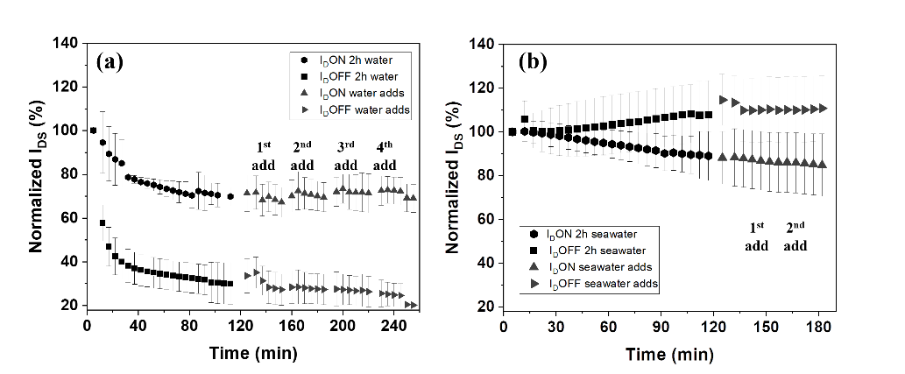
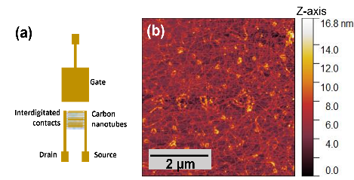
Glass was used as substrate for the devices, the main advantages of this material are the transparency, that could be exploited for optical studies, and the ability to withstand high operating temperatures. EG-FET was the chosen configuration of the device, and a schematic of the design is shown in figure 1a; the three electrodes are in a co-planar configuration. After CNTs spraying, AFM images were taken of the devices; in figure 1c, the network of CNTs is visible; the image was taken on glass part of the interdigitated contacts. It was observed that upon addition of electrolyte (liquid) solution, the EG-FETs were not stable (i.e., I_{DS} measured decreased with time, especially I_{D}ON); a study on their stability was performed, and at first, stability in DI-water was studied. It was noticed that with DI-water, the decrease was of 20% after 22 minutes, almost 1% per minute; then after 70 minutes I_{D}ON presented a good stability, with a small linear decrease of less than 1% every 5 minutes, as presented in figure 2a. Addition of more volume of DI-water did not influence I_{D}ON, which remained stable (total decrease of less than 5%), meaning that a change in volume does not drastically affect the devices. The stability of the devices was studied also in a more complex medium, artificial seawater, which contains salts. In figure 2b, the normalized response of 4 devices is shown; I_{D}ON was stable after about 60 minutes of test (total decrease of 18%, with a decrease of less than 1% every 5 minutes after 60 minutes). A difference with DI-water was the I_{D}OFF, in fact with artificial seawater it increased over time (of 15% at the end of the test), while for DI-water it decreased with time (of almost 70%). Two additions of artificial seawater were done, also in this case I_{D}ON and I_{D}OFF were not affected by the change in volume.
Figure 2: a) DI-water stability test. Normalized response of five devices, I_{D}ON and I_{D}OFF (I_{DS} at V_{GS} -0.8 and 0.4 V, respectively) were normalized against value at time 5 minutes, then average (and standard deviation) is depicted here. b) Artificial seawater stability test. Normalized response of four devices, I_{D}ON and I_{D}OFF (I_{DS} at V_{GS} -0.8 and 0.4 V, respectively) were normalized against value at time 5 minutes, then average (and standard deviation) is depicted here.
Figure 1: a) Schematic of the EG-FET, with gold electrodes (gate, source and drain) in a co-planar configuration. b) AFM image of CNTs network on the interdigitated contacts (glass part).

3.2 Nanoplastics test
To detect NPs in environmental samples, nowadays long and expensive processes are needed, some of the required steps are collection, filtration, optical characterization and identification (using spectroscopic techniques like Raman spectroscopy) (Oliveria and Almeida, 2019). Thus the final goal of the project is to use our developed EG-FET as a fast and reliable sensor for NPs detection. To do so, first the effect that different concentrations of PS- NPs have on the device was studied. After stabilization of the device (92 minutes in DI-water), six concentrations of PS were tested. Transfer curves were taken every 5 minutes and then I_{D}ON and I_{D}OFF were normalized using
equations 3 and 4. In figure 3a, transfer curves of one device are depicted; for clarity, only few time points are shown (5 and 92 minutes for DI-water, 12 minutes for each PS concentration). As expected, I_{D}ON with DI-water after 92 minutes decreased compared to the initial value. Upon addition of PS solution, I_{D}ON was at first stable,
Table 1: Increase (n=5 for DI-water, n=4 for artificial seawater) of I_{D}ON after 12 min of each PS concentration. Increase compared to the final value of I_{D}ON during water stability (92 min). ON/OFF of one representative device (I_{D}ON and I_{D}OFF at time 12 min of each concentration used).
PS concentration | DI-water test |  | Artificial seawater test
 | I_{D}ON increase (%) | ON/OFF | I_{D}ON increase (%) | ON/OFF
0.05 mg/ml | 9.31 (±7.3) | 3.98 | 3.53 (±1.9) | 9.33
0.1 mg/ml | 8.93 (±10.2) | 4.32 | 9.24 (±5.7) | 9.53
0.25 mg/ml | 25.92 (±12.5) | 5.18 | 13.72 (±5.1) | 9.67
0.5 mg/ml | 45.52 (±13.8) | 6.72 | 17.8 (±7.1) | 9.57
1 mg/ml | 66.28 (±16.1) | 7.98 | 20.36 (±9.6) | 9.28
2 mg/ml | 80.40 (±20.4) | 8.80 | 22.80 (±11.3) | 9.04
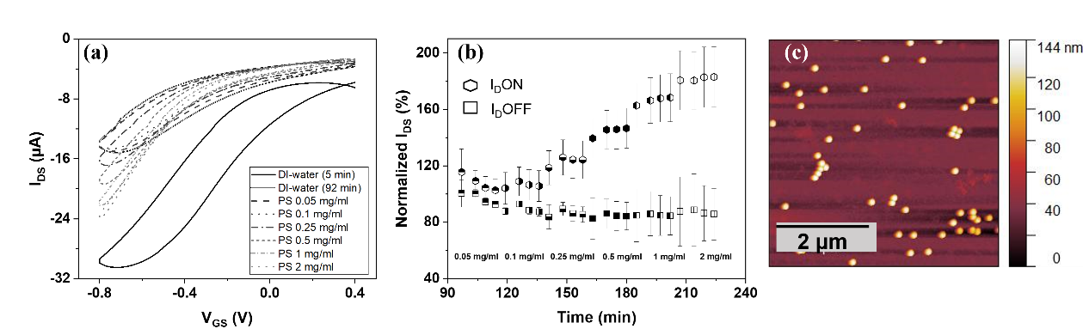and then started to increase with PS concentration 0.25 mg/ml, as it can be seen from the normalized response in
Figure 3: DI-water and PS NPs test. a) Transfer curves of one EG-FET (only few time points are shown) V_{DS} -0.1 V, V_{GS} swept from 0.4 to -0.8 V (backward and forward direction). b) Normalized response of four devices. I_{D}ON (V_{GS} -0.8 V) and I_{D}OFF (V_{GS} 0.4 V) normalized against value at time 92 min of water stability, average (and standard deviation) is depicted here. c) AFM image of interdigitated contacts (glass part) after PS test; NPs can be seen on top of CNTs network.
figure 3b. In table 1, the increase of I_{D}ON at each concentration is summarized. For the first two concentrations, the increase was low (less than 10% ) and the standard deviation was in the same range, because of a high variability between devices. However, from PS 0.25 mg/ml, the increase was more remarked (25.92% ±12.5). With higher concentrations, I_{D}ON showed an increase of 45.52(±13.8)% (0.5 mg/ml), 66.28(±16.1)% (1 mg/ml) and 80.4(±20.4)% (2 mg/ml). The increase of I_{D}ON with increasing PS concentration, could indicate that PS NPs interacted with CNTs. Also, the hysteresis in transfer curves decreased during the test (clearly visible in figure 3a); PS NPs might act as a “passivation layer” (due to its hydrophobicity) and avoid water molecules to penetrate in CNTs network, which is one of the causes of high hysteresis in FETs (Kim et al, 2003). ON/OFF ratios were also compared and in table 1, values of one device are presented; higher PS NPs concentration was influencing the ON/OFF, which increased. For EG-FET with CNTs, ON/OFF values are in the range of 10-10² A/A (Shkodra et al, 2021)), so our devices have comparable values. This parameter is often used in EG-FET based sensors, since it is directly influenced by the presence of the analyte of study. AFM images confirmed that PS NPs were adsorbed on the CNTs network, as shown in figure 3c. In addition, with XPS analysis, a difference in CNTs spectra before and after the test was noticed in the C1s peak. This could indicate a non-covalent interaction between CNTs and PS, possibly a π-π interaction. When artificial seawater was used as electrolyte, a general smaller increase in I_{D}ON was noticed for each PS concentration, this is summarized in table 1. In this case, ON/OFF did not change with time, because also I_{D}OFF increased with time (similar to I_{D}ON). This could be due to the presence of salts, which interfere with the current and the electric double layers, thus mitigating the effect of PS NPs.

3.3 PS-PET comparison
Same concentrations in particles/ml as for PS were tested, however only the three lower concentrations were tested because of low availability of the material. I_{D}ON decreased with increasing concentrations of PET. For the first concentration (9.09*10¹⁰ particles/ml) the decrease was -25.07%(±1.7) after 12 minutes; for concentration 2 (1.82*10¹¹ particles/ml) it was -36.19%(±4.0), for the third concentration (4.55*10¹¹ particles/ml) it was -57.66%(±5.6). This result shows an opposite trend compared to PS NPs (table 1). When artificial seawater (diluted 1:5 in DI-water) was used, the trend was similar, with a smaller total decrease (just like a total smaller increase was noticed with PS). The decrease was -0.97% (±1.39), -5.97%(±5.5) and -24.59%(±3.9) for the three concentrations respectively. AFM images of one device after the test were taken, CNTs network is still clearly visible, however no NPs seem present. This indicates that, probably, there was no interaction between PET NPs and CNTs. This result confirms that CNTs interact with PS NPs, not because of their shape but also because of their chemical structure. This is important for the developed sensor, since one of the most difficult tasks in NPs detection is the chemical identification.

3.4 PS-contaminants complexes
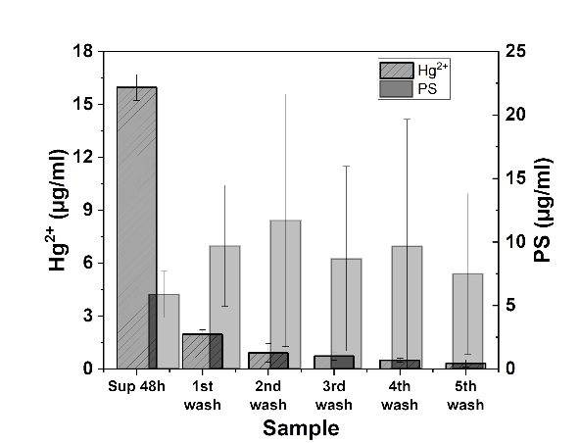
In the environment, NPs interact with other molecules, such as organic and inorganic contaminants, for this reason we wanted to study how PS NPs interacted with known environmental contaminants. First, Hg²⁺ ions solution was tested. Concentration of both Hg²⁺ and PS in each collected supernatant were measured, to assess the amount of Hg²⁺ and PS lost in each washing step, and thus calculate the amount of Hg²⁺ adsorbed on PS NPs; in figure 4 they are shown. It can be seen that after the first centrifugation step (sample sup 48h), ions concentration in the supernatant was high, however in the following washing steps, very little amount of Hg²⁺ was present, meaning that the remaining Hg²⁺ ions were indeed strongly adsorbed by PS. Using equation 5, the binding capacity was measured; three replicates were done and the average binding capacity was 2.04%. To confirm this interaction, XPS analysis was performed on the final solution containing PS-Hg complexes. As expected, Hg4f peak was present in the general XPS survey, along with C1s and O1s peak (which were present also in pure PS solution). Furthermore, in the O1s peak there was an important difference: in pure PS solution, C-O and C=O are the main peaks, while for PS-Hg (both before and after the washing steps) also Hg-O peak is present. This confirms the chemical adsorption of Hg on PS NPs surface. PS-Hg complexes will be tested on EG-FET devices, to compare them with pure PS NPs (some preliminary tests have already been performed, but now shown here). The same test performed with glyphosate, did not produce the same results. In fact, most of the glyphosate was recovered in the supernatant after the first centrifugation step (after 48h of adsorption), meaning that it was not adsorbed on PS surface. To overcome this problem, different test conditions will be tested in the future; changes will include time of incubation, temperature or pH of the solution.
Figure 4: PS-Hg²⁺ adsorption test. Concentrations of both Hg²⁺ and PS measured in the collected supernatants after each washing step.

4 Conclusions and Future Perspectives
We developed an EG-FET device that could be used to study the interaction between PS NPs and CNTs; this interaction led to an increase in the measured I_{DS}. We saw an increase in I_{DS} dependent on the concentration of PS NPs; starting from PS 0.25 mg/ml, a net increase could in fact be seen. A physical interaction was first confirmed by AFM images, where NPs were indeed present on CNTs network. Then a possible non-covalent interaction (thus chemical interaction) between PS and CNTs was hypothesized, after XPS spectra of CNTs before and after test with PS NPs were compared. Furthermore, CNTs did not interact in the same way with another type of NPs, PET; in this case no physical or chemical interaction was observed. Compared to the current detection methods (for NPs), our device is fast, easy to fabricate and less expensive. In addition, the main novelty of our device consists in using EG-FETs as sensor for this specific contaminant; nowadays many EG-FETs are being developed, however not many in the field of environmental monitoring and no EG-FET for NPs detection has been yet developed. However, the developed device cannot be considered specific for the desired analyte yet, which is an important aspect for sensors to be used for environmental monitoring.
Our efforts are now concentrated on using a specific biorecognition element, to be functionalized on the device and that would allow us to obtain specificity and selectivity towards PS. With such a device, studies comparing pure PS NPs solution and PS-contaminants complexes solution will be performed, to assess how the devices interact with different solutions of NPs. Comparing the different solutions could give an indication on how the devices act on environmental samples, which is the final goal. Such a device would improve the current detection methods and especially improve them towards more standardized, fast and easy-to-use methods.

5 References
- Elli, G.; Hamed, S.; Petrelli, M.; Ibba, P.; Ciocca, M.; Lugli, P.; Petti, L. (2022) “Field-Effect Transistor-Based Biosensors for Environmental and Agricultural Monitoring”, Sensors, 22, 4178.
- Kim, W.; Javey, A.; Vermesh, O.; Wang, Q.; Li, Y.; Dai, H., (2003) “Hysteresis caused by water molecules in carbon nanotube field-effect transistors,” Nano Lett, vol. 3, no. 2, pp. 193–198.
- Magrì, D.; Sánchez-Moreno, P.; Caputo, G.; Gatto, F.; Veronesi, M.; Bardi, G.; Catelani, T.; Guarnieri, D.; Athanassiou, A.; Pompa, P.P; Fragouli, D., (2018) “Laser ablation as a versatile tool to mimic polyethylene terephthalate nanoplastic pollutants: Characterization and toxicology assessment,” ACS Nano, vol. 12, no. 8, pp. 7690–7700.
- Oliveira, M.; Almeida, M., (2019) “The why and how of micro(nano)plastic research,” TrAC - Trends Anal Chem, vol. 114, pp. 196–201.
- Shkodra, B.; Petrelli, M.; Costa Angeli, M.A.; Garoli, D.; Nakatsuka, N.; Lugli, P.;Petti, L., (2021) “Electrolyte-gated carbon nanotube field-effect transistor-based biosensors: Principles and applications,” Appl. Phys. Rev., vol. 8, no. 4, p. 041325.
- Shkodra, B.; Petrelli, M.; Costa Angeli, M.A.; Inam, A.S.; Lugli, P.; Petti, L., (2022) “Optimization of the spray-deposited carbon nanotube semiconducting channel for electrolyte-gated field-effect transistor-based biosensing applications,” IEEE Sens J.

