Formulation design strategies to increase the stability, quality and nutritional properties of frozen desserts
Johnny Ciancetta (jciancetta@unite.it)
Dept. of Bioscience and Technology for Food, Agriculture and Environment, University of Teramo, Italy
Tutor: Prof. Paola Pittia
Co-Tutor: Dott. Marco Faieta, dott. Sandro Ferretti

Frozen desserts are complex systems whose quality and stability are highly dependent on their formulation and storage conditions. Product design approaches that consider the effects of the ingredients and related biomolecules on the final product's physical, physicochemical, colloidal and nutritional attributes need to be applied to maintain consumer acceptability.
This PhD project aims to design and develop formulations of frozen dessert-type products with improved quality, stability and nutritional value. The use of ingredients and biomolecules to stabilize the aqueous phase in the frozen state and the development of dairy- and egg-free product formulations are studied. The project is developed taking as a reference the mascarpone-based cream used as the main ingredient in the Italian typical dessert tiramisu.

Strategie di formulazione per migliorare stabilità, qualità e proprietà nutrizionali di semifreddi congelati
I dessert congelati sono sistemi complessi la cui qualità e stabilità dipende dalla formulazione e dalle condizioni di stoccaggio. Per mantenere l’accettabilità del consumatore, è necessario applicare approcci di progettazione della formulazione, che considerino l’effetto di ingredienti e relative biomolecole sugli attributi fisici, fisico-chimici, colloidali e nutrizionali. Questo progetto di dottorato ha l’obiettivodi progettare e sviluppare formulazioni di dessert con maggiore qualità, stabilità e valore nutrizionale. Vengono studiati l'uso di ingredienti e biomolecole per stabilizzare la fase acquosa in stato congelato e lo sviluppo di formulazioni di prodotti senza uova e latticini. Il progetto si sviluppa utilizzando come riferimento la crema a base di mascarpone impiegata come ingrediente principale nel tipico dolce italiano, il tiramisù.

Keywords: frozen dairy desserts, mascarpone, water phase stabilisers, saccharides, colloidal properties, rheology, hydrocolloids

1. Introduction
The PhD project aims to develop new formulations for milk-based frozen dessert products with higher quality, physical stability, and nutritional and health benefits. The project includes the following steps:
T1. Understanding the physical, physicochemical, and colloidal properties of mascarpone and corresponding mascarpone-based dessert custard cream, freshly made and in the frozen state.
T2. Effect of saccharides and hydrocolloids on the quality properties and stability of dairy custard cream in frozen state
T3. Design and development of dairy-free, egg-free custard cream for formulated frozen desserts.

2. Frozen desserts and sugar substitutes
The frozen dessert sector is a niche, but growing, market of the ready-to-eat products with a high level of diversification (e.g., preparations, serving or consumption temperatures, recipes, channels sales) and services,. The production process includes, after formulation, a freezing, or deep-freezing, phase and, for the consumption of some products, defrosting at chilling and/or serving temperature to obtain a soft product. The formulation of these products varies by including ingredients of various nutritional value, nature and type that, overall, contribute from one side to products with high energetic value, and, on the other, to develop simple-to-complex colloidal or dispersed systems, including foams, oil-in water emulsions and weak gels.
Frozen desserts, including ice-creams, are characterised by a stability that depends on the liquid-solid transition of the water of the aqueous phase, the ice crystals formation and the maintenance of temperatures below the freezing point during storage. However, external temperature fluctuations may induce melting and recrystallization, ice crystals size growth, and migrating crystallization along with protein aggregation, creaming or water separation, and solute crystals formation that impair the sensory quality attributes, structural properties and rheology. This occurs in particular when the products are stored at temperatures above the glass transition temperature of the maximally concentrated solution (T’g), i.e. in rubbery state. Formulation and process strategies in frozen products to enhance stability include: i) use of solutes or stabilizers with “water binding capacity” (e.g. saccharides, fibers, hydrocolloid(Tsai et al., 2020; VanWees et al., 2022) s); ii) improvement of the water holding/binding capacity of ingredients by physical technologies (e.g. high dynamic pressure for proteins, ball milling for starch) (Ahmad et al., 2020; Sim et al., 2021).
To enhance both the nutritional value impaired by a composition rich in sugars and lipids and their safety due to allergenic ingredients (eg milk and derivatives, eggs), reformulation strategies with alternative protein sources (e.g. soy, peas) mimicking the functionality of the milk and eggs ones, sugar reduction strategies that could reduce the energy intake while keeping the frozen food stability could be interesting strategies to be investigated. The most applied formulation strategies to reduce the energetic content of frozen desserts is to find sugar replacer able to exhibit the same technological functionalities. In fact, sugars and simple saccharides serve multiple functions in foods beyond its sweetness, by acting as a bulking agent, increasing viscosity, and, thanks to their water binding capacity by reducing the water activity and the amount of freezable water. Inulin (I) is a polysaccharide whose usage in formulated foods has grown in the last years due to its prebiotic function by promoting the beneficial micro-flora in the gut (Van Loo, 2004). Moreover, the short-chain inulin enhances the sweetness of sucrose (De Castro et al., 2009) making it a good sucrose replacer and a low-calorie bulking agent (Shoaib et al., 2016). Maltodextrins (MD), partially hydrolysed starch derivatives are soluble carbohydrates whose functionalities vary significantly depending on the degree of depolymerisation (DE). MD at low DE can form weak gels and are used as texture modifiers and bulking agents replacing fat and sugar, in combination with acaloric sweeteners (Khan et al., 2018). Trehalose (T) is a disaccharide with unique technological molecular and technological functionalities related to its thermo- and cryo-stabilising effects on proteins and other biomolecules, inhibition of lipid oxidation, inhibition of starch retrogradation (Zhang et al., 2017).
The plant-based food industry, in recent years, has seen a quick development branching into almost all the fields of the food market that is progressively investing also the dairy-based frozen desserts (Kyriakopoulou et al., 2021). Increasing are the innovative and alternative products made by plant-based derivatives (e.g. soya derivatives, almond milk, vegetable oils, etc.) that are matching the needs of foods for specific consumers (vegan, lactose-intolerant, etc.) The substitution of animal-origin compounds in food formulations to obtain good products from a nutritional and sensory point of view is still challenging, due to the different characteristics of plant-origin fats and proteins. In the first case, the main feature is related to the quality of the crystals, while in the second, it is a effects of all the functionalities of the molecules in the food matrix (e.g., emulsifying, foaming, gelling ability) (Day et al., 2022).

3. Experimental Procedure
T1: Study of the physical (colour, rheology, dispersed state of the dispersed phase), microstructural and thermal properties of mascarpone cheese (two different commercial products, M1 and M2) and two corresponding custards creams (D1, D2) were made at a laboratory scale according to a standard recipe (mascarpone cheese 61.3%; fresh egg white 17.2 %; fresh egg yolk 9.2 %; sucrose 12.3 %). M samples were analyzed fresh or freshly made (t0) and D samples after 30 days of frozen storage (t30).
T2: Experiments were carried out on a model custard cream made of whole milk, egg yolk, starch, and sucrose prepared by using a Thermomixer, heated at 90°C for 7.5 min (CON). The experimental samples were prepared by substituting 25 %, 50 %, and 75 % sucrose with inulin (I), medium-DE maltodextrin (M), or trehalose (T). Custards were characterised by chemical, physicochemical, physical, and microstructural properties. Samples were analyzed just after preparation and after 30 days of frozen storage (t30). Formulations of the custards are reported in Table 2.
 | Ingredient (% w/w)
 | Whole milk | Rice starch |  | Egg yolk |  | Sucrose |  |  | Trehalose |  | Inulin |  | Maltodextrin
CON | 75 |  | 4 |  | 7.5 |  | 13.5 | 0 |  | 0 |  | 0
I03 | 75 |  | 4 |  | 7.5 |  | 10.13 | 0 |  | 3.37 |  | 0
I06 | 75 |  | 4 |  | 7.5 |  | 6.75 | 0 |  | 6.75 |  | 0
I10 | 75 |  | 4 |  | 7.5 |  | 3.37 | 0 |  | 10.13 |  | 0
M03 | 75 |  | 4 |  | 7.5 |  | 10.13 | 0 |  | 0 |  | 3.37
M06 | 75 |  | 4 |  | 7.5 |  | 6.75 | 0 |  | 0 |  | 6.75
M10 | 75 |  | 4 |  | 7.5 |  | 3.37 | 0 |  | 0 |  | 10.13
T03 | 75 |  | 4 |  | 7.5 |  | 10.13 | 3.37 |  | 0 |  | 0
T06 | 75 |  | 4 |  | 7.5 |  | 6.75 | 6.75 |  | 0 |  | 0
T10 | 75 |  | 4 |  | 7.5 |  | 3.37 | 10.13 |  | 0 |  | 0

Table 1 Formulation of custard model samples: control (CON), and Inulin (I), Maltodextrins (M), and Trehalose (T) at different degrees of sugar substitution, 03 (25%), 06 (50%), 10 (75%)

T3: The model cream custard (see T2) was used as control to design and formulate a plant-based model, in which milk and egg yolk are substituted by coconut oil and plant-based proteins.

4. Methodologies
The moisture content was determined by gravimetric method; pH and a_{w} by a 3510 Jenway pH meter and an Aqua Lab 4TE a_{w}-meter, respectively. Colour was analysed with a colorimeter (CR-5 Konica Minolta) by using the CIE-LAB space: L*, a* and b* parameters were considered and used to determine the C*, and h° parameters, the ΔE and the Yellow Index (YI). Differential Scanning Calorimetry (Perkin Elmer DSC 8500) was applied () to determine thermal properties including: T’g, ice and fat melting, with temperature scans and annealing approaches in the temperature range from -80°C and 70°C (10°C/min). Rheological analyses (Anton Paar MCR 302) were performed and oscillatory test (frequency strain, frequency sweep, 0.1 to 10Hz) and flow behaviour (from 0.1 to 100s⁻¹) were carried out. Confocal laser scanning microscopy (CLSM) was used to evaluate microstructure, utilising Nile red and Fast Green FCF for fats and protein staining, respectively. Along with microscopy, dispersed state (fat particle size and distribution curves) was evaluated (Mastersizer Hydro 3000, Malvern instruments); the refractive index was 1.46 (Ningtyas et al., 2019).

5. Results and Discussion

5.1 T1 Characterisation of physico-chemical, microstructural and rheological properties of mascarpone and corresponding custard dessert creams and stability over frozen state
M1 and M2 samples presented significant differences in moisture, physicochemical and rheological properties, index of two different process conditions used for their production; these properties affected also those of the corresponding dairy dessert creams (D1, D2, respectively) (Ciancetta et al., 2022). In particular the rheological properties of the D1 and D2 were significant lower G’ in respect to the corresponding M1 and M2 due to the effect of the other ingredients while tanδ resulted the same for D1 and D2(data not shown). By thermal analysis the first- (fat crystallization and melting, water solid-liquid transition) and second-order (glass transition temperatures Tg and T’g) of the M and D samples were studied. A single fat crystallization peak and two melting peaks were observed; differences were observed only in the enthalpy between the M and D samples but no within each product type. D samples showed a significant increase of the glass transition onset temperature (Tg), along with a significant decrease of the freezable water content due to the effects of the solutes. The size of the fat globules of M samples was similar with D[4,3] values lower than 10µm when dissolved in SDS solution. The D[4,3] values of the D1 and D2 were significantly higher than the corresponding mascarpone samples due to the presence of egg’s fats, with a flocculation index higher than 50% (higher for D1).
Freezing and frozen state (for 30 days) affected the rheological properties of both D samples with a decrease in tanδ values after 30 days of frozen storage for both samples even if of different entity, likely due to protein aggregation and degradation induced by the frozen state No significant differences on the particle size distribution and DSC analysis were observed. By CLSM images it is possible to notice a clear difference in the microstructure of M samples: M1 shows very lower and spread fat particles, while in M2 they seem to be more aggregated. Moreover, D samples’ fat dispersion is in line with the related Mascarpone cheese, with D1 showing an overall lower dimension and higher dispersion. The protein structure seems to be different, since in M samples blocks of protein and fat structures are shown, while in D samples it is also possible to notice zones in which the 2 molecules are separated.

5.2 T2. Effect of saccharides and hydrocolloids on the quality properties and stability of dairy custard cream in frozen state

5.2.1 Chemical and physico-chemical properties
Overall, control and experimental samples made with different content of inulin, trehalose, and maltodextrins didn’t show significant moisture content difference, ranging from 69.12±0.1 for the T03 sample and 70.35±0.01 for the M10 sample while a significant, while limited, increase of pH was observed, from 6.44±0.01 (C) to 6.54±0.01 (I), 6.66±0.01 (M) and 6.69±0.01 (T). a_{w} values didn’t show meaningful changes with respect to the C sample, even if the substitution of S with M at the highest ratio (75%) caused an increase of the a_{w} due to the lower binding capacity of this component with respect to sucrose.

5.2.2 Colour
All the experimental samples showed, in respect to the control one, an increase of L* and hue angle, h,° along with a decrease of C* (data not shown) and YI with an effect non-concentration dependent.
Overall, due to the different L* and chromatic parameters values, a colour change, computed as ΔE higher than 3.0, reaching values higher than 5 for M and T samples was observed; these result indicates the possibility for a consumer to perceive the difference at sight. Colour is resulting from various compositional, physicochemical and structural factors that affect light reflectance onto the sample surface and, thus, the observed differences may reflect the properties of the matrix induced by the different saccharides.

5.2.3 Thermal properties
Thermal analysis was used to determine the effect of the different sucrose-substitutes on thermal properties, i.e., T’g, and ice melting enthalpy (Figure 1). The CON sample showed a T’g equal to -33°C, and the substitution of sucrose with the alternative saccharides determined an increase of the Tg_{onset} , mainly for M samples, reaching ca. -21°C in the case of 75% of sucrose substitution; At the highest concentrations, both I and M samples showed an increase of ice melting onset temperature, while no significant differences were seen for T samples. The enthalpy of the ice melting (ΔH) resulted to increase in the M samples in respect to CON with a concentration-dependence, due to the lower binding capacity in respect to sucrose, while the opposite has been determined in the T samples. I sample don’t show a concentration-dependent trend and the decrease is similar for all concentrations tested.
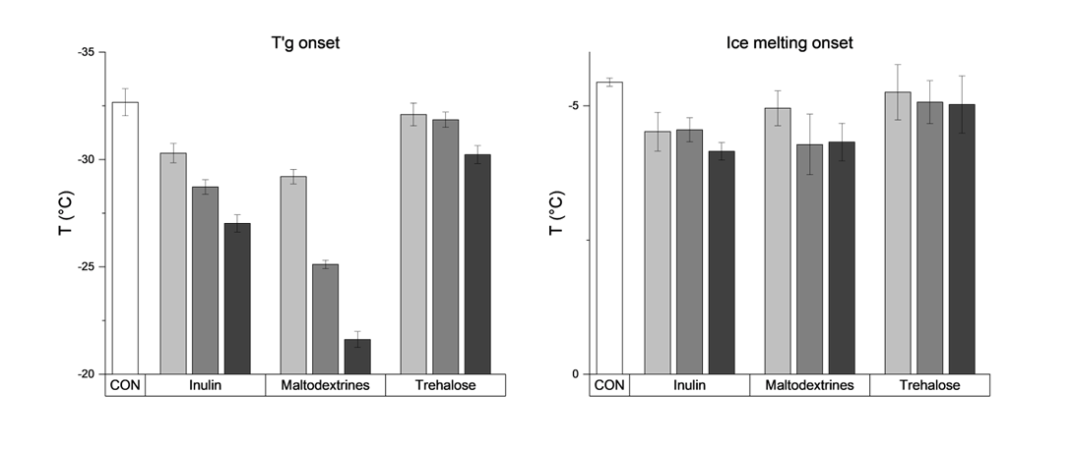
Figure 1 Onset temperatures of T’g and ice melting of control (white) and I, M, and T samples (grey) at 25% (light grey), 50% (medium grey), and 75% (dark grey) sucrose substitution.

5.2.4 Rheology
The substitution of sucrose with I, M and T effected the rheology of the experimental custard cream samples. In particular, I caused a significant decrease of the loss modulus (G’) with a correspondent increase of the G’’ that determined a significant increase of tanδ (Figure 4). An opposite effect was determined by M and T with an increase of G’ concentration-dependent effect but overall the tanδ did not change significantly due to an opposite effect on G’’. The effect of the sucrose substitutes on the rheology of the custards could be referred to various factors including the different water binding capacity (see Figure 2), and/or interactions between the different solutes in the system and/or competitive effects during the formation of the structure. The apparent viscosity values are in line with G’ ones, and a very similar trend can be seen. Moreover, from Herschel-Barkley regression, it is possible to notice an increase of n value for I samples, while for M samples an initial increase is seen at 25% substitution, while at 75% substitution a significant decrease is shown.
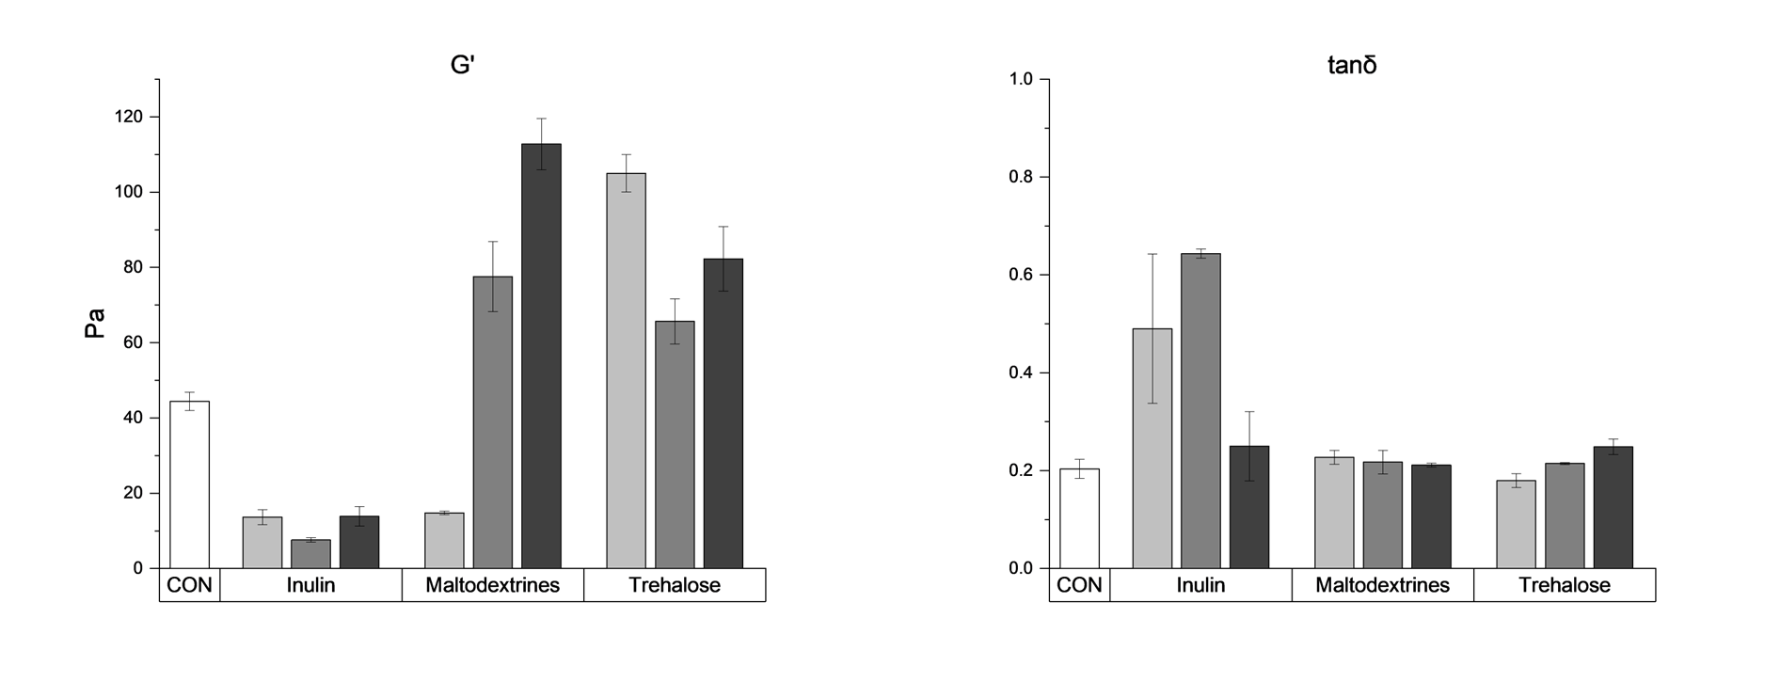
Figure 2 G’ and tanδ values of control (white) and I, M, and T samples (grey) at 25% (light grey), 50% (medium grey), and 75% (dark grey) sucrose substitution.

5.2.5 Dispersion state
The particle size analysis was affected by the sucrose substitution with effects due to the saccharide type and its concentration. In all cases the D[4,3] values were higher with respect to CON (data not shown), with minor variations only in the case of the T samples. On the contrary, for M and I samples the D[4,3] values showed a significant increase, with an effect of the % of sucrose substitution, being higher for the higher concentrations of the polysaccharides present in the formulations . In particular, for I samples values ranged from 100% to 150% increase, for M ones from 50% to 150%, and for T samples from 50% to 80%. These results reflect the different distribution curve of the CON and experimental samples. CON exhibited a bi-modal curve, showing two peaks of µ1 and µ10 order. For T samples a decrease of the 1µm peak was seen, while for M and I samples the higher increase of D[4,3] values is related to the appearance of a second shoulder or peak, seen at the highest % of sucrose substitution at ca. 100µm order.
5.2.6 Effect of frozen storage
No significant differences have been seen for all the parameters considered, but the rheological properties with differences depending on the saccharide type and % of sugar substitution: M samples showed a significant (p<0.05) decrease of G’ with respect to corresponding fresh samples and the effect was related to the degree of substitution. T resulted to protect the matrix after thawing since no weakening was seen at 50% and 75% substitution, while a clear weakening was showed at 25% substitution. Eventually, I samples were not analysed due to the very high degree of syneresis.
5.3 Design and development of dairy-free, egg-free custard cream for formulated frozen desserts
Starting from a typical custard-like matrix as a control sample, a formulation design approach has been developed in order to substitute animal-origin ingredients with plant-based fats (coconut oil) and proteins. Preliminary experiments showed that the type and the concentration of protein in the matrix highly affect the viscoelastic characteristics of the samples (data not reported). The dispersion degree of the lipidic phase, despite the different types of fat used (coconut oil), didn’t show significant differences, while at the highest concentrations of proteins, it is possible to see an increase in D[4,3] values.

6. Conclusions and Future Perspectives
T1 This research step allowed to assess the influence of Mascarpone cheese on the structure of the dairy-based custard cream, showing a strong influence on the dispersion state and rheological characteristics. On the contrary, the formulation and in particular the sugar affected the thermal properties of the aqueous phase (water crystallization and melting behaviour, T’g).
T2 The role of sugar in the physical, rheological and thermal properties of the custard matrix and was evaluated along with the effects of sucrose-substitutes with different molecular and technological functionalities. In the freshly made products, Maltodextrin and Trehalose determined an increase of the viscosity and G’ that was not preserved after freezing and frozen storage in both cases, despite their different ability to affect the bind water and affect the mobility of the water phase.
Further studies are necessary to unravel the factors that could contribute to improve the stability of fresh and frozen desserts, also by to use of stabilisers (e.g. hydrocolloids) and/or innovative saccharides (e.g. modified starches).

7. Acknowledgments

The author acknowledges “PON RI 2014-20,” azione 1.1 “Dottorati innovativi con caratterizzazione industriale,” A.Y. 2020-21, XXXVI Cycle, for the PhD project grant.The author acknowledges “PON RI 2014-20,” azione 1.1 “Dottorati innovativi con caratterizzazione

8. References
Ahmad, M., Gani, A., Masoodi, F.A., Rizvi, S.H., 2020. Influence of ball milling on the production of starch nanoparticles and its effect on structural, thermal and functional properties. Int J Biol Macromol 151. https://doi.org/10.1016/j.ijbiomac.2020.02.139
Ciancetta, J., Faieta, M., Pittia, P., 2022. Physical, and microstructural properties of dairy dessert creams: effect of composition and frozen storage. Proceedings of the 26th Workshop on the Developments in the
Italian PhD Research on Food Science, Technology and Biotechnology, Università degli Studi di Torino – Asti. Asti: pp. 222-223.
Day, L., Cakebread, J.A., Loveday, S.M., 2022. Food proteins from animals and plants: Differences in the nutritional and functional properties. Trends Food Sci Technol. https://doi.org/10.1016/j.tifs.2021.12.020
De Castro, F.P., Cunha, T.M., Barreto, P.L.M., Amboni, R.D.D.M.C., Prudêncio, E.S., 2009. Effect of oligofructose incorporation on the properties of fermented probiotic lactic beverages. Int J Dairy Technol 62. https://doi.org/10.1111/j.1471-0307.2008.00447.x
Khan, S., Rustagi, S., Choudhary, S., Pandey, A., Khan, Mohd.K., Kumari, A., Singh, A., 2018. Sucralose and maltodextrin-An altrernative to low fat sugar free ice-cream. Biosci Biotechnol Res Commun 11. https://doi.org/10.21786/bbrc/11.1/19
Kyriakopoulou, K., Keppler, J.K., Van Der Goot, A.J., Boom, R.M., 2021. Alternatives to Meat and Dairy. Annu Rev Food Sci Technol 12. https://doi.org/10.1146/annurev-food-062520-101850
Ningtyas, D.W., Bhandari, B., Bansal, N., Prakash, S., 2019. Sequential aspects of cream cheese texture perception using temporal dominance of sensations (TDS) tool and its relation with flow and lubrication behaviour. Food Research International 120. https://doi.org/10.1016/j.foodres.2018.11.009
Shoaib, M., Shehzad, A., Omar, M., Rakha, A., Raza, H., Sharif, H.R., Shakeel, A., Ansari, A., Niazi, S., 2016. Inulin: Properties, health benefits and food applications. Carbohydr Polym. https://doi.org/10.1016/j.carbpol.2016.04.020
Sim, J.Y., Enteshari, M., Rathnakumar, K., Martínez-Monteagudo, S.I., 2021. Hydrodynamic cavitation: Process opportunities for ice-cream formulations. Innovative Food Science and Emerging Technologies 70. https://doi.org/10.1016/j.ifset.2021.102675
Tsai, S.Y., Tsay, G.J., Li, C.Y., Hung, Y.T., Lin, C.P., 2020. Assessment of melting kinetics of sugar-reduced silver ear mushroom ice cream under various additive models. Applied Sciences (Switzerland) 10. https://doi.org/10.3390/APP10082664
Van Loo, J.A.E., 2004. Prebiotics promote good health: the basis, the potential, and the emerging evidence. J Clin Gastroenterol. https://doi.org/10.1097/01.mcg.0000128928.99037.e6
VanWees, S.R., Rankin, S.A., Hartel, R.W., 2022. Shrinkage in frozen desserts. Compr Rev Food Sci Food Saf. https://doi.org/10.1111/1541-4337.12888
Zhang, B., Wu, H. xiao, Yang, H. cheng, Xiang, X. wei, Li, H. bo, Deng, S. gui, 2017. Cryoprotective roles of trehalose and alginate oligosaccharides during frozen storage of peeled shrimp (Litopenaeus vannamei). Food Chem 228. https://doi.org/10.1016/j.foodchem.2017.01.124

