Eco-design tools development for sustainability optimization in food production systems
Andrea Casson (andrea.casson@unimi.it)
Department of Agricultural and Environmental Sciences, Via Celoria, 2 Milano (Italy),
Tutor: Prof. Riccardo Guidetti; Co-tutor: Prof.ssa Sara Limbo; Industrial tutor: Anna Bortoluzzi

This PhD project aims to develop eco-design tools based on Life Cycle Assessment (LCA) methodology to provide food systems with a reliable resource when moving towards sustainability. The project aims to identify the most appropriate models to accurately assess the eco-profile of selected food products, processes or systems and to provide a user-friendly and strategic decision-making tool for businesses.

Sviluppo di strumenti di eco-design per l'ottimizzazione della sostenibilità nei sistemi di produzione alimentare
Questo progetto di dottorato mira a sviluppare strumenti di eco-design basati sulla metodologia Life Cycle Assessment (LCA) per fornire ai sistemi alimentari una risorsa affidabile nel passaggio verso la sostenibilità. Il progetto mira a identificare i modelli più appropriati per valutare accuratamente l'eco-profilo di prodotti, processi e sistemi alimentari e fornire uno strumento decisionale strategico e di facile utilizzo per le imprese.

Key words: Eco-design, Life Cycle Assessment (LCA), sustainability, eco-profile, decision-making tool.

1. Introduction
The agri-food system has been identified as a significant contributor to environmental impacts, as highlighted in the United Nations Sustainable Development Report (2019). In recent years, there has been a notable increase in the importance of environmental sustainability as a critical factor affecting business performance (Bernal Torres et al., 2021; Adams et al., 2021). Both policymakers and consumers are putting increasing pressure on companies to prioritise environmental friendliness, not only within their internal processes but also across their entire value chain, including customers and suppliers (Mata et al., 2012). Environmental sustainability goals often influence product development and business decisions, but the production process is rarely optimised to address these concerns (Linnemann et al., 2006). To answer this need, different solutions based on the Life Cycle Management (LCM) method to guide companies in measuring sustainability are increasing.

2. Materials and Methods
As a first part of this PhD project, a systematic review (Casson et al., 2023) was conducted to assess the available simplified tools in the agri-food sector. The aim of the review was to provide a comprehensive analysis of environmental sustainability tools used in the agri-food chain for both academic and business communities. The focus was on simplified environmental impact tools and calculators applicable to agriculture, food processing and the wider agri-food system. The review identified quality parameters and carried out the multivariate analysis, which allowed differentiation between the 79 tools examined.
Based on the findings of the review, an eco-design tool was developed in collaboration with the research and development team of a nutraceutical company based in Lombardy (Italy). The development of all data sets started with a study of all raw materials used by the company, reviewing all production flowsheets and raw material emission models for all raw materials and the associated direct emissions from ingredient formulation. The obtained datasets were then incorporated into the tool as a library source of primary data. The tool has been developed using a cradle-to-gate approach, which allows the life cycle of the intended product (1 package of the finished product) to be studied, from the extraction of raw materials to the finished product being packaged and ready for shipment.

3. Results and Discussion

3.1 Systematic review findings
The systematic review results highlighted a clear separation between the simpler tools, characterised by high usability, low data entry requirements and accessibility, and the more complex tools, characterised by transparency and presentation of results.
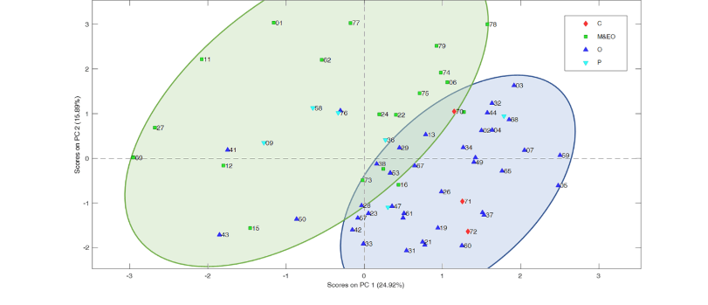
PCA was used to analyse the influence of quality parameters on simplified environmental impact tools and to generate a scores plot representing the current scenario. The plot showed two clusters: tools for operators and consumers, represented by blue triangles and red diamonds, were located within the blue circle, while tools for managers and policymakers, represented by green squares and light blue triangles, were located further away within the green circle. Although the first two components (PC1 and PC2) explained about 40% of the total variability, the different clusters indicated different user requirements and levels of complexity within the simplified environmental impact tools tool system.
Figure 1 Scores plot highlighting tools grouped by potential users.
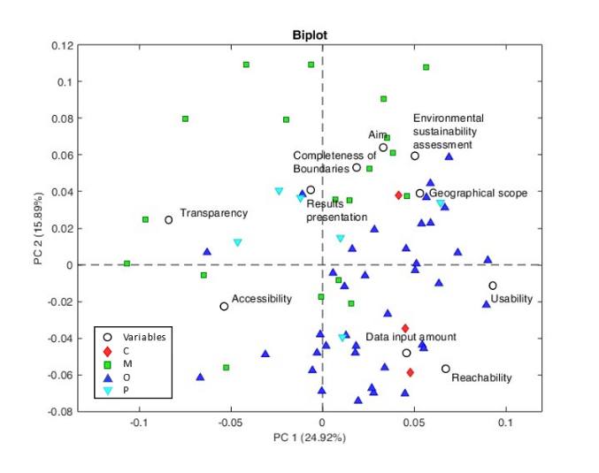
A biplot analysis was performed to assess the significance of the different factors among the analysed tools, taking into account their multivariate nature. Figure 2 shows the PCA biplot generated from the same data set as the score plot in Figure 1. The biplot shows the samples coloured according to their intended user categories, including consumers, operators, managers, environmental offices and policymakers. It highlights the key quality parameters that differentiate tools based on their intended users. Tools designed for simplicity (shown as blue triangles) have high usability, low data entry requirements and are accessible to a wider range of users. Notably, transparency and accessibility are positioned opposite each other at the intersection of the axes, representing the characteristics of tools intended for more experienced users, located in the upper left-hand section with negative values of PC1 and positive values of PC2.
Figure 2 Biplot deriving from PCA, showing tools and quality parameters.

3.2 Development of LCA tool for Ecodesign
Based on the results of the review, a TaylorMade environmental impact tool, called MAPPER, has been developed following the reference Product Category Rules (PCR) guidelines. The LCA model was built without the approximations typical of the simplified eco-design tools, allowing for more accurate and certifiable environmental footprints of products without significant changes to the calculation model. The obtained tool incorporates convenient accessibility, achieves the organisational objective and demonstrates relevance to the intended application. It has minimal data entry requirements and uses a transparent computational framework based on recognised patterns that suggest different impact categories. The MAPPER can help to reduce the time and effort required to perform environmental assessments, allowing Research and Development department, designers, and engineers to quickly evaluate different ingredient options and identify areas for improvement. This can lead to more efficient and sustainable product choices, ultimately reducing the environmental footprint of products and processes.

4. References
Adams D, Donovan J, & Topple C (2021) Achieving sustainability in food manufacturing operations and their supply chains: Key insights from a systematic literature review. Sustainable Production and Consumption, 28, 1491-1499.
Bernal Torres C A, Paipa Galeano L, Jarrah Nezhad Y, Agudelo Otálora L M, & Millán J (2021) Continuous improvement and business sustainability in companies of an emerging market: Empirical analysis Journal of Industrial Engineering and Management, 14(4), 771-787.).
Casson A, Zambelli M, Giovenzana V, Tugnolo A, Pampuri A, Vignati S, ... & Guidetti R (2023) Simplified environmental impact tools for agri-food system: A systematic review on trends and future prospective. Environmental Impact Assessment Review, 102, 107175.
Linnemann A R, Benner M, Verkerk R, & van Boekel M A (2006) Consumer-driven food product development Trends in Food Science & Technology, 17(4), 184-190.
Mata T M, Martins A A, Neto B, Martins M L, Romualdo S, & Costa C (2012) LCA tool for sustainability evaluations in the pharmaceutical industry Chemical Engineering Transaction, 26.).
UN Sustainable Development Report 2019. https://sdgindex.org/reports/sustainable-development-report-2019/

