PhD DISSERTATION PROJECTS

Smart solution for crop production exposed to biotic and abiotic stresses

Valerio Mattei (valerio.mattei@unimi.it)
Department of Food, Environmental and Nutritional Sciences (DeFENS), Università degli Studi di Milano,
Via Celoria 2, Milano (MI), Italy
Tutor: Prof Matias Pasquali
Co-Tutor: Prof Antonio Ferrante

This PhD thesis research project is aimed at testing the use of Streptomyces as biostimulants, first in the growth chamber and then in the greenhouse, on plants under water stress conditions to investigate their mode of action, through -omics approaches and non-destructive tools, which assess the health status of the plant, in order to obtain a product that can be applied in the open field and that guarantees production even in arid climates.

Nuove soluzioni per la produzione di colture esposte a stress biotici e abiotici

Questo progetto di tesi di dottorato mira a testare l’utilizzo degli streptomiceti come biostimolanti, prima in camera di crescita e poi in serra, su piante in condizioni di stress idrico a investigarne il modo di azione, tramite approcci -omici e strumenti non distruttivi, che valutano lo stato di salute della pianta, al fine di ottenere un prodotto che possa essere applicato in campo aperto e che garantisca la produzione anche in climi aridi.

1. State-of-the-Art
Global agriculture is facing numerous challenges due to increasing demand for food and plant-based ecosystem services, driven by a predicted population growth from 7.7 billion to 9.7 billion by 2050. This necessitates sustainable agricultural practices to meet future food production goals (Camaille et al., 2021). Climate change, particularly the occurrence of drought, has a detrimental impact on crop productivity and is expected to worsen due to reduced soil water levels caused by increased temperatures (Camaille et al., 2021). Drought is a major abiotic factor limiting global crop productivity (Fahad et al., 2017), making it a crucial target of plant research. The ultimate objective is to develop crop plants with improved water use efficiency to minimize drought-induced yield losses and mitigate the threat of food scarcity (Mishra et al., 2012). Drought stress tolerance not only improves productivity on currently cultivated land but also allows the exploitation of cultivable land with limited water supplies. Plants employ various strategies to cope with drought, including maintaining high water status through efficient water absorption or reducing evo-transpiration. Drought-tolerant plants maintain turgor and metabolic activity even at low water potential through mechanisms like protoplasmic tolerance and synthesis of osmoprotectants (Mishra et al., 2012). Stomatal closure, mediated by abscisic acid (ABA), is triggered during drought stress to reduce water loss. However, closed stomata also decrease CO2 supply, leading to reduced photosynthetic activity and hindered plant growth. Drought-induced alterations in physiology, growth, metabolism, and production vary with the level of plant tolerance. Osmotic adjustment, a mechanism involving the accumulation of osmolytes like proline to stabilize and protect subcellular structures against oxidative damage. (Patanè et al., 2016). To ensure sustainable agriculture, the use of soil microorganisms, particularly plant growth-promoting rhizobacteria (PGPR), has gained attention. PGPRs not only promote plant growth but also have the potential to alleviate abiotic stress. Recent years have witnessed significant advancements in understanding the mechanisms of action of PGPRs. Thus, the use of PGPRs in agriculture is seen as a promising solution to enhance productivity and tolerance to both biotic and abiotic stresses. Endophytic actinobacteria have been shown to be able to adjust to both abiotic and biotic stresses (Mattei et al., 2022; Sathya et al., 2017; Yandigeri et al., 2012;), but no studies have been done on how they affect photosynthetic parameters (Passari et al., 2019).

Thus, this PhD project aims to study the plant-bacteria interaction under drought stress conditions using advanced non-destructive physiological methods and omics technologies. The goal is to correlate plant phenotype with molecular data to gain a comprehensive understanding of the interaction between the plant and PGPRs and how the plant physiological parameters can be related to this interaction. Moreover, by analysing the molecules and biosynthetic pathways involved in the system, Streptomyces can be exploited as a tool to ensure crop productivity in challenging environmental conditions.

2. PhD Thesis Objectives and Milestones
Within the overall objective mentioned above this PhD thesis project can be subdivided into the following activities according to the Gantt diagram given in Table 1:
WP1: Cultivation and selection of Streptomyces and seed coating of plant seeds. Plants are going to be grown in growth chambers, to further run multi-omics analyses. Moreover, drought stress is going to be imposed during the green house tests and assessed by non-destructive tools. These tools are going to be used even for measuring Streptomyces effects in-planta by comparison of data collected from control plants (non-stressed).
In parallel, genomic analysis of Streptomyces and comparative genomic analysis can be used to build a valuable database to be used for the following omics studies.

WP2: Transcriptomics: Analysis of the expression of BCGs which can be involved the bacteria-plant interaction. At
least 4 time points linked to the different stages of the interaction will be investigated. Identification similarities and
differences at the transcriptome level during the interaction will be obtained by careful definition of key points to perform RNA studies at the appropriate key steps in the PGP interactions. Diversity in gene expression will be linked to possible specific interactions within the system.
Deliverables: Transcriptomic analysis of the crosstalk occurring in the system (Streptomyces – plant) and set of specific
BCGs active in the PGPR process.
WP3: Proteomics: to investigate the relationship between the metabolic pathways and the natural products production. Proteomics gives information on differential pathways regulation, identifying major participants in natural product biosynthesis that can be exploited as targets for rational engineering, by comparing protein expression levels in different conditions.
Deliverables: strain characterization by linking natural products to specific gene clusters.
WP4: Metabolomics analyses to investigate the response to biological stimuli of secondary metabolite producing strain.
Measurement of the global levels of low molecular weight metabolites to obtain a metabolic comparison of the different
biological samples without any chemical redundancy, to identify secondary metabolites from silent BCGs.
Deliverables: fully characterized crosstalk in the PGP-plant interaction system.
WP 5,6,7: Field Trials and Hypothesis validation: The last working point will be the definition and the validation of the model in order to finally understand how the interactions occurs and which mechanisms are involved in the PGP interaction. Furthermore, the aim is to understand how Streptomyces stimulate the plant plant growth counteracting the drought stress by ensuring fruit production.
WP8: Writing and Editing of the PhD thesis, scientific papers and oral and/or poster communications.
Table 1 Gantt diagram for this PhD thesis project.
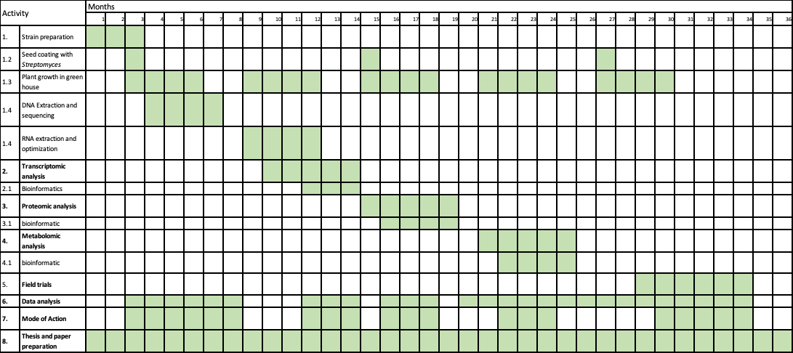

3. Selected References
Camaille, M. et al. (2021) ‘Advances in Wheat Physiology in Response to Drought and the Role of Plant Growth Promoting Rhizobacteria to Trigger Drought Tolerance’, Microorganisms, 9(4), p. 687. Available at: https://doi.org/10.3390/microorganisms9040687.
Fahad, S. et al. (2017) ‘Crop Production under Drought and Heat Stress: Plant Responses and Management Options’, Frontiers in Plant Science, 8. Available at: https://www.frontiersin.org/articles/10.3389/fpls.2017.01147 (Accessed: 3 June 2023).
Mattei, V. et al. (2022) ‘Wheat Seed Coating with Streptomyces sp. Strain DEF39 Spores Protects against Fusarium Head Blight’, p. 10.
Mishra, K.B. et al. (2012) ‘Engineered drought tolerance in tomato plants is reflected in chlorophyll fluorescence emission’, Plant Science, 182, pp. 79–86. Available at: https://doi.org/10.1016/j.plantsci.2011.03.022.
Passari, A.K. et al. (2019) ‘Enhancement of disease resistance, growth potential, and photosynthesis in tomato (Solanum lycopersicum) by inoculation with an endophytic actinobacterium, Streptomyces thermocarboxydus strain BPSAC147’, PLOS ONE, 14(7), p. e0219014. Available at: https://doi.org/10.1371/journal.pone.0219014.
Patanè, C. et al. (2016) ‘Physiological screening for drought tolerance in Mediterranean long-storage tomato’, Plant Science, 249, pp. 25–34. Available at: https://doi.org/10.1016/j.plantsci.2016.05.006.
Yandigeri, M.S. et al. (2012) ‘Drought-tolerant endophytic actinobacteria promote growth of wheat (Triticum aestivum) under water stress conditions’, Plant Growth Regulation, 68(3), pp. 411–420. Available at: https://doi.org/10.1007/s10725-012-9730-2.

