Fusarium musae, a potential new food safety threat. Can a diseased banana be the source of a fungal disease for humans?
Valeria Tava (valeria.tava@unimi.it)
Home institution: Dept. of Food, Environmental and Nutritional Sciences, University of Milan, Milan, Italy
Tutor: Prof. Matias Pasquali (matias.pasquali@unimi.it)
Host institution: Dept. of Imaging and Pathology, KU Leuven, Leuven, Belgium
Tutor: Prof. Greetje Vande Velde (greetje.vandevelde@kuleuven.be)
This PhD thesis dealt with the assessment of a comprehensive analysis of a cross-kingdom pathogen such as Fusarium musae by combining studies within different disciplinary field. This research project aims at characterising F. musae to document the diversity of the species, to better understand its mechanisms of infection and its ability to be transmitted from banana to humans.

Fusarium musae, una nuova potenziale minaccia per la sicurezza alimentare. Può una banana malata essere fonte di malattia fungina per l’uomo?
Questa tesi di dottorato riguarda lo sviluppo di un’analisi completa di un patogeno cross-kingdom come Fusarium musae combinando conoscenze in campi disciplinari diversi. Questo progetto di ricerca mira a caratterizzare F. musae documentando la diversità della specie, ad avere una visione più completa sui suoi meccanismi di infezione e la capacità di essere trasmessa da banana a uomo.

Key words: fungal characterization; infection mechanisms; fungal transformation; Fusarium musae.

1. Introduction
In accordance with the PhD thesis project previously described (Tava, 2021), this oral communication reports the main results of the following four activities directed to:
A1) characterise F. musae by testing its sensitivity to different azoles used in clinical and agricultural fields. We collected 18 strains of F. musae isolated worldwide from both banana fruits and human patients, eight DMIs used in crop protection and five medical antifungals were tested against the entire collection;
A2) genomics analysis of the entire collection of F. musae strains to study fungal diversity in relation to geographical and host origin. I obtained the first genome of F. musae complete at chromosomal level, whole genome of reference strains isolated one from banana fruits and one from human infection were analysed and compared. Mitogenomes of the entire population were assembled and comparatively analysed;
A3) proof experimentally for the first time the ability of F. musae to cause infection in both animal and plant kingdoms by building two infection models for banana fruits and Galleria mellonella (chose as “human proxy”) that could be representative of the infection;
A4) construction of fluorescent reporter strains to be used for host-pathogen interaction studies. Representative strains of F. musae were transformed and fluorescent strains were obtained for in vivo imaging of the infection in the two infection models established as described in A3.

2. Material and Methods
(A1) All molecules were prepared at final concentrations ranging from 0,03 to 16 mg/L according to the Clinical and Laboratory Standards Institute guidelines for filamentous fungi (Reference CLSI M38-A2). Inoculum suspensions were prepared from 2–5-day-old cultures diluting to a final working inoculum of 0,5–5 × 10⁴ CFU/mL. Plates were incubated at 28°C for 48 h. The minimum inhibitory concentration (MIC) value was the concentration of drug yielding no fungal growth at visual reading. Tests were performed in duplicate.
(A2) DNA used for sequencing was obtained from fresh mycelia of 17 strains according to a modified CTAB method (Pasquali et al., 2004), followed by Genomic tips column purification (Qiagen, Germantown, MD, USA). Sequencing was carried out using Illumina Hiseq 2000 (151 bp x2) by Novogene (Cambridge, UK). Mitogenomes of NRRL25059 strain was obtained from the NCBI database. Assembly was carried out de novo with NOVOplasty 4.2. Mitogenomes were then annotated by integrating MFannot and RNAWeasel. Sequences were then aligned using the MAFFT alignment tool using Geneious prime software and manually checked and analyzed using Median Joining Network in PopArt (Degradi et al., 2022).
Complete genome of one representative strain was obtained by combining Illumina with long-read sequencing using the MinION MIN101B platform, R9.4.1 flow cell (Nanopore). Assembly was performed using Canu v.2.1.1 + galaxy0. Autopolishing was performed using Medaka v.1.0.3 + galaxy2. Minimap2 v.2.17 + galaxy4 was used to align short reads on the obtained assembly. Manual correction was done using Geneious Prime software v.11 (Biomatters) and final assembly statistics were evaluated using Quast tool v.5.0.2 + galaxy1 (Degradi et al., 2021).
(A3) For infection of both banana fruits and G. mellonella, strains were grown in CMC liquid medium, spores were harvested after 5 days by filtering through one-fold miracloth and counted with Burker count chamber. Appropriate dilutions were made to obtain the required concentration of 10^5 spores/ml.
Bananas were sterilized by immersion in bleach 0,7% for 3 min, wash in deionized sterile water for few seconds and dry under sterile laminar flow hood on a sheet of paper. In the meanwhile, 20 sterile toothpicks were immersed in each conidia suspension for few minutes. Five toothpick per fruit were positioned at a regular distance deep enough to break the peal and touch the surface of the pulp. Groups of 4 bananas fruits were used for each strain, additional control group of 4 bananas inoculated with sterile water was also included. After infection I placed bananas on trays, covered by plastic bags and incubated at 20°C in the dark for 10 days. Infections were performed in three separate occasions.
Levels of infection were estimated by measuring the diameter of the spots grown on the banana fruits and a number from 0 to 4 was assigned to each spot based on halo, browning and mycelium formation. To compare the virulence of the different strains I calculated an overall index that could be comprehensive of both two parameters: $\frac{(disease scal{e)}^{2}+ average diameter}{2}$. Overall indexes calculated were plotted with the data analysis framework Estimation Stats with default parameters.
Specimens of Galleria mellonella at the larval final stage were bought from Biosystems Technology Ltd (Tanners' Yard, 100 High Street, Crediton, Devon, EX17 3LF) and maintained at 16°C until the time of infection within 7 days of arrival at our laboratory. I selected groups of 10 larvae confirming they were completely healthy and infected them with 10μL of each inoculum suspension with a 1ml insulin syringe into the last left proleg of the larva. Additional control group of 10 larvae injected with 10μL of PBS was also included. Larvae were incubated at 28°C for up to 7 day, twice a day each group of larvae was observed and each larva was awarded a score based on the level of activity, pigmentation, cocoon formation and state of life following the values shown in Table 1.
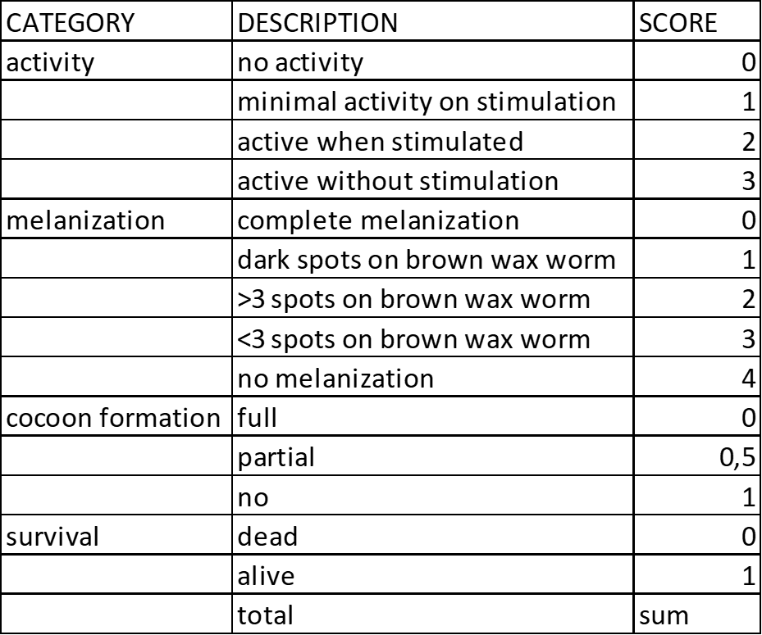
Levels of infection were estimated by calculating the sum of scores obtained for each larva. To compare the virulence of the strains of our collection we calculated an overall index comprehensive of these parameters: $\frac{\left[9- \left(sum*survival\right)\right]}{10}$. Death larvae at each check point were removed and placed at -20°C for at least 48h before being disposed of. Overall indexes calculated were plotted with the data analysis framework Estimation Stats with default parameters. Survival curve was plotted with the Kaplan-Meier method using SPSS Statistics (version 27).
Table 1 Representation of the categories and scores used to assess the level of disease caused by each strain in G. mellonella.

(A4) Two representative strains of F. musae were chosen to obtain fluorescent reporter strains, one isolated from banana fruits and one isolated from human patient. Genomic data allowed the construction of a specific plasmid containing the far-red fluorescent protein E2-Crimson expressed under control of the constitutively active F. musae enolase promoter Peno1. For transformation, we firstly obtained Competent cells from single colonies of E. coli DH5α by heat-shock protocol and then we transformed them with E2-Crimson plasmid following Thermoscientific user guide. Selected single colonies were grown in liquid media for plasmid DNA extraction using QIAGEN Plasmid Midi Kit following manufacture’s protocol. For fungal transformation protoplasts of the two selected strains were obtained and transformed with linearized plasmid DNA as described in (Liu and Friesen, 2012).
Success of transformation was confirmed with confocal fluorescence microscope (Nikon A1-3D SIM) using TRITC filter.

3. Results and Discussion

3.1 Azoles sensitivity
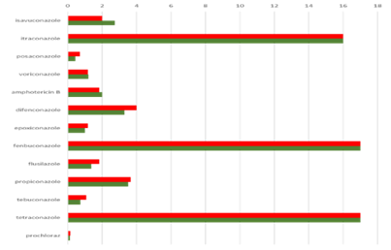
Each azole has a unique spectrum and power as represented by different MIC values in Figure 1. Results showed that itraconazole presented highest MICs (G-MIC = 16 mg/L) among the medical azoles against F. musae, while posaconazole, voriconazole and isavuconazole showed lower values (respectively 0.54 mg/L; 1.2 mg/L and 2.4 mg/L); amphotericin B showed a G-MIC of 1.93 mg/L. Prochloraz and the tebuconazole (G-MIC of 0.14 mg/L and 0.83 mg/L respectively) presented the highest activity among agricultural azoles, while higher values were showed by difenoconazole (2–8 mg/L), propiconazole (2–4 mg/L) and flusilazole (1.55 mg/L). Tetraconazole and fenbuconazole showed G-MICs > 16 mg/L for all strains. Overall our data resulted comparable with data already present in literature and we did not observed statistically significant differences linked to the different geographical and host origin of the strains of our collection (Tava et al., 2021).
Figure 1 Susceptibility to antifungal drugs of F. musae isolates from human (upper line) and bananas (lower line).

3.2 Mitogenomes
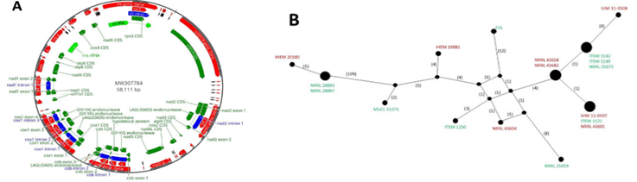
Mitogenomes of F. musae strains ranged from 56,439 to 59,256 bp (Figure 2A). The analysis of codon usage in coding sequences did not reveal significant differences among the whole set of analyzed strains, all mitogenomes showed a high similarity for protein-coding regions. However, our study confirmed that intergenic regions and endonucleases may be exploited to identify subgroups within a species. Different nuclear gene haplotypes exist and at least one set of strains belonging to the same mitochondrial haplotypes included both human and banana derived strains (Figure 2B) suggesting that the species can travel as hypothesized by (Triest and Hendrickx, 2016).
Figure 2 (A) Graphical representation of circular mtDNA of F. musae.
(B) Representation of mitogenomes network haplotypes using PopArt software.

3.3 Genome
Strain F31 presented a size of 44.07Mb divided into 12 chromosomes of which 11 have both telomers, the circular mitochondrial DNA (mtDNA), and one unplaced contig. Functional annotation led to a total of 13,963 annotated genes, of which 13,661 were proteins and 302 transfer RNA (tRNA) for nuclear DNA. This represents the first genome completed at chromosome level of F. musae and it will be a useful resource for comparative analysis of F. musae species, in addiction it represents an important reference for completeness and for understanding the genome evolution in the FFSC.

3.4 Banana fruits infection
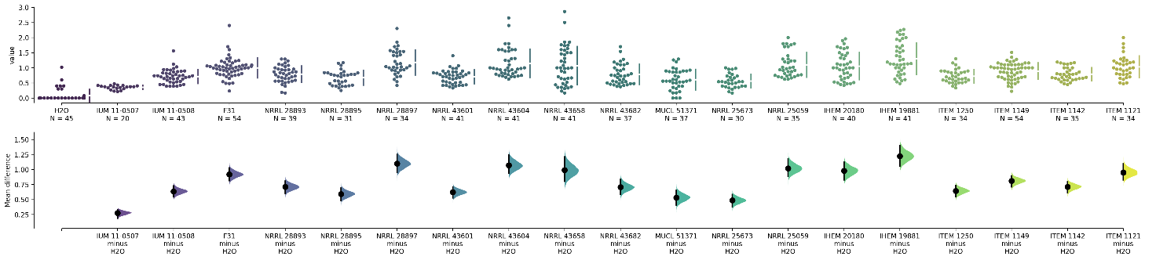
Results of infection of bananas demonstrated for the first time that human strains of F. musae are able to invade a plant host. All banana fruits infected with F. musae strains presented brown spots surrounding the point of toothpick insertion, symptoms varied from small halo with browning to big brown spot with spread visible mycelium proving that F. musae can be pathogenic of banana fruits. All strains presented level of infection statistically different from H2O, as represented in Figure 3, demonstrating that they were all able to cause significant disease in banana fruits. Geographical origin and host of original isolation did not correlate with the severity of the disease, all strains cause comparable disease level and no subgroup are present in our population based on their origin.
Figure 3 Distribution of overall indexes calculated for each infection point in banana fruits. Graph was made with the data analysis framework Estimation Stats with default parameters, H₂O was used as shared control. Each mean difference is depicted as a dot and each 95% confidence interval is indicated by the ends of the vertical error bars. All data are normalised by dividing for average value of F31 of the corresponding replicate.

3.5 Galleria mellonella infection
Galleria mellonella assay showed that F. musae causes visible disease in G. mellonella that in this way can be considered as a valid “human proxy” model for the investigation of this novel fungal species. Of the nineteen F. musae strains tested, five (three human IUM 11-0507, NRRL 43601, NRRL 43604 and two plant NRRL 28893, ITEM 1149) were not statistically different from PBS. Overall, all F. musae strains caused comparable levels of infection in G. mellonella (Figure 4) and no subgroups were present based on isolation source.
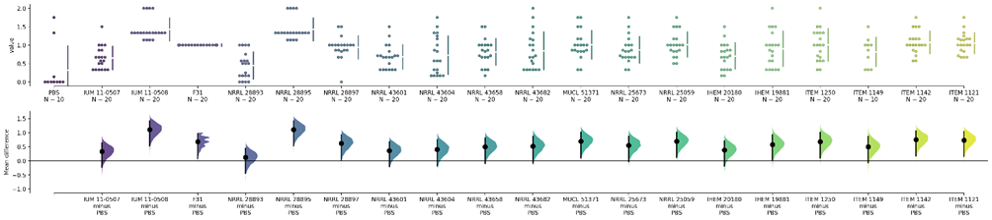
Additional Survival analysis was performed on the entire collection of F. musae strains. Inoculation of G. mellonella with all nineteen F. musae resulted in significant killing of the larvae, 96h post infection we started seeing a conspicuous number of death larvae that increased the days after. This demonstrated that also strains isolated from plants are potentially capable to cause infection in animal pathosystem.
Figure 4 Distribution of overall indexes calculated for each infection point in G. mellonella. Graph was made with the data analysis framework Estimation Stats with default parameters, PBS is used as shared control. Each mean difference is depicted as a dot and each 95% confidence interval is indicated by the ends of the vertical error bars. All data are normalised by dividing for average value of F31 of the corresponding replicate.

3.6 Fluorescent reporter strain
Fungal transformation resulted in the production of two fluorescent representative F. musae strains that open possibilities for the investigation in vivo of the interaction between F. musae and its hosts. One banana strain and one human strain were successfully transformed as we could verify by visualization with confocal fluorescence microscope (Figure 5).

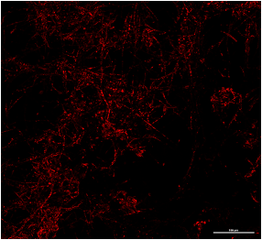
Figure 5 Representative picture of F. musae transformed with E2-Crimson observed with confocal fluorescence microscope (Nikon A1-3D SIM) using TRITC filter. From the picture we can clearly distinguish hyphae of the colony.

4. Conclusions and Future Perspectives
The “One Health” concept is based on the idea that the health of people is closely connected to the health of animals and our shared environment. Food safety has a crucial role within the “One Health” concept given the emerging threat pose by some fungal pathogens of food crops that can mine also human health. In recent years, the number of fungal pathogenic species able to cross kingdom borders is increasing, becoming of interest of both clinical and agricultural field (van Baarlen et al., 2007; Kim et al., 2020). This implies that plants (and food products derived) can become an important source of novel infecting agents for humans, and studying plant pathogens can contribute to establishing novel standards of food safety which will have to consider also the risk caused by this new category of pathogens. Very limited information is available for fungal agents and their mechanisms of action and in most of the cases their ability to “jump” from one host to another is not experimentally verified following Koch’s postulate.
With my PhD thesis I explored the potential cross-kingdom pathogenicity of Fusarium musae, recently isolated from banana fruits (Van Hove et al., 2011; Kamel, Cortesi and Saracchi, 2016) and human patients (Esposto, Prigitano and Tortorano, 2016; Triest et al., 2016). My project aimed at characterising this novel species by combining studies within different disciplinary field to understand peculiarities of the species as well as to explore a successful strategy that could be used as model for the investigation of other cross-kingdom pathogens. Fungicide sensitivity and genome sequencing highlight important characteristics for a correct identification of the F. musae. Infection assays prove experimentally for the first time the ability of F. musae to cause evident disease in a plant pathosystem as well as in an animal pathosystem confirming F. musae as a potential cross-kingdom pathogen.
Florescent strains will be a useful tool for future investigation in vivo of the interaction between F. musae and its hosts, and to better understand it’s mechanisms of action.

8. References
van Baarlen, P. et al. (2007) ‘Molecular mechanisms of pathogenicity: how do pathogenic microorganisms develop cross-kingdom host jumps?’, FEMS microbiology reviews, 31(3), pp. 239–277. Available at: https://doi.org/10.1111/j.1574-6976.2007.00065.x.
Degradi, L. et al. (2021) ‘Telomere to Telomere Genome Assembly of Fusarium musae F31, Causal Agent of Crown Rot Disease of Banana’, Molecular Plant-Microbe Interactions®, 34(12), pp. 1455–1457. Available at: https://doi.org/10.1094/MPMI-05-21-0127-A.
Degradi, L. et al. (2022) ‘Exploring Mitogenomes Diversity of Fusarium musae from Banana Fruits and Human Patients’, Microorganisms, 10(6), p. 1115. Available at: https://doi.org/10.3390/microorganisms10061115.
Esposto, M.C., Prigitano, A. and Tortorano, A.M. (2016) ‘Fusarium musae as cause of superficial and deep-seated human infections’, Journal De Mycologie Medicale, 26(4), pp. 403–405. Available at: https://doi.org/10.1016/j.mycmed.2016.02.021.
Kamel, M. a. M., Cortesi, P. and Saracchi, M. (2016) ‘Etiological agents of crown rot of organic bananas in Dominican Republic.’, Postharvest Biology and Technology, 120, pp. 112–120.
Kim, J.-S. et al. (2020) ‘Crossing the kingdom border: Human diseases caused by plant pathogens’, Environmental Microbiology, 22(7), pp. 2485–2495. Available at: https://doi.org/10.1111/1462-2920.15028.
Liu, Z. and Friesen, T.L. (2012) ‘Polyethylene Glycol (PEG)-Mediated Transformation in Filamentous Fungal Pathogens’, in M.D. Bolton and B.P.H.J. Thomma (eds) Plant Fungal Pathogens: Methods and Protocols. Totowa, NJ: Humana Press (Methods in Molecular Biology), pp. 365–375. Available at: https://doi.org/10.1007/978-1-61779-501-5_21.
Pasquali, M. et al. (2004) ‘Development of PCR Primers for a New Fusarium oxysporum Pathogenic on Paris Daisy (Argyranthemum frutescens L.)’, European Journal of Plant Pathology, 110(1), pp. 7–11. Available at: https://doi.org/10.1023/B:EJPP.0000010141.37327.d0.
Tava, V. et al. (2021) ‘Fusarium musae from Diseased Bananas and Human Patients: Susceptibility to Fungicides Used in Clinical and Agricultural Settings’, Journal of Fungi, 7(9), p. 784. Available at: https://doi.org/10.3390/jof7090784.
Triest, D. et al. (2016) ‘Fusarium musae infected banana fruits as potential source of human fusariosis: May occur more frequently than we might think and hypotheses about infection’, Communicative & Integrative Biology, 9(2), p. e1162934. Available at: https://doi.org/10.1080/19420889.2016.1162934.
Triest, D. and Hendrickx, M. (2016) ‘Postharvest Disease of Banana Caused by Fusarium musae: A Public Health Concern?’, PLOS Pathogens. Edited by D.A. Hogan, 12(11), p. e1005940. Available at: https://doi.org/10.1371/journal.ppat.1005940.
Van Hove, F. et al. (2011) ‘Gibberella musae (Fusarium musae) sp. nov., a recently discovered species from banana is sister to F. verticillioides’, Mycologia, 103(3), pp. 570–585. Available at: https://doi.org/10.3852/10-038.

