Colour Stability Of Rosé Wines As Affected By Phenolic Composition And Tannins Addition
Federico Baris (e-mail: federico.baris2@unibo.it)
Department of Agro-Food Sciences and Technologies, Alma Mater Studiorum, University of Bologna, Italy
Tutor: Fabio Chinnici

Two of the activities of the PhD thesis project are described. A first subject was the study of the colour and oxidative evolution of five model rosé wines during three weeks of storage. These were made by blending different ratios of anthocyanins and tannins in a model solution. As a second subject, 8 distinct oenological tannins were tested for their ability in modulate and stabilize the colour parameters of a rosé wine made at laboratory scale. The overall research project aims to investigate the mechanisms of formation, evolution and stabilisation of colour in rosé wines as a function of different technological intervention or storage strategies.
Stabilità del colore dei vini rosati in funzione della composizione fenolica e dall'aggiunta di tannini
Sono descritte due delle attività del progetto di tesi di dottorato. Un primo argomento è stato lo studio dell'evoluzione cromatica e ossidativa di cinque vini rosati modello durante tre settimane di conservazione. Questi sono stati ottenuti miscelando diversi rapporti di antociani e tannini in una soluzione modello. In secondo luogo, sono stati testati 8 tannini enologici distinti per la loro capacità di modulare e stabilizzare i parametri del colore di un vino rosato prodotto su scala di laboratorio. Il progetto di ricerca complessivo mira a indagare i meccanismi di formazione, evoluzione e stabilizzazione del colore nei vini rosati in funzione di diversi interventi tecnologici o strategie di conservazione.

Key words: oxidation, rosé wine, anthocyanins, oenological tannins, polyphenols, shelf life .

1. Introduction
The colour of rosé wines varies widely; for example, the colour density (CD) may vary from 0.30 AU in the lightest rosés to 1.40 AU in the darkest rosés, as does the tint (H) from 1.50 to 0.90 (Leborgne et al., 2022). These variabilities depend on both the grape cultivar and the winemaking procedures which eventually affect the acceptance and visual quality of the product. However, little is known about the impact of the different phenolic/pigments ratio on the attitude of a rosé wine to maintain its overall colour and oxidative balance. Furthermore, another matter of concern is how the exogenous addition of oenological tannins may affect the rosè wine attributes as they can influence the colour, helping to achieve the desired shade and brilliance of the wine. Tannins could also contribute to the wine stability, preventing oxidation and impacting the long-term colour expression and shelf-life durability of rosé wines.
2. Materials and Methods
For the A1 purpose, five distinct rosé nuances were obtained by mixing solutions of oenocyanin and grape tannins at different concentrations in a 12% V/V hydroalcoholic model solution containing tartaric acid and Fe (II) (5 mg/L) and stored in 50mL bottles. Depending on the ratio between oenocyanin and tannins, five different model rosé wines were obtained: VD (Very Dark), D (Dark), I (Intermediate), L (Light) and VL (Very Light). Oxidation was ignited by adding 200μM of hydrogen peroxide and bottles were kept in a cool and dark place during 20 days of storage. The analyses aimed at the quantification of the main wine's parameters related to the phenolic and the colour, together with the iron speciation and the oxidative evolution over time. Regarding the A2 purpose, this research is currently taking place at the faculty of pharmacy of the University of Sevilla (Spain). Eight tannins of different origins were separately added to a rosé wine made at laboratory scale from sangiovese and merlot grapes. All the oenological tannins were previously characterized to determine their phenolic richness (Vignault et al. 2018). The OCR (Oxygen Consumption Rate) was also evaluated, according to the non-invasive luminescence technique described by Pascual et al., 2017. Transparent glass bottles (0.30 L) equipped with a patch to measure dissolved oxygen were used. The experiments were conducted in a model wine solution composed of 10% ethanol, 4 g/L tartaric acid and pH adjusted to 3.5. This was supplemented with 5 mg Fe (III)/L in the form of iron chloride hexahydrate.

3. Results and Discussion

3.1 Determination of the colour evolution over time
The evolution of the phenolic component and the anthocyans content was studied over time, although particular attention was paid to the oxidation evolution of the solutions, as these were subjected to the Fenton reaction speeded up by adding hydrogen peroxide. The colour of the solutions changed differently over time, depending on their initial phenolic content. The colour change was observed in the different solutions; yellower nuances increased considerably compared to T0, whereas the coordinate a* decreased over time (Table 1). The increase in the b* coordinate was one of the main causes of the decrease in a* in all our samples, meaning that the final solutions absorbed at 420nm more than the T0 solution. HPLC analyses aimed to study the individual anthocyanins evolution over time, and they yielded interesting results. For example, it has been observed that specific anthocyanins degrade much faster than others and differently from one sample to another. Delphinidin-3-glucoside degraded the most and the fastest three weeks after the first sampling, remaining at levels of less than ten per cent compared to T0. On the opposite, vitisin A demonstrated to be highly stable to oxidation, undergoing to limited diminution over time. As a result of the analysis carried out it has been shown that in most cases the presence of a higher amount of anthocyanins seems to have a positive influence on the prevention of wine oxidation. Indeed, it seems that lighter-coloured wines tend to change colour more quickly, as a signal of faster oxidation.
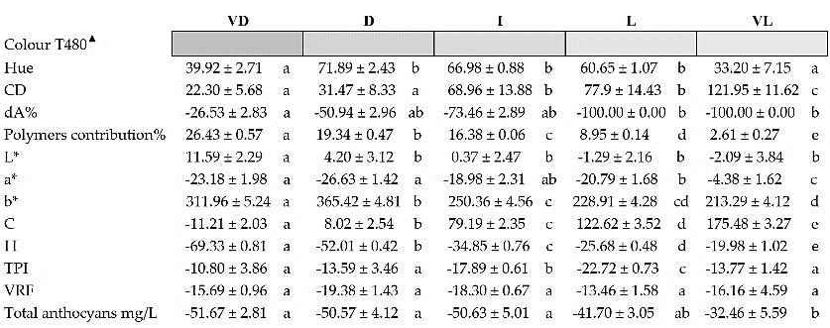
Table 1 Changes in colour and phenolic parameters (as percentages) of the distinct model rosé wines at T480 compared to T0.

3.2 Characterization of oenological tannins useful to stabilize the colour of rosé wines
The oxygen consumption kinetics of the different oenological tannins in an oxygen-saturated model wine solution was studied at 20°C (Figure 1a). The seed and tara tannins consumed oxygen slower than tannins from other sources; on the other hand, it is evident how the others followed a similar trend until they stabilised after about 8 days of storage because of the total consumption of dissolved oxygen. Tannins that consume oxygen the fastest are the most effective in terms of protecting the wine from chemical oxidation (Vignault et al., 2018). According to Pascual et al., 2017, of the various oenological tannins, ellagitannins are the fastest oxygen consumers, followed in decreasing order by quebracho tannins, skin tannins, seed tannins and ﬁnally gallotannins. Once the tannins were characterized, they were added at 200 mg/L to a rosé wine. The capacity of different tannin to chelate iron in the samples was studied. Figure 1b illustrates the varying degrees to which the different tannins chelate the iron present in the wine samples over a period of two months. Our findings indicate that chestnut tannin exhibited the highest efficiency in reducing total iron levels in the wine; it was found to consume approximately 20% of the initial iron concentration at T0. In conclusion, the first results of this study indicate some interesting properties of tannins depending on their botanical origins. Chestnut tannin, in particular, seems to have promising features in view to promote colour stability in the production process of rosé wines.
Figure 1a Oxygen consumption kinetics of eight different oenological tannins in an oxygen-saturated model
wine solution at about 20°C

Figure 1b Iron chelation kinetics of the eight sample wines containing the different oenological tannins and
control over time, compared to T0.

a.
b

4. References
Leborgne C, Lambert M., Ducasse M A, Meudec E A, Sommerer N, Boulet J C, Masson G, Mouret J R, Cheynier V (2022) Elucidating the Color of Rosé Wines Using Polyphenol-Targeted Metabolomics. Molecules 27: 1359.
Pascual O, Vignault A, Gombau J E, Canals J M, Hermosín-Gutíerrez I, Teissedre P L, Zamora F (2017) Oxygen consumption rates by different oenological tannins in a model wine solution. Food Chem 234: 26–32.
Vignault A, González-Centeno M R, Pascual O, Gombau J, Jourdes M, Moine V, Iturmendi N, Canals J M, Zamora F, Teissedre P L (2018) Chemical characterization, antioxidant properties and oxygen consumption rate of 36 commercial oenological tannins in a model wine solution. Food Chem 268: 210–219.

