"Green" Technologies in the Supply Chain of Agri-Food Company
Micaela Lembo (micaela.lembo@unitus.it)
Dept. Food Science and Technology, University of Tuscia, Viterbo, Italy
Tutor: Prof. Rinaldo Botondi

This PhD thesis research project involves three experimental plots of Soreli kiwifruit vineyards, irrigated with three different water regimes, and the plants subjected to the various irrigations are monitored by an IoT-TT Spectrum which provides data in real time, and a Soil sensor to determine the moisture content. Fruit quality analysis for weight loss, total soluble solid content, flesh color, flesh firmness, titratable acidity, ascorbic acid, total polyphenols, and flavonoids is conducted to correlate the productivity rate to amount of water availability. Overall, this study demonstrates that excessive or limited irrigation regimes adversely affect plant health based on vegetation indices and fruit quality.

Recupero di alcuni metabolici microbici da soluzioni modello per osmosi inversa
Questa proposta di tesi di dottorato coinvolge tre settori sperimentali di kiwi Soreli, irrigati con tre diversi regimi idrici, e le piante sottoposte alle diverse irrigazioni sono monitorate da uno spettro IoT-TT che fornisce dati in tempo reale, e un sensore del suolo per determinare il contenuto di umidità. L'analisi della qualità della frutta per la perdita di peso, il contenuto solido solubile totale, il colore, la consistenza, l'acidità titolabile, l'acido ascorbico, i polifenoli totali e i flavonoidi viene condotta per correlare il tasso di produttività alla quantità di disponibilità di acqua. Nel complesso, questo studio dimostra che regimi di irrigazione eccessivi o limitati influenzano negativamente la salute delle piante sulla base degli indici di vegetazione e della qualità dei frutti.

Key words: IoT, TT-Spectrum, Soreli kiwifruit, Leaf chlorophyll content, Fruit quality, Irrigation.

1. Introduction
In accordance with the PhD thesis project previously described (Rolle et al., 2022), this poster reports the main results of the first two activities concerning:
(A1) the determination of vegetation indices (NDVI, CVI, LNBI, and AI) and soil moisture content obtained through the analysis of data provided by IoT-TT Spectrum and Soil sensor; these are important indicators of the physiological status of kiwifruit plants and can be used to assess plant health and growth.
(A2) the assessment of the quality fruits through analysis of the chemical-physical parameters and bioactive compounds; These analyses aim to assess how the water deficit affects the productivity of the plant and the quality of the fruit being harvested.

2. Materials and Methods
  - Experimental design
In the summer of 2022 three experimental plots of "Soreli" kiwifruit vineyards at the "Tre Colli" farm, situated in Cisterna Campoleone (Velletri, Rome, Italy), were selected and irrigated with different volumes of water; 100% or full irrigation and deficit irrigation at 80% and 60% relative to the full irrigation approach.
  - TT Spectrum and soil sensors
Three IoT-TT Spectrums and three soil sensors for each treatment were used to obtain real-time observation of physical and biological parameters of the leaves and on soil moisture. TT Spectrum collects light reflectance data in 12 spectral bands, 610+, 680+, 730+, 760+, 810+, 860+ nm, 450*, 500*, 550*, 570*, 600*, 650* (* ±20 nm + ±40 nm). For further processing, four vegetation indices, Normalized Difference Vegetation Index (NDVI) (Tucker, 1979), Chlorophyll Vegetation Index (CVI) (Vincini et al. 2008), Leaf Nitrogen Balance Index (LNBI) (Fan et al. 2022) and Anthocyanin Index (AI) (Gitelson et al. 2001) are evaluated from TT Spectrum data.
  - Kiwi fruit analysis
Soreli kiwi fruits were collected and transported to the Postharvest Laboratory of DIBAF (University of Tuscia, Viterbo, Italy). Kiwifruits were stored for 24 h at room temperature and were then cooled to 1 ± 0.5 ◦C with 85 ± 5% RH in normal atmosphere with ethylene absorber. All analyses were performed at harvest time and after every 15 days of cold storage. At harvest and before storage the same 20 kiwifruits were weighed using a digital balance (Adam Equipment Co., Ltd., Milton Keynes, UK), to monitor weight loss during cold storage. Total soluble solid content (SCC) was measured on the fresh kiwifruit juice using a digital refractometer (ATAGO, Palette PR-32, Tokyo, Japan) and expressed as °Brix (%). Flesh colour was measured on peeled fruits using a Minolta colorimeter to evaluate the chromaticity values L*, a*, and b*. Flesh firmness was evaluated with a destructive method using a digital penetrometer (Mod. 53205; TR Turoni snc, Forlì, Italy), and with non-destructive method with an Instron Universal Tasting Machine. Titratable acidity was measured on the flesh juice according to the protocol of Grasso et al. (2022). Total phenols (TP) and flavonoids (TF) content was determined as reported by Grasso et al. (2022). Ascorbic acid (AA) content was assessed according to Grasso et al. (2022). Chlorophyll a, Chlorophyll b and β-Carotene in the sample were analysed as described by Goffi et al., (2017).
  - Statistical Analyses
All results are expressed as the means ± standard deviation (SD). Statistical significances between different maturity stages of the fruit of different orchards and storage time were analysed by two-way analysis of variance (ANOVA), and Tukey’s test at 5% level was calculated to compare differences between means. Differences at p < 0.05 were considered significant and are indicated with different letters.

3. Results and Discussion
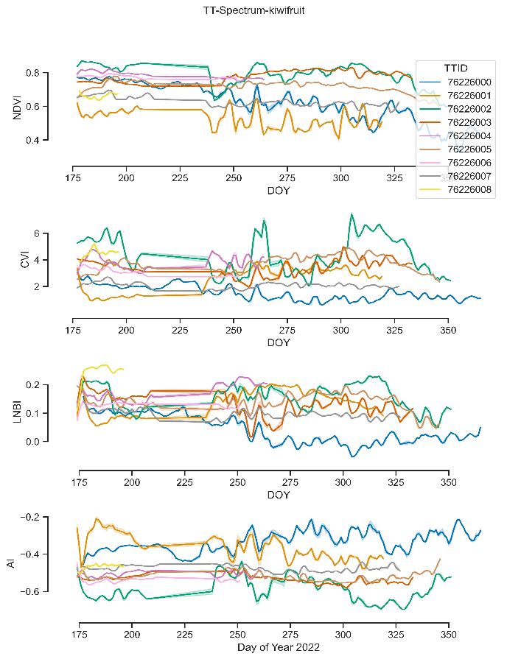
3.1 Effects of Overwatering or Underwatering on Kiwifruit Plants
In Figure 1, we present the TT-Spectrum output for the main vegetation indices for each individual, based on the reflectance data from various reported bands (450 to 860 nm). The results demonstrate that different levels of soil moisture availability for kiwifruit plants lead to distinct ecophysiological responses (Figure 1). The soil moisture data revealed that each individual plant received different levels of water availability, resulting in varying health, growth, and productivity conditions. For example, Tree 76226005 received lower irrigation during the early season and maximum water availability during the dry period, which resulted in a very high NDVI and CVI, lower AI, and a balanced leaf nitrogen level. In contrast, Tree 76226000 received full irrigation during the early season, and underwatering during the dry period did not show high foliage health based on the results of the aforementioned indexes (Figure 1).
Figure 1 The TT-Spectrum output for the main vegetation indices (NDVI, CVI, LNBI, and AI) for each individual, using reflectance data from different reported bands
    - Effects of water deficit on Soreli kiwifruit Chemical-Physical Parameters and Bioactive Compounds
The Brix° in stored fruits exhibited a notable increase over time across all treatments while the percentage of weight loss in fruits rose over time and no significant differences were observed between the various irrigation treatments. However, fruits subjected to full irrigation demonstrated lower sugar levels compared to those under deficit irrigation. The firmness decreased progressively for all fruits harvested during cold storage for all irrigations. Overall, the different samples had a uniform trend in terms of softening during the storage. For the colour, L*, a* and b* parameters at the time of harvesting were highest in fruits irrigated with 100% of water compared to fruits irrigated with 80% and 60% of water, while the results showed a decreasing and homogeneous trend until the end of the study without significant differences between the different irrigations. The changes in bioactive compounds content during ripening of kiwifruits do not appear to be significant between the irrigations.

4. References
Fan, K., Li, F., Chen, X., Li, Z., & Mulla, D. J. (2022). Nitrogen Balance Index Prediction of Winter Wheat by Canopy Hyperspectral Transformation and Machine Learning. Remote Sensing, 14(14), 3504.
Gitelson, A. A., Merzlyak, M. N., & Chivkunova, O. B. (2001). Optical properties and nondestructive estimation of anthocyanin content in plant leaves. Photochemistry and Photobiology, 74, 38−45
Goffi, V., Modesti, M., Forniti, R., & Botondi, R. (2017, September). Quality of green (Actinidia chinensis var. deliciosa'Hayward') and yellow (A. chinensis var. chinensis' Soreli') kiwifruit during cold storage at 0° C in normal atmosphere and with gaseous ozone. In IX International Symposium on Kiwifruit 1218 (pp. 473-480).
Grasso, C., Forniti, R., & Botondi, R. (2022). Post-harvest quality evaluation of “Soreli” kiwifruit at two ripening Brix values from vineyards of different age under hail nets. Foods, 11(3), 431.
Rolle, L. G. C., Alessandria, V., Bertolino, M., Botta, C., Cardenia, V., Cocolin, L., ... & Zuccolo, E. (2022). Proceedings ofthe 26th Workshop on the Developments in the Italian PhD Research on Food Science, Technology and Biotechnology, pp. 111-112
Tucker, C. J. (1979). Red and photographic infrared linear combinations for monitoring vegetation. Remote sensing of Environment, 8(2), 127-150.
Vincini, M., Frazzi, E. R. M. E. S., & D’Alessio, P. A. O. L. O. (2008). A broad-band leaf chlorophyll vegetation index at the canopy scale. Precision Agriculture, 9, 303-319.

