Probiotic bacilli incorporation in foods: is really so easy?
Maria De Sena (maria.desena@unina.it)
Dept. of Agricultural Sciences, University of Naples Federico II, Naples, Italy
Tutor: Prof.ssa Maria Aponte

The objective of this PhD thesis was to evaluate the resistance of Bacillus spp. strains with claimed probiotic properties added to different foods (pasta and croissants) at the beginning and the end of the products’ shelf life and after exposure to simulated GIT conditions.

Alimenti arricchiti con bacilli probiotici: è davvero così facile?
L'obiettivo di questa tesi di dottorato è stato quello di valutare la resistenza di ceppi di Bacillus spp. con riconosciute proprietà probiotiche, aggiunti a diversi alimenti (pasta e croissant), durante la conservazione e dopo l’esposizione a condizioni di digestione simulata.

Key words: Probiotic bacilli; Pasta; Croissant; Spores’ germination; Cold storage; Food matrix.

1. Introduction
In accordance with the PhD thesis project previously described, this oral communication reports the main outcomes obtained by the following three activities:
A1) assessment of the spores’ survival along GIT when incorporated in different matrices;
A2) evaluation of the effect of different thermal treatment (baking and boiling);
A3) monitoring of the storage at -18°.

2. Probiotic Food development
The development of probiotic foods, especially those with acidic pH, low water activity, or that will be exposed to thermal processes with temperatures exceeding 60°C, is a great challenge (Marcial-Coba et al., 2019). Spore-forming bacteria with claimed probiotic properties can help to overcome various technical troubles thus expanding the possibility of applying probiotic microorganisms to a broader range of products, including acidic beverages, thermally processed dairy products, and bakery goods.

3. Spore and Germination
From a probiotic perspective, spores and vegetative cells have separate but complementary functions (Bernardeau et al., 2017). Both spores and vegetative cells can promote some characteristics, such as immunomodulation and adsorption, whilst others, such as antimicrobial activity, are a distinctive trait of vegetative cells (Bernardeau et al., 2017). The germination process that ensures metabolic activity is highly dependent on the strain itself, GIT location, environmental conditions, as well as the conditions applied during the sporulation process prior to ingestion (Bernardeau et al., 2017). In general, there is clear evidence that Bacillus spores can germinate in GIT conditions, nonetheless, this fact should be confirmed during the food development process and before any potential in vivo test. Based on the previous considerations, the development of foods fortified with spores ought to ensure the germination of the spores along the gastrointestinal tract.

4. Experimental Procedure
Pasta and croissants were used as food matrices for the spore addition.
Pasta, in detail “spaghetti” and “sedanini rigati”, was prepared by means of a professional electric pasta machine (Dolly – La Monferrina, Padova, Italy) by using tap water (in which spores were resuspended) and commercial semolina. Croissants, were prepared in the laboratory and subsequently at a nearby patisserie (De Girolamo, Marigliano, Naples, Italy). In the last test, croissants were filled with probiotic chocolate cream, immediately placed in a blast chiller, and kept at -18°C for analysis. At each sampling point, pasta and croissants were subject to simulated digestion immediately after cooking. The protocol was that described by Ricciardi et al. (2014) with some modifications.
Furthermore, spores of the three probiotic bacilli were mixed with different matrices: starch, butter, and gluten. Gluten and starch were combined with sterile water (40%) to create a dough. Initial microbial loads were fixed at 10⁵ CFU g⁻¹. Food matrices were then monitored during freezing.

5. Materials and Methods
Poliantibiotic Bacillus (B.) clausii strain was used as spores’ suspension as available in Enterogermina and is herein named B. clausii SA (Sanofi Aventis). B. clausii UBBC07 and B. coagulans Unique IS2 were provided as dried powders containing 1.5 x 10¹⁰ spores by Unique Biotech. In all cases, the spores’ content was checked by plate counting onto the LB (Lennox) medium (Tryptone 10 g L⁻¹, Yeast extract 5 g L⁻¹, NaCl 5 g L⁻¹) as well as on the same medium after treatment at 75°C in a shaking water bath for 30 min at 50 rpm, followed by immediate cooling below 45°C (LB75°C). Vegetative cells deriving by spores’ germination along GIT or during the process were separately counted on the Spizizen medium (SM) with glutamic acid (1%) as nitrogen source (Anagnostopoulos & Spizizen, 1961). Significant differences among data were tested by ANOVA (Tukey). The significance level was p ≤ 0.05 throughout the analyses. Data elaboration was carried out using XLStat (version 2012.6.02), an add-in software package for Microsoft Excel (Addinsoft Corp., Paris, France).

5. Results and Discussion

5.1 Spores’ survival along GIT and storage when incorporated in pasta and croissants
The three bacilli cultures’ spores were added to two types of pasta and to a chocolate cream that was used to stuff croissants (Fig. 1). All spores that were added to pasta were induced to germinate, and vegetative cells were able to grow on minimum media, demonstrating that the induction to germination most likely occurs during the boiling process used to cook pasta. The population levels of the three strains decreased in pasta with counts following GIT, being at least one Log lower (Fig. 1). However, up to 60 days, counts on the two media before or after GIT were stable (p < 0.05).
When added to the chocolate cream used to fill croissants, the spores of the three bacilli performed entirely differently. Results at time 0, with the exception of strain B. clausii UBBC 07, make it possible to infer that no spores germinate during GIT.
The three types of probiotic products were subject to simulated digestion after 30 and 60 days of storage at room temperature and at -18°C for pasta and croissants, respectively. In pasta, all spores germinated independently by the strain and the pasta shape. Pasta boiling is able to induce complete spores’ germination, and the vegetative cells’ survival along GIT is consistent with data reported by Konuray and Erginkayafor (2020) for B. coagulans GBI-30 in spaghetti. The main differences in pasta appear to be strain-dependent: strain’s UBBC 07 tolerance to GIT seems to be reduced by storage. On the other hand, B. coagulans Unique is the sole strain that experienced a drop in SM counts after 30 days of storage, but only when added to Sedanini rigati, probably as a result of the longer cooking time. This shows that there are multiple factors that affect how spores react to thermal treatments.
The combination of chocolate filling and oven heating was found to be a better matrix. Probiotic bacilli displayed optimal tolerance to GIT conditions: with the exception of strain B. coagulans unique IS2, counts on LB and on the same medium after the thermal treatment produced overlapping population levels after GIT at 30 and 60 days. Conversely, minimal medium counts turned out to be somewhat unpredictable. For both B. clausii strains, populations on SM dropped under the threshold of detection of the method after two months. In other words, the harsh environmental conditions encountered along GIT seemed to have prevented the spores’ germination (Fig. 1). Only for B. coagulans Unique IS2 germination seems to be triggered by GIT at 30 and 60 days.
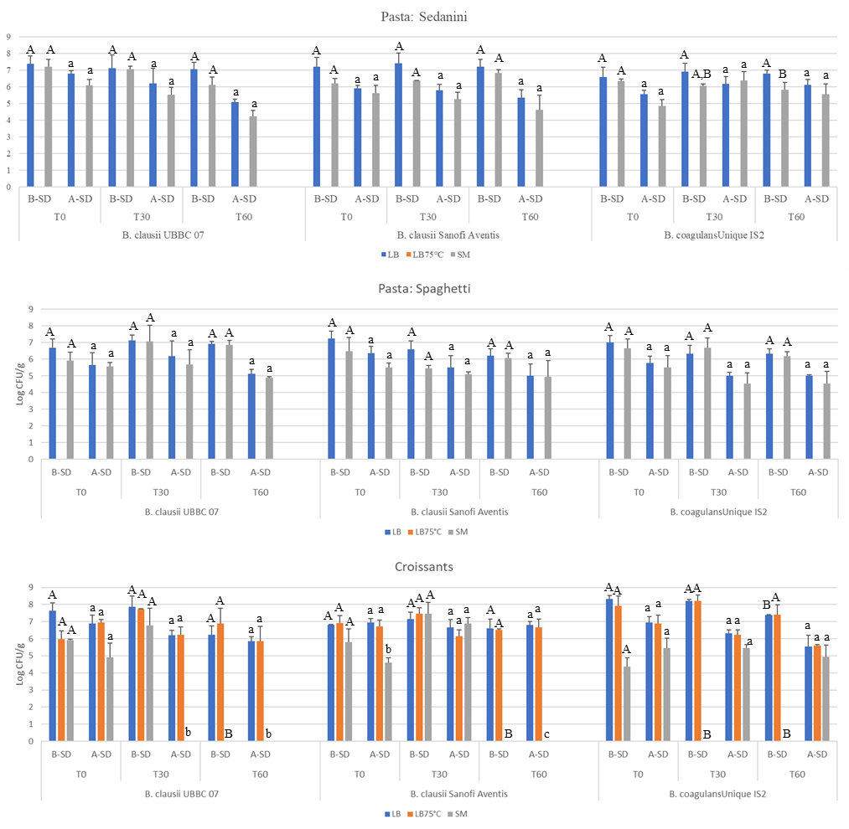
Figure 1 Spores counts before (B-SD) and after simulated (A-SD) digestion of spores incorporated in pasta or in chocolate croissants’ filling at time 0 and after 30 and 60 days of storage at room temperature (pasta) or -18°C (croissants). For data with the same letter, differences during storage are not statistically significant (p < 0.05).

5.2 Spores’ behaviour at -18°C
A second batch of croissants was made, and the product’s storage for up to four months was monitored (Fig. 2). After baking, the LB and spore counts were stable until the end of monitoring (p < 0.05), showing that this kind of product may be profitably utilized to vehicle probiotic bacilli. The graph in Figure 2 shows dashed lines for counts after GIT transit, which are consistently lower than counts before GIT. The most surprising information was the spores’ ability to germinate on minimal medium: in every case, after two months, spores appeared to lose this capacity. In both strains, B. clausii SA and B. coagulans Unique IS, the ability to germinate after three months is only triggered by GIT transit. B. clausii UBBC 07 exhibited the most peculiar behavior: counts on SM increased back at the end of monitoring (Fig. 2).
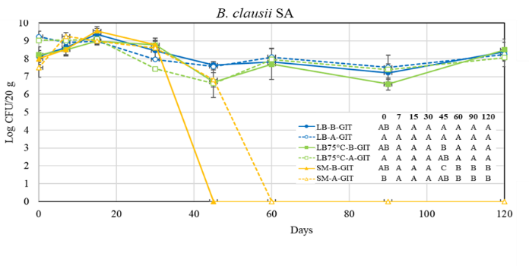
Figure 2 Monitoring of spores in the chocolate filling of croissants for up to 120 days. Counts before (B-GIT) and after (A-GIT) simulated digestion are reported as full and dashed lines respectively. For data with the same letter, differences during storage are not statistically significant (p < 0.05).
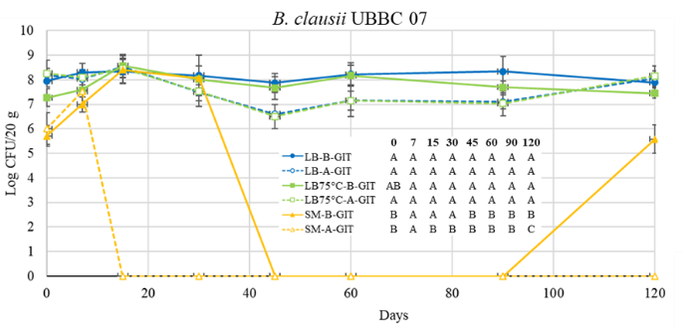
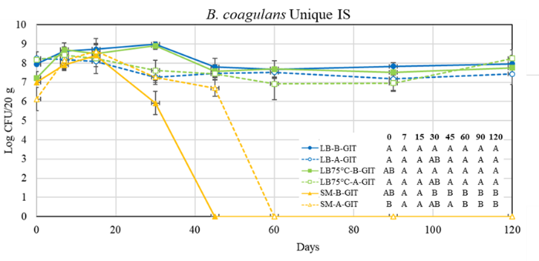

5.3 Influence of the thermal treatment
The completely different behaviour of spores incorporated in chocolate might be likely related to more than one factor, but basically, the lipidic nature of the matrix, storage at freezing temperatures, or the type of cooking.

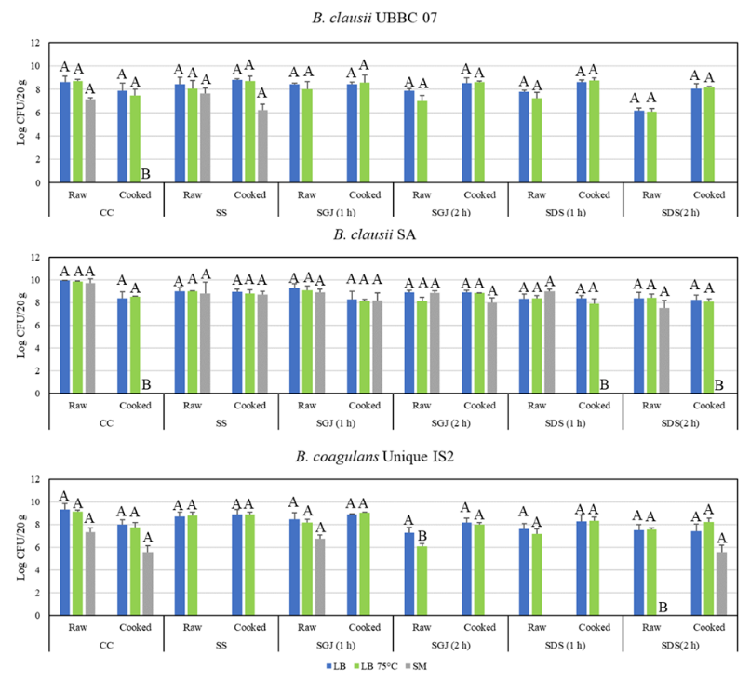 | Figure 3 Evaluation of probiotic spores during simulated digestion of raw and baked croissants’ chocolate filling after 120 days at -18°C. For data with the same letter, the differences during GIT are not statistically significant (p < 0.05). Raw and Cooked croissants were separately subject to Anova.

In order to exclude the influence of the baking, croissants after 120 days of storage at -18°C were subject to simulated digestion before and after cooking (Fig. 3). For all strains, a number of spores higher than 80% were able to germinate on the SM in raw croissants. Upon cooking this percentage is significantly lower for B. coagulans IS2, while no germination occurs for both B. clausii strains. Stressed encountered during simulated digestion lowered this percentage and, after simulated duodenum bacilli counts on SM were always under the threshold of detection except that for B. coagulans IS2. The stress of cold/hot coupled with the hostile conditions prevailing along GIT may be the cause of this phenomenon. For B. clausii SA, the thermal treatment seems to be the sole cause for the loss of viability: when submitted as raw to simulate digestion spores kept the ability to germinate on minimal medium throughout the simulated digestion (Fig. 3).

5.4 Influence of the storage at -18°
At a starting concentration of approximately 9 Log CFU mL⁻¹, spores were resuspended in water and monitored for up to 180 days at -18°C (Fig. 4). During freezing, spores experienced a loss of viability, among all B. clausii UBBC 07 suffered significantly higher losses. After the simulated digestion, both Unique Biotech strains lost more, with counts falling below 80%. The monitoring of the counts on minimal medium produced the most peculiar data. After two weeks, the spores’ capacity to germinate on SM diminished and they ceased to be countable. By the 90th day, it appears that the lengthy storage has encouraged germination since the proportion of spores that can grow on SM has gradually increased. Additionally, in these circumstances, the spore germination appears to be triggered by the GIT transit (Fig. 4).

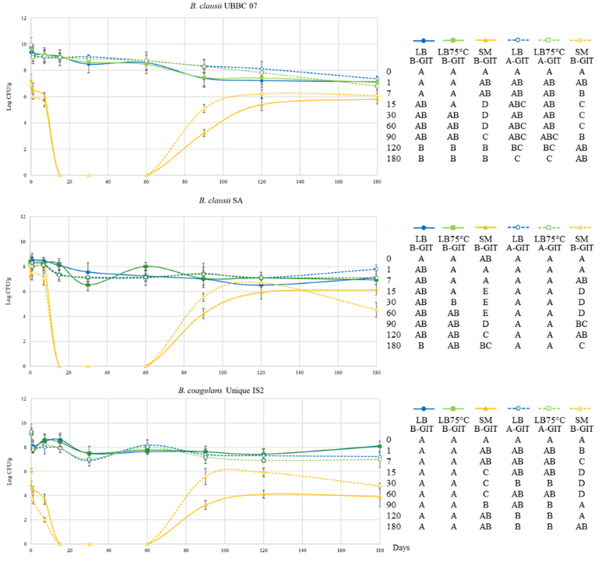
Figure 4 Monitoring of spores resuspended in water and stored for up to 180 days at -18°C. Counts before (B-GIT) and after (A-GIT) simulated digestion are reported as full and dashed lines, respectively. For data with the same letter, differences during storage are not statistically significant (p < 0.05).
Spores were simultaneously added to three distinct matrices, including gluten, starch, and butter (Fig. 5).

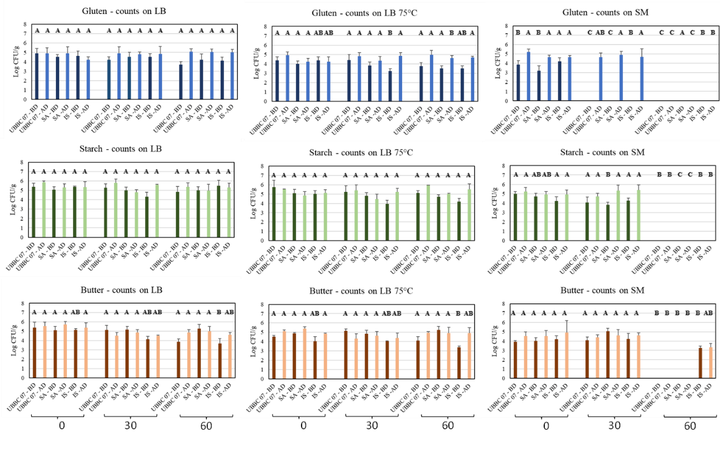 | Figure 5 Counts before (BD) and after (AD) simulated digestion of spores resuspended in gluten, starch, or butter and stored for up to 60 days at -18°C. For data with the same letter, differences during storage are not statistically significant (p < 0.05).
The idea that germination is influenced by the elements in the counting medium is supported by the lack of any noticeable differences between counts of spores on LB and those on LB75°C. The worst matrix is gluten, which after a month prevented germination on the minimal medium. But in this instance, the GIT appears to be what triggers the spores to germinate (Fig. 5).

6. Conclusions and Future Perspectives
Unquestionably important aspects that may affect the spores’ germination and outgrowth, and consequently its maximum recovery, include the medium’s components, pH, and whether it is nutritionally too rich or too poor. In order for bacilli to be beneficial, they must regain their metabolic function once they have entered the host. For this reason, it is crucial to know how many spores may germinate during food ingestion and digestion. Bacilli have been included in a vast array of diverse dietary matrices, but in every instance, spores have only been counted on complex media, putting information in jeopardy from germination triggered by nutrients in the counting medium. In this context, using minimal media may be a helpful strategy.
In the current work, probiotic bacilli were added to a frozen ready-to-bake product for the first time. This technology is becoming more and more popular among many for several viennoiseries because of how convenient it is. By extending product shelf life, increasing productivity, and reducing labour requirements, dough freezing can speed up distribution to far-flung areas (Ban et al., 2016).

7. References
Anagnostopoulos C, Spizizen J (1961). Requirements for transformation in Bacillus Subtilis. J. Bacteriol. 81: 741-6.
Ban C, Yoon S, Han J, Kim SO, Han JS, Lim S, Choi YJ (2016). Effects of freezing rate and terminal freezing temperature on frozen croissant dough quality. LWT 73: 219-225.
Bernardeau M, Lehtinen MJ, Forssten SD, Nurminen P (2017). Importance of the gastrointestinal life cycle of Bacillus for probiotic functionality. J. Food Sci. Technol. 54(8): 2570-2584.
Konuray G, Erginkaya Z (2020). Quality evaluation of probiotic pasta produced with Bacillus coagulans GBI-30. Innov. Food Sci. Emerg. Technol. 66: 102489.
Marcial-Coba MS, Pjaca AS, Andersen CJ, Knøchel S, Nielsen DS (2019). Dried date paste as carrier of the proposed probiotic Bacillus coagulans BC4 and viability assessment during storage and simulated gastric passage. LWT 99: 197-201.
Ricciardi A, Blaiotta G, Di Cerbo A, Succi M, Aponte M (2014). Behaviour of lactic acid bacteria populations in Pecorino di Carmasciano cheese samples submitted to environmental conditions prevailing in the gastrointestinal tract: evaluation by means of a polyphasic approach. Int. J. Food Microbiol. 179: 64-71.

