POSTER COMMUNICATIONS

Plant health monitoring of durum wheat, pathogen identification with advanced diagnostic tools and design of sustainable prevention system
Merima Jasarevic (merima.jasarevic@unitus.it)
Department for Innovation in Biological, Agro-food and Forest systems – DIBAF, University of Tuscia, Viterbo, Italy
Tutor: Prof. Gabriele Chilosi

According to the activities described in the PhD thesis project, some changes were made in order to focus better on main objectives and reach best possible results. We decided to focus on only one crop species, Triticum durum in order to be able analyse in detail the microbiome community of fungal species of the crop in the period of three years. Firstly, the caryopsis analysis were done by using morphological identification of fungal species and molecular analysis followed by assessment of mycotoxin analyses. Secondly, the soil microbiome community was studied for a period of three years 2020-2022 in order to understand the differences between plots treated with organic compost and mineral fertilizer.

Monitoraggio fitosanitario del grano duro, identificazione di agenti patogeni con strumenti diagnostici avanzati e progettazione di un sistema di prevenzione sostenibile

Secondo le attività descritte nel progetto di tesi di dottorato, sono state apportate alcune modifiche al fine di concentrarsi meglio sugli obiettivi principali e raggiungere i migliori risultati possibili. Abbiamo deciso di concentrarci su una sola specie vegetale, il Triticum durum per poter analizzare in dettaglio la comunità microbiotica delle specie fungine della coltura nel periodo di tre anni. Innanzitutto, l'analisi della cariosside che è stata effettuata utilizzando l'identificazione morfologica delle specie fungine e l'analisi molecolare seguite da verifica delle micotossine presenti. Inoltre, la comunità del microbiotica del suolo è stata studiata per un periodo di tre anni 2020-2022 per capire le differenze fra le parcelle trattate con il compost organico e fertilizzante minerale.

Key words: wheat, Triticum durum, fungal species, microbiome community, organic compost, mineral fertilizer.

1. Introduction
In accordance with the PhD thesis project and the changes previously described, this poster reports the main results of the first two activities concerning:
(A1) Biodiversity and metagenomics. The sampling of wheat (Triticum durum), variety Antalis in year 2022 and microbiome analysis of the wheat rhizosphere for years 2020, 2021 and 2022 by using PCR and HTS analysis.
(A2) Food safety. Fungal contaminants of caryopses and mycotoxins. Morphological and molecular analysis of fungal species isolated from wheat caryopsis collected through the period of three years (2020 – 2022) and assessment of mycotoxins present.

2. Materials and Methods
The sampling of wheat took place three times in each experimentation year in order to understand if there is a difference between different phenological phases: A) Tilling; B) Rising; C) Ripening. Besides that, different soil treatments were considered: organic compost or mineral fertilizer, as well as different soil tillage practices: A) Ploughing; B) Digging; C) Ripping. Total DNA was extracted from soil samples using the Nucleo Spin Soil Kit (Macherey - Nagel), following the protocol. The PCR reaction was done using the ITS1 region was amplified with a dual indexing primer using the tagged primer pair ITS1F and ITS2. The thermal cycle was an initial denaturation at 94 ºC for 10 min followed by 30 cycles of 95 ºC for 40 s, 60 ºC for 40 s and 72 ºC for 1 min, and a final elongation step of 72 ºC for 10 min. Amplicons were purified using the Mag JET NGS Clean-up (Thermo Scientific, USA), quantified with the Qubit Quantitation kit (Invitrogen, USA), and pooled at equal concentrations for sequencing. Paired-end sequencing (2 x 300 bp) was carried out on an Illumina Mi Seq sequencer by Fasteris SA (Switzerland) for samples collected in 2020.
Furthermore, the analyses of caryopses were done by isolation of fungal species and their morphological and molecular analyses. The morphological analyses were done by placing the caryopses in Petri plates using the DFB method as described by (Liomonard 1996) and the culture medium PDA (Potato Dextrose Agar). Once the pure cultures were obtained the morphotypes were assigned based on macro morphology. Afterwards, the molecular analyses were done in order to reach the fungal species, started from the DNA extraction of morphotypes, PCR, purification of amplicons, quantification and sequencing (M. T. Senatore et al., 2023; G. Beccari et al., 2020). The PCR reaction was done using ITS1 and ITS4 primers and elongation factor.

3. Results and Discussion

3.1 Biodiversity and metagenomics
Bioinformatics analyses are still in progress. Results for the fungal population in are completed for year 2020 in terms of order distribution. We are witnessing the first year of experimentation with a strong increase in fungal orders in plots fertilized with compost with a significant change in the percentage of orders. The order with greater frequency is the Hypocreales, represented by Fusarium species (Fusarium brachygibbosum, Fusarium equiseti, Fusarium oxysporum species complex, Fusarium redolens, Fusarium poae, Fusarium solani species complex) which results to be more abundant in plots treated with mineral fertilizer (Fig. 1). From what emerges from the Venn diagram (Fig. 2), the rhizosphere soil of the plots fertilized with compost together present 60% more of the fungal orders. Ongoing analyses will provide more detail on the functionality of fungal species over the three years and the role of compost in providing ecosystem systems for the biological part of soil fertility.
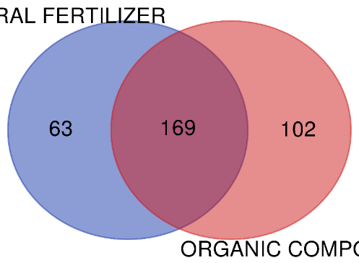
Mineral fertilizer
Organic compost
Figure 1 Relative abundance of orders according to different treatments Figure 2 Venn diagram

3.2 Food safety: fungal contaminants of caryopses and mycotoxins
The results obtained indicate that in the three years of experimentation there has been a variation in the abundance of the various fungal species colonizing the caryopsis. These variations were mainly due to the meteorological trend. All three years were characterized by a drought during the spring summer period, with 2022 demonstrated with arid climate. The general trend was characterized by a greater colonization by s of the genus Alternaria. This genus is characterized by a greater development in warm periods during the ripening phase, than in the years of experimentation. The 2022 was the driest and this certainly favoured Alternaria species. Conversely, the species belonging to the genus Fusarium have recorded a poor development that can be related to the low spring rainfall during the flowering phase, site of penetration and colonization of these mycotoxin fungi. Some species of Fusarium, such as F. equiseti (2020 and 2021) and F. poeae (2020) have been absent in chemically fertilized theses, compared to the organic, which however has recorded extremely low values. On the whole, it can be said that the experimental theses have shown little influence on the rate of colonization of the different mycotoxin fungi, while the climatic factor is predominant.
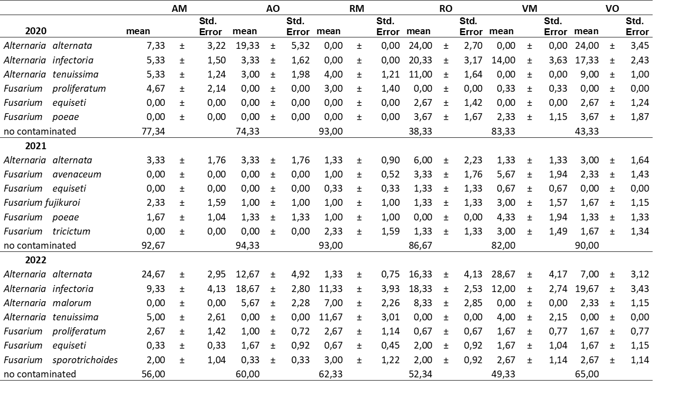
Table 1 Relative abundance (%) of mycotoxin fungal species detected in caryopses by blot - deep freezing method. Data refer to standard error averages.

4. References
Limonard T (1966) A modified blotter test for seed health. Government Seed Testing Station, Wageningen. Neth. J. PI. Path. 72 (1966): 319-321
Gholizadeh S et al., (2022) Changes in root microbiome during wheat evolution. BMC Microbiology.
Bakker P (2022) The soil-borne ultimatum, microbial biotechnology and sustainable agriculture. Microbial Biotechnology 15(1), 84–87
Beccari G et al., (2020) Cultivation Area Affects the Presence of Fungal Communities and Secondary Metabolites in Italian Durum Wheat Grains. Toxins 12, 97. MDPI

